Cyber Security Evaluation Tool

CSET

User Guide

July 2014

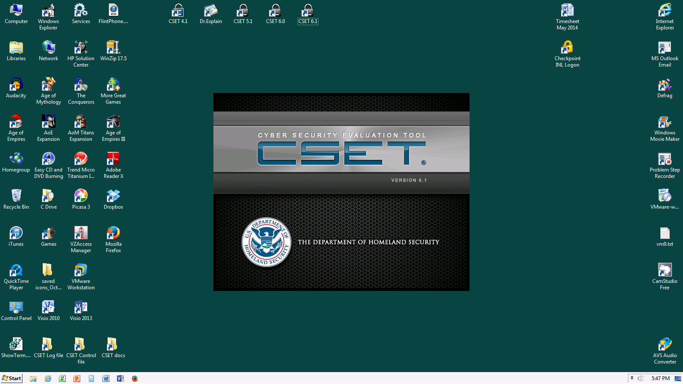

**DISCLAIMER**

The analysis, data, and reports in CSET® are provided “as is” for informational purposes only. The Department of Homeland Security (DHS) does not provide any warranties of any kind regarding any information contained within. In no event shall the United States Government or its contractors or subcontractors be liable for any damages, including but not limited to, direct, indirect, special, or consequential damages and including damages based on any negligence of the United States Government or its contractors or subcontractors, arising out of, resulting from, or in any way connected with this report, whether based on warranty, contract, tort, or otherwise, whether injury was sustained from, or arose out of the results of, or reliance upon the report.

DHS does not endorse any commercial product or service, including the subject of the assessment or evaluation in this report. Any reference to specific commercial products, processes, or services by trademark, manufacturer, or otherwise, does not constitute or imply its endorsement, recommendation, or favoring by DHS.

The display of the DHS official seal or other DHS visual identities on this report shall not be interpreted to provide the recipient organization authorization to use the official seal, insignia or other visual identities of DHS. The DHS seal, insignia, or other visual identities shall not be used in any manner to imply endorsement of any commercial product or activity by DHS or the United States Government. Use of the DHS seal without proper authorization violates federal law (e.g., 18 U.S.C. §§ 506, 701, 1017), and is against DHS policies governing usage of the seal.

The report is prepared and intended for internal use by the organization that made the request. The contents of this report may be subject to government or private intellectual property rights. To request distribution of this report outside the organization for which it was prepared, contact the CSET Program Office. The contents of this report may be reproduced or incorporated into other reports, but may not be modified without the prior express written permission of the CSET Program Office.

USER GUIDE REVISION HISTORY

| **Document Revision** | **Date** | **Change Description** |
| --- | --- | --- |
| 0 | August 2009 | Initial release |
| 1.0 | April 2010 | Updated Regulatory Basis in Section 2. Added instructions for new functionality in the drawing tool. |
| 1.1 | May 2010 | Added need for Word 2007 to support RTF report. Revised description of component diagram zones. |
| 2.0 | August 2010 | Updated Regulatory Basis in Section 2. Added instructions for new navigation and user interface. |
| 3.0 | July 2011 | Updated Regulatory Basis in Section 2. Added instructions for the resource library, diagram layering, line security, and new report format. |
| 4.0 | January 2012 | Updated the component diagram section to explain the use of Microsoft Visio. |
| 5.0 | December 2012 | New architectural change to .NET and new approach with questions and requirements. New diagramming tool and system redesign for ease of use. Added new standards and modified default approach for component questions. Added new analysis capabilities and enhance resource library. |
| 5.1 | June 2013 | Modifications to the Questions screen with headings, new standards, and modifications to standards and analysis to accommodate the CNSSI baseline and overlay. |
| 6.0 | January 2014 | Added aggregation functionality and new standards, modified the diagram interface to improve usability, added the ability to create a component inventory list from the diagram, and added new Security Plan Report option. Video tutorials were moved to YouTube for on-line viewing. |
| 6.1 | July 2014 | Added new Cybersecurity Framework mode to the standards options, revised the Analysis function to include Framework details, and modified the Network Diagram tool to improve how Zones are used and to clarify tab and menu names. |
|  |  |  |

**ADVISORY**

**Cyber Security Evaluation Tool**

The Cyber Security Evaluation Tool (CSET®) is only one component of the overall cybersecurity picture and should be complemented with a robust cybersecurity program within the organization. A self-assessment with CSET cannot reveal all types of security weaknesses and should not be the sole means of determining an organization's security posture.

The tool will not provide a detailed architectural analysis of the network or a detailed network hardware/software configuration review. It is not a risk analysis tool, so it will not generate a complex risk assessment. CSET is not intended as a substitute for in‑depth analysis of control system vulnerabilities as performed by trained professionals. Periodic onsite reviews and inspections must still be conducted using a holistic approach including, facility walk‑downs, interviews, and observation and examination of facility practices. Consideration should also be given to additional steps including scanning, penetration testing, and exercises on surrogate, training, or nonproduction systems, or systems where failures, unexpected faults, or other unexpected results will not compromise production or safety.

CSET assessments cannot be completed effectively by any one individual. A cross-functional team consisting of representatives from operational, maintenance, information technology, business, and security areas is essential. The representatives must be subject matter experts with significant expertise in their respective areas. No one individual has the span of responsibility or knowledge to effectively answer all the questions.

Data and reports generated by the tool should be managed securely and marked, stored, and distributed in a manner appropriate to their sensitivity.

Contents

Page

1) INTRODUCTION 14

Background 14

Objectives and Benefits 15

Limitations of this Tool 15

User Qualifications 15

User Guide Overview 16

2) CSET OVERVIEW 18

Regulatory Basis 18

CSET Structure 19

Basic Evaluation Process 19

Form the Assessment Team 20

Add Assessment Information 20

Select the Mode and Standards 21

Determine the Security Assurance Level 21

Build the Network Diagram 21

Answer Standards and Component Questions 22

Analyze the Results 22

Utilize Document Library 23

Utilize Resource Library 23

Protect Information 23

Data Recovery 23

Data Security 23

3) CSET installation 24

System Requirements 24

Installation Procedure 24

From Disk 25

Download 25

Windows XP 25

4) Preparation & User Functions 26

Prepare for Evaluation 26

Select Team 26

Gather Supporting Documentation and Information 27

User Functions 27

Launch CSET 27

Window Features 29

Menu Options 30

Function Buttons 33

Resource Library 33

Help Icons 34

Help Button 35

Video Tutorial Button 35

Docking Windows 36

Docking Options 38

5) Beginning the Evaluation 43

Start Screen 43

Create a New Assessment 44

Open a Previously Saved Assessment 45

Open an Existing Assessment 46

Use Multiple Assessments 47

Open Resource Library 50

View the User Guide 50

View the Video Tutorials 50

Exit the CSET Application 51

Assessment Recovery 51

Opening Recovery Files 52

Removing Recovery Files 53

Adding Assessment Information 53

6) Selecting the Mode and standards 56

Quick Start Option 57

Select the Assessment Mode, Step 1 57

Select the Questions and Standards or Framework Tiers, Step 2 59

Questions-Based Approach 60

Standard Requirements Approach 61

Standards and Question Groupings 62

General Control System Standards 63

Sector Specific Standards 64

Information Technology (IT) Specific Standards 67

Requirements Mode Only Standards 67

Committee on National Security Systems Instruction (CNSSI) 1253 69

Cybersecurity Framework Implementation Tiers 70

7) Determining Security Assurance Level (SAL) 72

Determine the SAL, Step 3 72

General Security Assurance Level Determination 73

NIST Security Assurance Level Determination 75

SAL of None 78

CNSSI Security Assurance Level Determination 79

DoD Assurance Level Determination 80

CFATS Tiers 82

Cybersecurity Framework Profile Management 83

8) Building a Network Diagram 92

Drawing the Network Diagram 94

Diagram Symbols 94

Adding Icons 95

Adding a Shape 95

Adding a Component 97

Adding a Zone 99

Selecting Multiple Icons 101

Home Menu Options⎯Files 102

Home Menu Options⎯General 106

Home Menu Options⎯Export 111

Home Menu Options⎯Settings 112

Diagram Menu Options - Tools 112

Diagram Menu Options⎯Edit 115

Diagram Menu Options⎯Zoom 117

Diagram Menu Options⎯Show/Hide 117

Format Menu Options⎯Label Styles 118

Format Menu Options⎯Commands 118

Integration with Microsoft Visio 124

For Visio 2010 125

For Visio 2007 126

Instructions 126

Drawing Standards 129

Using an Existing Visio Diagram 131

Building a Component Diagram from Scratch 132

Using a CSET Template 132

Importing an Existing CSET Diagram 133

Viewing the Diagram in CSET 133

Troubleshooting 134

9) answering Questions 136

Question and Answer Main Area 137

Question Information Window 140

Question Detail Window 143

Question Categories Window 146

Component Questions 148

10) analyze results 152

Analysis Screen 152

Display of Analysis Data 153

Detail Screens from the Analysis Main Screen 155

Analysis Buttons 158

Framework Analysis 159

Reports Screen 161

Report Builder 162

Report Details 165

Executive Report 165

Site Summary Report 166

Detail Report 168

Security Plan Report 169

11) LIBRARIES 171

Resource Library 171

Document Tree 174

Search Screen 178

Filtered Search 180

Document and Topic Display Area 181

Document Library 182

ADDITIONAL TECHNICAL GUIDANCE 186

A) Security Assurance Level 187

Characterize Assets 187

Define Worst‑Case Scenarios 188

Estimate Consequences 188

Injury and Loss-of-Life Estimate 189

Capital Asset Loss Estimate 189

Environmental Impacts 190

Economic Impact 191

EVALUATE TOTAL IMPACT 192

B) Initiation Scenarios 193

Common Initiation Scenarios 194

Scenario 1: Privilege Escalation 194

Scenario 2: Traffic Sniffing 196

Scenario 3: Introduction of Malicious Software from Outside the System 197

C) CSET ACCESSIBILITY Features 198

CSET® Accessibility Features 198

Screen Readers 198

High Contrast Functionality 198

Keyboard Access 198

Access Keys 199

D) Upgrade an Older Assessment File 201

Screen Features 204

Mapping to Universal Questions 204

Mapping to Requirements-Based Questions 206

Component Questions 207

E) Use Multiple ASsessments (AGGREGATION) 208

Add Assessments 209

Screen Features 210

Summary Analytics 212

F) Cybersecurity Framework 221

Framework Core 221

Framework Tiers 224

Framework Profiles 226

CSET Implementation 226

G) Glossary 229

Acronyms 230

Key Terms 232

FIGURES

Page

Figure 2-1. CSET process. 20

Figure 4-1. Terms of Use. 28

Figure 4‑2. Start or Welcome Screen. 29

Figure 4-3. Window Features. 30

Figure 4-4. File Menu. 31

Figure 4-5. Windows Menu Options. 31

Figure 4-6. Help Menu. 32

Figure 4-7. Access Keys List. 32

Figure 4-8. Function Buttons. 33

Figure 4-9. Navigation Buttons. 33

Figure 4-10. Resource Library Button. 33

Figure 4-11. Resource Library. 34

Figure 4-12. Help Icons. 35

Figure 4-13. Web Link to Video Tutorial Window. 36

Figure 4-14. Document Library Side Tab. 37

Figure 4-15. Docking Window. 37

Figure 4-16. Dockable Window States. 38

Figure 4-17. Floating Window. 39

Figure 4-18. Window on Bottom of the Screen. 40

Figure 4-19. Open Document Library Window. 41

Figure 4-20. Relocated Windows. 41

Figure 5-1. Start or Welcome Screen. 44

Figure 5-2. Advisory Screen. 45

Figure 5-3. Open Previous Assessment. 46

Figure 5-4. Upgrade Wizard Start Screen. 47

Figure 5-5. Aggregation Screen. 48

Figure 5-6. Aggregation Files Added. 49

Figure 5-7. Video Tutorial Screen. 51

Figure 5-8. File Recovery Screen. 52

Figure 5-9. Assessment Information Screen. 54

Figure 6-1. Standards Screen. 56

Figure 6-2. Assessment Mode Options. 58

Figure 6-3. Step 2, Questions and Standards. 60

Figure 6-4. Question Sets for Questions Based Approach. 61

Figure 6-5. Requirements Based Approach. 62

Figure 6-6. Standard Groupings. 63

Figure 6-7. Cybersecurity Framework Implementation Tiers. 70

Figure 6-8. Cybersecurity Framework Tier Determination Wizard. 71

Figure 7-1. Security Assurance Level (SAL) Screen. 73

Figure 7-2. General SAL Determination Screen. 74

Figure 7-3. NIST SAL Determination Screen. 75

Figure 7-4. NIST SAL, Step 2. 77

Figure 7-5. NIST SAL, Step 3. 78

Figure 7-6. SAL of None Warning. 79

Figure 7-7. Security Assurance Levels Using CNSSI 1253. 79

Figure 7-8. DoD SAL Levels. 81

Figure 7-9. CFATS Tiers. 83

Figure 7-10. Cybersecurity Framework Profile Management. 85

Figure 7-11. Manage Profile Screen. 86

Figure 7-12. Manage Profile Screen Expanded. 87

Figure 7-13. Profile Question Screen. 88

Figure 7-14. Manage Profile With New Requirement. 89

Figure 7-15. New Requirement Added to Question Screen. 90

Figure 7-16. Profile Category Screen. 90

Figure 7-17. Manage Profile With New Category. 91

Figure 7-18. Import Requirements Screen. 91

Figure 8-1. Opening Diagram Screen. 92

Figure 8-2. Diagram with Maximum Drawing Area. 93

Figure 8-3. Minimize Toolbar Checkbox. 93

Figure 8-4. Adding a Shape. 96

Figure 8-5. Adding a Component. 97

Figure 8-6. Adding a Zone 100

Figure 8-7. Selecting Multiple Icons. 101

Figure 8-8. Home Menu Options. 102

Figure 8-9. Manage Templates Screen. 104

Figure 8-10. Changing a User Template Name. 105

Figure 8-11. Load Template. 106

Figure 8-12. Manage Layers Screen. 107

Figure 8-13. Manage Layers with New Layers. 107

Figure 8-14. Layer Example. 108

Figure 8-15. Building 101 Layer Visible. 109

Figure 8-16. Network Analysis. 110

Figure 8-17. Diagram Network Analysis Warnings. 111

Figure 8-18. Inventory List. 112

Figure 8-19. Diagram Menu Options. 113

Figure 8-20. Line Types. 114

Figure 8-21. Snap to Items. 117

Figure 8-22. Format Menu Options. 118

Figure 8-23. Format Menu Commands. 118

Figure 8-24. Objects Placed in Order. 119

Figure 8-25. Objects after Positioning. 120

Figure 8-26. Before Object Alignment. 121

Figure 8-27. After Object Alignment. 122

Figure 8-28. Before Size Changes. 123

Figure 8-29. Sizing Changed Results. 124

Figure 8-30. Example Add-On Menu. 125

Figure 8-31. Example Reconcile Screen from Export CSET. 127

Figure 8-32. Example Shape Data Screen. 130

Figure 8-33. Example of Identifying Shapes. 132

Figure 8-34. Setup Visio Plugin 134

Figure 8-35. Plugin Complete. 135

Figure 9-1. Questions Screen. 136

Figure 9-2. Full Questions Area. 137

Figure 9-3. Breadcrumb Navigation 139

Figure 9-4. Related Question Drop-Down List 140

Figure 9-5. Question Info Window. 141

Figure 9-6. Question Detail Screen. 143

Figure 9-7. Question Detail with Alternate Text Box. 145

Figure 9-8. Question Categories Screen. 147

Figure 9-9. Question Information for Component Defaults. 149

Figure 9-10. Component Answer Override Screen. 150

Figure 10-1. Analysis Screen. 153

Figure 10-2. Top Categories of Concern Screen. 155

Figure 10-3. Analysis Questions Detail Screen. 156

Figure 10-4. Analysis Screen Drill-Down Options. 157

Figure 10-5. Analysis Screen Buttons. 158

Figure 10-6. Framework Analysis Screen. 159

Figure 10-7. Framework Analysis Screen Drill-Down Options. 161

Figure 10-8. Reports Screen. 162

Figure 10-9. Detail Options. 164

Figure 11-1. Resource Library Button. 171

Figure 11-2. Resource Library Window. 172

Figure 11-3. Resource Library Parts. 173

Figure 11-4. Expanded Document Tree. 175

Figure 11-5. Cyber Security Procurement Language. 176

Figure 11-6. Catalog of Recommendations. 177

Figure 11-7. Search Screen. 179

Figure 11-8. Filter Search Results 180

Figure 11-9. Document and Topic Display Area. 181

Figure 11-10. Document Library 183

Figure 11-11. Adding a New Title. 184

Figure 11-12. Question List 185

Figure D-1. CSET Welcome Screen. 201

Figure D-2. Upgrade Notification Screen. 202

Figure D-3. Upgrade an Older Assessment File. 203

Figure D-4. CSET 4.1 Standard to Universal Questions. 205

Figure D-5. CSET 4.1 Standard to Requirements. 206

Figure E-1. Use Multiple Assessments Option. 208

Figure E-2. Add Assessments Screen. 209

Figure E-3. Aggregation Information Tab. 211

Figure E-4. Summary Analytics for Trend. 213

Figure E-5. Summary Analytics for Compare. 214

Figure E-6. Top Commonly Missed Questions 215

Figure E-7. Individual Assessment Comparison. 216

Figure E-8. Best to Worst. 217

Figure E-9. Merge Differences. 218

Figure E-10. Merge Question Detail Information. 219

Figure E-11. Merge Warning for Delete 220

Figure E-12. Merge Warning for Add 220

Figure F-1. Function and Category Identifiers 222

Figure F-2. Framework Core Example. 223

Figure F-3. Risk Categories and Tiers. 224

Figure F-4. Framework Question Screen. 227

Figure F-5. Expanded Drop-Down List. 228

TABLES

Page

Table 6-1. Risk Categories and Implementation Tiers. 71

Table 8-2. Valid CSET Component Types. 128

1) INTRODUCTION



1

The Cyber Security Evaluation Tool (CSET®) provides:

1. a framework for analyzing industrial control system (ICS) security vulnerabilities associated with an organization’s overall control system architecture;
2. a consistent and technically sound methodology to identify, analyze, and communicate to security professionals the various vulnerabilities and consequences that may be exploited by cyber means;
3. the means for the user to document a process for identifying control system cybersecurity vulnerabilities; and
4. suggested methods to evaluate options for improvement based on existing standards and recommended practices.

This section provides an introduction to the tool.

Background

The Department of Homeland Security (DHS) National Cyber Security Division developed CSET for asset owners with the primary objective of reducing the risk to the nation’s critical infrastructure. Control systems are defined as electronic devices that control physical processes and, as such, are a crucial element in the protection of our nation’s infrastructure.

CSET provides users with a systematic and repeatable approach for assessing the cybersecurity posture of their ICS network components. This desktop software tool guides users through a step‑by‑step process to collect facility-specific control system information that addresses topics such as hardware, software, administrative policies, and user obligations. It then compares that information to relevant security standards and regulations, assesses overall compliance, and provides appropriate recommendations for improving the system’s cybersecurity posture. The tool pulls its recommendations from a database of the best available cybersecurity practices that have been adapted specifically for application to control system networks and components. Where appropriate, recommendations are linked to a set of actions that can be applied to remediate specific security vulnerabilities.

Objectives and Benefits

The primary objective of CSET is to reduce the risk of cyber attacks by identifying current vulnerabilities within an ICS architecture. CSET implements a simple, transparent process that can be used effectively by all sectors to perform an evaluation of any ICS. It offers the following benefits:

1. repeatable and systematic approach for assessing the cybersecurity posture of the ICS networks,
2. comprehensive evaluation and comparison to existing industry standards and regulations,
3. combined control system security knowledge and experience of many organizations,
4. identification of potential vulnerabilities in the control system design and security policies,
5. guidelines for ICSs cybersecurity solutions and mitigations,
6. access to centralized repository of cybersecurity requirements, and
7. opportunity for a dialogue on security practices within the user’s facility, particularly with regard to control system cybersecurity.

Limitations of this Tool

The tool has a component focus rather than a system focus. Therefore, network architecture analyses, including network hardware and software configuration analyses, will be limited to the extent that they are defined by programmatic and procedural requirements.

CSET is not a risk analysis tool; it will not create a detailed risk assessment.

Most importantly, CSET is only one component of a comprehensive control system security program. A security program based on a CSET assessment alone must never be considered complete or adequate.

User Qualifications

CSET assessments cannot be completed effectively by any individual. A cross-functional team consisting of representatives from multiple company areas is essential. The representatives must be subject matter experts with significant expertise in their respective areas. No one individual has the span of responsibility or knowledge to be able to fully and accurately answer all the questions.

User Guide Overview

This guide clarifies the functions and operations of the CSET software.

Section 1 describes the purpose, development background, objectives, and benefits of CSET.

Section 2 presents an overview of CSET including the regulatory framework and introduction to the evaluation process.

Section 3 provides user instructions for installing CSET on a desktop computer and includes technical requirements for optimal performance.

Section 4 includes assessment preparation activities and provides information on general screen navigation and user interface.

Section 5 describes how to begin an assessment or open and resume an assessment that is in progress.

Section 6 explains the different assessment modes available and how to select a standard for the evaluation.

Section 7 describes the different options for determining the security assurance level (SAL) and includes details on how to use both the General SAL and the National Institute of Standards and Technology (NIST) SAL question screens.

Section 8 presents details on the diagram tool features and explains how to build and analyze the network diagram.

Section 9 describes the process of answering both the standard and component questions. It includes a description of supporting information and detail screens.

Section 10 discusses the two different ways to analyze the results of the evaluation, including both the online analysis screen and the printed reports.

Section 11 presents the Resource Library and reviews the materials that are available in it, as well as the mechanics of using the screen.

Appendixes are included to provide additional technical guidance as follows:

Appendix A—Determining the security assurance level

Appendix B—Defining worst‑case scenarios

Appendix C—Explaining CSET accessibility features

Appendix D— Upgrading an Older Assessment File

Appendix E—Using Multiple Assessments (Aggregation)

Appendix F—Explaining Cybersecurity Framework

Appendix G—Glossary of acronyms and key terms

**Note:** The figures provided in the following sections are examples only. The actual screens may vary from the examples provided.

2) CSET OVERVIEW



2

CSET is an evaluation tool for performing cybersecurity reviews of ICSs. The tool may be used by any organization using such systems to control a physical process.

This section describes CSET’s regulatory basis, underlying framework, the basic evaluation process, and additional activities to enhance the assessment process.

Regulatory Basis

CSET requirements were derived from widely accepted standards such as:

* Catalog of Control Systems Security: Recommendations for Standards Developers (CoR), U.S. Department of Homeland Security, Version 7.
* NERC CIP‑002 through CIP‑009: North American Electric Reliability Council (NERC) Critical Infrastructure Protection (CIP), Effective June 1, 2006. Revision 3 and Revision 4 are included in the tool.
* CIP‑002‑2 and CIP-002-4—Critical Cyber Asset Identification
* CIP‑003‑2 and CIP‑003‑4—Security Management Controls
* CIP‑004‑2 and CIP‑004‑4—Personnel and Training
* CIP‑005‑2 and CIP‑005‑4—Electronic Security Perimeter(s)
* CIP‑006‑2 and CIP‑006‑4—Physical Security of Critical Cyber Assets
* CIP‑007‑2 and CIP‑007‑4 —Systems Security Management
* CIP‑008‑2 and CIP‑008‑4—Incident Reporting and Response Planning
* CIP‑009‑2 and CIP‑009‑4—Recovery Plans for Critical Cyber Assets.
* NIST Special Publication (SP) 800‑53: Recommended Security Controls for Federal Information Systems, Revision 3, August 2009 and Revision 4, April 2013.
* NIST SP800‑82: National Institute of Standards and Technology (NIST), Special Publication (SP) 800‑82, Guide to Industrial Control Systems (ICS) Security, June 2011.
* Twenty Critical Security Controls for Effective Cyber Defense: Consensus Audit Guidelines (CAG), Version 1, November 2009.
* DoD Instruction 8500.2: US Department of Defense (DoD) Instruction Number 8500.2, “Information Assurance (IA) Implementation,” February 6, 2003.
* NRC RG 5.71: US Nuclear Regulatory Commission (NRC) Regulatory Guide (RG) 5.71, “Cyber Security Programs for Nuclear Facilities,” January 2010.
* FIPS 199: Federal Information Processing Standards (FIPS) Publication 199, Standards for Security Categorization of Federal Information and Information Systems, February 2004.
* CFATS RBPS: The Chemical Facility Anti-Terrorism Standards, Risk-Based Performance Standards Guidance, RBPS 8, “Cyber,” May 2009.
* Transportation Security Administration (TSA) Pipeline Security Guidelines, April 2011.
* Committee on National Security Systems Instruction (CNSSI) No. 1253, March 15, 2012.
* CNNSI 1253, Industrial Control Systems (ICS) Overlay, Draft, April 2013.
* Framework for Improving Critical Infrastructure Cybersecurity, Version 1.0, National Institute of Standards and Technology, February 12, 2014.
* Industry standards, leading practices, and related white papers.

CSET Structure

The underlying structure for CSET includes:

* analysis and user interface tools to assist in the evaluation of an ICS;
* a knowledge base of ICS cybersecurity requirements, regulations, and practices; and
* a database of solutions to help mitigate vulnerabilities.

CSET was designed to assist in identifying control system parameters by guiding the user through a series of questions that represent ICSs security requirements. The presented requirement questionnaires are based on selected standards, common requirements, and the design of the control system component diagram (or network topology and architecture).

Basic Evaluation Process

Figure 2-1 graphically depicts the basic steps of the self-assessment process. A brief summary of the process is provided below. A more detailed description is provided in the following sections of this User Guide.

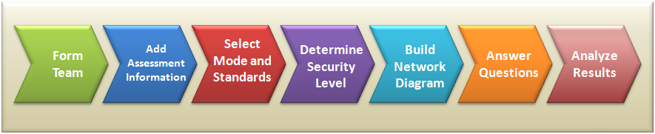

Figure 2-1. CSET process.

Form the Assessment Team

Form a subject matter team prior to beginning the CSET process. Teams typically include representation from senior management, business, operations, Information Technology (IT), ICSs (Process Control/Supervisory Control and Data Acquisition (SCADA)), and security. The assembled team is responsible for determining the evaluation levels and answering specific, detailed questions on the control system and security configuration.

Familiarity with the tool will improve and speed the assessment process. Anyone in the organization who has had training or experience with the tool should be included on the team. Alternately, the primary user should spend some time using the tool with test-only or “dummy” data prior to commencement of the team activity.

Gather Reference Materials

Documents that may be referenced should be gathered prior to the assessment. Useful reference materials include information relating to operations, maintenance, physical security, cybersecurity, and hazardous materials.

Open CSET

Begin execution of CSET by selecting the Windows Start Menu item or double-clicking the desktop shortcut. After acknowledging the disclaimer notice if it appears, select “Create a New Assessment” or one of the other options at the Start or Welcome screen.

Add Assessment Information

Begin the assessment by filling out information about the process in the Assessment Information screen. This includes the assessment name and date, location information, information on the subject system, points of contact, comments, and a description of the assessment. Such information will be helpful when referring to the assessment months or years later. The option for the user to modify text for an executive summary is also found here; however, it is recommended that the executive summary and description fields be modified after the assessment so as to provide a more valid summary of the results.

Select the Mode and Standards

There are three different modes or approaches to performing the assessment. The first uses a set of simplified yes/no questions that have been extracted from the standards. These questions do not combine multiple concepts; rather, they address a single idea with each question.

The second approach presents the strict requirement text and provides answers of met and unmet. The requirement-based approach is designed for regulated industries where the exact wording is important. The choice of which mode to use is made in the Standards screen.

Also included on the Standards screen is a menu of standards and guides applicable to the first to mode options. The list of choices will vary depending on which of the first two modes was selected. You will be required to accept the defaults or check a standard that you would like to be evaluated against.

The third mode option is related to cybersecurity framework. It contains the recommended activities from the Framework Document. It also allows the user to tailor the questions and categories to best fit their business or facility.

Determine the Security Assurance Level

The system requires that you identify a security assurance level or SAL, and several options are provided to determine what the SAL should be. You may bypass the screens and simply select the SAL in the Standards screen or you may use the General SAL (consequence based) or the NIST SAL (based on FIPS 199 and NIST SP800-60) screens to find a recommended level.

The SAL value is used to limit the questions to only those related to the selected level, and it is also used in the ranking of missed questions.

Build the Network Diagram

CSET provides the necessary tools to create a network diagram including the following:

* Build the diagram from scratch using the drawing tools and available objects and shapes.
* Import a pre-built template from a list of templates provided with the tool.
* Import a diagram file from another CSET user including diagrams from previous releases.
* Export a Microsoft Visio diagram to a CSET format that can be opened in the tool.

Once the diagram has been developed, attribute data can be assigned that will enhance the visual presentation, allow grouping and layers, and provide input to the analysis and question ranking. Simple network analysis is available within the tool and is provided in the reports and the Analysis screen.

Answer Standards and Component Questions

When the approach and the standards have been selected, the system builds a set of questions that can be accessed through the Questions screen.

**Answer Standard Questions**

All questions using the questions-based or cybersecurity framework-based approaches will be answered as either Yes, No, Not Applicable (N/A), or through an Alternate method (Alt). If the requirements-based approach is selected, then the questions will be presented as explicit requirements from the standard. The available answers in this mode are Met, Unmet, N/A, and Alt.

The process of going through the questions is tedious but straightforward. As a team, start with Question 1 and continue through each subject area or category until you have discussed and answered all questions.

**Answer Component Questions**

After the user builds the network diagram, CSET generates the component questions based on component types and which components were marked as unique. The questions are grouped so that a default question can apply to a range of types. The system also allows overrides to an answer based on either the type or the individual component.

Analyze the Results

The results of the assessment can be reviewed in two locations. The first is through the Analysis screen where charts present both summary and detailed information about how well you are doing. By drilling down you are able to open new screens that show an even finer level of detail until you get down to the list of actual questions and answers. All the missed questions are ranked in the order of what is recommended to be addressed first.

The second way to view the results is through a set of printed reports. From the Executive to the Site Summary and the Site Detail reports, each report provides increasing levels of detail. Finally, the Security Plan report provides a template for documenting the required cybersecurity controls and the degree to which they are met. All charts, lists, and detail information found in the Analysis screen are captured in the printable reports.

Utilize Document Library

CSET gives users the opportunity to collect and store all cybersecurity documents relevant to the assessment. This may be done in two ways. All questions have a link that allows the user to add documents related to that question. The second way is a link to the Main Document Library available as a docking window. The Document Library screen lists all documents currently added to the assessment. Users may add, edit, export, or delete documents from within the library. More information is available later in this User Guide.

Utilize Resource Library

The Resource Library is a source for cybersecurity documentation. It is accessed from the Welcome screen or from the resource library button in the upper-right of the CSET window. It contains reference materials to answer many of your technical or policy questions and aid in the creation and maintenance of a comprehensive cybersecurity program. More information is available in the section titled Resource Library later in this User Guide.

Protect Information

Data Recovery

An auto-save file is created at set intervals and will automatically be detected if the application was stopped unexpectedly. If the assessment is correctly saved and CSET closed, the auto‑save file is deleted. However, if CSET is prematurely terminated, by a power failure for instance, the auto-save may be available to help recover entered information. When CSET is restarted, the user will be presented with the option to load the auto-save file, if one was created.

Data Security

All files containing identification of vulnerabilities should be encrypted and protected. The assessment file, report file, and any associated files, such as auto-save, recovery, or temporary files, should be protected against loss and damage. Recovery files must not be encrypted, revised, or deleted until after the assessment is successfully saved and the CSET application closed or the ability to recover will be lost.

3) CSET installation



3

This section provides instructions for installing CSET.

System Requirements

It is recommended that users meet the minimum system hardware and software requirements prior to installing CSET. This includes:

* Pentium dual core 2.2 GHz processor (Intel x86 compatible)
* CD-ROM disk drive
* 2 GB free disk space
* 3 GB of RAM
* Microsoft Windows 7 or higher. It is highly recommended that Windows be fully patched through Windows Update.
* A Portable Document Format (PDF) reader such as Adobe Reader is required to view supporting documentation such as the standards; the latest version of Adobe Reader may be downloaded free from <http://www.adobe.com/products/>
* Microsoft Office compatible (.doc or docx) document reader is required to open the reports.
* Microsoft Visio 2007 or 2010 is required if Visio is the preferred tool to create or revise the network diagram. Visio 2013 is not currently supported.
* Microsoft Excel is required to open the network diagram inventory list.

CSET installs the Microsoft .NET Framework 4.5 Full Runtime if required.

Installation Procedure

During installation, a license agreement will be presented. It must be accepted before the installation can be completed.

By default, CSET will be installed into C:\Program Files\DHS or C:\Program Files (x86)\DHS. This can be changed during installation. A desktop shortcut to the selected file location will be created.

If for some reason the same version of the tool needs to be reinstalled, uninstalling the tool before reinstallation is necessary. CSET can be uninstalled from the Control Panel.

From Disk

Insert the installation disk into the disk drive. Navigate to the drive and then run the executable file s*etup.exe*. With some CD-ROM drives and depending on the installed anti-virus software, the install process may take 10 to 15 minutes.

Download

To download a copy of the tool from the Internet, go to the DHS Web site at: <http://ics-cert.us-cert.gov/Downloading-and-Installing-CSET>. Download the .ISO file labeled *CSETxx.iso* (where “xx” is the version identifier).

The .ISO file is a disk image file and will need to be burned to disk. Some newer compression utility software may also be used to open the .ISO file. To install, run *setup.exe*.

Windows XP

Microsoft Windows XP is not an officially supported platform for CSET.

4) Preparation & User Functions



4

This section provides information to help prepare for an assessment using CSET.

Prepare for Evaluation

Two preliminary tasks are required before using the tool to perform an assessment: forming the subject matter team and collecting the ICS network/architecture documentation and related information.

Select Team

The first step is to select a cross‑functional assessment team consisting of subject matter experts selected from the various operational areas in the organization. Organizations may add additional team members as needed to address specific topics. Anyone in the organization who has had training or experience with the tool should be included on the team.

The primary user should spend some time using the tool with test-only or “dummy” data prior to commencement of the team activity. Familiarity with the tool will improve speed and ease of tool use.

Representatives from the following areas are suggested for an effective assessment. The representatives should have significant expertise in their areas of responsibility.

* Industrial Control Systems (knowledge of industrial control system architecture and operations),
* System Configuration (knowledge of systems management),
* System Operations (knowledge of system operation),
* IT Network/Topology (knowledge of IT Infrastructure),
* IT Security/Control System Security (knowledge of policies, procedures, and technical implementation),
* Risk Management (knowledge of the user's organization’s risk management processes and procedures),
* Business (knowledge of budgetary issues and insurance postures), and
* Management (a senior executive sponsor/decision maker).

Gather Supporting Documentation and Information

Previous CSET users have found that the following types of documents and information are useful to have during completion of the assessment. Collecting this reference information before beginning the assessment is advisable:

* organizational chart that outlines responsibilities;
* annual operating and capital budgets;
* insurance policy description;
* previously performed risk assessment and vulnerability assessments;
* capacity, operation, management, and maintenance manuals;
* risk management documentation;
* hazardous waste operations and emergency response standards;
* Emergency Operations Plan/Emergency Response Plan;
* asset inventory and criticality rating from Computerized Maintenance Management System (CMMS);
* inventory list of process control/SCADA software and hardware, including interfaces;
* network topology diagram and supporting documentation;
* documentation/knowledge from previous incidents or near misses;
* general asset inventory, criticality asset determination, business impact analyses, contingency plans, etc.; and
* information security policies, plans, and procedures.

When the assessment team is prepared and supporting documents are gathered, the organization is prepared to launch CSET and begin the actual evaluation.

User Functions

Launch CSET

If the software is not already loaded on a computer, the instructions provided in Section 3 of this User Guide should be followed. Once installed, the application may be launched by using the Windows Start > Programs menu or by double-clicking the desktop shortcut.

After opening the application, the Terms of Use screen will be displayed as shown in Figure 4-1.

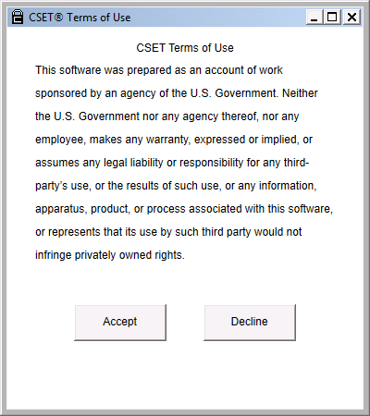

Figure 4-1. Terms of Use.

Once the terms of use have been read and accepted, the Start or Welcome screen will be displayed as shown in Figure 4-2.

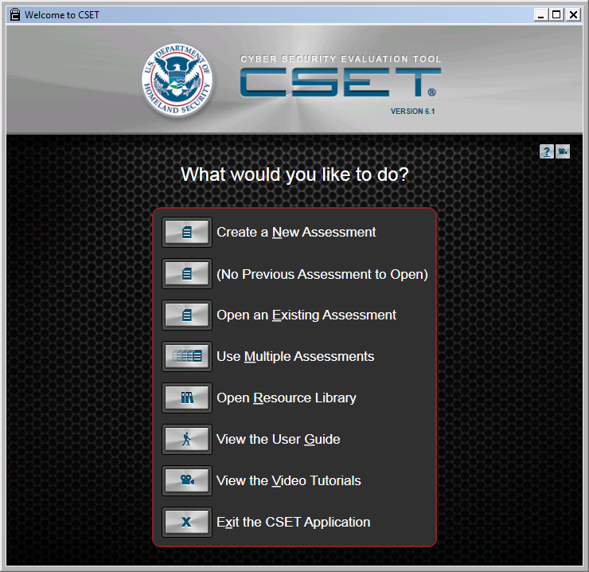

Figure 4‑2. Start or Welcome Screen.

From this initial Start or Welcome screen, you are able to create a new assessment, open the latest file or select an existing assessment, (including one from a previous CSET version), use multiple assessments (also known as aggregation), open the User Guide, view the video tutorials, or exit the application.

When you click the button to create a new assessment, the system will first display an advisory screen and then open the Information Screen. From here, you can move through all the functions in the tool.

Window Features

Multiple features and navigation aids are available in the CSET screens. To demonstrate, we will use the Information Screen as shown in Figure 4-3.

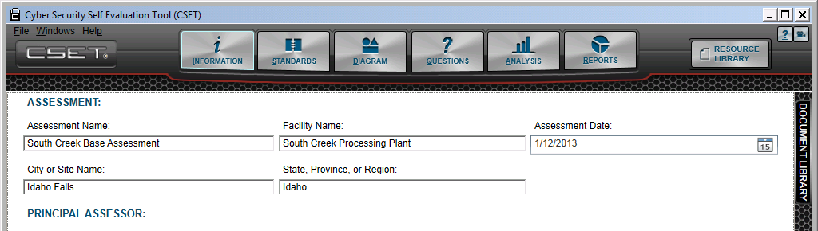

Figure 4-3. Window Features.

From this screen, like many others, you are able to navigate to each of the key functions within the system.

From left to right, the first noted area contains the Menu options of File, Window, and Help. The next area allows you to move between the main functional areas of the tool. These are the Information screen, the Mode, Standards, and SAL selection screen, the Diagram screen, the Questions screens, the Analysis screen, and the Reports screen. The next button highlighted opens the Resource Library. The upper-right icons open the Help screens and the Video tutorials respectively. The last highlight shows an example of a docking Window, in this case, the Document Library.

Each of these areas will be discussed below. For a more complete understanding of the respective areas, select the specific function name in the help system.

Menu Options

The File Menu option is shown in Figure 4-4. It allows you to save the assessment and to save it under a different name. It is recommended that you save often. You can close the assessment without closing CSET. This action will result in a prompt to save the file. You can select Exit to close the CSET application, which will also result in a prompt to save the file if one is open.

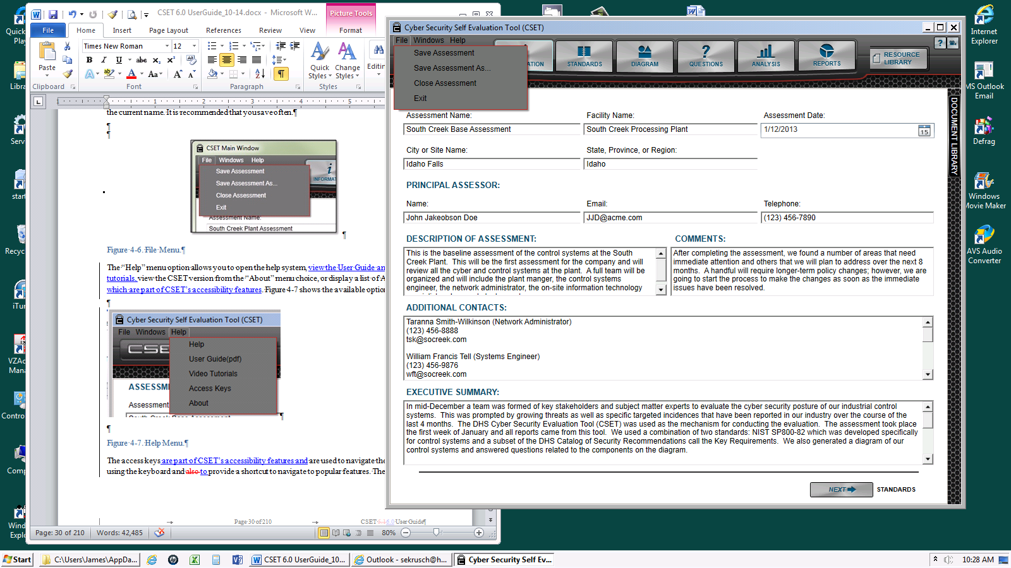

Figure 4-4. File Menu.

Select the Windows menu item as seen in Figure 4-5 to access the docking windows and libraries.

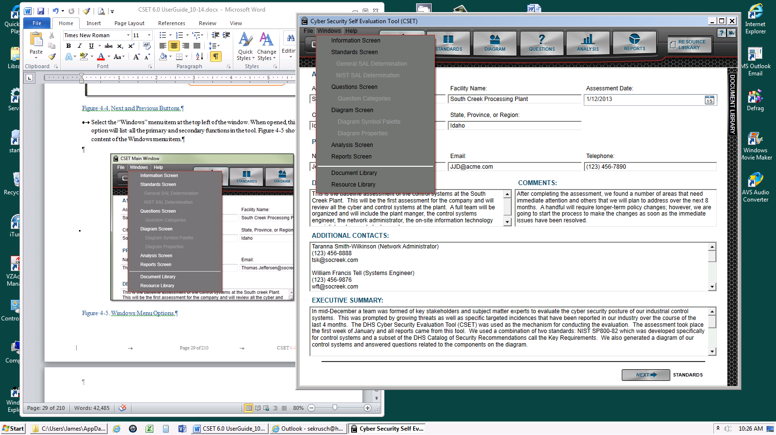

Figure 4-5. Windows Menu Options.

The Help menu option allows you to open the help system, view the User Guide and video tutorials, display a list of Access keys that are part of CSET’s accessibility features, re-run the Visio setup, or view the CSET version from the “About” menu choice. Figure 4-6 shows the available options.

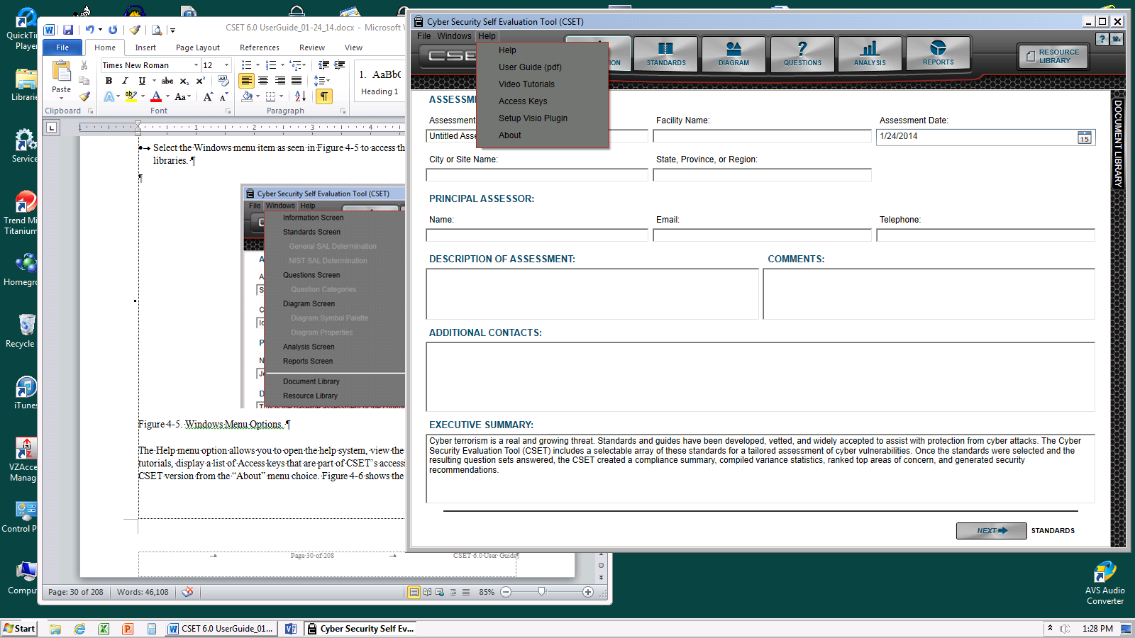

Figure 4-6. Help Menu.

The access keys are part of CSET’s accessibility features and are used to navigate the system using the keyboard and to provide a shortcut to navigate to popular features. The mapped keys are displayed in a list that is opened when the “Access Keys” menu item is selected. Figure 4-7 provides a glimpse of the list that is provided.

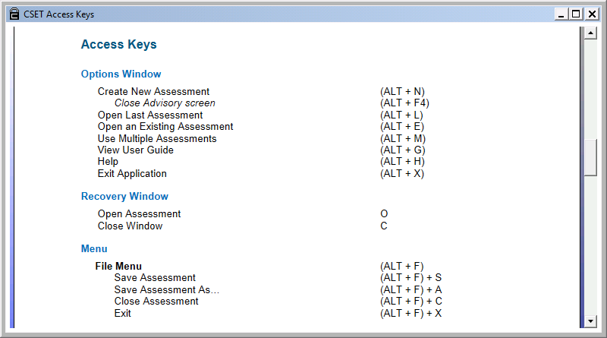

Figure 4-7. Access Keys List.

More information is available in Appendix C, CSET Accessibility Features.

Function Buttons

The next set of buttons access the main portions of an assessment in sequential order. Figure 4-8 provides an example.

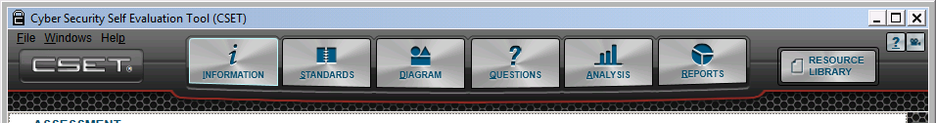

Figure 4-8. Function Buttons.

In a typical assessment, you would fill in the assessment information, select the standards you wish to use and a SAL, create your network diagram, and then proceed to answer the questions generated by CSET based on your selections. Once all the standard and component questions are answered, you would review your results on-screen or create printed reports. This sequence of actions is represented by and made accessible by the function buttons at the top of the screen.

You can also navigate through the sequence of functions by using the Previous/Next buttons located at the bottom right of the CSET window. Figure 4-9 provides an example.

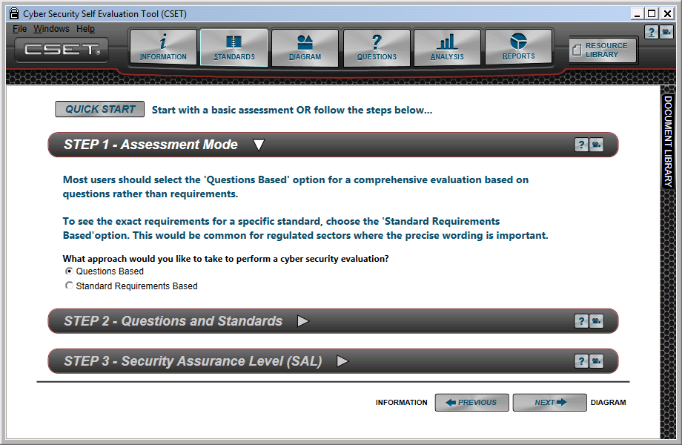

Figure 4-9. Navigation Buttons.

The upcoming function name is shown at the right side of the button with the preceding function name on the left. If you are anywhere in the middle of the list, both a “Next” and a “Previous” button will be displayed.

Resource Library

The Resource Library button shown in figure 4-10 is similar to the other function buttons; however, when it is clicked, a new window is displayed as shown in Figure 4-11.



Figure 4-10. Resource Library Button.

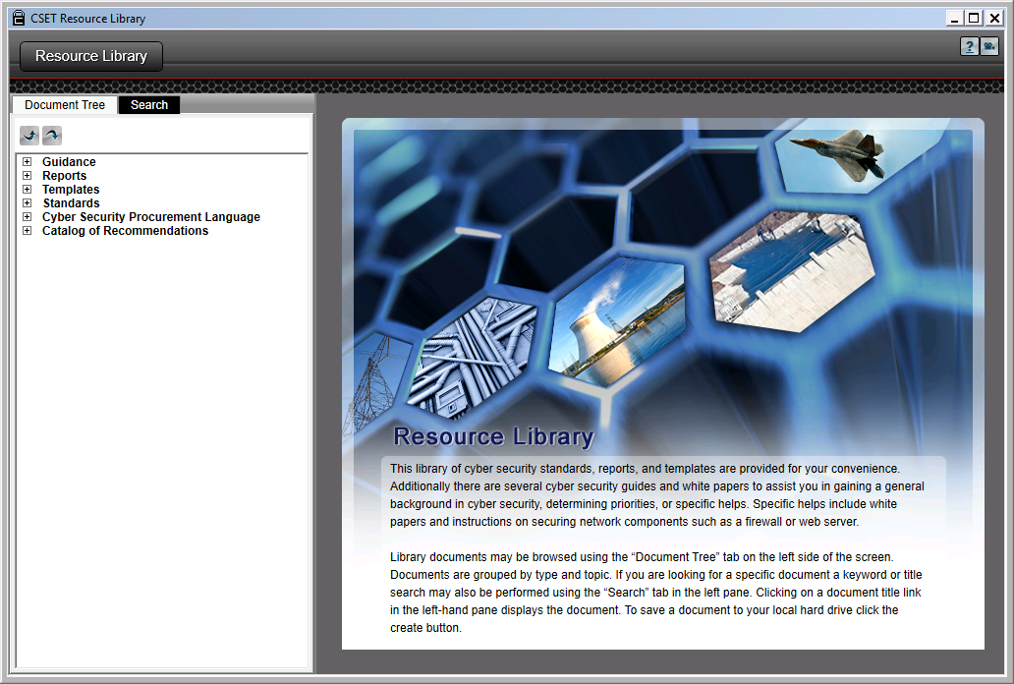

Figure 4-11. Resource Library.

This library is provided for information only. It is not necessary to access the library to complete an assessment. However, it contains a wealth of helpful information including guides, reports, and standards that can aid you in answering questions. The library has a tree structure for quickly scanning the document available. It also has a search feature so you use key words to find specific documents or topics.

Detailed information about the Resource Library is provided later in this User Guide.

Help Icons

Figure 4-12 presents the icons that open the context-specific help screens and the context-specific video tutorials.

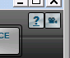

**Help Video Tutorials**

Figure 4-12. Help Icons.

Context-specific means that they open to the topic most closely related to the screen you have open. For example, if you open the User Guide from the Start or Welcome screen, the document opens to the title page. If you click the question mark icon from the Information screen, the help text will open to the section that discusses the Information screen.

Help Button

Help is available throughout the application. The button with the question mark can be clicked to open the help system. The help buttons will typically be in the upper right-hand corner of the screen and will be found in all the main screens in CSET.

Video Tutorial Button

A series of video tutorials have been prepared to help you better understand how to use this tool. Where applicable, the video tutorial buttons will be found to the side of the help buttons. You may also open the tutorials at the Start or Welcome screen.

The video tutorials are designed to play within YouTube. Therefore, you must have an active Internet connection to view them. Clicking the video tutorial link from within CSET will provide the needed web address or Uniform Resource Locator (URL) as shown in Figure 4-13. Copy then paste the address into an Internet browser to open the YouTube page. To copy the URL, you may either drag the mouse pointer over the address and right-click to select Copy or click the Copy to Clipboard button.

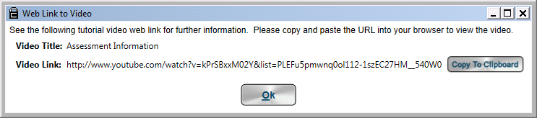

Figure 4-13. Web Link to Video Tutorial Window.

Similar to the help system, the tutorials are context specific. Opening a video from within CSET will provide the video address related to that screen. Once inside YouTube however, you can select any of the videos that you wish to see.

You can also access the videos by opening YouTube ([www.youtube.com](http://www.youtube.com)) separately and searching on “Cyber Security Evaluation Tool.” Searching on “CSET” may not provide the desired results.

Note that internet connections with low bandwidth can result in reduced video quality.

To view close captioning in YouTube, click on the "cc" icon on the video window.

Docking Windows

Docking windows have been in use in CSET since Version 5. They address a design requirement to maximize the space in both the Question and Diagram screens. In the Questions screen, the intent was to provide as much of the complete set of questions as possible for both the requirements and questions‑based approaches. The Diagram screen needs as much space as possible to facilitate both the drawing and review of the network and control system diagram. The docking window is designed to save space but still be available when needed.

In explaining how the docking windows work, the Document Library will be used as an example. It is also the first window that is seen when entering the application.

In the CSET Window, you will see the Document Library label on the right side as shown in Figure 4-14.

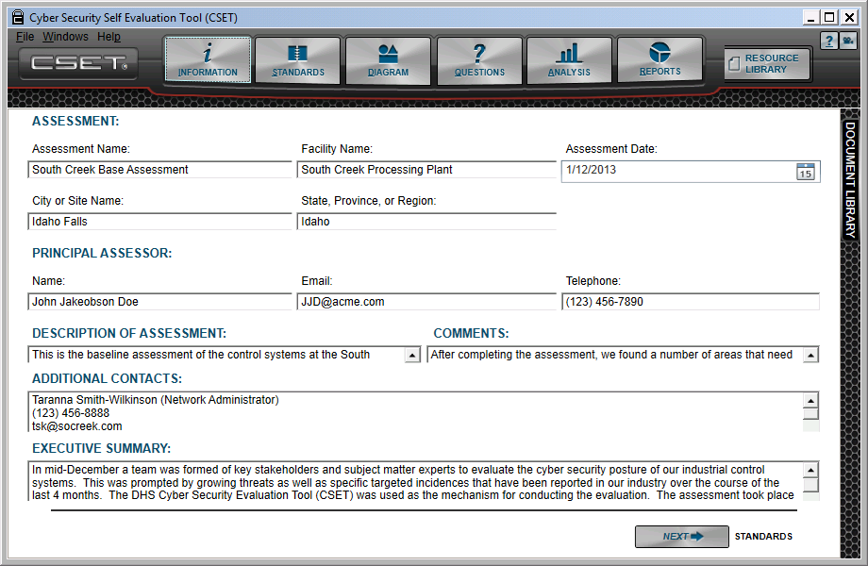

Figure 4-14. Document Library Side Tab.

By clicking on the side tab, labeled Document Library, you will open the window so that it appears like Figure 4-15.

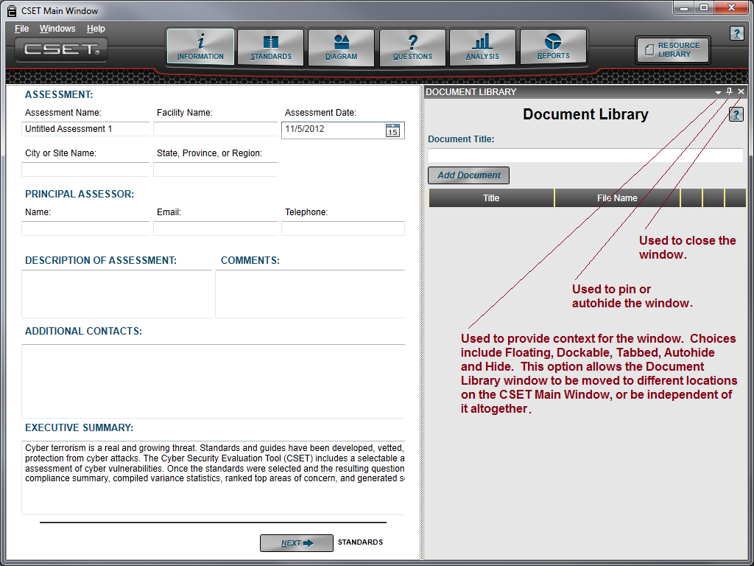

Figure 4-15. Docking Window.

Docking Options

Notice the icons in the upper right corner of the window frame. The first icon is the Context Menu and looks like a downward facing triangle. When clicked it allows the window to be as listed below.

**Floating:** The window is able to move to any location on the screen, independent of the application main window.

**Dockable:** It may be tied to any physical border of the main form.

**Tabbed:** This option is not used in CSET and is therefore dimmed.

**Auto Hide:** This is the default when entering the form and the state that allows it to open and close the window by touching the tab.

**Hide:** Selecting Hide removes the window from the view.

All the options will not be available until the window has been pinned open or the Auto Hide option has been unchecked. Figure 4-16 shows the options in context.

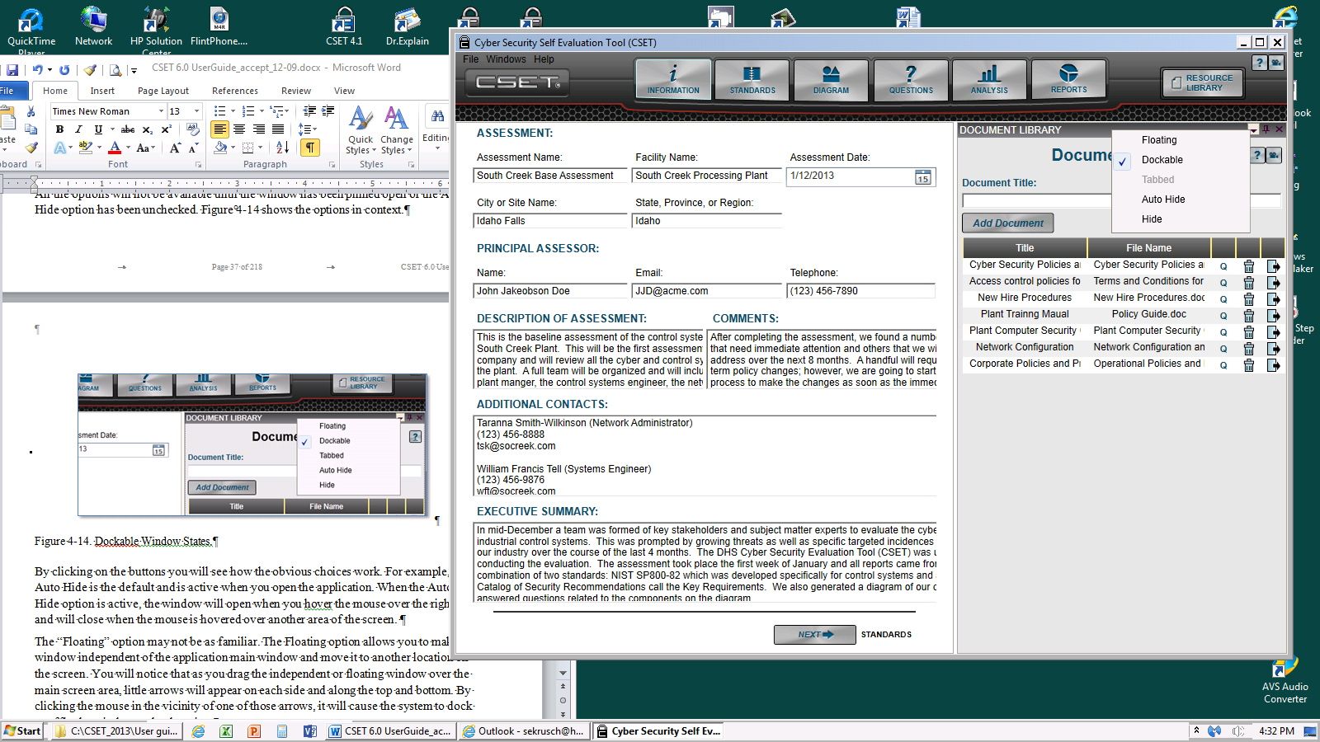

Figure 4-16. Dockable Window States.

By clicking on the buttons you will see how the obvious choices work. For example, Auto Hide is the default and is active when you open the application. When the Auto Hide option is active, the window will open when you hover the mouse over the right tab and will close when the mouse is hovered over another area of the screen.

The “Floating” option may not be as familiar. The Floating option allows you to make the window independent of the application main window and move it to another location on the screen. You will notice that as you drag the independent or floating window over the main screen area, little arrows will appear on each side and along the top and bottom. By clicking the mouse in the vicinity of one of those arrows, it will cause the system to dock or affix the window to that location.

Figure 4-17 shows the anchor points inside of the orange circles. The Document Library floating window is shown in the example being dragged from its original location on the right-hand side of the screen.

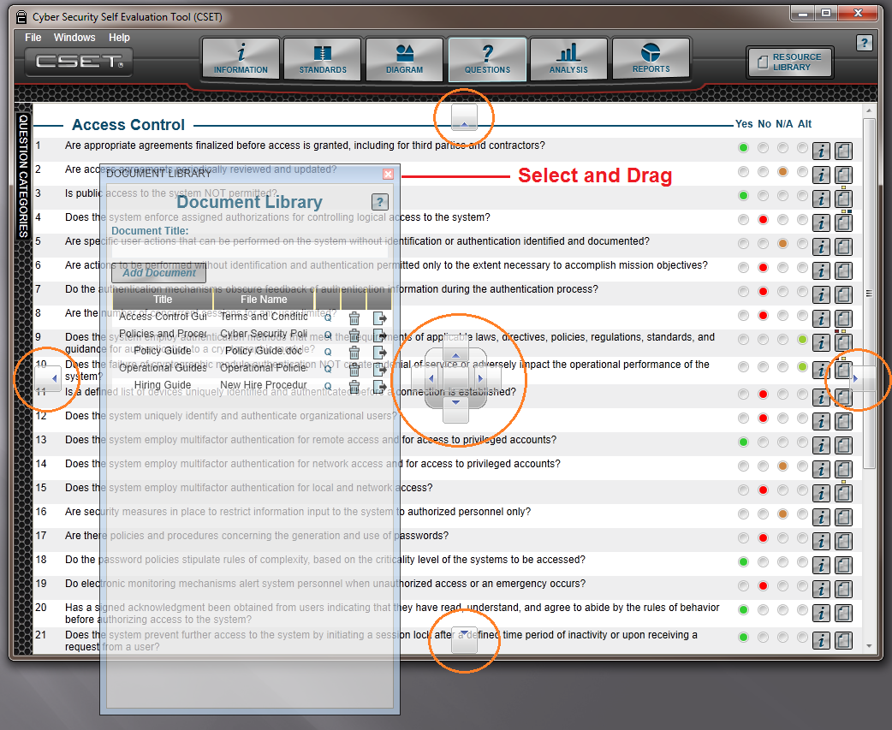

Figure 4-17. Floating Window.

In the example shown, the window is being moved away from its location. In Figure 4-18, the bottom button was clicked, and the window was placed on the bottom of the screen.

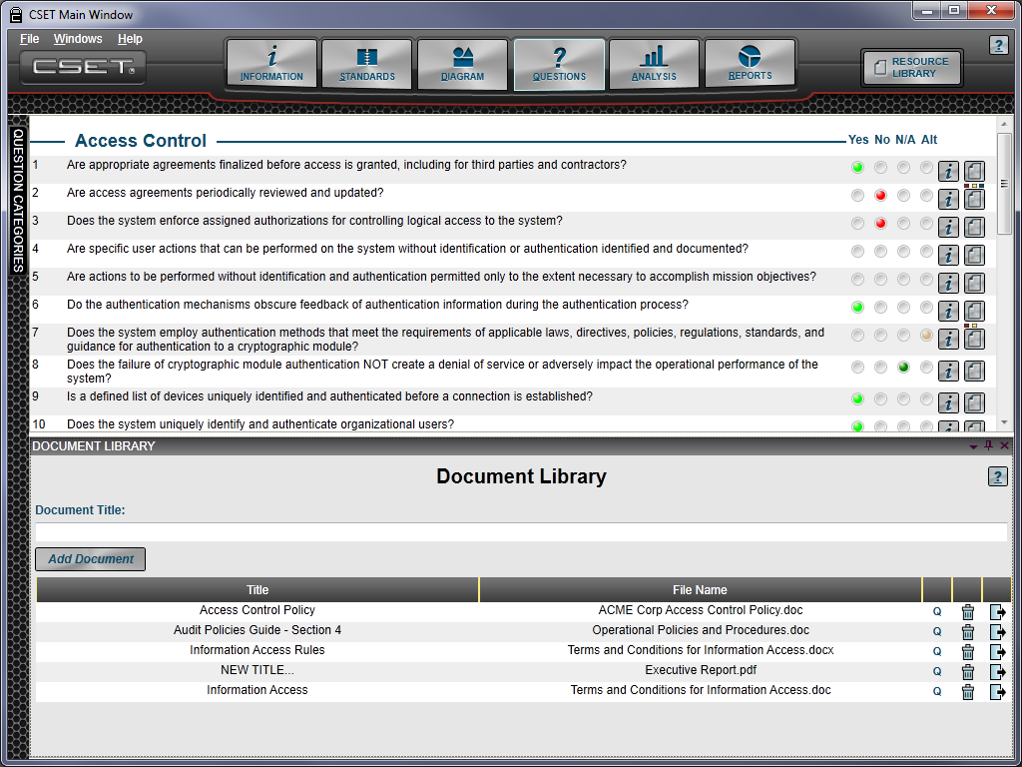

Figure 4-18. Window on Bottom of the Screen.

The second icon is the “pin,” and it is used either to keep the window permanently displayed or allow it to open and close, depending on whether you mouse-over or touch the tab. With the pin pointing sideways and highlighted, the window will slide open and closed in an Auto Hide state. By clicking on the tab or clicking the pin icon so that it faces downward, you can keep the window open and displayed in the Dockable state. You can also click on the frame when the window is pinned and pull it out if it’s intended to be floating.

The “X” icon, when selected, will cause the application to close the docked window. The close will put the window in a Hide state. You can also select Hide from the dropdown list of the Context menu.

If the window has been closed or hidden and is no longer displayed, it can be re-opened by going to the “Windows” menu item and then clicking on Document Library to make it visible again. Figure 4-19 highlights that option.



Figure 4-19. Open Document Library Window.

The flexibility of the docking windows is shown in Figure 4-20. In this situation, the Document Library, Question Detail, Question Info, and Question Categories windows were all opened and moved to the top location. They were then changed to a state of Auto Hide, and the tabbed labels were automatically moved to the top of the screen as shown in the example.

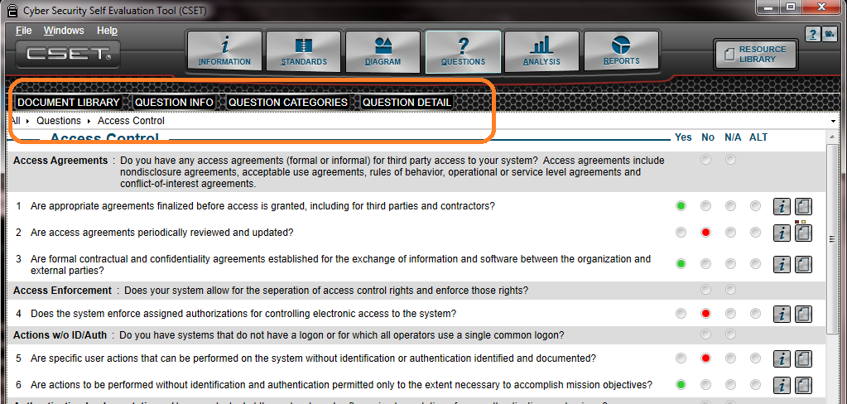

Figure 4-20. Relocated Windows.

If you are unfamiliar with docking windows, they can take a little practice to get used to. However, once you are comfortable with them, they prove to be a valuable way to save screen space while still having immediate access to important information.

5) Beginning the Evaluation



5

This section provides detailed instructions for beginning a cybersecurity evaluation using CSET. It includes opening the Start screen and then entering basic assessment information.

Start Screen

The Start or Welcome screen shown in Figure 5-1 opens when the CSET application is started. This screen provides navigational options for creating a new assessment, opening one that had previously been created, or working with multiple assessments (aggregation). From this screen you can also open the Resource Library, open the User Guide, view the video tutorials, or leave the application. Each action is initiated by clicking the respective button with the mouse.



Figure 5-1. Start or Welcome Screen.

Create a New Assessment

After first loading CSET, you will need to create an assessment file by using the “Create a New Assessment” option. The tool creates a new assessment file with a default name. However, the action first opens an advisory screen shown in Figure 5-2.

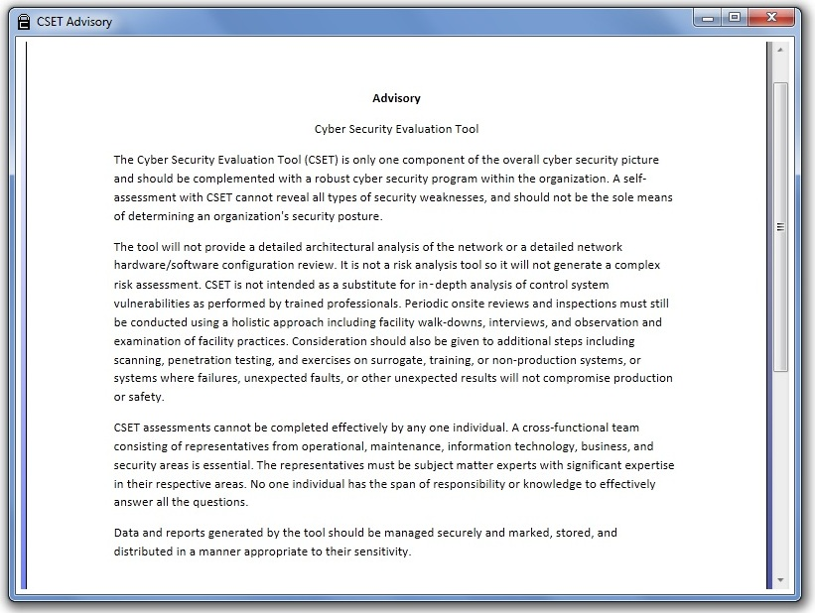

Figure 5-2. Advisory Screen.

Please read the advisory and note the limitations and intended use of the tool. After reading the notice, you can close the advisory by clicking the “X” in the upper right corner. When the advisory is closed, you will see the assessment Information screen. The assessment name should be changed to reflect the specific assessment, and background information should be entered to capture specific information about the assessment effort.

No programmatic restrictions exist to the number of assessments you can create. In fact, you may wish to create a new file with which to experiment prior to beginning a formal assessment of the control systems.

Open a Previously Saved Assessment

Once you have used CSET, it remembers the last assessment file used and displays the name next to the “Open” button. In the example shown in Figure 5-3, the South Creek Base Assessment was the last file used and was, therefore, displayed next to the button. This is a nice feature that is intended to quickly get you back to working on your most current assessment.

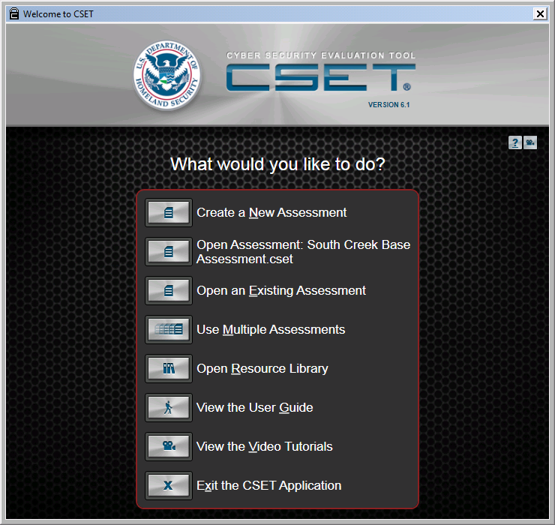

Figure 5-3. Open Previous Assessment.

The file will open to the state that it was last saved. If no previous assessment has been started this option will be disabled.

Open an Existing Assessment

This method opens a standard Windows file search form. You can open a file created in the current version of CSET or a file from previous versions of CSET.

The Open an Existing Assessment option allows you to search through your directories to locate a previously saved assessment file. Note that the file type for CSET Version 5 and later is **.cset**. When the desired file has been located, it should be selected by clicking on the name in the list. The Open button should be clicked to open the selected file in CSET. The file will open to the state that it was last saved.

To open a file created in CSET prior to Version 5, you will need to select the file name, and click Open. If the type is **.orxml,** an upgrade wizard will be initiated. Figure 5-4 shows an example of the screen that will be displayed to start the process.

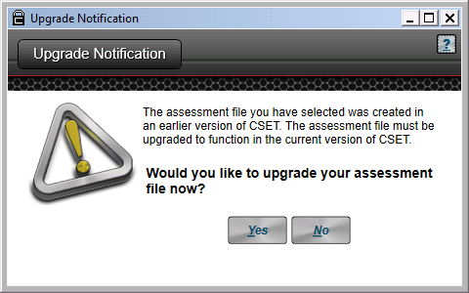

Figure 5-4. Upgrade Wizard Start Screen.

More information about the upgrade process can be found in Appendix D and with the screen help associated with the process.

Use Multiple Assessments

Using multiple assessments, called Aggregation in CSET, means that you want to work with two or more assessments rather than just create or edit a single one. Selecting this option opens a new window as shown in Figure 5-5.

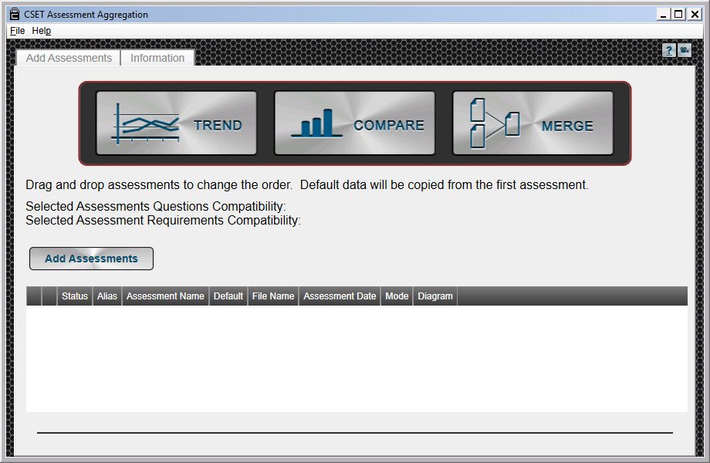

Figure 5-5. Aggregation Screen.

There are three types of aggregation: Trend, Compare, and Merge. Trend shows cumulative changes to a facility over time by analyzing several assessments of the same facility completed, say, annually. Compare looks at multiple assessments to determine their strengths and weaknesses and creates a summary compliance report. This would be helpful for a facility consisting of several sites, each with their own complete assessment. The Merge function melds several partial assessment files into a cohesive whole in the case where members of the assessment team were each assigned a portion of the assessment and each created an incomplete or partial assessment file.

The analysis result of Trend and Compare is a report. The result of the Merge function is a new assessment.

**Add Assessments:** In order to use these aggregation types, you must first load the subject assessments. To do so, click the Add Assessments button. A file browser window will open, allowing you to select the desired files. You may select one or multiple assessment files. Continue adding files until the desired assessments are loaded. With more files, the time for analysis is increased proportionately. It is recommended that no more than five files be analyzed at a time. Figure 5-6 shows the Aggregation screen with files added and Trend selected as an example.

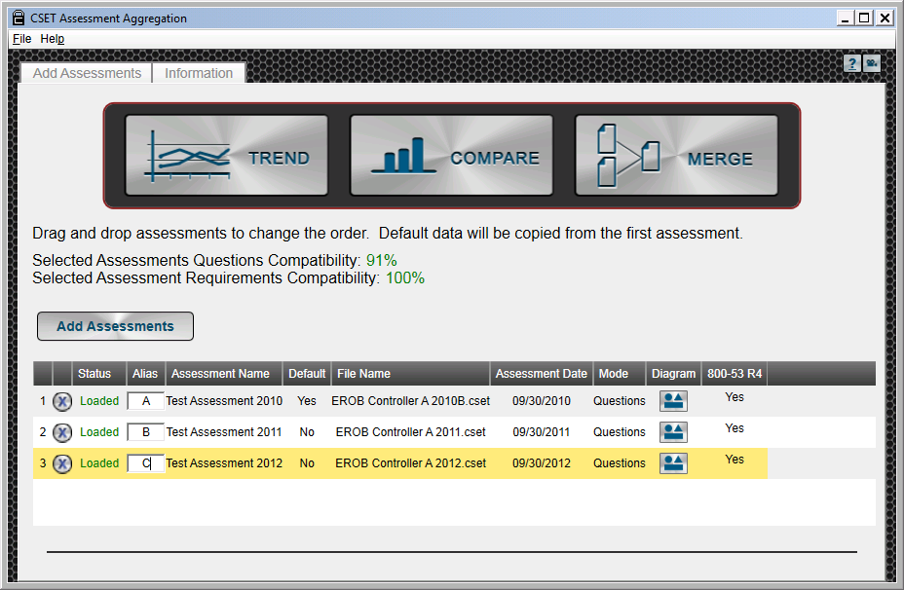

Figure 5-6. Aggregation Files Added.

The top assessment in the list is the default. That means it is considered the baseline. Other assessments will be added to it or trending will start from that one. The Mode, SAL, and assessment information come from the default assessment. Use drag and drop functionality to change the order of the listed assessment files to establish the correct file as the default.

The compatibility estimates reflect the similarity of the standards addressed by the loaded assessments. It is not an estimate of how alike the answers are among the assessments.

**Tabs:** Notice the tabs at the top of the screen. They become active after at least two assessments are loaded and an aggregation type is selected.

The first tab is labeled Add Assessments. It is the default screen shown above. The Information tab is similar to the assessment information filled in at the start of a normal assessment, except that it applies to the aggregation rather than an assessment. It provides the user an opportunity to add information identifying the aggregation, the facility, and the participants. Comments and an executive summary may also be added. Some of the fields are pre-populated using information from the default assessment, but it may be edited.

**Perform the Analysis:** Once the assessment file table is complete, click the Trend, Compare, or Merge button to begin the analysis. Depending on the number and size of the selected assessment files, analysis may take a few moments. New tabs will appear across the top of the screen. They change with the type of aggregation selected and provide the detailed results of the aggregation.

For Trend and Compare, the results are primarily graphical and can be seen under the Summary Analytics tab. For Merge, the user is asked to resolve any inconsistencies between the assessments prior to the creation of a new assessment. This is done under the Merge Differences tab. Once resolved, click a create assessment button to create, save, and open the new, combined assessment.

Click the new tab to see the results of the aggregation analysis. Much more detail on Aggregation is provided in Appendix E of this User Guide.

Open Resource Library

The Resource Library contains cybersecurity documentation and reference materials to answer many of your technical or policy questions and to aid in the creation and maintenance of a comprehensive cybersecurity program. More information is available later in this User Guide in the section titled Resource Library.

View the User Guide

Clicking this button will open the CSET User Guide using a PDF reader. If an updated compatible reader has not been installed on the computer, then the file will open with an installed default reader. The User Guide may be saved or printed for later reference.

It is recommended that a native Adobe PDF reader be installed on the computer. It will be useful when opening files in the Resource Library and for opening help files associated with questions and requirements.

View the Video Tutorials

Selecting this option will open a new window containing the list of available video tutorials and the web addresses or URLs needed to access them. See Figure 5-7. The videos are designed to play in YouTube meaning that an active Internet connection is required for viewing. Click on the address of the desired video to highlight it. Then either right-click and select Copy, or click the Copy to Clipboard button. Open an Internet browser and paste in the web address. Note that internet connections with low bandwidth can result in reduced video quality. Additional information is available under the discussion of the Help menu options above.

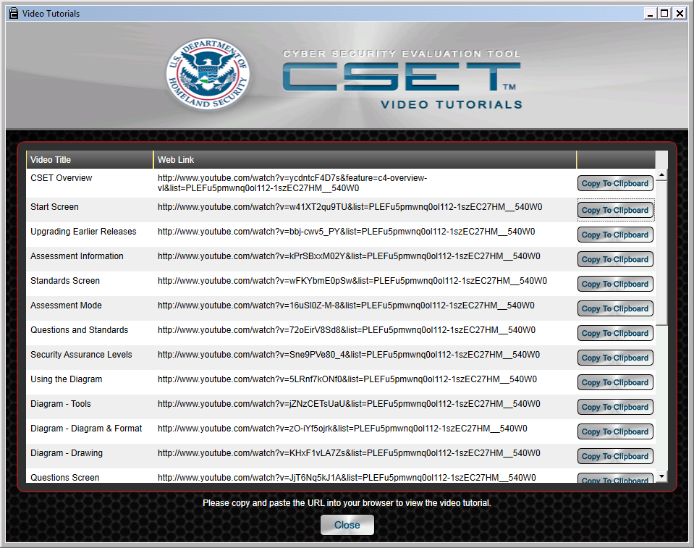

Figure 5-7. Video Tutorial Screen.

Exit the CSET Application

Clicking this option will close the CSET application.

Assessment Recovery

There may be times when the CSET application is interrupted by a system shutdown or a software-related error. A system shutdown may be caused by a sudden loss of power to the computer; an operating system error; hardware failure such as a faulty disk drive or CPU; or errors with other software concurrently running on the computer that may affect the CSET application. Application errors could also occur with either the .NET framework or the CSET program itself.

CSET is designed to save temporary files for situations like those mentioned above. If the user has deliberately saved a recent copy of the assessment file, using the Save or Save As menu options, then no temporary files will exist, and you can simply open the saved file. If several minutes have passed since the user initiated a save, then a copy that is valid as of the last automatic save point will be available.

If a problem has occurred that caused an unintended shutdown of either the application or the system, then, when CSET is started next, the recovery screen will be displayed. A copy of the screen is shown in Figure 5-8.

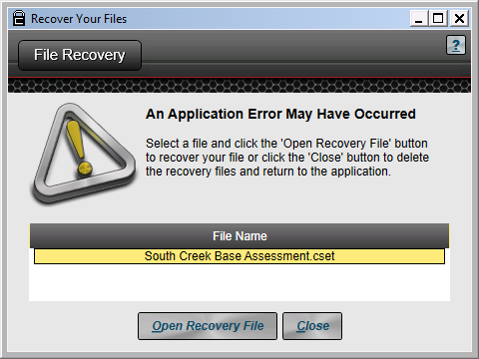

Figure 5-8. File Recovery Screen.

Opening Recovery Files

After CSET is started, it checks to see if there are any recovery files available in the temp directory. If it finds a file, then it will display the file name in the window on the screen shown above.

To recover the file, select the desired file name in the window. The system will then highlight the selected file. With the recovery file highlighted, click on the “Open Recovery File” button shown on the bottom of the screen. This will open the assessment at the last point where it was saved. Once the assessment is open, it is recommended that the file be immediately saved under a new name, so that a permanent copy is available.

Removing Recovery Files

To remove a recovery file from the system, you will simply need to click on the Close button at the bottom of the screen. This will permanently remove the temporary file from the computer and return you to the application.

Adding Assessment Information

The initial screen shown when you open a new assessment is the Assessment Information screen. If you have opened an existing assessment, then the system will return you to the location where you left. You can also navigate back to this screen using the functional buttons or the Windows Menu at the top of the screen.

When the Information button has been selected, the “Assessment Information” screen is displayed as shown in Figure 5-9. This screen provides a place to capture specific information about the assessment itself, including who was responsible, when it occurred, what facility or facilities were involved, and both descriptive and summary information. To use the screen, simply enter textual data into the fields provided.

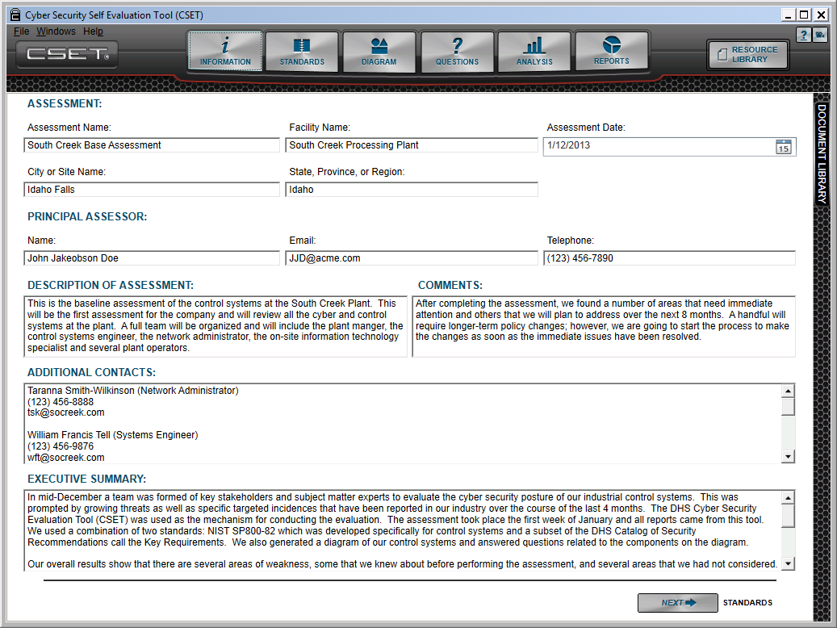

Figure 5-9. Assessment Information Screen.

The following fields are alphanumeric and are limited to 100 characters. You may enter any data you wish, but the reports will label the entered text to match the labels on this screen.

These fields include:

* Assessment Name,
* Facility Name,
* City or Site Name,
* State, Province, or Region,
* Principal Assessor – Name,
* Email, and
* Telephone.

The Assessment Date field requires a valid date format and provides a date picker to facilitate date selection.

The additional fields have unique considerations that will be described below:

**Description of Assessment.** This field will show up on all reports. This should be a brief description of the assessment and may include anything you wish, but like the other fields, the content in the reports will be associated with the respective label.

**Comments.** This is a general comments block that will not show up on the Executive report and can be more free-form. This field is a place to store useful information that is important to the assessor or the assessment team.

**Additional Contacts.** This field is open format and can be used to store the contact and title information for anyone that is associated with the assessment. It is recommended that for historical purposes this type of information be entered with as much detail as is practical. Often, after months or years have passed, it is helpful to look back and see who participated in the assessment.

**Executive Summary.** Like the Description of Assessment field, the content that is included in this field will be displayed on the Executive report and the other reports. Even though there is prepared text preloaded in this field, it is highly recommended that after the assessment has been completed, this field should be rewritten with paragraphs summarizing any key topics, issues, or recommendations that should be seen by top management.

This section is intended for an executive audience and should be relatively brief and to the point. You can write the section and print the Executive report to see how it will be presented on the second page in the report.

The assessment information screen is a place to capture historical data about the assessment process and who was involved. It is recommended that you take a few minutes and fill in the fields before running the final reports.

6) Selecting the Mode and standards



6

There are three basic steps involved in selecting the standards and the SAL. This section of the User Guide will focus on the first two steps found on the Standards screen. The final step helps you determine your SAL. This function will be explained in the next section.

The Standards screen allows you to select the approach you want to take in performing an assessment, the standard to be evaluated against, and the SAL to be used in the assessment. Figure 6-1 shows the screen that is displayed when the Standards button is selected from the top of the CSET window or when the Next button is selected from the Information screen.

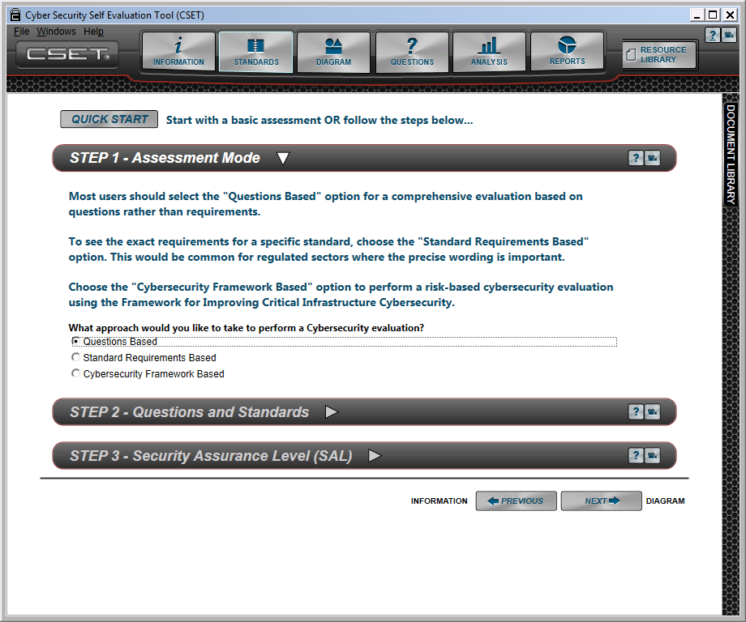

Figure 6-1. Standards Screen.

Quick Start Option

At the top of the screen is a “Quick Start” button. This allows you to bypass the three‑step process and jump directly into the assessment.

If you select this option, the system will do the following for you:

* Set the default “Questions” approach as the assessment mode. This means that you will be answering yes/no type questions that are straightforward and easy to understand.
* Select the “Key Questions” standard. This is a limited set of questions that subject matter experts have deemed to be the most critical to be answered as part of any assessment. This is an excellent set with which to start.
* Select a SAL of Low. This is also a good starting point for performing an assessment.
* Open the Questions screen. This will allow you to start the process of answering questions.

This combination is great for someone that wants to jump right into the assessment and begin answering questions. A feature of this approach is that after you have answered questions, you can go back and select the Universal Questions or other standards and many of the questions will already be answered. You can also change the SAL to a higher level, and the system will add more questions to the assessment.

If you change the Assessment Mode to Standard Requirements Based, then the questions that you answered will not be carried forward because of the strict language associated with meeting a standard requirement. This means that if you want to follow the language of the requirement, you should not use the Quick Start approach.

Select the Assessment Mode, Step 1

If you do not use the Quick Start approach, then you will need to define the assessment using the three‑step approach described here. It is anticipated that most users will use these three steps to define the assessment.

The first step in the standards selection process is to determine the assessment mode. Three ways are used to approach the assessment: questions based, requirements based, or Cybersecurity Framework based. Figure 6-2 shows the options. To select the desired approach, simply click on the radio button to the left of the respective label.

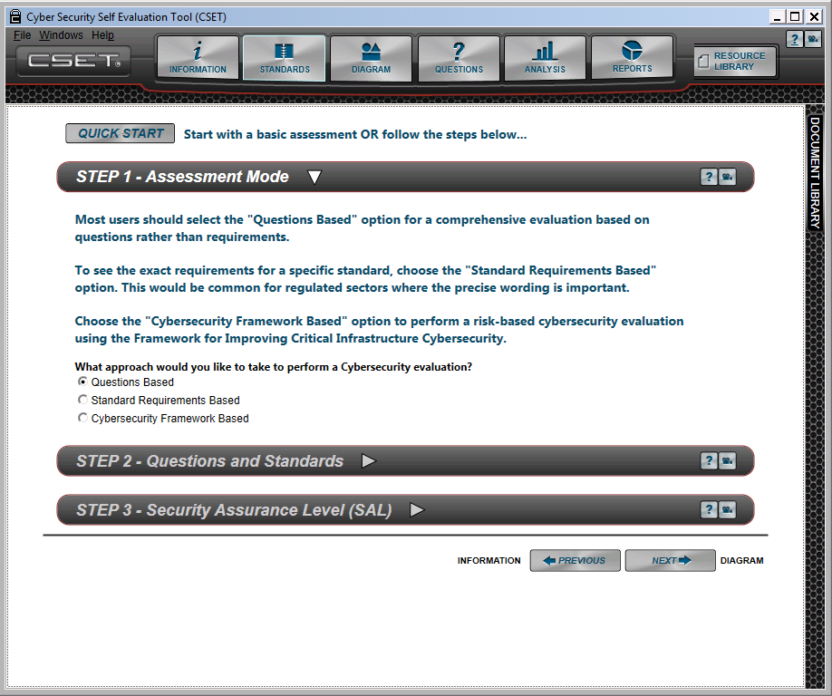

Figure 6-2. Assessment Mode Options.

**Questions Based Approach:** A comprehensive set of questions have been prepared with straightforward language that encompasses all the topics and requirements found in the major ICS and IT standards. Each question is written in such a way that it can be answered as either yes or no. (Questions can all be answered as using alternates or not applicable; however, they do not use multi-part or multiple choice answers.) The full set of questions is filtered and limited by the standards selected in Step 2 and by the SAL determined in Step 3. The questions-based approach is recommended for most assessments and is set by default.

**Standard Requirements Based Approach:** This approach was developed primarily for regulated industries such as nuclear or electrical power. This approach is designed so that you will see the exact wording of each requirement in the standard. The question must be read in its entirety and the answers are “Met” or “Unmet” rather than yes or no. As mentioned earlier, you can also mark the question as Not Applicable or select an Alternative Approach.

**Cybersecurity Framework Based Approach:** The Cybersecurity Framework allows the user to perform a risk—based cybersecurity evaluation using a customized question set. The default questions are taken directly from the governing document. New questions and categories can be added by the user if needed to tailor the question set to the specific entity being assessed. See Appendix F for more detailed information on the basis for and approach to cybersecurity framework.

Select the Questions and Standards or Framework Tiers, Step 2

The second step is to select one or more standards that will be used in the assessment. The options will be made unselectable (grayed out) if they do not apply to the mode chosen in Step 1. After selecting either Questions Based or Standard Requirements Based under Step 1, clicking on the Step 2 bar will change the screen to display the available standards and requirements as shown in Figure 6-3.

Step 2 options resulting from selection of Cybersecurity Framework Based are discussed later in this section.

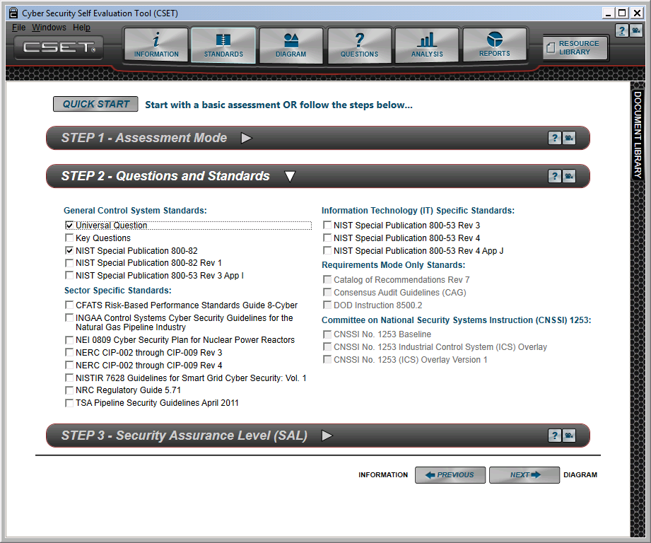

Figure 6-3. Step 2, Questions and Standards.

Questions-Based Approach

If the “Questions Based” mode is selected in Step 1, then most of the standards will be available. Some standards, labeled Requirements Mode Only, will be disabled or grayed out. If you are only going to select one standard, then to get the most comprehensive evaluation, check the “Universal Category” option. If other standards are selected without including the Universal Category, then the question set will be limited to only those questions that are associated with the standard.

If multiple standards are selected, then the questions will be the superset of both standards. The standards may have some questions that are so unique that they are not included in the universal set. This means that selecting both the Universal Category and a standard will result in a set of questions that is potentially greater than just the Universal Category themselves. These situations are described in detail below.

In Figure 6-4, three examples are presented. (In the cases presented, there is no consideration for the SAL.)

Universal Category

Universal Category

Universal Category

Standard

A

Standard B

**Case 1**

**Case 2**

**Case 3**

Figure 6-4. Question Sets for Questions Based Approach.

**Case 1.** In this scenario, only the Universal Category option has been selected. As shown in the diagram, all the Universal questions are displayed.

**Case 2.** This scenario shows two options. If only Standard A was selected, then only those questions included in the orange inner circle would be presented. The Universal Category outside the orange circle would not be included in the assessment. The second option shows where both Standard A and the Universal Category were selected. Because the standard is completely included in the Universal question set, the resulting assessment questions would look exactly like Case 1.

**Case 3.** Unlike the example in Case 2, the standard has extra questions not found in the Universal question set. If onlyStandard B was selected, then everything shown in the blue ellipse would be displayed in the assessment. If both the Standard and Universal questions sets were selected, then the total assessment would be greater than what is included in Case 1 and would include the combination of both the green and blue shapes.

Standard Requirements Approach

If the Standard Requirements Approach is chosen in Step 1, the Universal Category and Key Questions options are disabled in Step 2. In the screen where Step 2 is open, you may click the checkbox associated with one or more standards. If multiple standards are selected, then for each choice a completely different set of requirements will be displayed on the Questions screen. Figure 6-5 provides examples.

**Case 1**

**Case 2**

**Standard A**

**Requirements**

**Standard A**

**Requirements**

**Standard B**

**Requirements**

**Standard C**

**Requirements**

Figure 6-5. Requirements Based Approach.

Two examples are presented. (In these cases, there is no consideration for the SAL.)

**Case 1.** In this scenario, a single standard has been selected, and only the requirements for Standard A will be presented in the questions screen.

**Case 2.** This second scenario shows the selection of multiple standards. No matter how many standards are selected, the tool will display the full set of requirements for each set regardless of any overlap. Because the wording in the standard is unique, each requirement will be given verbatim. In the application, the requirements in the standards will simply show up on the question tree in a sequential manner.

Standards and Question Groupings

The standards and question sets are grouped into four areas as shown in Figure 6-6. Each will be explained in greater detail.

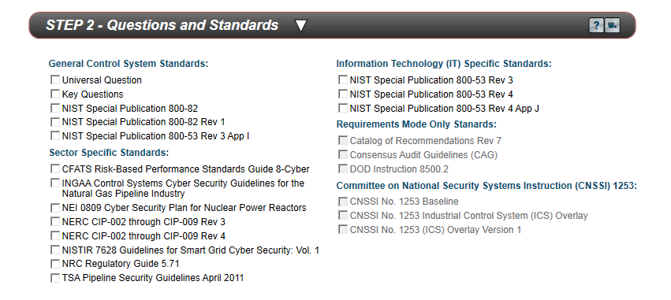

Figure 6-6. Standard Groupings.

General Control System Standards

Several standards are specifically designed around ICS requirements. The Catalog of Recommendations Rev. 7, from DHS, is a compilation of requirements derived from other standards all focused on control system security. The Universal Category questions are based on the Catalog of Recommendations, are only available with the Questions Based approach, and include a full range of ICS security questions. The questions are written as simple yes/no questions and are grouped in a set of common security categories. The Key Questions are a subset of the Catalog of Recommendations and are limited in scope to what subject matter experts consider to be the top set of requirements, limited by size. NIST SP800-82 provides guidance for establishing a secure ICS. While not as comprehensive as the Catalog, it provides valuable information about ICS vulnerabilities. NIST SP800-53 with Appendix I tailors the 800‑53 standard with guidance for 64 of the security controls applicable to ICS. Each of these topics will be presented in greater detail.

**Universal Category:** The Universal Category questions are the core set of questions found in CSET. They were developed from all the standards but are primarily taken from the DHS Catalog of Requirements, Version 7. Each standard was reviewed, and then each of the unique requirements and controls were identified. Any duplicates or requirements that were outside the realm of cybersecurity or control systems were removed (such as physical security guidelines). The requirements were written such that they could be answered as either yes or no. Requirements that had multiple answers were reduced to a set of questions that addressed each answer individually. All questions were also written in a simple and straightforward manner.

The simplified questions were then divided up by the SAL based on the assignments made in the NIST SP800-53, Catalog or Requirements and other standards so that each question was associated with a SAL.

**Key Questions:** The assessment Key Requirements Evaluation is a standards-based subset of assessment questions taken from multiple standards and geared toward providing meaningful results in a limited amount of time. It should be used only when an assessment based on one or more full standards cannot be completed within an allotted time. It is intended for any industry using control systems.

**NIST Special Publication 800-82:** The NIST Guide to Industrial Control Systems (ICS) Security publication provides guidance for establishing a secure ICS including SCADA systems, distributed control systems (DCSs), and other systems performing control functions. It identifies typical threats and vulnerabilities to these systems, provides recommended security countermeasures to mitigate the associated risks, and includes a list of many different methods and techniques for securing ICSs.

The scope includes ICSs that are typically used in the electric, water, oil and gas, chemical, pharmaceutical, pulp and paper, food and beverage, and discrete manufacturing (automotive, aerospace, and durable goods) industries. This version of SP800-82 is based on the formal publication of the document in June 2011.

**NIST SP800-82 Rev 1:** Revision 1 of the NIST SP800-82 standard has the same aims and audience as the earlier version. This question set includes all the requirements that have been added or modified for Revision 1.

**NIST Special Publication 800-53 Rev. 3 with Appendix I:** Appendix I of the NIST SP800-53 adds guidance on ICS security to the control system guidance already contained in the publication. In this context, an ICS is an information system used to control industrial processes such as manufacturing, product handling, production, and distribution. ICSs include SCADA systems, DCSs, and programmable logic controllers (PLC). The appendix modifies selected questions and requirements in SP800-53 based on the differences between ICS and typical information systems.

The information in Appendix I is not as comprehensive as that found in NIST SP800-82 but may provide useful information on tailoring, security controls, and control enhancements. NIST guidance was developed for the federal government, but other organizations are encouraged to use it.

Sector Specific Standards

These standards are designed for a specific sector. The Chemical Facilities Anti-Terrorism Standards (CFATS) RBPS 8 is focused on cybersecurity for processors of specific chemicals. The NERC CIP standard defines the reliability requirements for the North American bulk power system. NRC RG 5.71 targets the nuclear power sector and provides an evaluation against the guidance text. The TSA Pipeline Security Guidelines provide basic guidelines to support the transportation sector with emphasis on pipelines.

**CFATS Risk-Based Performance Standards Guide 8 – Cyber:** This guidance is part of the overall efforts defined in 6 CFR Part 27 to protect chemical facilities from the effects of a terrorist attack. “CFATS,” or the Chemical Facilities Anti-Terrorism Standards, is made up of 18 Risk-Based Performance Standards Guidance (RBPS) sections that provide guidance on protecting various aspects of a chemical facility. RBPS 8 is focused on cybersecurity with emphasis on protecting both information management and control system-based networks. It is the only RBPS pertinent to the CSET.

The audience for this instruction is personnel involved in the chemical industry who are required to comply with the 6 CFR Part 27 regulations as well as others seeking to follow these simple actions to better protect their systems.

The Department of Homeland Security has developed a risk-based tiering structure that will allow it to focus resources on the high-risk chemical facilities. To that end, the DHS will assign facilities to one of four risk-based tiers ranging from very high (Tier 1) to low (Tier 4) risk. Note that these tiers are not related to the Cybersecurity Framework tiers.

**INGAA Control Systems Cyber Security Guidelines for the Gas Pipeline Industry:** The Interstate Natural Gas Association of America (INGAA) is a trade organization for the natural gas pipeline industry in North America. As such, its standard applies to the gas pipeline industry. The guidelines can be thought of as a subset of the TSA Pipeline Security Guidelines (described below) and provide additional detail on securing large SCADA and smaller, local control systems. The intended audience is administrators, network security personnel, SCADA software manufacturers, operators, vendors, and other stakeholders involved in the natural gas pipeline industry. Because INGAA is a nongovernment body, a disclaimer will be seen upon selection of this standard.

**NEI 08-09 Cyber Security Plan for Nuclear Power Reactors:** The Nuclear Energy Institute (NEI) developed this standard to assist nuclear energy facilities in meeting cybersecurity regulations required by requirements of 10 CFR 73.54 and the NRC. NEI 08-09 describes a defensive strategy that consists of a defensive architecture and set of security controls that are based on NIST SP800-82 and NIST SP800-53. Because INGAA is a nongovernment body, a disclaimer will be seen upon selection of this standard.

**NERC CIP-002 through CIP-009 Rev. 3:** The NERC CIP standards apply to the electric power industry. Standards CIP-002 through CIP-009 provide a cybersecurity framework (unrelated to the cybersecurity framework based assessment mode option) for the identification and protection of critical cyber assets to support reliable operation of the bulk electric system.

Standard CIP-002-3 requires the identification and documentation of the critical cyber assets. Standard CIP-003-3 requires that responsible entities have minimum security management controls in place to protect critical cyber assets. Standard CIP-004-3 requires that personnel having authorized cyber or authorized unescorted physical access to critical cyber assets, including contractors and service vendors, have an appropriate level of personnel risk assessment, training, and security awareness. Standard CIP‑005-3 requires the identification and protection of the electronic security perimeters. Standard CIP‑006-3 is intended to ensure the implementation of a physical security program. Standard CIP-007-3 requires responsible entities to define methods, processes, and procedures for securing those systems determined to be critical cyber assets. Standard CIP-008-3 ensures the identification, classification, response, and reporting of cybersecurity incidents, and Standard CIP-009-3 ensures that recovery plans are put in place.

The NERC CIP standards are designed specifically for the needs of the electric power sector.

**NERC CIP-002 through CIP-009 Rev. 4:** Revision 4 of the CIP standards has the same aims and audience as the Revision 3 version. This version includes all the requirements that have been added or modified for Revision 4.

**NISTIR 7628 Guidelines for Smart Grid Cyber Security, Volume 1:** Dealing with standards for the national electrical transmission systems and applicable to the electric sector, this NIST Interagency Report presents a framework that organizations can use to develop cybersecurity strategies to secure existing systems while upgrading to newer “smart” grid technology. It includes identification of security requirements, risk assessment processes, and high-level architecture. It presents a sample logical interface reference model used to identify and define 22 logical interface categories within and across 7 commonly accepted Smart Grid domains. The intended audience is individuals and organizations responsible for addressing cybersecurity for Smart Grid systems and the constituent subsystems of hardware and software components.

**NRC Regulatory Guide 5.71:** The NRC RG 5.71, Cyber Security Programs for Nuclear Facilities, provides a framework to aid in the identification of those digital assets, referred to as critical digital assets or CDAs, which must be protected from cyber attacks. The framework offers licensees and applicants the ability to address the specific needs of an existing or new system. The goal is to harmonize the well‑known set of security controls (based on NIST cybersecurity standards) that address potential cyber risks critical digital assets, thus providing a flexible programmatic approach in which the licensee or applicant can establish, maintain, and successfully integrate security controls into a site-specific cybersecurity program.

The intended audience is owners and operators of nuclear power plants.

**TSA Pipeline Security Guidelines April 2011:** This Transportation Security Administration (TSA) document provides a set of short guidelines for protecting and securing the transportation of various liquids through transmission pipelines. It includes cybersecurity guidelines in addition to other security measures including physical protection, personnel security, equipment maintenance and testing, etc. These guidelines are applicable to natural gas and hazardous liquid transmission pipelines, natural gas distribution pipelines, and to liquefied natural gas facility operators. In addition, they apply to pipeline systems that transport material categorized as toxic inhalation hazards.

Information Technology (IT) Specific Standards

NIST SP800-53, Recommended Security Controls for Federal Information Systems and Organizations, is the primary U.S. government standard for securing information systems. Because many nonfederal entities have adopted its use, it is probably the most widely used standard for IT system security.

**NIST Special Publication 800-53 Rev 3:** The NIST SP800-53 provides guidelines for selecting and specifying security controls for information systems supporting the executive agencies of the U.S. federal government. The guidelines apply to all components of an information system that process, store, or transmit federal information. Information system components can include mainframes, servers, workstations, operating systems, and applications. Network components can include firewalls, switches, routers, wireless access points, and network appliances. Servers can include database servers, authentication servers, electronic mail and Web servers, proxy servers, and domain name servers. Information system components may be purchased commercially off-the-shelf or custom developed.

Although developed for the federal government, other organizations are encouraged to use the guidelines. This version of the standard does not include the adjustments addressed in Appendix I. See the Appendix I version under “General Control System Standards” for those modified controls.

**NIST Special Publication 800-53 Rev 4:** Revision 4 has the same audience and intended use as Revision 3; however, it includes updates, additions, and changes to make it more current and relevant.

**NIST Special Publication 800-53 Rev 4 App J:** Appendix J of 800-53, Rev 4, is titled the Privacy Control Catalog. It relates specifically to protection of individual’s privacy and their personally identifiable information (PII). The appendix provides a structured set of controls for protecting privacy and serves as a roadmap for organizations to use in identifying and implementing privacy controls concerning the entire life cycle of PII.

Requirements Mode Only Standards

The options shown under this heading are only available using the Standard Requirements Based mode. This is mainly due to the nature and format of those standards. The Catalog of Recommendations is not listed as a “questions” option because it is entirely included in, and is the basis for, the Universal Questions option.

The Consensus Audit Guidelines or CAG is not an actual standard but rather guidelines based on expert recommendations.

The DoD Instruction 8500.2 is used in the military for cybersecurity and is based on both the Confidentiality and MAC levels.

**Catalog of Recommendations Rev 7:** The Catalog of Recommendations or “CoR” questionnaires are based on the “Catalog of Control Systems Security, Recommendations for Standards Developers,” a document developed for DHS. Version 7 is the latest version of the CoR and incorporates changes and updates made in 2010.

The controls in the CoR are organized into families based on NIST SP800-53 with contributions from AGA, ISO, IEC, IEEE, ISA, NERC, and other standards documents. Requirements for each security control include: detailed recommended security practices and mechanisms; supplemental guidance with information that may be beneficial for understanding and implementing the recommendations; and requirement enhancements including supplementary security constraints for the recommendations.

The CoR is not limited for use by any specific industry sector. It is intended to be broad enough to provide any industry using control systems the flexibility needed to develop sound cybersecurity standards specific to their individual security needs. Its use is strongly recommended if you are using the Standards-based approach and is the most comprehensive control system requirement set in CSET.

**Consensus Audit Guidelines:** The Consensus Audit Guidelines (CAG) is a prioritized baseline of information security measures and controls to be applied across U.S. federal agency enterprise environments. The described control areas focus on technical aspects of information security with the goal of supporting organizations in prioritizing their efforts in defending against today’s most common and damaging computer and network attacks. In the CAG definition, certain subcontrols are categorized as Quick Wins (QW), Improved Visibility and Attribution (Vis/Attrib), Hardened Configuration and Improved Information Security Hygiene (Config/Hygiene), and Advanced (Advanced). The questions are presented as written, but the results are based on the met/not met approach used in other requirements-based standards.

**DoD Instruction 8500.2:** This U.S. DoD Instruction implements policy, assigns responsibilities, and prescribes procedures for applying integrated, layered protection to DoD information systems and networks. It is applicable to information resources organized for the collection, storage, processing, maintenance, use, sharing, dissemination, disposition, display, or transmission of U.S. military-related information. It is predicated on five competencies, the ability to: (1) assess security needs and capabilities, (2) develop a purposeful security design or configuration, (3) implement required controls or safeguards, (4) test and verify, and (5) manage changes to an established baseline in a secure manner.

The audience for this instruction is personnel who use IT to share DoD information across the Global Information Grid.

The DoD Instruction 8500.2 option is available only under the Requirements-based mode. If this option is selected, then you are required to identify both the Confidentiality and the Mission Assurance Category or MAC level. A mid-range default is provided; however, you should adjust both the Confidentiality and MAC levels to reflect your unique requirements. As was mentioned earlier, because these two settings are required for the standard, any changes to the SAL will be overridden by what is set in this screen. The SAL will still apply to the component questions. The assurance levels are defined in the section titled Determine Security Assurance Level (SAL).

Committee on National Security Systems Instruction (CNSSI) 1253

The options shown under this heading are only available using the Standard Requirements Based mode. This is mainly due to the nature and format of the standards. The CNSSI 1253 standard is requirements-based because it does not follow the high water mark SAL approach used in the questions-based standards. It uses the specific levels for confidentiality, integrity, and availability rather than a single overall level. Because this standard is based entirely on NIST SP800-53, Rev. 3, you can select the NIST standard to get the question-based questions for CNSSI 1253 if you wish. The CNSSI 1253 ICS overlay also uses this approach, and so it too is a requirements only option.

**CNSSI No. 1253 Baseline:** CNSSI No. 1253, Security Categorization and Control Selection for National Security Systems, is based entirely on NIST SP800-53, Revision 3. It is intended to be a baseline for a series of overlays that are developed by specific sectors and is being incorporated into the military’s approach for cyber assessments. The primary difference between this standard and SP800-53 Revision 3 is the way that it identifies the required controls. The SP800-53 standards use a single high water mark approach where the highest of the confidentiality, integrity, or availability assurance level is applied to the whole system. For example, a set of marks of Low, Low, and High would yield a High level for the system. The CNSSI 1253 approach uses each individual level separately. This means that certain controls that may have been tied to a type like integrity at the high level will not be required if the integrity value was low, even though one of the others was high.

**CNSSI No. 1253 Industrial Control System (ICS) Overlay:** This is the first of what is anticipated to be many overlays developed for the CNSSI 1253 baseline and incorporated into CSET. It has not added new requirements but has removed a large number of non-ICS-related controls and has modified the levels for some of the controls that remained. This version was considered a final draft when the previous version of CSET was released.

**CNSSI No. 1253 (ICS) Overlay Version 1:** The ICS Overlay Version 1 is the final version of the first overlay. It has the same audience and intended use as the original ICS overlay.

Cybersecurity Framework Implementation Tiers

If Cybersecurity Framework Based is selected in Step 1, the title of Step 2 will become Cybersecurity Framework Implementation Tiers as seen in Figure 6-7. Here, one of four tiers is assigned to each of three risk categories.

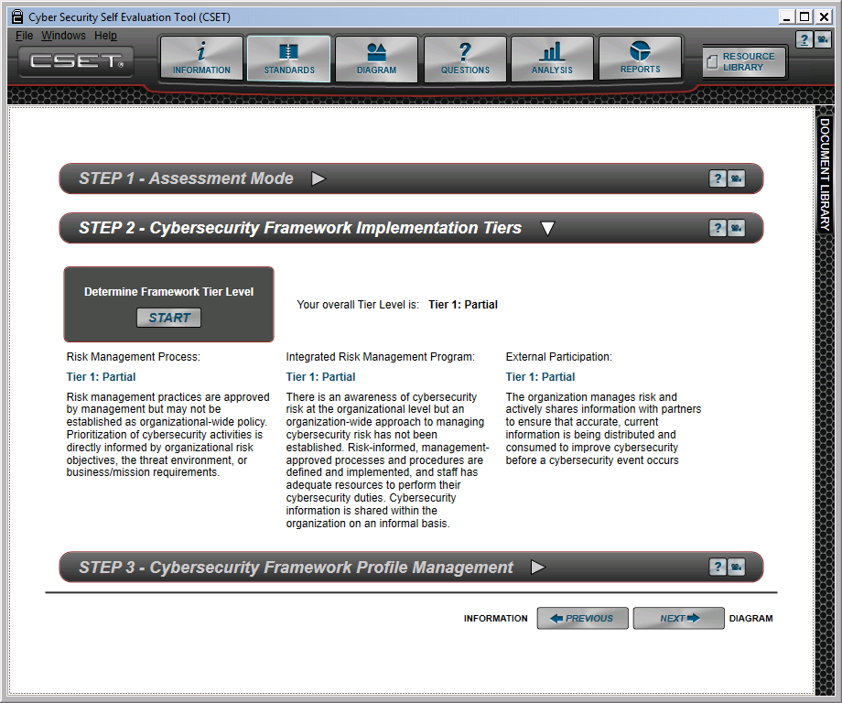

Figure 6-7. Cybersecurity Framework Implementation Tiers.

For assistance in selecting the correct tier, a wizard has been provided. Click the Start button in the box labeled Determine Framework Tier Level and select the statement that best matches the level of risk at the site. Click OK when finished. The wizard screen is shown in Figure 6-8. The available categories and tiers are listed in Table 6-1.

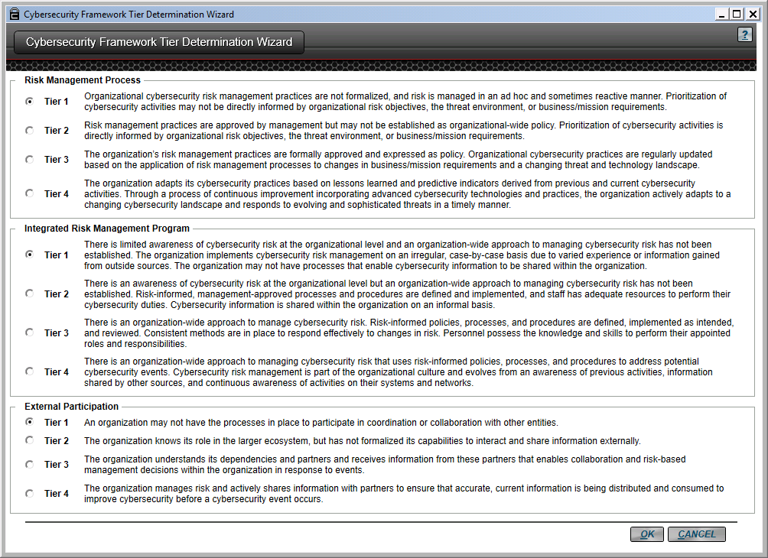

Figure 6-8. Cybersecurity Framework Tier Determination Wizard.

Table 6-1. Risk Categories and Implementation Tiers.

| Risk Categories |  | Tiers |
| --- | --- | --- |
| Risk Management Process |  | Tier 1: Partial |
| Integrated Risk Management Program |  | Tier 2: Risk Informed |
| External Participation |  | Tier 3: Repeatable |
|  |  | Tier 4: Adaptive |

The overall Tier Level will be the highest or riskiest of the three. If the wizard is not used, the default assigned risk will be Tier 1, Partial for each category.

See Appendix F for more detailed information on the Cybersecurity Framework.

7) Determining Security Assurance Level (SAL)



7

In the previous section, Steps 1 and 2 on the Standards screen were introduced. The final step on the Standards screen is to determine the security assurance level or SAL. In most cases, you can elect to use one of two methods for determining the SAL. The general SAL is consequence based and offers a General SAL Determination wizard to help establish the potential for harm and loss both on-site and off-site. The second method uses guidance from the FIPS 199 and NIST SP800-60 standards to determine Confidentiality, Integrity, and Availability which is rolled-up into a single SAL. It also offers the aid of a wizard called NIST SAL Determination.

Selecting certain standards or requirements will display additional options for selection. For example, selecting the DOD 8500.2 requirement will cause the SAL section to offer Confidentiality and MAC level sections. Using CNSSI No. 1253 or a related overlay will open options to set Confidentiality, Integrity, and Availability individually.

If the Cybersecurity Framework Based was selected, Step 3 will entail profile management as discussed later in this section.

Determine the SAL, Step 3

Step 3 of the standard selection process is to determine the SAL for your facility. CSET will default the General SAL to “Moderate.” The available levels include:

* Low,
* Moderate,
* High, and
* Very High.

These levels correspond with the levels identified by NIST in the NIST SP800-53 standards and the NIST SP800-60 Volumes 1 and 2 documents, and the CFATS risk-based tiering structure.

If you know your SAL or want to select a target SAL, then simply select the level from the list box with the SAL label. If you need help in determining your SAL, two wizards are available to help. See Figure 7-1 to view the options.

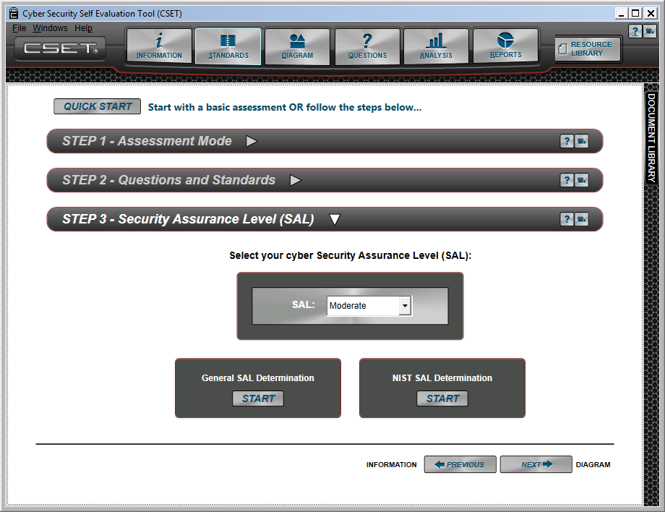

Figure 7-1. Security Assurance Level (SAL) Screen.

The General SAL Determination option shown on the lower left of the screen will allow you to answer questions related to the consequence of an incident related to the control systems.

The NIST SAL Determination option on the lower right will provide a way to determine the SAL based on the information type (with predetermined levels) in conjunction with a set of questions, that when combined, provide the SAL according to NIST.

General Security Assurance Level Determination

When you click on the General SAL Determination wizard button on the Standards screen, the system will open the screen shown in Figure 7-2.

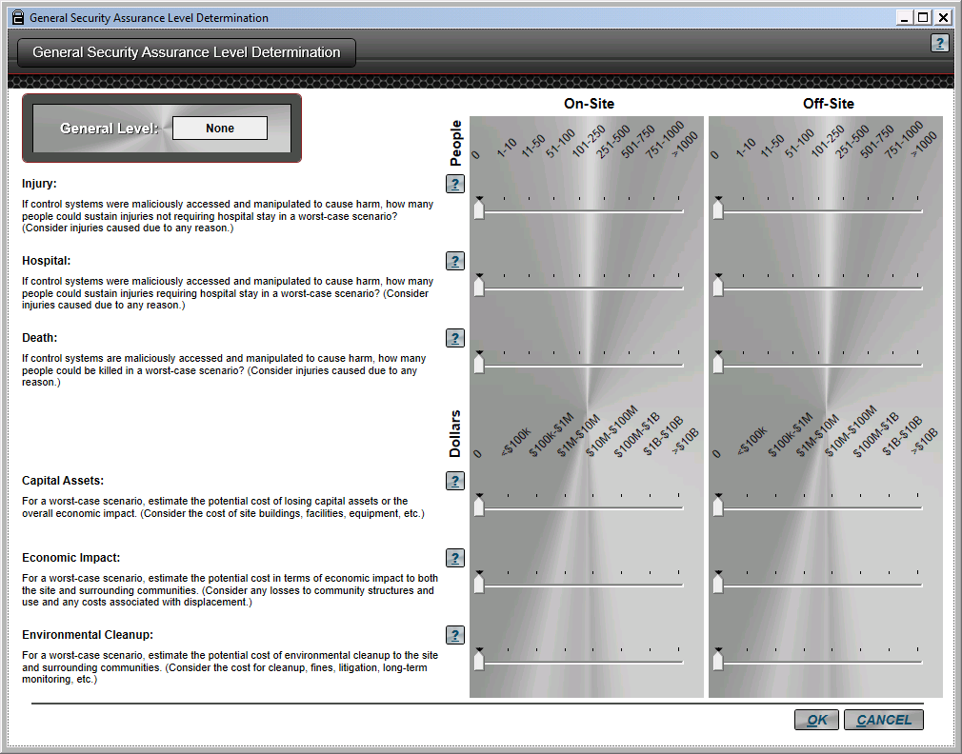

Figure 7-2. General SAL Determination Screen.

As was mentioned earlier, the General SAL approach is consequence based. To use the screen, simply move the slider to align with the total number of people or total dollar amount impacted for each question and category. An answer should be provided for both onsite and offsite impact.

For example, to determine the numeric value for potential injury, estimate the number of people, (onsite at the facility or those affected offsite) who could be injured without the need for hospitalization, should the scenario occur.

You should estimate a worst-case number by assuming a full work shift with the addition of any visitors, contractors, vendors, etc., who may also be onsite. For the offsite estimate, assume peak occupancy of affected areas. For example, if a business district will be impacted by an event, then plan the estimate during the primary business hours. Consider all aspects of the scenario such as chain reactions. For example, an explosion could be followed by a fire that could then close roadways, or even release toxic materials. See appendices A and B for additional information.

When considering the money-based questions, consider all costs including legal fees, fines, penalties, replacement costs, compensation, etc. After you click OK on this screen, the tool will update the SAL to the level shown in the upper left of the screen, overwriting the previous value.

NIST Security Assurance Level Determination

After you click the NIST SAL Determination button, the system will open the NIST Security Assurance Level (SAL) Determination screen shown in Figure 7-3.

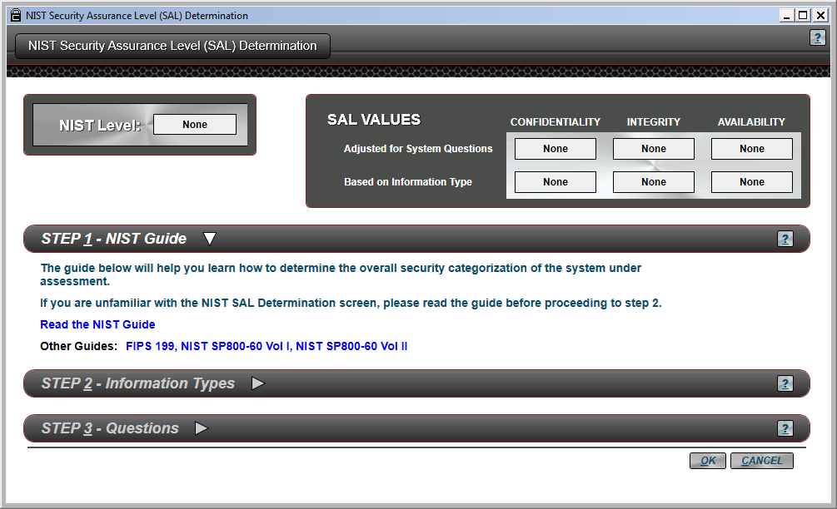

Figure 7-3. NIST SAL Determination Screen.

The three security objectives are defined as:

**Confidentiality.** The unauthorized disclosure of information.

**Integrity.** The unauthorized modification or destruction of information.

**Availability.** The disruption of access to or use of information or an information system.

The three impact levels are defined as:

**Low.** The loss of confidentiality, integrity, or availability could be expected to have a limited adverse effect on organizational operations, organizational assets, or individuals.

**Moderate.** The loss of confidentiality, integrity, or availability could be expected to have a serious adverse effect on organizational operations, organizational assets, or individuals.

**High.** The loss of confidentiality, integrity, or availability could be expected to have a severe or catastrophic adverse effect on organizational operations, organizational assets, or individuals.

**STEP 1–NIST Guide:** If you are going to use the NIST SAL determination method, then you will need to have some understanding about how the level is derived. A short guide to the process is provided with the application and is shown under “STEP 1-NIST Guide.” The hyperlink reads “Read the NIST Guide.” In addition, the source documents are provided and can be opened by clicking on the respective hyperlinks. They include the FIPS 199 document and Volumes I and II of NIST SP800-60. To understand the NIST process, it is necessary to carefully read these three documents.

While the system does not require you to read either the guide or documents, it is highly recommended that you do so in order to understand how the level is being determined.

**STEP 2–Information Types:** In this step, you will review the information types and check all the types that apply. The developers of NIST SP800-60 determined the SAL as it relates to Confidentiality, Integrity, and Availability for each of the information types. Because these three levels have already been defined, you simply need to select the information type, and the levels will be populated automatically. In the process, both the adjusted values and the overall level are based on a “high water mark” concept. This means that the highest of any of the three values is the overall value. For example, if you come up with a Low, Low, and Moderate set of values, then your overall SAL is Moderate because that is the highest value. Figure 7-4 shows several selected types and the assigned level values for each of the three categories.

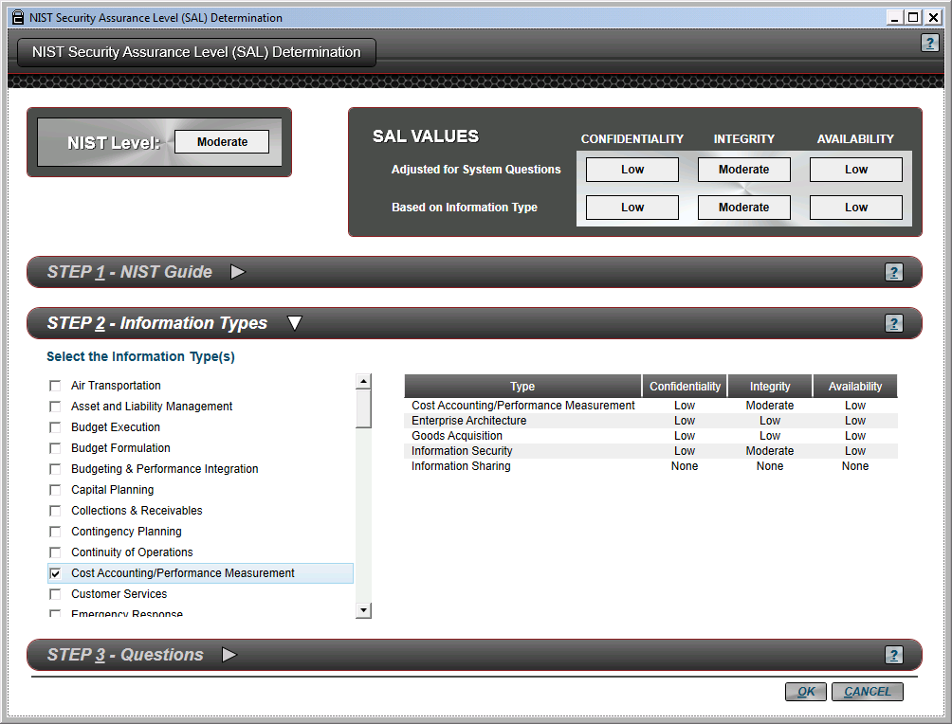

Figure 7-4. NIST SAL, Step 2.

When an information type is selected in the list on the left of the screen, the system displays that type with the values in the block on the right and at the same time dynamically updates the combined values in the block on the top, including the overall SAL level.

No specific definition is given for each information type in the system. To understand how the types are broken out, you must open the NIST documents located under Step 1.

**STEP 3–Questions:** The final step in determining your SAL using the NIST method is to answer a short set of questions that may adjust the level in one or more of the categories. Figure 7-5 shows the screen when Step 3 has been clicked.

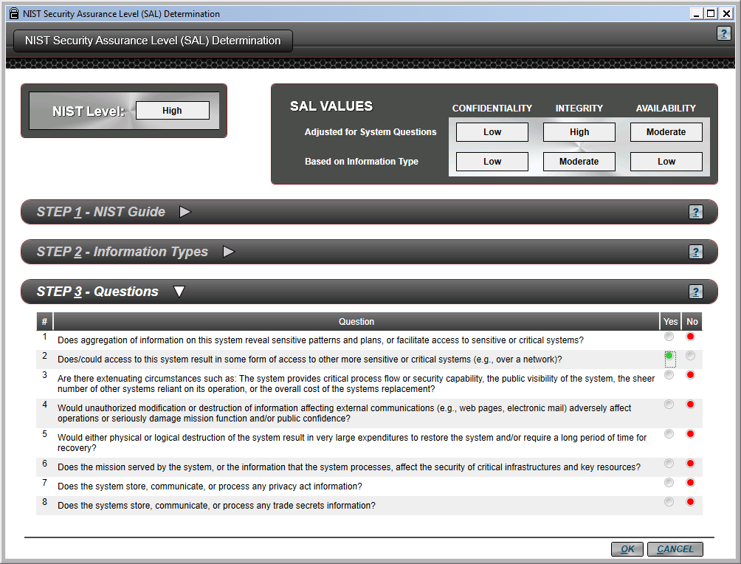

Figure 7-5. NIST SAL, Step 3.

After you open Step 3 - Questions section, the system will display a set of eight questions that were taken from the NIST documents. The answers to these questions may cause the SAL values to be changed. As you mark either Yes or No to the question, the system will update the “Adjusted for System Questions” fields at the top of the screen, (in the SAL Values block).

As was mentioned earlier, to better understand the questions and the process, see the NIST documents provided under Step 1.

The final SAL value is shown in the upper left portion of the screen. This value will be carried forward to the Standards screen. The SAL will affect how many questions you will have to answer in both the questions and standard requirements‑based approaches.

SAL of None

If the General SAL or NIST SAL wizard results in a SAL of None, the SAL level will not be changed and a warning will be displayed as shown in Figure 7-6.

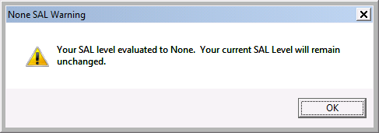

Figure 7-6. SAL of None Warning.

CNSSI Security Assurance Level Determination

If you have selected the CNSSI 1253 baseline or an overlay option, then all three values will be moved forward to new fields on the Standards screen. Figure 7-7 shows the additional fields that are displayed when these standard options are selected.

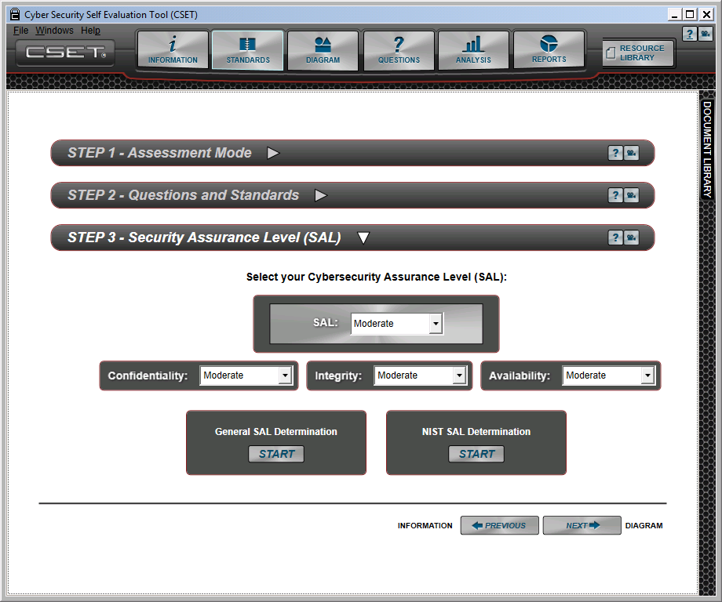

Figure 7-7. Security Assurance Levels Using CNSSI 1253.

The levels are defined in the standard as:

**Confidentiality (C):** “Preserving authorized restrictions on information access and disclosure, including means for protecting personal privacy and proprietary information…” [44 U.S.C., Section 3542] A loss of *confidentiality* is the unauthorized disclosure of information.

**Integrity (I):** “Guarding against improper information modification or destruction, and includes ensuring information nonrepudiation and authenticity…” [44 U.S.C., Sec. 3542] A loss of integrity is the unauthorized modification or destruction of information.

**Availability (A):** “Ensuring timely and reliable access to and use of information…” [44 U.S.C., Section 3542] A loss of availability is the disruption of access to or use of information or an information system.

Like the general SAL value, you can also adjust the Confidentiality, Integrity, and Availability SAL values if circumstances would dictate a different level in any of those areas.

DoD Assurance Level Determination

If the Department of Defense (DoD) standard is selected, the Confidentiality and MAC levels are set on the Questions and Standards screen as shown in Figure 7-8.

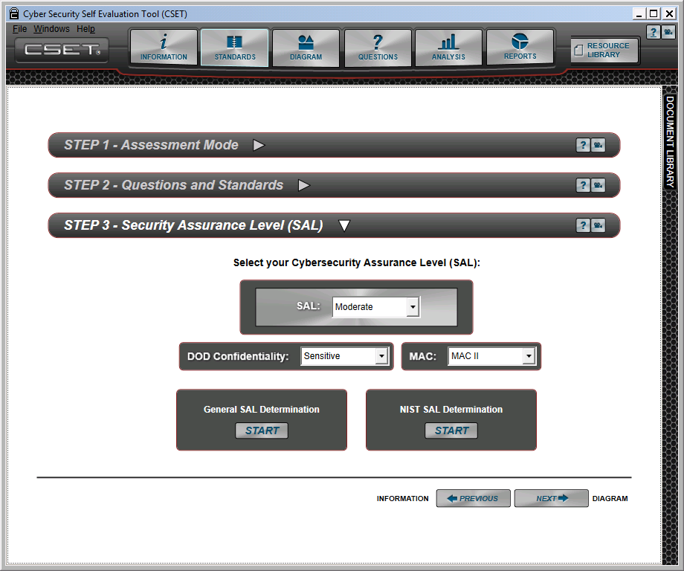

Figure 7-8. DoD SAL Levels.

The assurance levels are defined in the standard as:

**Confidentiality Level:**

Applicable to DoD information systems, the confidentiality level is primarily used to establish acceptable access factors, such as requirements for individual security clearances or background investigations, access approvals, and need-to-know determinations; interconnection controls and approvals; and acceptable methods by which users may access the system (e.g., intranet, Internet, wireless).

The DoD has three defined confidentiality levels: classified, sensitive, and public.

**Classified Information.** Concerning or derived from intelligence sources, methods, or analytical processes, that is required to be handled within formal access control systems established by the Director of Central Intelligence

**Sensitive Information.** Information, the loss, misuse, or unauthorized access to or modification of, could adversely affect the national interest or the conduct of federal programs, or the privacy to which individuals are entitled under Section 552a of Title 5, United States Code, "The Privacy Act," but which has not been specifically authorized under criteria established by Executive order or an Act of Congress to be kept secret in the interest of national defense or foreign policy.

**Public Information**. Official DoD information that has been reviewed and approved for public release by the information owner in accordance with DoD Directive 5230.9.

**Mission Assurance Category (MAC):**

Applicable to DoD information systems, the mission assurance category reflects the importance of information relative to the achievement of DoD goals and objectives, particularly the warfighters' combat mission. Mission assurance categories are primarily used to determine the requirements for availability and integrity.

The DoD has three defined mission assurance categories: MAC I, MAC II, and MAC III.

**Mission Assurance Category I (MAC I).** Systems handling information that is determined to be vital to the operational readiness or mission effectiveness of deployed and contingency forces in terms of both content and timeliness. The consequences of loss of integrity or availability of a MAC I system are unacceptable and could include the immediate and sustained loss of mission effectiveness. MAC I systems require the most stringent protection measures.

**Mission Assurance Category II (MAC II).** Systems handling information that is important to the support of deployed and contingency forces. The consequences of loss of integrity are unacceptable. Loss of availability is difficult to deal with and can only be tolerated for a short time. The consequences could include delay or degradation in providing important support services or commodities that may seriously impact mission effectiveness or operational readiness. MAC II systems require additional safeguards beyond best practices to ensure assurance.

**Mission Assurance Category III (MAC III).** Systems handling information that is necessary for the conduct of day-to-day business, but does not materially affect support to deployed or contingency forces in the short-term. The consequences of loss of integrity or availability can be tolerated or overcome without significant impacts on mission effectiveness or operational readiness. The consequences could include the delay or degradation of services or commodities enabling routine activities. MAC III systems require protective measures, techniques, or procedures generally commensurate with commercial best practices.

CFATS Tiers

Selecting the Chemical Facilities Anti-Terrorism Standards (CFATS) opens a list of Tiers under Step 3 as shown in Figure 7-9. This serves as a reminder to select the tier assigned to the facility by DHS. Use the SAL drop-down option that corresponds to the assigned tier.

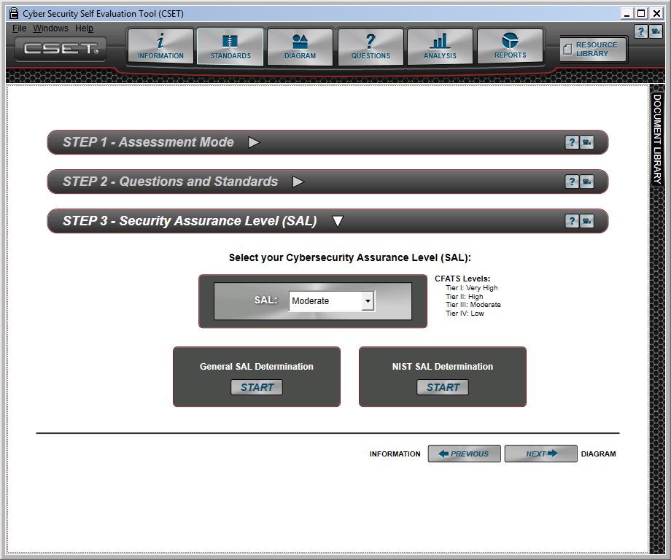

Figure 7-9. CFATS Tiers.

The tier designations are:

* Tier I, Very High
* Tier II, High
* Tier III, Moderate
* Tier IV, Low

The CFATS tiers are unrelated to those associated with the Cybersecurity Framework.

Cybersecurity Framework Profile Management

Once Cybersecurity Framework Based has been selected under Step 1, clicking the Step 3 bar opens the list of profiles as shown in Figure 7-10. The baseline profile is created by default and can not be edited. Any other profiles created for this or another assessment will also be shown.

The profile allows for creation of a question set uniquely tailored to the organization’s cybersecurity needs. Each profile is created with a baseline set of questions. Additional questions of the user’s choosing may be added and saved with the Profile. From this screen, new profiles may be created, existing profiles may be edited, and previous profiles may be imported. The selected profile will be used for the assessment.

Profiles can be useful in tracking progress and identifying areas of needed improvement. For example, a “current” profile can be compared to a “target” profile. They can also be shared among business entities so that the same questions are answered during each assessment with results being fully comparable.

Profiles may be copied for ease of editing. When complete, they may be exported. This saves the profile file separately from the assessment file. The profile file is saved with a **.csetp** extension. It may be imported into other assessments. It may also be sent to related business entities if, for example, a company has several branches. Having each branch use the same requirement set results in each creating an assessment with fully comparable results.

To import or export a profile, return to the Standards screen. Under Step 3 click Export in the row of the profile to be saved. A file save window will open so that a directory and filename may be selected. To import a profile, click the Import a Profile button, navigate to the desired file, and open it.

Appendix F has more detailed information on the basis for and approach to the cybersecurity framework. This section assumes that the purpose and use of the Framework is understood and will therefore focus on use of the screens.

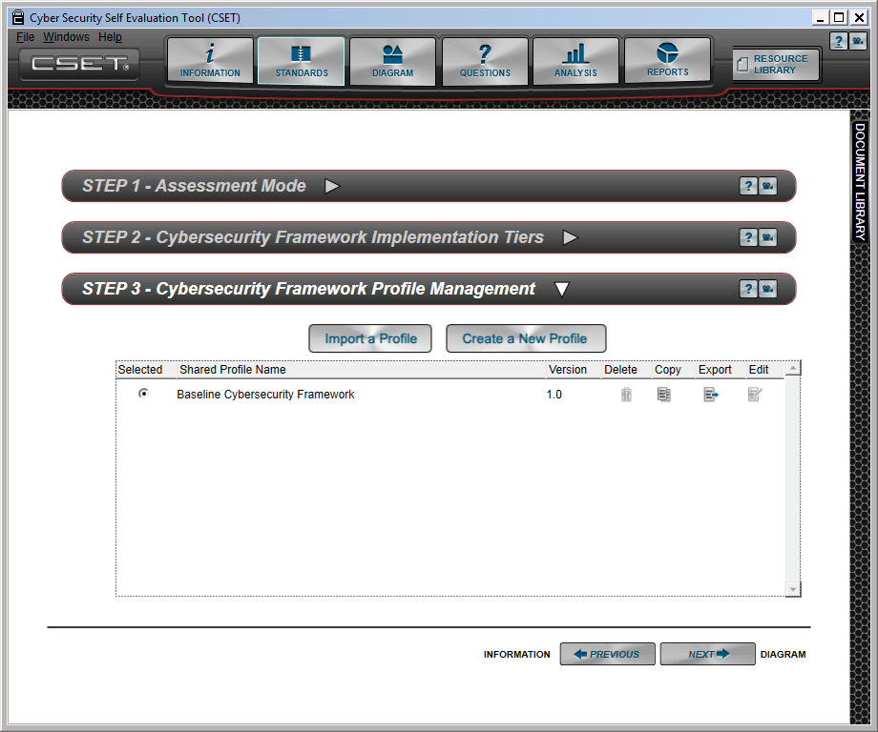

Figure 7-10. Cybersecurity Framework Profile Management.

To create a new profile, either click the button labeled Create a New Profile or make a copy of the default profile and click the Edit icon. This opens the Manage Profile screen shown in Figure 7-11.

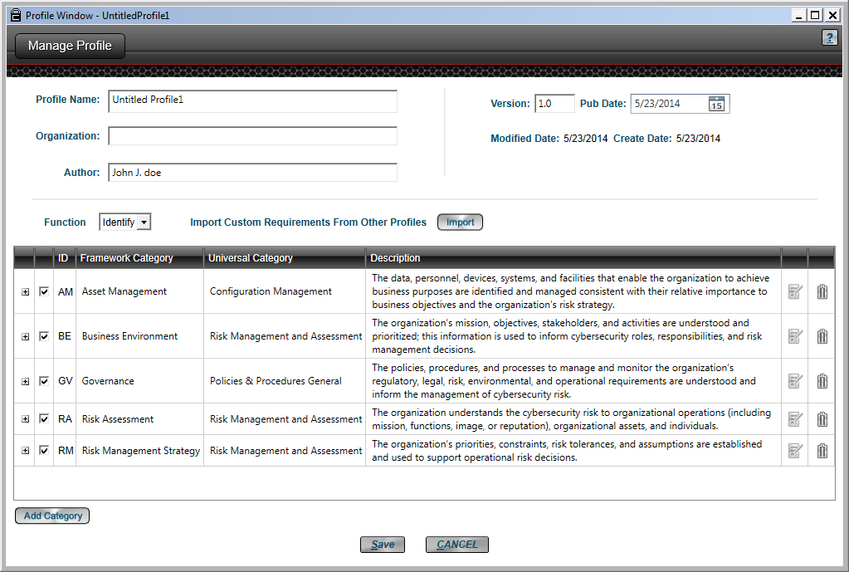

Figure 7-11. Manage Profile Screen.

This screen allows the user to add identifying information to the profile such as profile name, organization, author, and publish date. The Pub (publish) date defaults to the current date but can be modified. If needed, increment the version number. The table provides the function identifier, category name, Universal Category, and Description. The Universal Category column lists the related CSET category from which the analysis charts with weights and ranking will be build.

The baseline requirements from the Framework document are pre-loaded. To see them, click the plus (+) sign to the left of the ID column. Figure 7-12 shows the Asset Management category opened to display the related requirements. Clicking the minus (-) button closes the list.

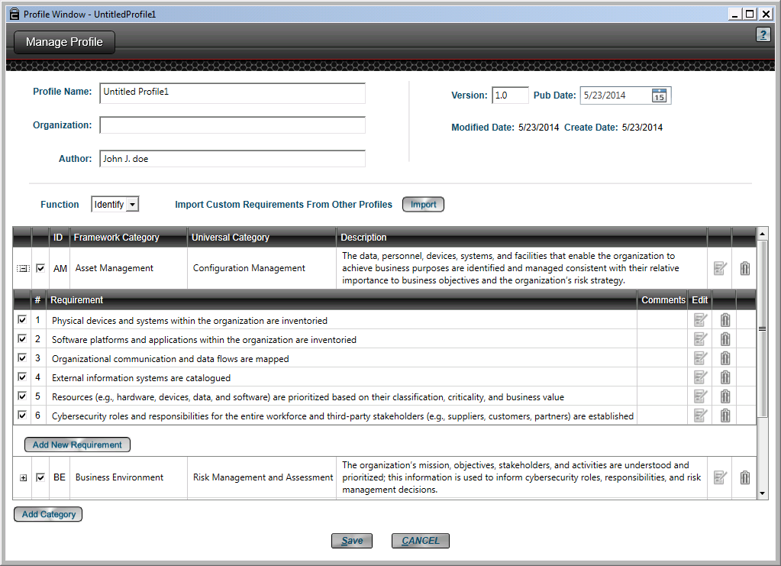

Figure 7-12. Manage Profile Screen Expanded.

To see the categories and questions related to a different function, use the drop-down button labeled Function to select another area. If a requirement is unchecked, it will not appear in the Questions section of the assessment. If the category is unchecked, none of the related questions will appear in the assessment. To remove a question or category altogether, use the Delete (trashcan) icon at the right end of the row.

The paper icon near the right end of a row allows the question to be edited. It is only active for questions added by the user. The baseline questions may not be edited.

To add new questions, click the Add New Requirement button. The Profile Requirement screen will open with blank fields. Figure 7-13 shows the screen with example data filled in.

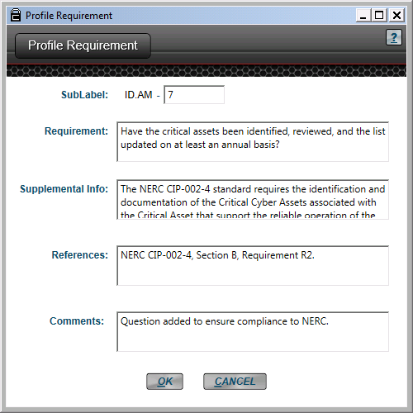

Figure 7-13. Profile Question Screen.

Be sure that the question ID is unique. It will default to the next available number for that category, but may be manually changed. The requirement text and comments will appear on the Manage Profile screen. The text added to the Supplemental Info and References fields will be available on the Question Information docking window on the Questions screen, described later in this document.

Click OK to close the screen and add the new requirement. At the Manage Profile screen, ensure that the requirement is checked so that it will be included in the assessment. Figure 7-14 shows the Manage Profile screen with the new requirement.

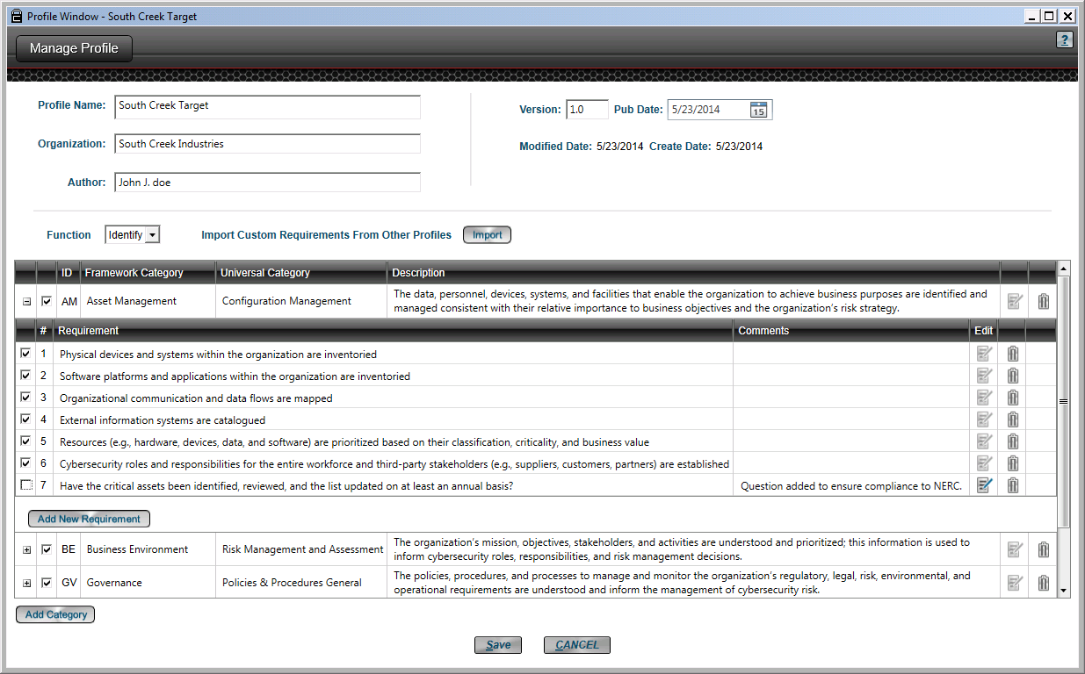

Figure 7-14. Manage Profile With New Requirement.

Clicking the Edit icon near the right of the row will reopen the Profile Requirement screen so that any needed changes can be made to the new requirement.

When checked, the new requirement will be seen in the Questions screen as shown in Figure 7‑15.

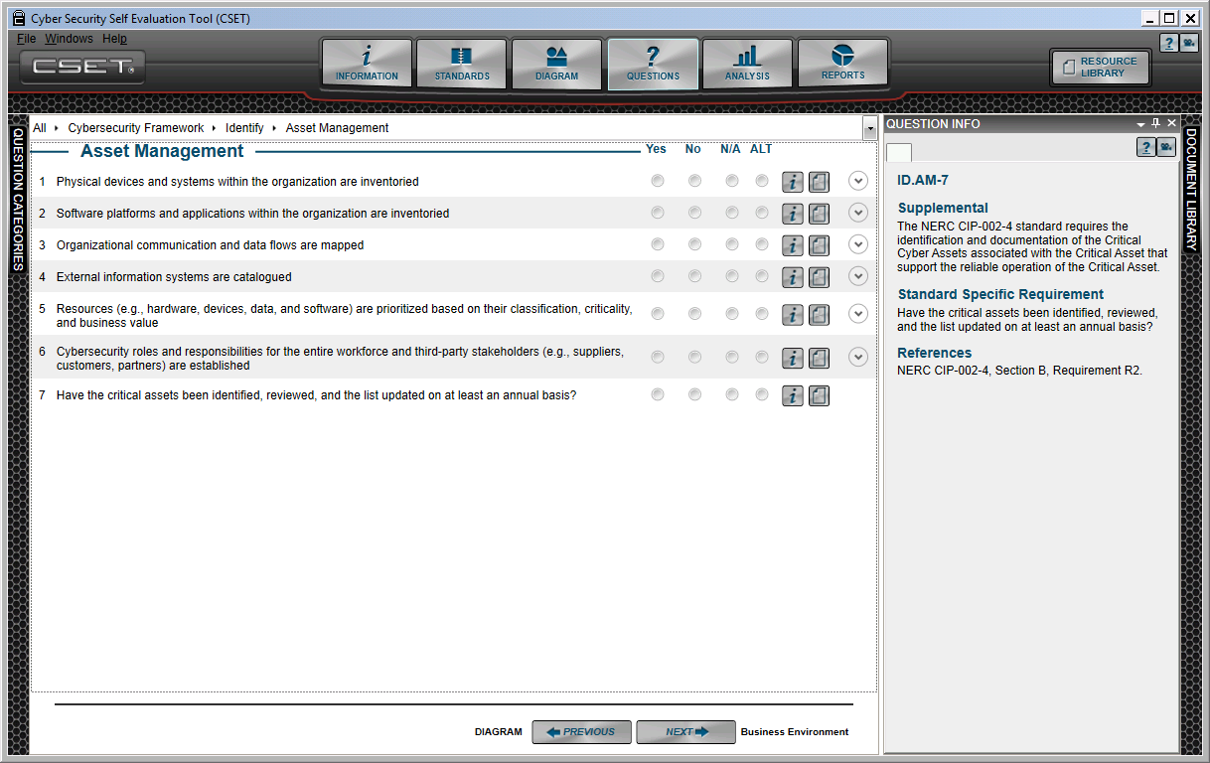

Figure 7-15. New Requirement Added to Question Screen.

To add a new category, click the Add Category button. This opens the Profile Category screen. The screen opens with blank fields. Figure 7-16 shows the screen with example text filled in.

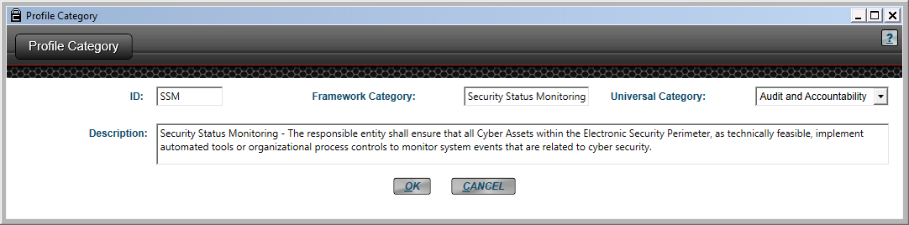

Figure 7-16. Profile Category Screen.

Click OK to close the screen and add the category. At the Manage Profile screen, select the applicable Function to see the new category. Ensure that it is checked so that it will be included in the assessment. Figure 7-17 shows the added category.

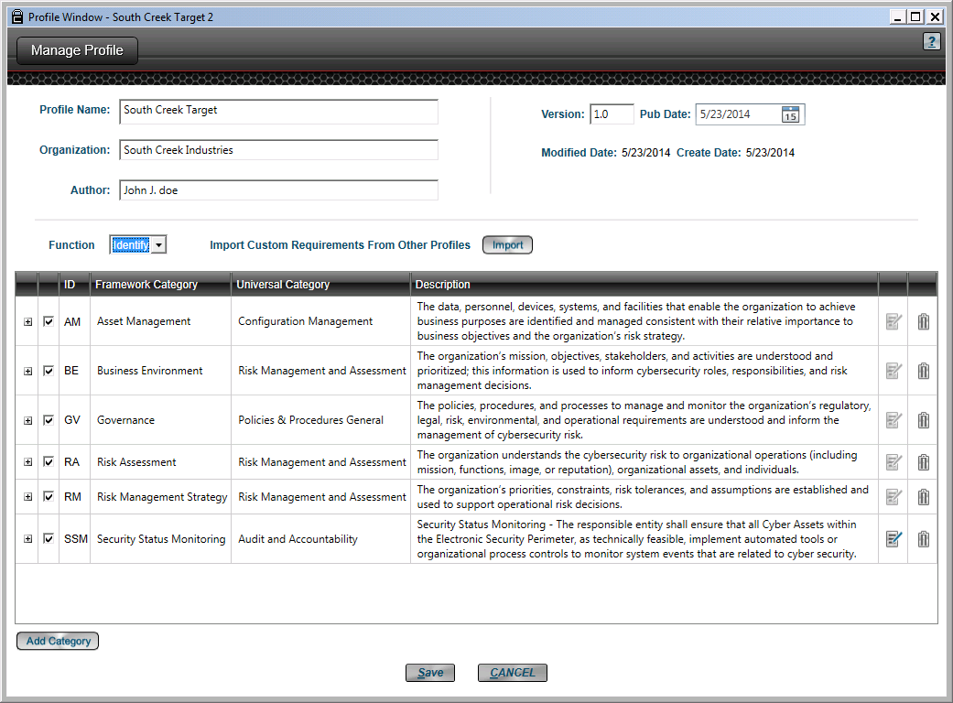

Figure 7-17. Manage Profile With New Category.

If requirements have already been added to another profile, they may be imported to the current profile to avoid retyping each new requirement individually. Click the Import Custom Requirements From Other Profiles button to begin the process. The Import Requirements screen will open listing the available questions. Figure 7-18 shows the screen populated with example text.

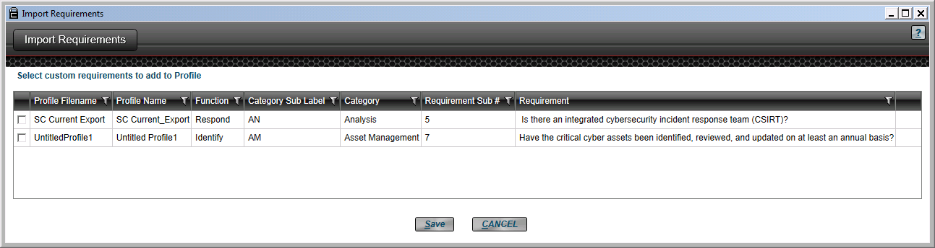

Figure 7-18. Import Requirements Screen.

Click the check box at the left end of the row to select the question then click Save. The new requirement will appear in the question set under the appropriate Function and Category.

8) Building a Network Diagram



8

This section provides detailed instructions for creating a network diagram and using the diagramming tool. The diagram may be created within CSET or in Microsoft Visio and then imported into the tool. The first part of this section discusses the CSET drawing tool. Use of Visio is addressed later in this section.

CSET includes a drawing tool that is valuable in several ways. First, it provides a place to graphically capture a picture of the control system or IT network. Second, it incorporates simple network analysis features to identify areas of vulnerability and recommendations for protection. Third, it is used to create the foundation for the question set that is incorporated into the overall assessment and analysis.

When you start a new assessment and click on the Diagram button on the top row of the CSET Window, the system will open the screen shown in Figure 8-1.

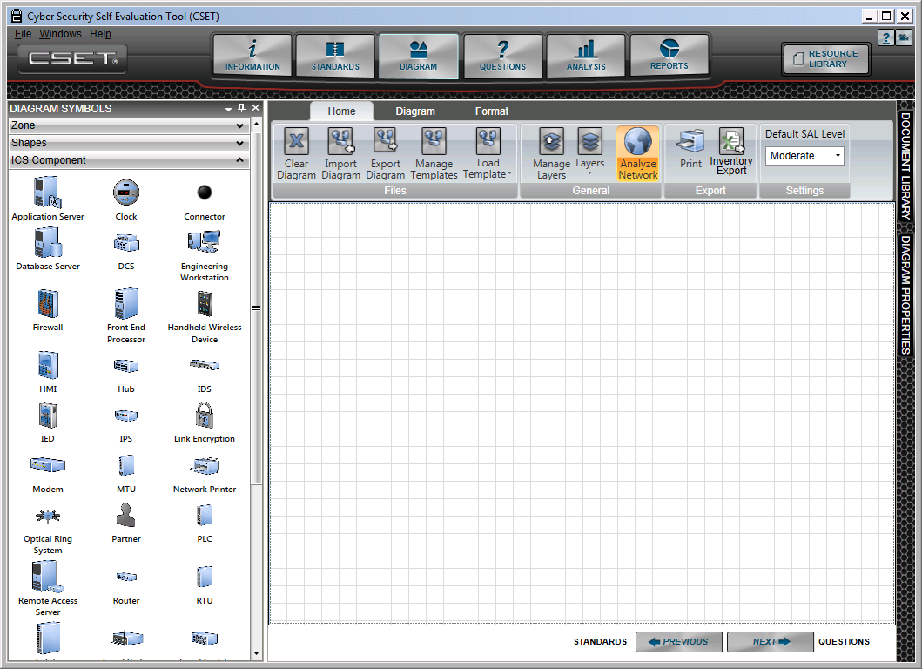

Figure 8-1. Opening Diagram Screen.

When the screen is first opened, the ICS Components window is open on the left‑hand side of the screen. The component menu items are displayed and the drawing area is shown with gridlines. The Diagram Properties dockable window is collapsed on the right side of the screen.

As an example, Figure 8-2 shows an image of the screen with settings changed to maximize the drawing area and with gridlines displayed.

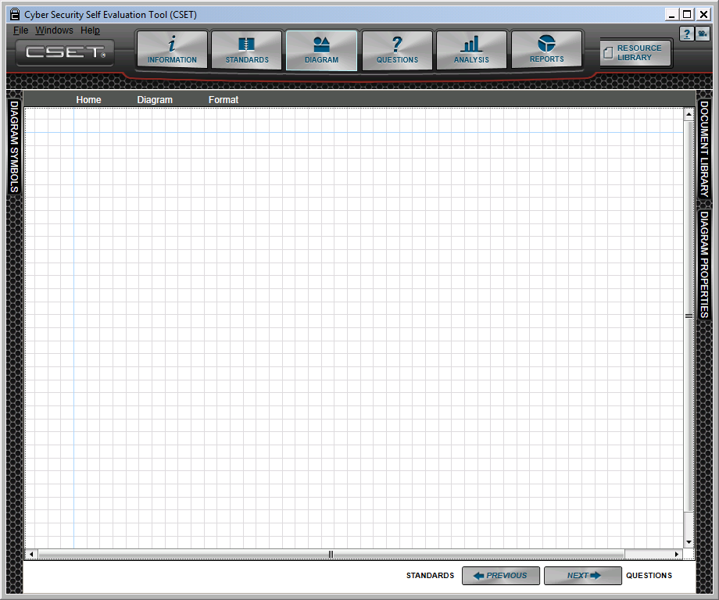

**Symbols window docked**

**Diagram properties window docked**

**Grid on**

**Ribbon off**

**Diagram selected**

Figure 8-2. Diagram with Maximum Drawing Area.

To change the diagram screen to look like the figure above, simply Auto Hide the Diagram Symbols docking window. To close the ribbon and open up more space on the top of the screen, right click the mouse in the blank space to the right of the menu choices. This will cause the system to display a popup menu with the label Minimize Toolbar. Check this menu item and the ribbon will close. See Figure 8-3 for an image of the checkbox.

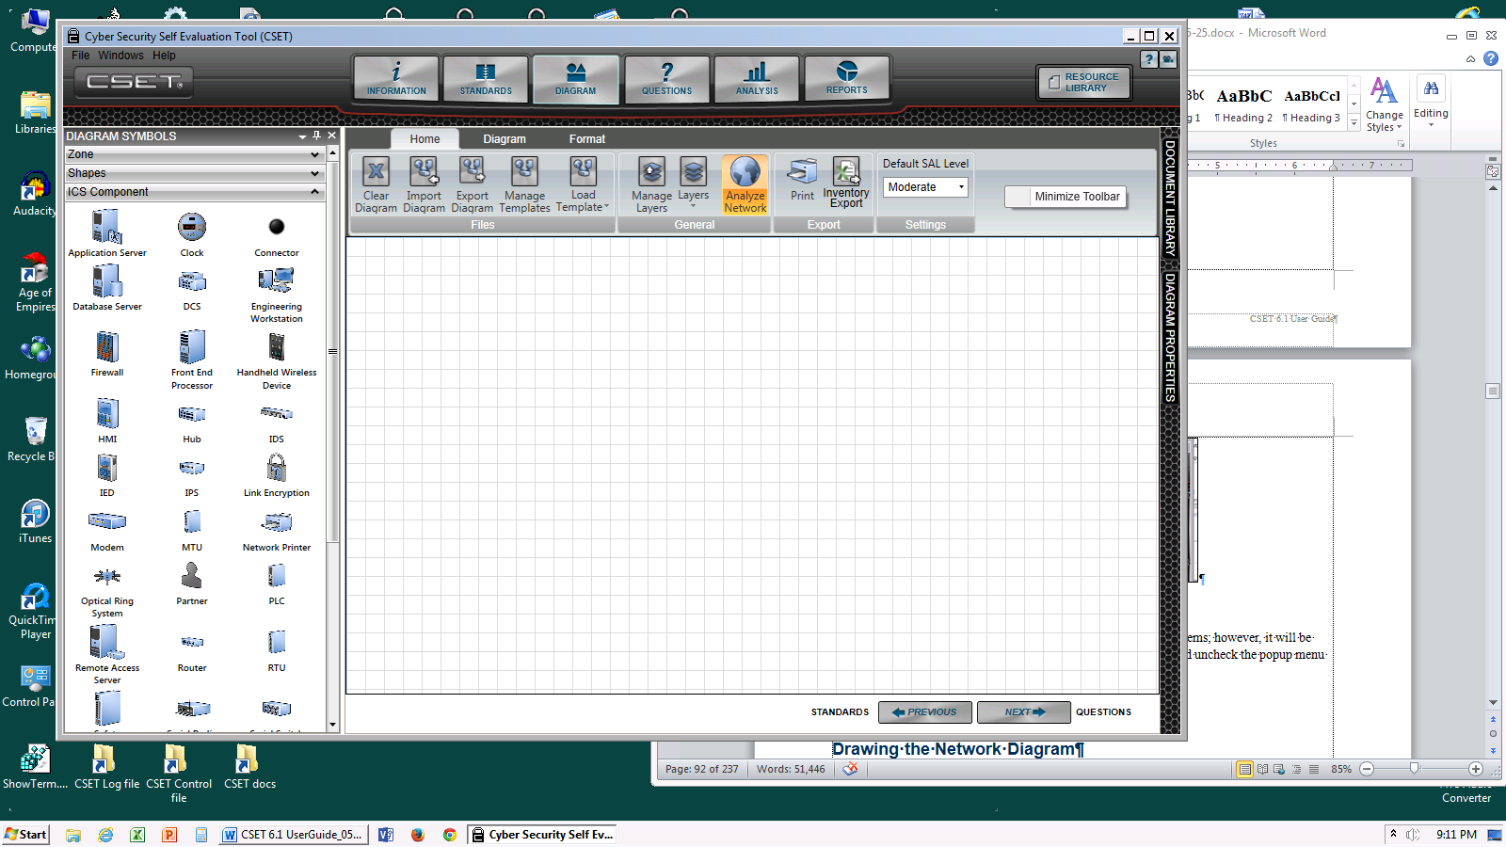

Figure 8-3. Minimize Toolbar Checkbox.

The ribbon will be displayed whenever you touch one of the menu items; however, it will be minimized after you are done. To keep it open, simply right click and uncheck the popup menu labeled Minimize Toolbar.

Drawing the Network Diagram

A couple of ways are available to start drawing a diagram. The first approach is to use a template. Templates exist that come loaded with CSET, or you can use a template that was shared by someone in your organization or industry. The templates included in the tool are generic for a particular sector or control system type. To select a template, go to the “Home” menu tab; and when it has been opened, select the “Load Template” option. Clicking the button will open a list of preloaded templates. When you select a template from the available list, the system will then load the components, network connectors, and zones in the diagram. You will need to modify the components and the layout to match your system.

The second approach is to start a diagram from scratch. You do so as follows:

1. Click and drag an ICS component icon from the symbol palette onto the drawing area. Continue to drag components onto the diagram until you have placed those that you need.
2. Add metadata for each icon, including the name, layer, and other information to make the component unique in the system using the Diagram Properties window. The window pops up when a component has been placed.
3. Connect the components using line connectors.
4. Add zones with the necessary diagram properties, and then move the respective components into the zone boundaries.
5. Add any labels, shapes, or text to polish the diagram.
6. Continue to add to, remove, or edit the icons until the diagram is complete.

Always remember to save the assessment as you are creating it.

The details of each area of the diagram screen will be described in the sections that follow.

Diagram Symbols

The Diagram Symbols docking window contains three panels; Zone, Shapes, and ICS Component. The icons within the panels can be dragged and dropped onto the drawing area to create or modify a network diagram. While these icons are specifically designed for CSET, a similar stencil set was included in the installation and is available to be used with Microsoft Visio if that software is installed. The use of Visio is addressed in the section titled Integration with Microsoft Visio.

The Diagram Symbols window contains zones, general shapes, and all the CSET control system and network components that are to be used in the tool. Some devices may be physically contained within a single shell such as a firewall and intrusion detection system (IDS). In this case, a logical combination of the firewall and the IDS should be placed on the diagram.

Adding Icons

To add a new shape, component, or zone icon to the diagram you will need to open the Diagram Symbols docking window. When you first come into the diagram screen, it is docked against the left border. If the window is closed, you can hover the mouse over the tab name, and it will open. You can also use the Windows menu item at the top right of the tool.

An important part of adding icons is including appropriate properties associated with the shape, component, zone, connector, or text icon. To do so, you must have the Diagram Properties docking window open. This window will open, if closed, when you place an icon on the diagram. If the window is already pinned open, then it will remain open; and the data will be associated with the currently selected object. If the window is closed, you can hover the mouse over the tab name, and it will open. You can also use the Windows menu item at the top left of the tool. Click Windows then select Diagram Properties to open the window. It is recommended that you pin the window open while inserting components.

Adding a Shape

To add a new shape to the diagram, open the Diagram Symbols docking window. Click the shape you wish to add and drag it onto the drawing area. While active, the shape will have a gray box around it. You can select a corner to change the size of the shape. You can also rotate it using the handle shown above the gray frame. If you click within the gray box, you can drag the shape across the screen. Figure 8-4 provides an example.

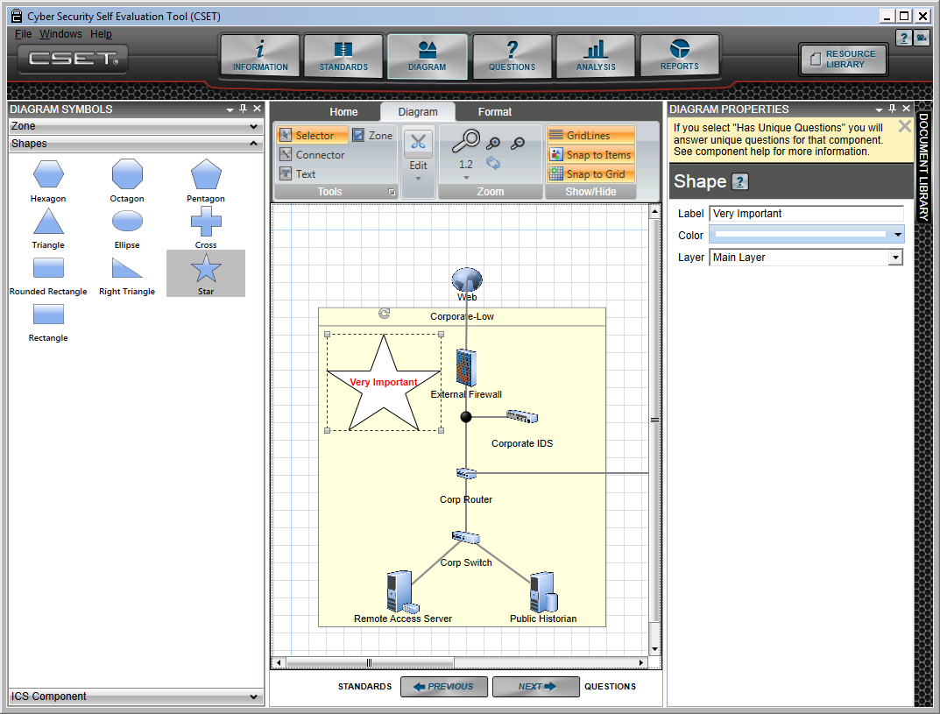

Figure 8-4. Adding a Shape.

Double-clicking within the shape will allow you to enter text. The text can be formatted using options found under the Format menu.

Each shape has a set of associated properties found in the Diagram Properties window. They are:

**Label:** This is a text string that is overlayed onto the shape outline. The text can be changed either in this field or by clicking on the text object itself.

**Color:** As the name implies, this field allows the color of the shape to be changed. CSET provides color themes, standard colors, and a form that allows you to create any color that you wish. This feature does not allow gradients, transparencies, or anything other than a solid color.

**Layer:** This is the layer with which the shape is associated. Within the CSET diagram, you can create as many layers as you wish. In this field, you can change the layer assignment. You must set up the layers using the “Manage Layers” function found under the Home menu followed by the Manage Layers menu item.

Adding a Component

To add a new component to the diagram, open the Diagram Symbols window and drag the desired icon onto the drawing area.

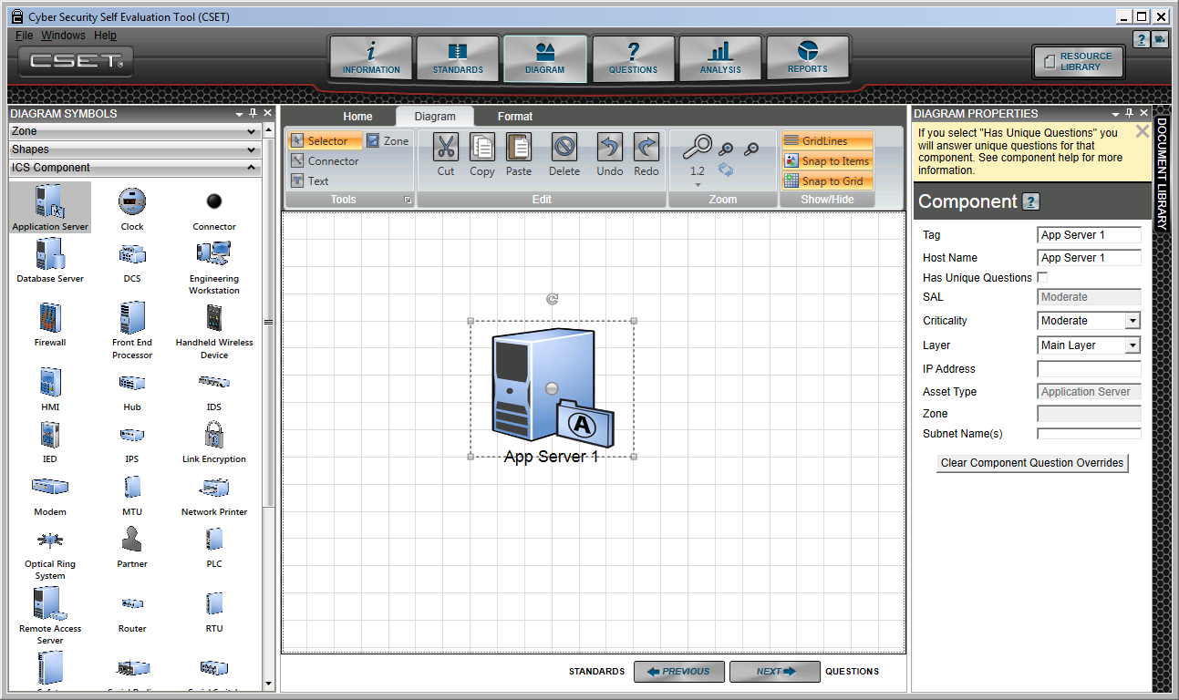

Figure 8-5. Adding a Component.

In Figure 8-5, the user has clicked on the “Application Server” icon from the symbols palette and while holding the mouse down, dragged a copy of the icon onto the diagram background. As with adding a shape, the selected component icon has been identified with a gray frame, and the component on the diagram has a move/modification box surrounding it in gray. While the frame is displayed, you can select a corner to change the size of the icon. You can also rotate the icon using the handle shown above the gray frame. If you click within the gray box, you can drag the component across the screen.

With the Selector tool active you can draw connecting lines between components. Click the grey dot in the center of the icon and drag the mouse to form the line. Release the mouse where the line is meant to end. You can also use the connector tool, discussed later.

The diagram properties options shown in the window are associated with all components. They are:

**Tag:** This is the common name used to refer to the component. This name will be used in the questions screen, the analysis, and the reports. It should be the name with which people are most familiar. Examples may be “Main Historian,” “Corp Firewall,” “Pump House HMI,” etc. A default name will be entered when you first place a diagram. The name will be a short abbreviation of the type and an incremented number.

**Host Name:** This is the official reference name for the piece of hardware. Often the organization will keep a database or inventory of assets, including network equipment. The name in the inventory may have a property number that is unique but may not be remembered by most people. An example might be “ACME1-43222-AC-22.” The Host Name is useful for verification of exact equipment, but is not used elsewhere in the system at this time. It defaults to the tag name.

**Has Unique Questions:** This is an important field for identifying a component that is different from other components in the system. By marking a component as being unique, you are instructing the tool to create a separate full set of questions for this device. This means that the default questions that are answered for all components in the system, or even for those of a given type, will not propagate to any component marked as unique.

As an example, you may have five servers in your facility, and four of those have been replaced in the last year with new models. These four are configured with the latest policies and take advantage of features inherent in a new operating system and other improved utilities. The fifth server is several years old and uses technology from an earlier period. In this situation, the fifth server should be marked as unique, so that the answers related to the four new servers are not assigned to the older fifth server.

**SAL:** This field is only applicable to a zone object and allows you to change the SAL for that specific zone. This can be helpful in separating areas of the facility into those areas that need greater protection and those that do not. If you are referencing a device, then the SAL will be displayed, but will not be editable.

If, for example, you have an overall SAL of High based on the consequences of an event happening at the facility and you do not use zones or do not change the SAL, then all component questions that are marked as High will be presented. If you changed a particular zone to Low, because it was not included in the critical areas, the question set would be smaller and would be less rigorous than the High questions. The zone approach allows you to minimize costs and limited resources, while still providing the appropriate levels of protection for your site.

**Criticality:** This field allows you to adjust the relative importance of a particular component as compared with others on the diagram. When you place a component on the diagram, the default setting will be Moderate. If the component is of lesser importance, then it can be changed to Low. Conversely, if the component is of greater importance to the system, then it should be changed to High.

The level in this field serves two purposes. First, it captures the relative importance of each component in the diagram and can be used in planning, design, and maintenance decisions. Second, it is used in the CSET formula for determining the ranking of questions. For example, if all else is equal, questions pertaining to a component marked High will be ranked above questions pertaining to a component marked Moderate or Low.

**Layer:** Within the CSET diagram, you can identify as many layers as you wish. In this field, you can change the layer assignment. You must set up the layers using the “Manage Layers” function found under the Home menu followed by the Manage Layers menu item.

Layers can be useful to isolate areas visually on the diagram. Layers are often used for marking backup systems, safety systems, redundant equipment, or components in physical locations such as a building, fenced area, substation, remote pumping site, etc.

**IP Address:** This field is only for your reference. It is not used by CSET at this time and is for you to capture the internet protocol address information if you wish.

**Asset Type:** This is a static field that displays the asset or component type. It is used to help identify the selected component type and is not editable.

**Subnet Name(s):** This field is also used for your reference in developing the network diagram. It can be useful in building the subnets; however, it is not used by CSET.

**Clear Component Question Overrides Button:** If you click the “Has Unique Questions” checkbox, mentioned above, the tool will open a set of questions for this specific component. When you are answering component questions and you choose to override the default answer for one or more components, the tool will generate a new specific question with the overridden answer for that component. For most purposes this is what is desired and expected. However, there may be cases where the unique checkbox was clicked by mistake, or you might have changed your mind on the override. Neither case is a problem. It just means that you would have to answer more questions. Nevertheless, this button allows you to clear those extra questions for this component.

When you click this button, the system will uncheck the “Has Unique Questions” checkbox and then remove all unique questions, regardless of how they were created.

Adding a Zone

A zone is a virtual representation (on the diagram) of a physical boundary separating different functional areas. It could also be used to represent systems that are bordered by physical structures such as a fence, building, rooms in a building, or even a plant. A common example is the separation of a corporate information system and an industrial control system. These two networks could be miles apart or all located at the same facility.

The advantage to using zones is that you are able to provide the appropriate level of security for both the highly critical areas and those that have little consequence. An area in the plant that has very high risk may be secured to a level of Very High, while much of the plant or organization may be at a Moderate or even Low level. This can be helpful when resources are limited, and you need to know where to spend your time, energy, and budget.

To add a zone, you must first access the zone window which is located in the Diagram Symbols docking window. Click the symbol then drag it onto the drawing area as shown in Figure 8-6. The zone will be initially placed as a blank rectangle. Drag the corners of the zone to include the desired components. If in doubt, place the zone first then add the components and links. The zone will expand to accommodate newly placed components that are at least halfway into the Zoned area.

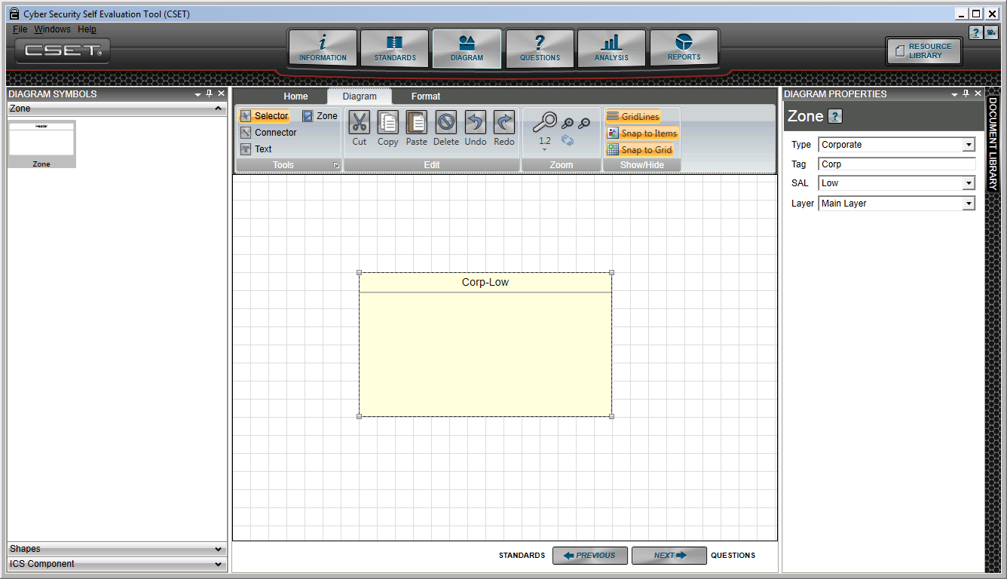

Figure 8-6. Adding a Zone

You may also use the Zone icon available in the top ribbon under the Diagram tab. Click the Zone icon to activate the tool then click in the drawing area where the Zone is meant to begin. Drag the mouse to draw the zone box to the desired size.

To add properties to the zone, select it and then open the Diagram Properties window that is docked on the right-hand side of the screen. The available fields are:

**Type:** The type field provides a list of general categories of systems, including “Other.” Each type has a predefined Security Assurance Level or SAL and an associated background color.

**Tag:** The tag field contains the label text that will be associated with the zone. Changes made to the text in this field will be reflected in the zone on the diagram. You can also change the tag name by first clicking on the zone and then double clicking to access the text. Once the text string is highlighted, you are able to go in and overwrite the existing string or remove everything and add a new label.

**SAL:** The SAL value allows you to modify the SAL for that zone. This is important because the SAL value will be used in analysis and reports to determine if you are meeting the requirements for the components. It is also used in the basic network analysis to evaluate how you are connecting components between zones with different SAL values.

**Layer:** The Layer field allows you to change the layer assigned to the zone. The Main layer is included by default. Other layers must be assigned using the Home menu Manage Layers function, as discussed later.

You can change the layer, or any other zone property, at any time by selecting the zone and then opening the Diagram Properties window. With the window open, you can update the zone properties as you wish.

Selecting Multiple Icons

To select multiple icons, you can drag a selection box around them or click each individually while holding down the Control (Ctrl) key on the keyboard. While dragging a selection box may be faster, it can gather unwanted items such as nearby lines and zones.

Once the multiple objects have been selected, including shapes, zones, text, components, and connectors, the Diagram Properties window will open to display the option to change the layer, as shown in Figure 8-7.

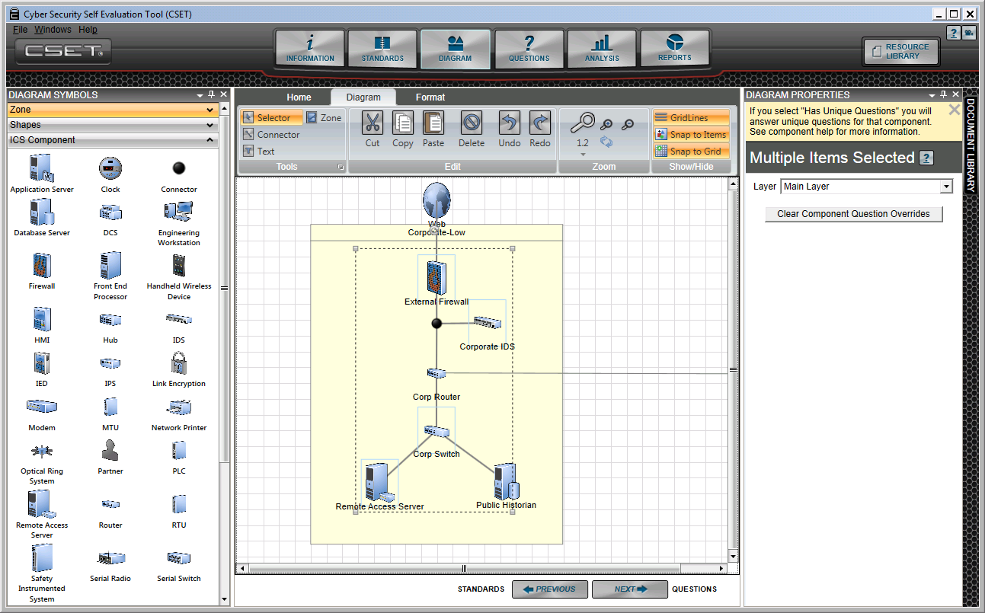

Figure 8-7. Selecting Multiple Icons.

The Diagram Properties options are:

**Layer:** This is the layer that the selected group of objects is associated with. Within the CSET diagram, you can create as many layers as you wish. In this field, you can change the layer assignment. You must set up the layers using the “Manage Layers” function found under the Home menu followed by the Manage Layers menu item.

**Clear Component Question Overrides Button:** This button is only relevant if you had clicked the “Has Unique Questions” checkbox when you first added one of the selected components to the diagram. When you click this button, the system will uncheck the “Has Unique Questions” checkbox and then remove all unique questions for the selected components, regardless of how they were created.

Home Menu Options⎯Files

A number of functions are available in the diagram screen that will allow you to manage your diagrams and templates. Figure 8-8 highlights the available options under the Home Menu tab.

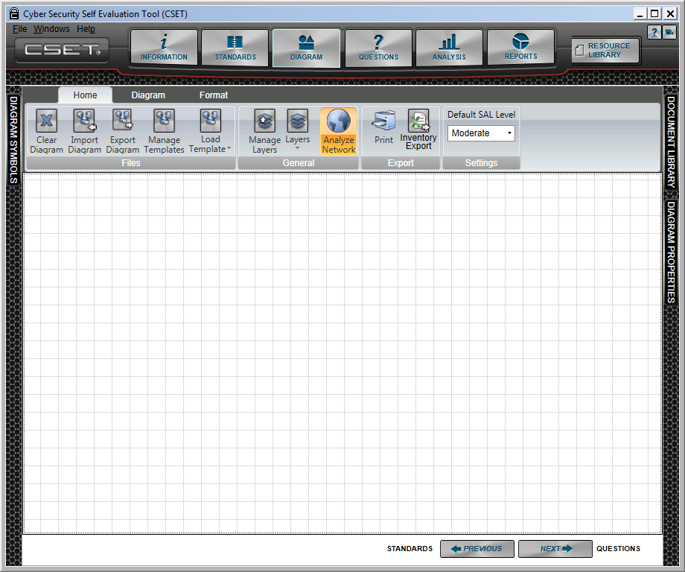

Figure 8-8. Home Menu Options.

The Home menu tab is divided into several groupings. The first, called Files, is oriented around file management. The second grouping, called General, focuses on layer management and network analysis. The third grouping is Export which deals with printing and creation of an inventory list. The last group, Settings, allows the Default SAL Level to be set for new components added to the diagram without being in a Zone. Each of the options under this tab will be described in the sections that follow.

**Clear Diagram:** The clear diagram button will cause the system to remove all the objects from the diagram, including components, connector lines, shapes, and text. The system will prompt you before it removes the objects and clears the diagram. If the diagram is important, you could export the diagram to a backup file before you clear it. If you have spent time answering component questions, it is recommended that you save the full assessment as a backup using the Save Assessment As option under the File menu.

Note: When you clear the diagram, it is important to remember that any questions that were answered, which were associated with any component on the diagram, will be lost. This is also true if you choose to load a template. Loading a template will clear the diagram and then import a new one, and all answers will be lost.

**Import Diagram:** This function will open a file selection dialog window and prompt you to select a file from your directory. The file selection screen will look for all files that have the following extensions:

* **.cset** (Files from a CSET Version 5 or later assessment),
* **.csetd** (Files exported from a CSET Version 5 or later diagram export – not the full assessment),
* **.ogxml** (Files exported from a CSET Version 4 diagram export), and
* **.orxml** (Files from a CSET Version 4 assessment).

To import the diagram, simply select the desired file name from the list of files in the open directory, and then click the Open button. The diagram will be loaded into the Diagram screen. Diagrams built using previous versions of CSET will load in the current version. However, because of the differences in the component icons, the layout may be slightly different, and the zones may overlap and require adjustment.

As a warning, if you answer questions associated with specific components and then either clear the diagram or import another diagram (which first clears the current diagram and components before the import), then your answers will be gone. It is recommended that you save the full assessment as a backup if you have spent time answering component questions.

Diagrams can be imported from Microsoft Visio if the associated CSET add-in has been included. If Visio had been installed on the computer prior to the CSET installation, then the add-in code would be loaded automatically. This code allows you to open Visio and then both import and export CSET diagrams. Use of Visio is addressed in more detail later in this section.

**Export Diagram:** The diagram that you have created can be shared with others, saved, or stored as a backup by using the Export Diagram function. The process is simple, just click the Export button, and when the file directory dialog screen is presented, enter the file name that you want to save it as. The system will save the diagram as a **.csetd** file type. This is not a full assessment that has the **.cset** extension and includes the diagram and answers to the questions. The .**csetd** file type is an XML file that only saves the diagram objects.

**Manage Templates:** A set of default templates are pre-installed with CSET. These are available by clicking the Load Template button and selecting one from the list. They are also shown in the Manage Template window with the Default Template field marked “Yes.” These preloaded templates are somewhat generic and are generally associated with a specific sector such as water, oil and gas, etc. They are provided as a way to start off the diagram with a given base set of components, organized in zones, and arranged in a sample network configuration.

You are able to add and manage new templates yourself. To do so, click on the Manage Templates button. The system will then display the window shown in Figure 8-9.

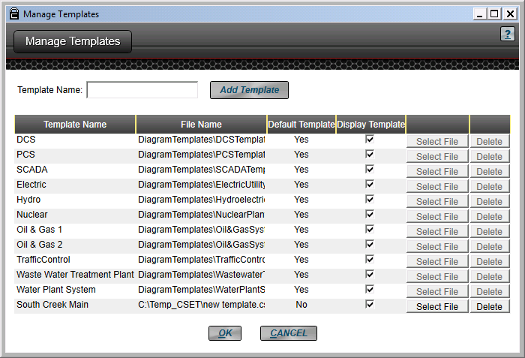

Figure 8-9. Manage Templates Screen.

The screen shows the name of the template as it will appear in the Load Templates list. It also shows the file name and directory path. The next two columns indicate whether the template is a default (preloaded) and whether or not it should be displayed in the Load Template List. The default templates cannot be changed or removed, but they can be disabled. The next two columns hold the buttons that allow you to select the file or delete the template from the list. These are active for user-entered templates only.

The column sizes can be changed by clicking on the yellow, vertical lines and then sliding them horizontally to the location that you want. The column settings will last during the session and will be reset when you exit the screen.

To add a new template, click on the Add Templates button, and the system will display a file selection dialog box. You must find and select the file you wish to add, and then click the Open button on the bottom of the dialog screen. This will then load the file into the template list.

In the example above, the final entry in the list, “South Creek Main” was added by the user. Note that the Select and Delete buttons are active for that template. The template name was added by clicking in the Template Name box and typing the desired text.

A template name can also be modified after it has been created. For example in Figure 8‑10, we see the new template selected (highlighted in yellow) and the Template Name field clicked with the word “Rev 1” added to the end of the name. You can change the names of the default templates as well; however, you are not able to change the file or delete them.

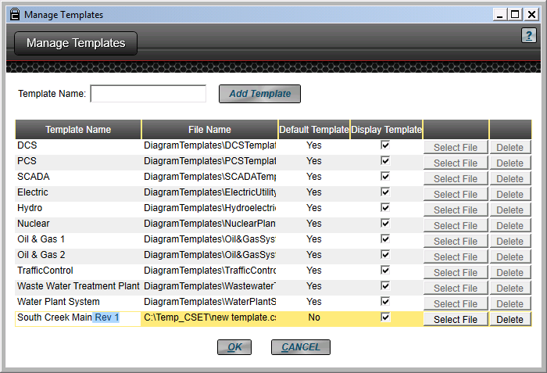

Figure 8-10. Changing a User Template Name.

As mentioned earlier, all the user-entered templates can be changed or removed using the Select File and Delete buttons on the same row as the template name. The Delete button will completely remove the template from the list. The Select File button will allow you to change the actual file that is associated with the name in the list.

The changes made using the Manage Templates screen will apply to the application. It is not associated with any single assessment.

**Load Template:** Eleven pre-installed templates are included with CSET. As mentioned earlier, these are basic configurations that are somewhat unique to a given sector or system type. They are intended to provide a starting point for building the diagram.

In the example shown in Figure 8-11, the user has clicked on the Load Template button. The list that is provided includes the default templates as well as the user-entered template on the bottom called “South Creek Main Rev 1,” which was added using the Manage Templates functionality described in the preceding section.

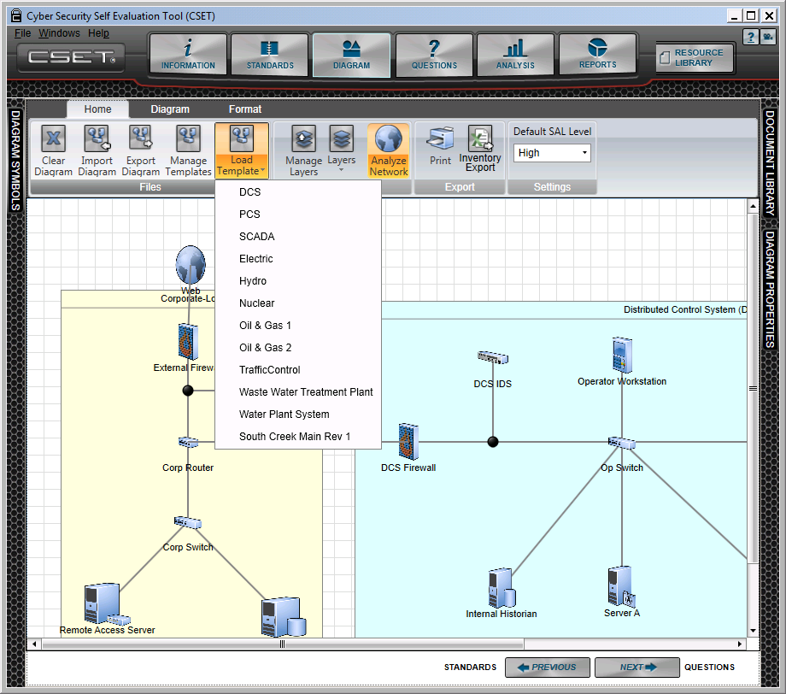

Figure 8-11. Load Template.

To select a template, simply click on the Load Templates button, and then click on one of the items shown in the list. The example above shows the list, and it also shows the results when the user selected the SCADA option from the list. Remember that if you load a new template, the system will clear or wipe away what is currently there. The answers to any questions related to components will be lost as will the diagram itself. If you want to save just the diagram, make sure to export it to a new name first. To save the diagram and any answered questions, use the File menu option to save the assessment under another name as a backup.

Home Menu Options⎯General

Several functions are found under the General group in the Home menu.

**Manage Layers:** The first function in the group is the ability to define and manage layers. When you click the Manage Layers button, a pop-up window will appear as shown in Figure 8-12.

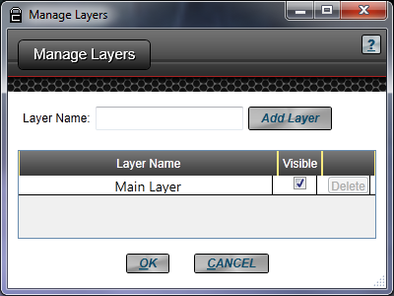

Figure 8-12. Manage Layers Screen.

A Main Layer is used as a default canvas on which to place all objects. Once the component has been added, its assigned layer can be modified by selecting another layer using the diagram properties window.

To add one or more new layers to the diagram, you will need to type in the name that you want for the new layer and then click the Add Layer button. As you add layers, they are displayed on the list as shown in Figure 8-13.

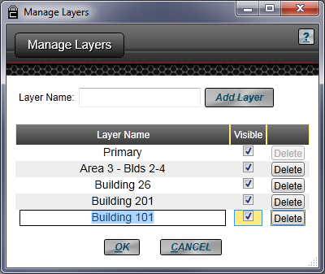

Figure 8-13. Manage Layers with New Layers.

By clicking in the Layer Name field, you are able to access the name and change it if you wish. The example shows the name of the Main Layer changed to Primary and the layer named “Building 101” highlighted prior to a name change.

In this window, you can also set which layers are visible. The Delete button allows you to remove a layer name from the list. If you delete a layer that has components or zones assigned to it, the component assignment reverts back to the Main Layer.

Figure 8-14 shows a simple configuration that has two zones and components associated with each of the zones. The Corporate zone, as shown in yellow, has the zone, the components, and the connecting lines all assigned to the “Corporate” layer. The zone labeled “Control System” with its associated components and connecting lines is assigned to the Building 101 layer. All layers are marked as visible.

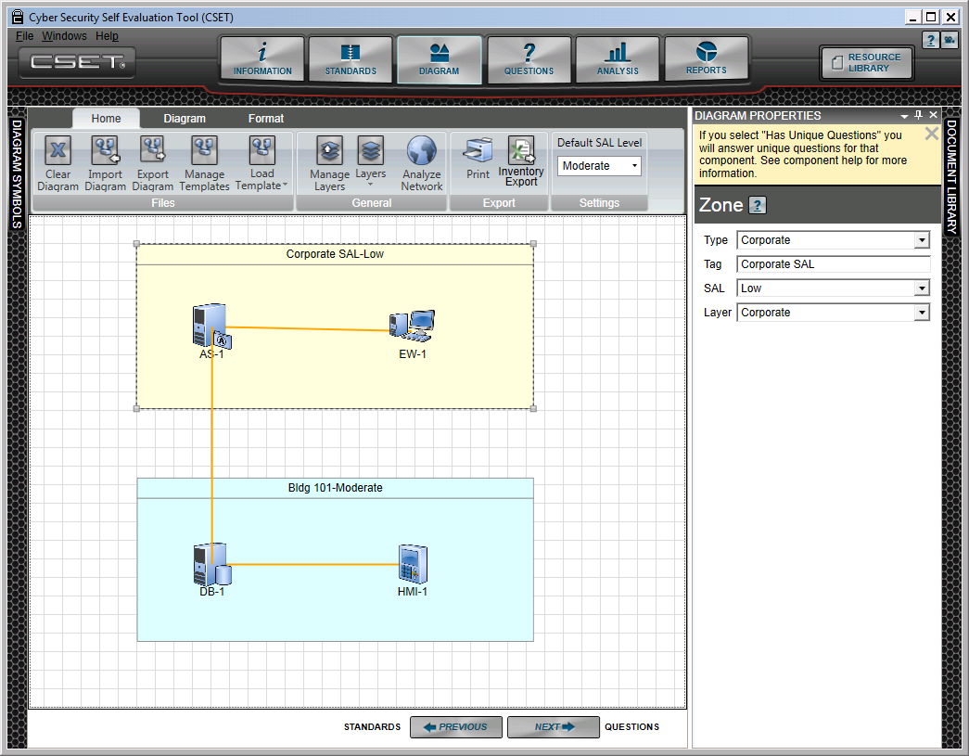

Figure 8-14. Layer Example.

There are two ways to change the visible display of one or more layers. The first method was described above and requires opening the Manage Layers and selecting the combination of layers from the list. The second method allows layers to be made visible by using the Layers menu option.

**Layers:** The Layers button will open a list of available layers. Figure 8-15 shows the button activated and the list displayed. In this example, only the layer called “Building 101” is checked for display. As you can see in the figure, only those objects that are assigned to the Building 101 layer are visible.

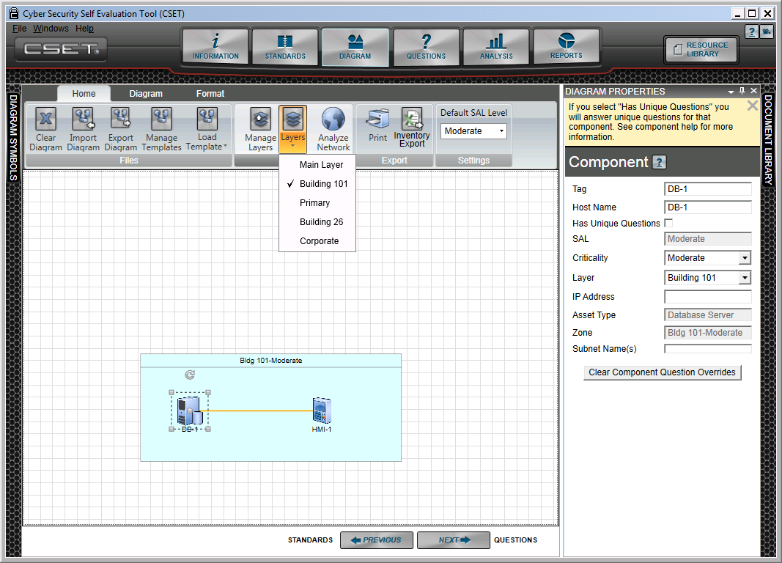

Figure 8-15. Building 101 Layer Visible.

Using the Layers button, you can add layers or remove them; however, you can only do so one at a time after each click. This is a fast and easy way to adjust the visibility in your diagram. If you want to open or close different combinations of layers, then the Manage Layers button would be the better choice.

CSET has the ability to change the layer assignment for a group of objects at one time. To make the change, simply draw the selection window around those objects that you wish to change. You may also single-select each object by holding down the “Ctrl” or “Shift” keys while clicking with the mouse on the objects. In the Diagram Properties window, you can pick the layer that will apply to all the selected objects.

Any object that can have a layer assignment will be modified when changing the layer in the Diagram Properties window. This includes lines, zones, components, shapes, and text blocks.

**Analyze Network:** This is a toggle button that will turn on or off the basic network analysis. If the button is turned on, then the system will analyze the diagram as components, zones, or lines are added, removed, or modified. If the button has been turned off, then no analysis will take place until it has been clicked back on.

In the example shown in Figure 8-16, the Analyze Network button is on. The two zones created earlier have different SALs, and the network connection is joining the application server in the Corporate zone to a database server in the Control System zone. No firewalls are between them, and as a result, a warning is shown. Each warning is identified by a numbered red circle in proximity to the line or component to which it refers.

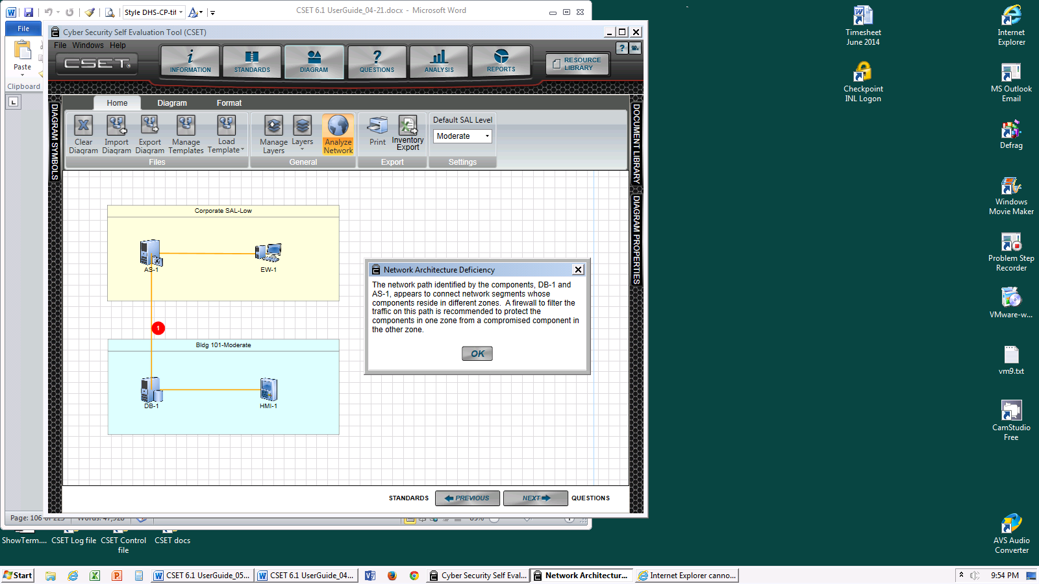

Figure 8-16. Network Analysis.

The information related to the warnings (red circle) can be reviewed in several locations. The first and most direct way to see the message is to click on the circle itself. The figure above also shows the message that is displayed when the user has clicked on the red circle shown on the screen.

In addition to the pop-up message that appears when you click on the red icon, you can also review the analysis messages from the Analysis screen and in the printed reports.

An example diagram network analysis warning from the Analysis screen is shown in Figure 8‑17. This screen is opened when you click the “Network Warnings” button from the Analysis screen. Each number corresponds with the numbered red icon on the diagram screen.

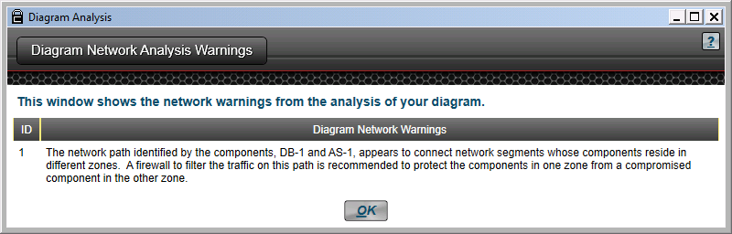

Figure 8-17. Diagram Network Analysis Warnings.

Home Menu Options⎯Export

The Export group focuses on distributing information.

**Print:** The Print button allows you to print only the diagram. It behaves much like most Windows-based applications. After you click on the Print button, the system will open a window that allows you to select a printer, adjust print preferences, identify a range of pages (if any), and indicate the number of copies. You also are able to modify the preferences depending on the printer you have selected.

Once you have entered the required information, then you click the Print button. Depending on the available printer models, you should be able to send the print information to both standard printers and to engineering plotters.

**Inventory Export:** The Inventory Export function creates a list of all the components contained in the diagram along with their properties and displays the list as a Microsoft Excel spreadsheet. Figure 8-18 shows the spreadsheet created from the example diagram used above.

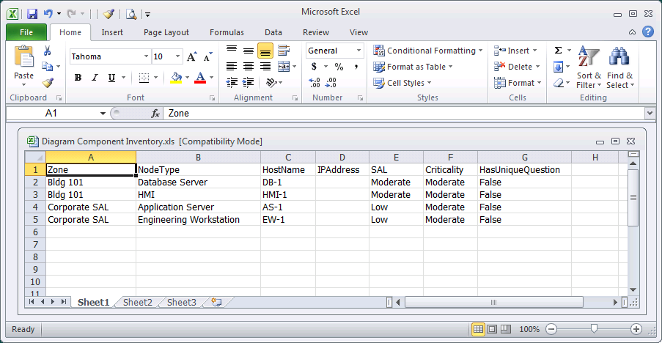

Figure 8-18. Inventory List.

The list is completely editable by the user. It is available for inclusion in the Security Plan report as well.

Home Menu Options⎯Settings

The settings group has a single function.

**Default SAL Level:** The default SAL is the setting assigned to new components added to the diagram. It is usually set at the Standards screen but if Cybersecurity Framework Based is selected as the assessment mode, the SAL level must be manually set here.

The default SAL level applied to a component is overridden by placing that component in a Zone.

Diagram Menu Options - Tools

The Diagram menu option has four sections; Tools, Edit, Zoom, and Show/Hide. Figure 8-19 highlights the available options under the Diagram tab.

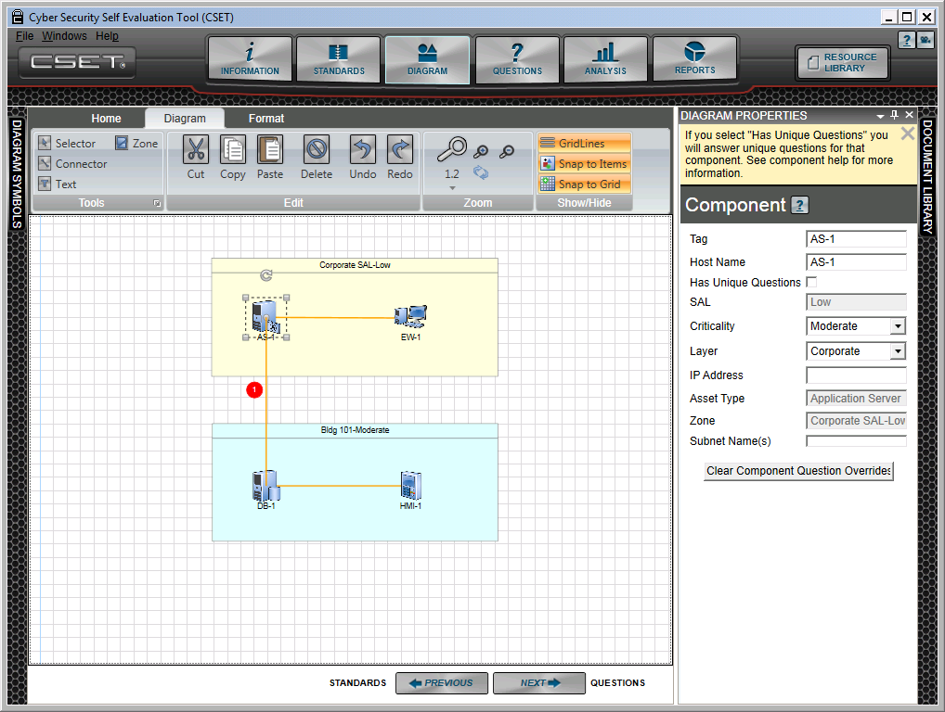

Figure 8-19. Diagram Menu Options.

The first option is labeled Tools. It includes the Selector, Connector, Text, and Zone tools.

**Selector:** This is the default tool. It is the standard mouse pointer for clicking buttons, dragging components onto the diagram, and selecting objects on the drawing area. It will also turn off any selected drawing functions like adding text boxes. For components with grey connector dots within the icon, the selector tool may also be used to create connector lines.

**Connector:** Click this tool to draw connecting lines or links. To do so, click the connector tool then click the component to be connected. Look for a small dot near the center of the component. Click that as the starting point of the link. Drag the link line to the next component which will display a red dot near its center. Click that to end the link. If the link lines are not anchored correctly to these dots, they will not move with the components.

To start a new link, it is often best to click outside the immediate area so the tool does not try to move the link just made. When finished drawing links, click the Selector tool. To delete a link, click it with the Selector tool and hit the Delete key or the delete button under the Diagram > Edit options.

**Connector Shape:** To change the shape of a connecting line, click to select it. Add nodes where it needs to change direction. Do this by selecting the line with the Selector tool then holding down the control (Ctrl) key and clicking along the line where the nodes are needed. Release the Ctrl key, click on a node, and drag it to a new position. Drag the rest of the nodes until the line has the desired shape. The nodes will only be visible when the line is selected.

If arcs or wavy lines are desired, go to the Diagram Properties window and select Spline under Line Type. Return the Line Type to Polyline for straight lines. Polyline is the default. Figure 8-20 illustrates the difference. The left picture shows the green line as a Polyline. The right picture is the same line with Spline selected under Line Type. Notice the visible nodes when the line changes direction.

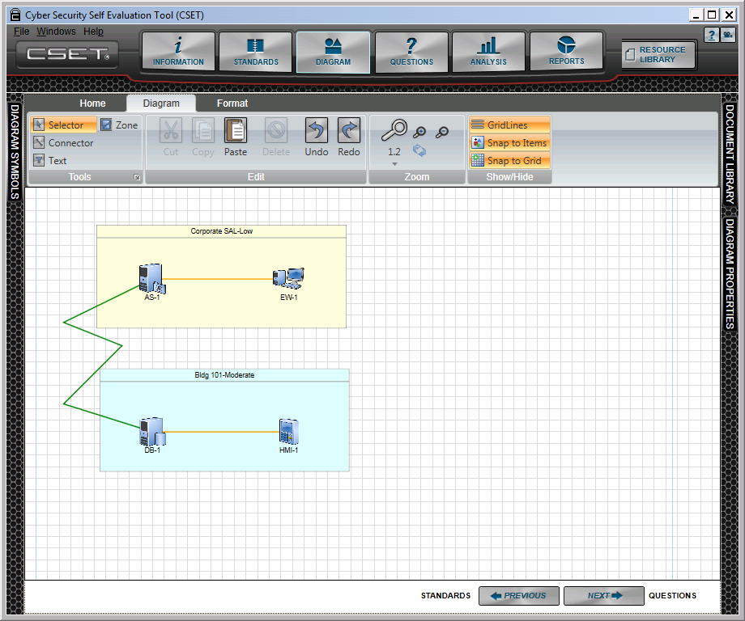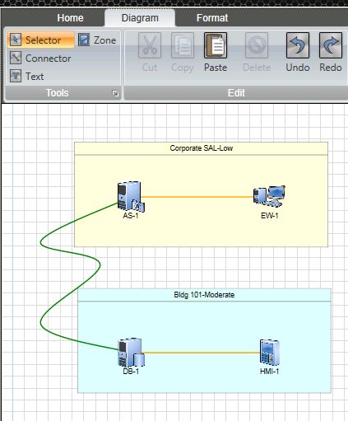

Figure 8-20. Line Types.

Each connector has a set of associated properties found in the Diagram Properties window. They are:

**Label:** The label is an optional field that is normally left blank; however, if you wish to associate a label with the line, then you would enter text into this field.

**Subnet Name:** The subnet name is an optional field that is intended for reference purposes only. It is not used in the analysis or reports in CSET. It can be valuable for accurately laying out your network and for design and planning purposes.

**Security:** This field is important for identifying trusted and untrusted lines. An untrusted line may be one where communications are carried, for example, over a public phone line. It could also include internal lines that may cross physical locations that have public access. This field is used in the network analysis.

When a line is marked as “Untrusted,” the system will change the line color to red. This color can be modified if you want to use a different combination of color and thickness.

**Layer:** This field allows the user to assign or modify the layer assignment. Similar to the layers associated with components, layers can also be assigned with lines that connect the components. Layers must be defined using the Manage Layers commands before they can be assigned to a line or component.

**Head Line Decorator:** This feature allows you to assign an end image, such as a circle, arrow, or diamond, to the head of the line. While this capability is not used often in developing a network diagram, it is available.

**Tail Line Decorator:** This field is similar to the Head Line Decorator with the exception of the end to which it applies. The same options are available with this field.

**Line Type:** Select PolyLine for straight angles. This is the default. Select Spline for wavy lines.

**Line Thickness:** Each line in the system can be altered to modify its thickness. Simply enter a number in the field to change its thickness. The Default is 1.

**Color:** As the name implies, this field allows the color of the line to be changed. CSET provides color themes, standard colors, and a form that allows you to create any color. This does not allow gradients, transparencies, or anything other than a solid color.

**Text:** Clicking the text tool allows you to create free-form text anywhere on the diagram. After clicking the button, click in the drawing area where you want the text box to be located. With the mouse button held down, drag the pointer to form a box. Release the mouse button and type the desired text. Double-click the text to edit it. Formatting the text is done using options found under the Format tab, which is discussed later.

Selecting the text box opens the Diagram Properties docking window. The fields related to the text string are:

**Label:** This is the actual text string itself. The text can be changed either in this field or by clicking on the text object itself.

**Layer:** This is the layer associated with the text object. Within the CSET diagram, you can create as many layers as you wish. In this field, you can change the layer assignment. You must set up the layers using the “Manage Layers” function found under the Tools menu.

**Zone:** This icon places a blank zone box onto the drawing area. Click the tool icon then click in the drawing area where the box should begin. Drag the mouse to draw the box. This icon is a repeat of the one found in the Zone pane of the Diagram Symbols docking window. It was copied into the top ribbon for convenience. See the section above titled “Adding a Zone” for more information.

Diagram Menu Options⎯Edit

The next option is labeled Edit. Under the Edit section of the Diagram menu options are six buttons. Most will become active when an object is selected. Each is described below.

**Cut:** Most of these options work as you would expect, based on using Microsoft Windows applications, and the Cut button is no exception. This function allows you to select an object, such as a line or component, and then click on the Cut button to remove the object from the diagram. The Cut option is slightly different than the Delete button in that the cut method will hold a copy of the object for pasting whereas the Delete option will simply remove the object.

**Copy:** The copy button allows you to select an object from the diagram and then have it available to paste. The Paste icon is no longer grayed out when the object has been copied.

Multiple objects can be copied at one time using the block selection function. See the topic titled Selecting Multiple Icons for more information.

When you copy and paste a component, the name will remain the same, as will all the other properties. A copied component or set of components is created slightly offset from the original. Remember to change the name to something unique after you have created it.

You can use the familiar Ctrl-C combination to copy a selected object. You cannot copy objects from CSET and paste them into other applications. Attempting to do so will produce useless metadata in the new application if it pastes anything at all.

**Paste:** Paste is a familiar action for most computer users and will make a copy of the selected objects that have been cut or copied. When they are created, they will be in a selected state and slightly offset from the original. While in this state, they can be moved to a new location on the diagram. You can use the Ctrl-V combination to paste the objects that have been cut or copied.

You cannot place non-CSET objects onto the diagram using the Paste command. For example, you may want to place a logo on the diagram or even a text string, but the tool will only allow objects that are native to CSET to be inserted into the diagram. It will not use the contents of the Windows Clipboard.

**Delete:** Like the other edit commands, the Delete command is familiar and behaves much like the Cut command. The difference is that it does not perform an associated copy. The Delete key from the keyboard will also remove the selected object or text string.

**Undo:** This key will reverse a previous change such as the movement of an object or a deletion. This function does not undo every action that was issued, but it does cover most of the commands.

**Redo:** The Redo button will reverse most of the Undo changes. The combination of Undo and Redo involve buffering up a set of actions. The Undo reverses the buffered change, and the Redo reissues the command. Both Undo and Redo have limitations in terms of the number and types of actions performed.

Diagram Menu Options⎯Zoom

**Zoom:** The zoom functionality is captured in several buttons. The zoom factor, indicated by the large magnifying glass, is incremented through a range of selected values. The default is the smallest factor of 1.2.

To actually perform the zoom, you click on the magnifying glass icons with either the plus or minus symbols. The tool will expand or shrink the display to match the zoom factor and whether it was a zoom in or out. The mouse wheel may also be used for zooming in or out. While the larger zoom factors can be used for dramatic changes in size, the most common action entails a quick zoom in and out using the default factor. Be aware that once the display reaches the minimum display resolution, it will no longer get smaller, regardless of the factor.

The reset button returns the display to the original size.

Diagram Menu Options⎯Show/Hide

The Show/Hide grouping allows you to display or hide several diagram options like the gridlines. All three buttons are toggle type meaning they click on and click off.

**Gridlines:** To show Gridlines, you need only click on the respective button. When the option has been enabled, the icon will display an orange background and gridlines will appear in the drawing area.

**Snap to Items:** Figure 8-21 illustrates the Snap to Items option. The red guidelines appear when adding or moving an object to help align it with surrounding items.

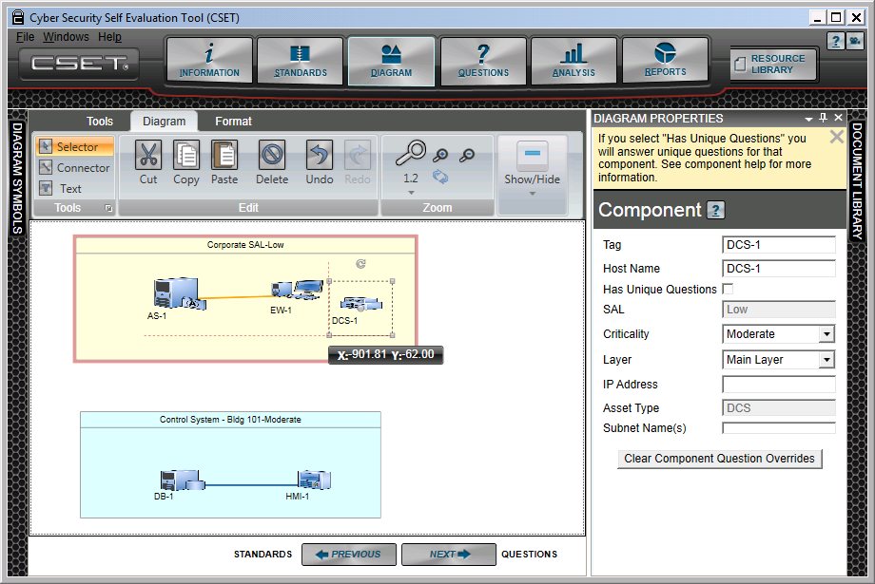

Figure 8-21. Snap to Items.

**Snap to Grid:** Snap to Grid is similar, but instead of aligning to surrounding items, snap to grid focuses on the gridlines and is more forceful in controlling the placement or resizing of items.

Format Menu Options⎯Label Styles

Two groups of commands are under the Format menu option in the Diagram screen as seen in Figure 8-22. Both groups are used to modify the format or layout of the diagram objects and text.

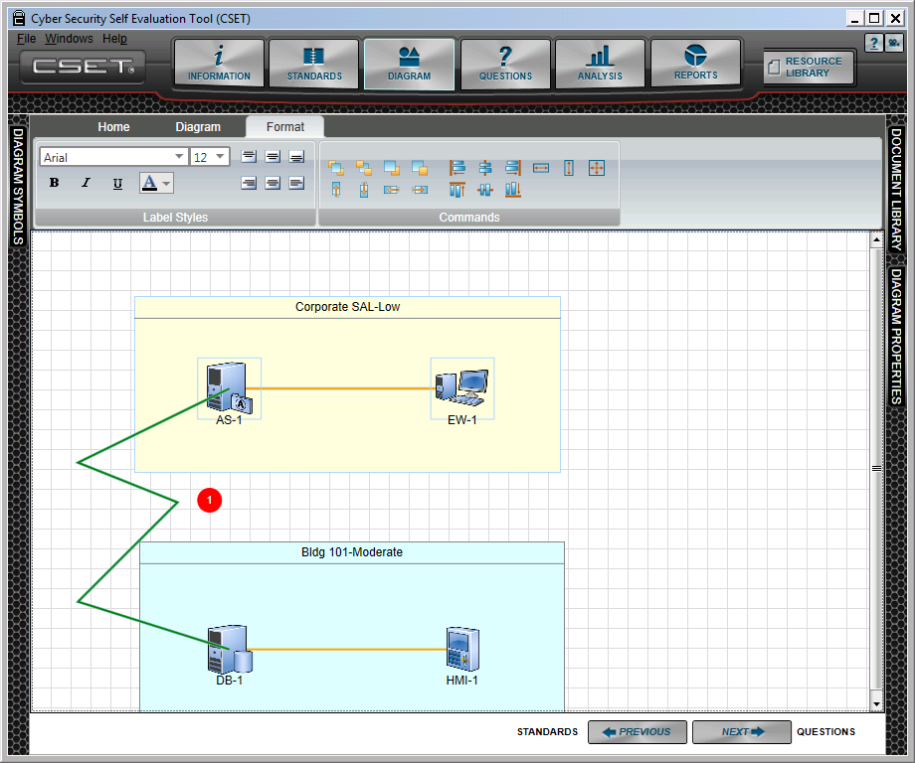

Figure 8-22. Format Menu Options.

The first group is Label Styles. After selecting a label, object, or text block by double-clicking, the font type and font size may be changed. Click outside the text block to exit edit mode and see the changes. Bold, italics, and underline may also be applied and the font color may be changed.

The six buttons at the right side of the group are for text alignment. To change the placement of component text, click the component to select it then click the desired alignment button. The label text will move to the chosen alignment within the component icon area. To change the text alignment on several icons at once, drag a selection box around them or click each while holding the Control (Ctrl) key then click the desired alignment button.

Format Menu Options⎯Commands

The second grouping of commands under the Format menu option is titled Commands and includes several command types. Figure 8-23 highlights each of the group types.

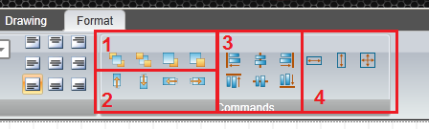

Figure 8-23. Format Menu Commands.

These commands are often used on groups of items. When selecting items to be changed, you may drag a selection box around them. However, this may lead to unwanted items, such as a zone, to be included in the selection. For more control, it is recommended that each item be selected individually by holding down the Ctrl key and clicking each item separately.

Each type of command group will be described below.

**Forward and Backward Placement:** In the red block marked as “1,” there are four buttons that allow you to move an object to the front or to the back of another. This is most often used with shapes, but could also apply to lines or components. Zones are usually placed in the back for example, but can be brought forward.

From left to right, the buttons will first bring the select object to the front of all other objects; second, send the selected object behind all other objects, (typically done for a zone); third, bring the selected object forward in front of any object that is one position in front of it; and fourth, send the select object one position behind a related object.

The relative positioning commands that move objects to the front or back are more straightforward in how they work. The commands that move an object forward or backward are based on the relative position of one object to another and are not always as easily seen.

In Figure 8-24, a set of objects have been placed on the screen in the order that they are labeled. All the objects are placed on top of each other, in order, except for the zone which by default is sent to the back.

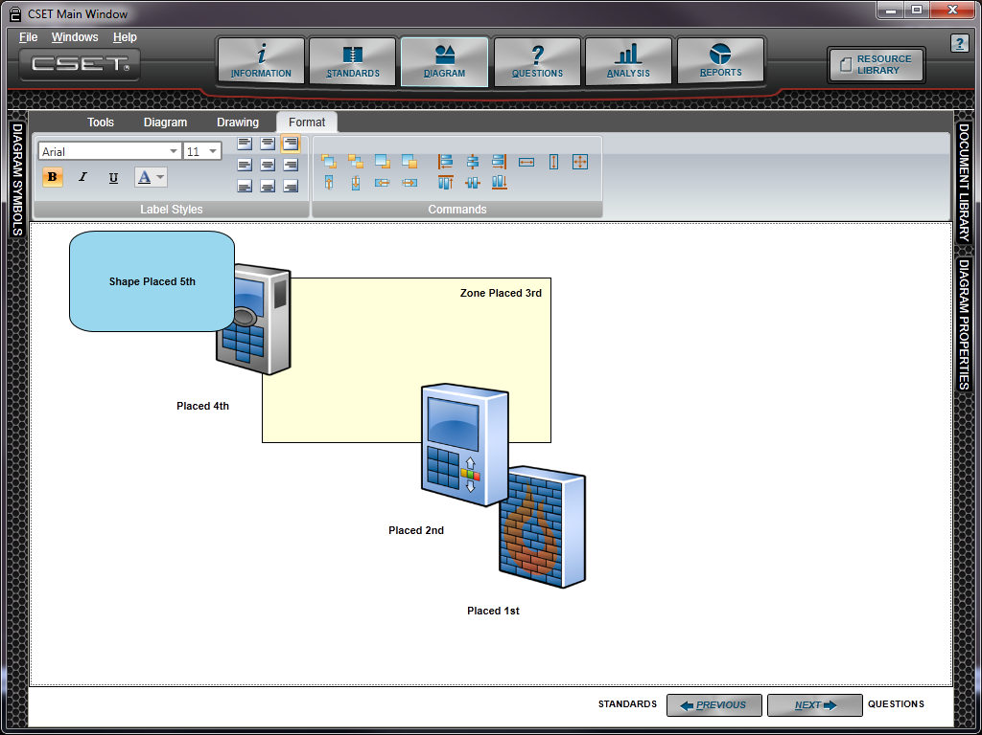

Figure 8-24. Objects Placed in Order.

In the Figure 8-25, the objects have been moved as follows:

* The firewall, placed first, has been moved forward.
* The zone, placed third, has been moved to the front.
* The blue shape, placed fifth, has been enlarged and then moved to the back.

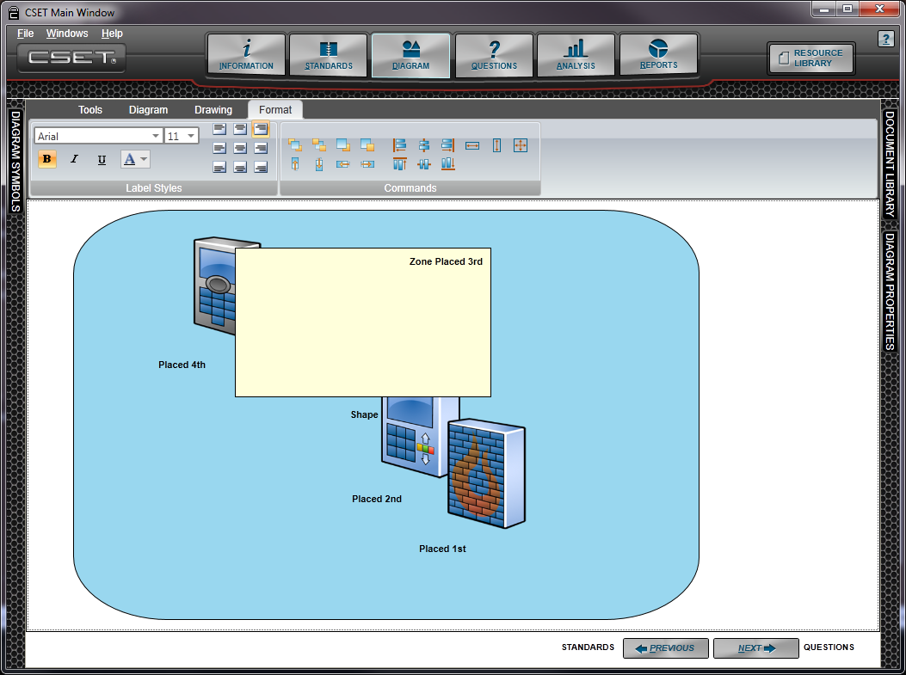

Figure 8-25. Objects after Positioning.

**Nudging or Slight Object Movement:** The second set of commands that are labeled as “2” allow you to move selected objects a small distance. The buttons will do the following in the order shown:

* Nudge or move the object slightly upward.
* Move the object slightly downward.
* Move the object slightly to the left.
* Move the object slightly to the right.

This provides a consistent movement that is not related to how the pointer is controlled by the mouse or trackball.

**Aligning Objects Relative to Each Other:** The set of buttons found in the block labeled as “3” will allow you to align objects relative to a single selected object. To use this functionality, you would first select an anchor object and then select other objects that you want to align with the anchor. After the objects have been selected, you then click on one of the buttons. The objects are moved to the respective position, based on which button you clicked.

Figure 8-26 shows the before image of objects that have been placed on the diagram.

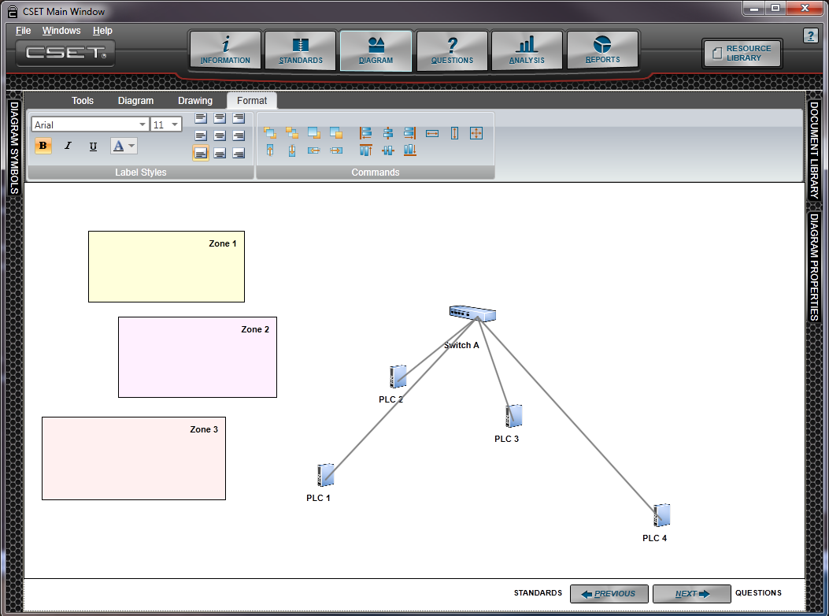

Figure 8-26. Before Object Alignment.

In Figure 8-27, the three zones are left aligned with Zone 1. To do this, first select Zone 1 (as the anchor) and then select Zone 2 and Zone 3. When all the objects are selected, click on the Align Left button.

To align the PLCs along the bottom, first select PLC 1 and then select the remaining PLCs. When all the components have been selected, click on the Align Bottom button, and the PLCs will align as shown.

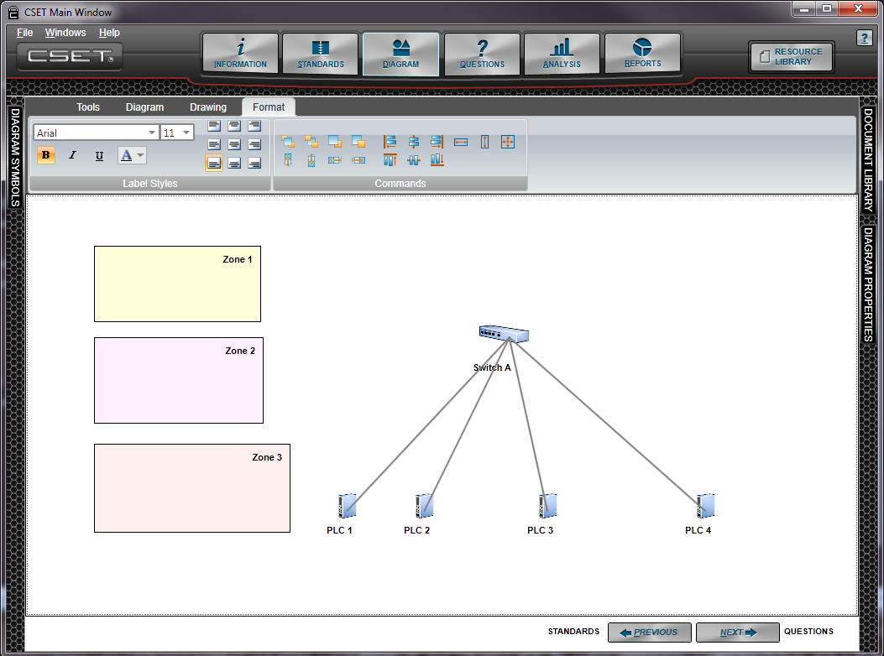

Figure 8-27. After Object Alignment.

Each of the icons will align the selected objects to the left, right, center, top, middle, and bottom, depending on the button clicked. Each icon identifies what the alignment will be.

**Match Height, Width, and Size:** The last group of buttons is used to match size of an object according to height, width, or both. The process is the same as with the other buttons in this grouping. First, you will need to select the anchor object and then select all other objects that are going to be used to match it.

Figure 8-28 shows an image before the function has been used.

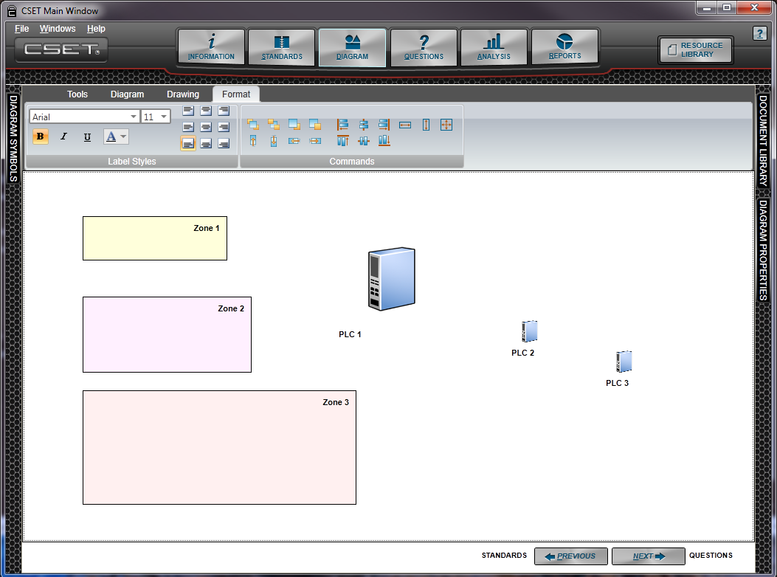

Figure 8-28. Before Size Changes.

A set of zones of different sizes and a set of PLCs also of different sizes are shown.

In Figure 8-29, the following changes have been made:

* Zone 1 was selected as the anchor object and Zone 2 was selected to be acted upon.
* With Zones 1 and 2 selected, the “Same Size” button was clicked, resulting in the layout as shown.
* PLC 1 was then selected as the anchor object, and PLCs 2 and 3 were selected as the objects to be changed.
* With the PLCs selected, the “Same Size” button was clicked, resulting in the layout for the three PLCs shown.
* Zone 1 was again selected as the anchor object, and Zone 3 was selected.
* With Zones 1 and 3 selected, the “Same Height” button was clicked, and Zone 3 maintained the original width, but had the height changed to match the height of Zone 1.

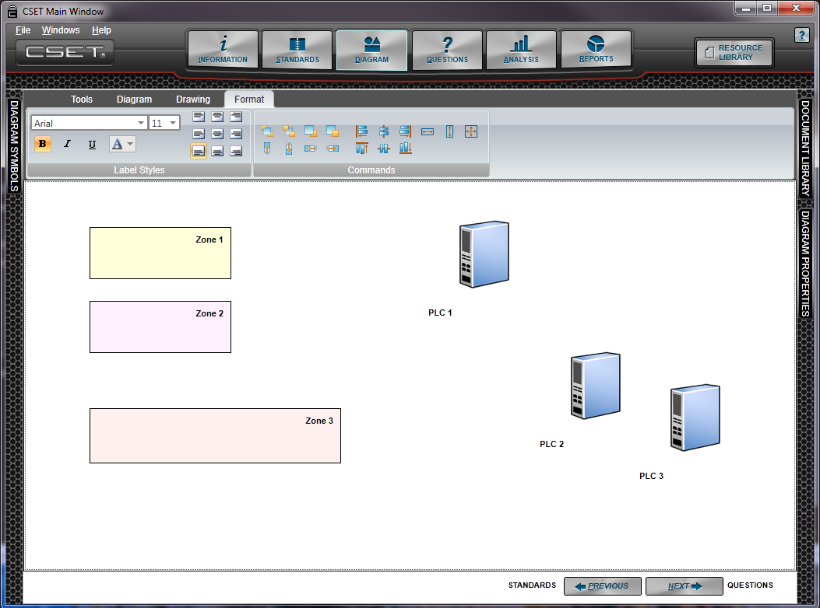

Figure 8-29. Sizing Changed Results.

You can see the changes that have been made to the objects as compared with the original sizing.

The diagram functionality provides a way to capture the major components and connections in your business or control systems. The components in the diagram will cause the system to create a set of questions for cybersecurity evaluation.

Integration with Microsoft Visio

When CSET is installed, a Microsoft Visio add-on application is also installed. It allows importing and exporting of the CSET drawing type into Visio and provides a drawing template and stencil of component shapes recognized by CSET. With the add-on, Visio can be used to create and modify the network diagram to be used in CSET.

The add-on works with either Visio 2007 or Visio 2010. Other versions of Visio, including Visio 2013, are not supported.

The CSET add-on for Visio can recognize either an assessment file type (**.cset**) or a diagram file type (**.csetd**) as created within CSET. Diagrams created by other drawing programs will not be compatible.

Standard click and drag functionality as used for other Visio diagramming will be used for the CSET diagram within Visio. When complete, the diagram must be exported back into CSET in order for the component question set to be generated and the network architecture deficiency analysis to be made.

In Visio, it is helpful to know where to find the templates and add-ons.

For Visio 2010

To open the CSET drawing template, use File > New > New from Existing and navigate to My Documents\My Shapes and select CSETTemplate 50.vst, then click on Create New. Enable macros if prompted. This will open a blank drawing and the CSET shape stencil.

To open just the CSET shape stencil, go to More shapes > My Shapes, and select CSET if a drawing is open. Use the File > Open function if no drawing is open.

To run the CSET add-ons, go to View > Add-Ons, then select either Export CSET or Import CSET (see Figure 8-30). The Run Add-On option may also be used.

Layers are in the Home ribbon.

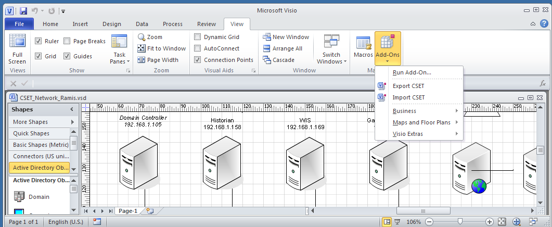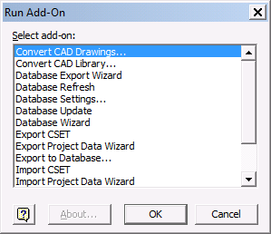

Figure 8-30. Example Add-On Menu.

For Visio 2007

To open the CSET drawing template, go to File > New > New Drawing from Template and navigate to My Documents\My Shapes and select CSETTemplate 50.vst, then click on Create New. Enable macros if prompted. This will open a blank drawing and the CSET shape stencil.

To open just the CSET shape stencil, go to File > Shapes > My Shapes, and select CSET.

To run the CSET add-ons, go to Tools > Add-Ons, then select either Export CSET or Import CSET. The Run Add-On option may also be used.

Layers are in the Format menu.

Instructions

To start a new diagram or to modify an existing Visio diagram, open the CSET template in Visio. Use the CSET stencil shapes to create a representation of the control system to be assessed. When finished, use the Export CSET Add-On to prepare the diagram for use in CSET.

To modify an existing CSET diagram, use the Import CSET Add-On from within Visio to transform the diagram into a Visio file type. The Import function can accept either an assessment file or a CSET diagram file. Open the CSET shape stencil, and use it to make the needed modifications. When finished, use the Export CSET Add-On to prepare the diagram for use in CSET.

It is recommended that you always use the network shapes provided in the CSET shape stencil. Do not use the shapes that come with Visio, because they may not be recognized by CSET, so no network analysis or question sets can be generated. However, during export, a reconcile screen (Figure 8-31) will be provided from within Visio to assign valid CSET shape types to the unrecognized Visio shapes. Unrecognized shapes are listed as unknown. Table 8-1 lists the valid CSET component types with a brief description of each. If the unknown Visio shape is something not normally associated with control systems (i.e., beepers), it may be left as unknown, because no compliance questions exist for it and it will not be included in the CSET network analysis.

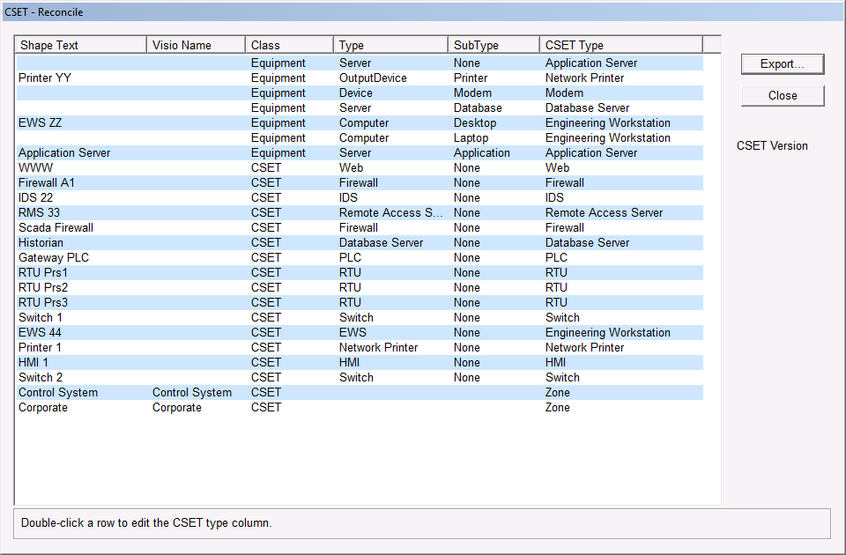

Figure 8-31. Example Reconcile Screen from Export CSET.

Table 8-2. Valid CSET Component Types.

| CSET Type | Brief Description |
| --- | --- |
| Application Server | A computer used to control distribution of a computer application to one or more users |
| Clock | A timing device coordinated for accuracy to a GPS, CDMA, or time server used by the control system |
| Connector | A logical (not physical) node that allows network lines to be shown as connected |
| Database Server | Server managing relational database table data, most commonly for a historian |
| DCS - Distributed Control System | System used to remotely monitor and control distributed equipment |
| EWS - Engineering Workstation | Computer that the process control engineer uses for technical support of control systems |
| Firewall | Hardware and/or software used to prevent communications not authorized by the security policy |
| Front End Processor | Device to handle communications to peripherals on behalf of the main processor |
| Handheld Wireless | A wireless device in a hand-held form factor. |
| HMI – Human‑Machine Interface | A display that shows control system status/alarms, usually generated by an application server |
| Hub | A device to connect separate lines of a network together |
| IDS Intrusion Detection System | System that detects unauthorized or malicious access to a computer system or network |
| IED Intelligent Electronic Device | Microprocessor-based controller of power system equipment. |
| IPS Intrusion Protection System | System that detects and filters unauthorized or malicious access to a network |
| Link | Enables connections between devices and captures subnet, security, and layer information. |
| Link Encryption | A device providing bulk encrypting of all traffic passed via a link |
| Modem | A device that modulates/demodulates an analog signal to encode digital information for transmission over a PSTN |
| MTU - Master Terminal Unit | A device that collects and disperses data between a SCADA system and Remote Terminal Units (RTU) |
| Network Printer | Printer that is connected directly to the network |
| Optical Ring System (Sonet Device) | A device providing access to the Sonet Ring |
| Partner | Represents a connection to a company partner |
| PLC-Programmable Logic Controller | Small programmable device for managing and collecting data from end devices |
| Remote Access Server | Server managing remote access to intranet components |
| Router | A computer networking device that forwards data packets to their destinations between disparate networks |
| RTU - Remote Terminal Unit | A device that interfaces objects to a DCS or SCADA system by transmitting telemetry data |
| Safety Instrumented System | An engineered set of hardware and software control especially used on critical process systems. The combination is treated as a single component |
| Serial Radio | A device providing modem functionality for use over wireless links |
| Serial Switch | A device providing automatic or manual switching between serial devices |
| Switch | A network device that connects computer devices in a network (sometimes referred to as a Managed Switch) |
| Terminal Server | A device providing protocol encapsulation of serial data via a network |
| Unidirectional Device | Allows data to travel only in one direction (i.e., corporate network to control system network) |
| Unknown | Icon to represent a component type not already available in the CSET shape list |
| Vendor | Represents a connection to an external vendor |
| VLAN Router | A networking device that forwards data packets between standard or virtual subnets |
| VLAN Switch | A network device that connects computer devices in a network, handling multiple subnets |
| VPN - Virtual Private Network | A software tunnel used for secure communications over a public network |
| Web | A symbol to represent the part of the network that is accessible to the public |
| Web Server | Server used to store and manage access to Web pages and applications |
| Wireless Network | Communication device that exchanges data with other wireless components using radio signals |
| Zone | Allows the user to assign different Security Assurance Levels (SALs) to components. |

Drawing Standards

For CSET to recognize and analyze a network diagram made in Visio, certain standards must be met. These include the following elements.

The shapes and symbols used to represent components must be recognizable to CSET so that appropriate question sets can be generated. Use the shapes on the CSET shape stencil to ensure this. Visio network shapes may be used if they are properly identified during reconciliation.

It does not matter if Visio shapes are in metric or US units.

Lines representing component connections must be attached to the shapes rather than just visually near them so the network vulnerabilities can be assessed. Lines must end at a shape; a connector (dot) shape is acceptable. Use the Link.cset shape to represent connectors between components. Doing so allows the user to enter a subnet address and security level (trusted vs. untrusted). Lines are properly attached when they move with the shapes. The Visio connector tool or connector lines from the Visio Connectors stencil may also be used if care is taken to connect to each shape. Subnet and security data would then have to be entered in CSET.

Labels and descriptive text must be part of each shape and not just near it so that CSET can maintain the relationship. When a CSET shape is added to a drawing, a pop-up box (Figure 8-32) allows the user to enter information such as host name, tag, criticality, and IP Address. For non-CSET shapes, that data must be entered in CSET.

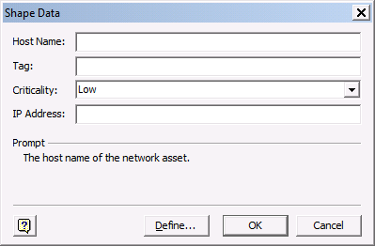

Figure 8-32. Example Shape Data Screen.

The shape data box contains a button labeled Define. This should not be used. The defined strings are needed for CSET to recognize the shapes.

Once the component has been placed in the diagram, you can access the shape data by selecting the component and opening the shape data window located along the right side of the drawing window.

The CSET shape stencil includes a zone shape. A pop-up box provides an opportunity to change the zone defaults. Other Visio shapes may be used to represent zones but must be identified as zones during reconciliation. The zone type will default to Corporate with a SAL of Low. The tag will match the type. These can be changed in CSET after the diagram is opened.

Layers are assigned using the Visio Layer option.

If Visio shapes are used, double-click the shape to enter shape text if a label is needed. Annotations are not recommended. Use the Shape Data window to enter additional information whenever possible. It is available under the View tab in Visio 2007 and under the Data tab in Visio 2010.

The more these standards are met, the less revision will be needed within CSET.

As summarized above, the user may use a diagram created earlier in Visio, may create a new diagram from scratch, may start from a CSET network template, or may import a diagram made earlier in CSET. The following sections provide greater detail on the various diagramming options.

If problems are encountered, see the Troubleshooting section below.

Using an Existing Visio Diagram

* Open Visio. Open the desired Visio diagram. Open the CSET shape stencil.
* Review the diagram carefully.
* Ensure that the drawing standards listed above are met.
* Look for unneeded rectangles, such as those for text boxes, which could be misinterpreted by CSET.
* Check layer assignments.

Use the shapes on the CSET shape stencil to modify the diagram. When modifications are complete, run the Export CSET add-on to start the reconciliation process. Common network shapes will automatically convert into CSET shapes. Generic or unusual shapes will be assigned a CSET Type of unknown. Double click the row with the unknown CSET Type. Use the drop‑down to select the CSET component type that most closely matches the unknown shape. If left as unknown, no compliance questions will be generated for the shape, and no network deficiencies will be analyzed. However, Visio shapes not normally associated with control systems, such as cell phones and cameras, may be left as unknown because no compliance questions exist for them.

If multiple copies exist of the same shape, it could be difficult to determine which shape in the diagram is represented by which Visio Name. One way to solve this problem is to name the shape in the diagram by double-clicking it and entering shape text. Another way is to open the Shape Data window. The Visio name of the selected shape will be displayed in the title bar of the pane (Figure 8-33). The window size may need to be expanded to see it. If not already visible along the right side of the drawing area, select it under the Task Panes option in Visio.

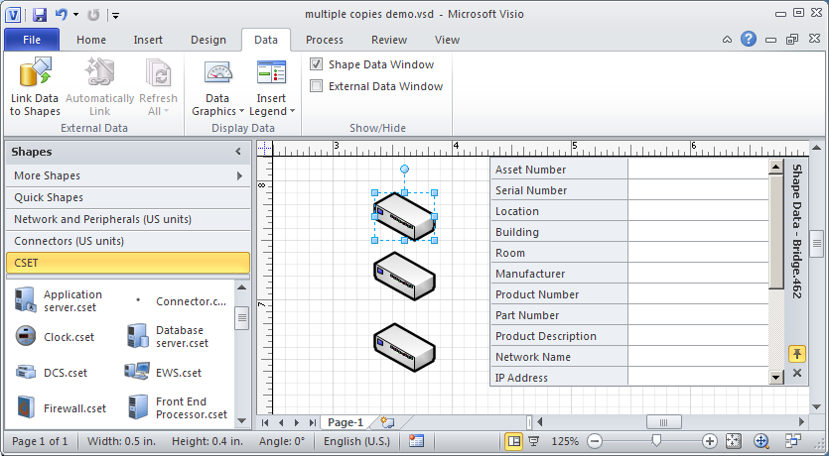

Figure 8-33. Example of Identifying Shapes.

When reconciliation is complete, click Export. Name and save the file. Close the CSET Reconcile screen. It is good practice to save the Visio file, although the Visio file type is not needed by CSET.

Building a Component Diagram from Scratch

Open Visio. Open the CSET template. Use the shapes on the CSET stencil for building the component diagram. Follow the drawing standards above.

Arrange the components and lines to form an accurate system representation. When complete, run the Export CSET add-on function, which opens the CSET Reconcile screen. To identify an unknown shape, double-click that row and use the drop-down box to select a valid CSET shape. When reconciliation is complete, click Export to name and save the file. Close the CSET Reconcile screen. It is good practice to save the Visio file, although the Visio file type is not needed by CSET.

Using a CSET Template

Open an assessment in CSET. Import the desired template as the component diagram. Use the CSET export function to save the template as a **.csetd** file. Alternately, the assessment may be saved and imported into Visio.

Open Visio. Run the Import CSET add-on. Import either the assessment file (**.cset**) or the diagram file (**.csetd**). Open the CSET Shape Stencil. Use the shapes on the CSET stencil to modify the diagram as needed. Follow the drawing standards above.

When revisions are complete, run the Export CSET add-on to open the CSET Reconcile screen. To identify an unknown shape, double-click that row, and use the drop-down box to select a valid CSET shape. When reconciliation is complete, click Export to name and save the file. Close the CSET Reconcile screen. It is good practice to save the Visio file, although the Visio file type is not needed by CSET.

Importing an Existing CSET Diagram

**Note**: If component questions were answered in CSET, the answers will be lost when the diagram is replaced by the one revised in Visio. To keep the existing answers, do not use Visio. Use CSET to modify the diagram instead.

Open Visio. Run the Import CSET add-on. Import either the assessment file (**.cset**) or the diagram file (**.csetd**). Open the CSET Shape Stencil. Use the shapes on the CSET stencil to modify the diagram as needed. Follow the drawing standards above.

When revisions are complete, run the Export CSET add-on. Use the CSET Reconcile screen to categorize unknown shapes into recognized ones. Double-click the row with the unknown shape and use the drop-down to select the recognized shape. When reconciliation is complete or if no unknown shapes are present, click Export to name and save the file. Close the CSET Reconcile screen. It is good practice to save the Visio file, although the Visio file type is not needed by CSET.

Viewing the Diagram in CSET

Open CSET. Open an existing assessment or start a new one.

Click on the Diagram button from the CSET Window. You can either click the “Clear Diagram” button and then click the Import option or just click Import Diagram because it will first clear what is present anyway.

**Note**: If component questions have already been answered for the existing diagram in CSET, the answers will be lost when the diagram is replaced by the one modified in Visio.

Click Import and navigate to the saved diagram to open it in CSET.

Review the diagram carefully. Text and lines not correctly linked to a shape may be placed too far from the shape to be effective. Connector line routing may have changed. Unknown shapes will be represented by a question mark. Poorly identified shapes will be shown as an icon only.

Troubleshooting

Three files are needed to import and export diagrams to Visio. If Visio was not installed on the PC prior to installing CSET, some files may have been installed to temporary locations. If the add-ons are not seen in Visio, check that the files were installed to the correct locations. If not, try uninstalling CSET then reinstalling it. Or, copy the files from the CSET installation media, and paste them as noted below.

* CSET 50.vss and CSETTemplate 50.vst should be installed into the My Shapes folder under My Documents.
* CSETVisio5.vsl should be in the Program Files (x86)\DHS\CSET x\visio folder for 64-bit systems. For 32‑bit systems, the CSET.x folder may be in the Program Files directory. Replace the “x” with the current version number of CSET.
* Ensure that the Add-Ons and Start-up file locations within Visio are set to the location of the CSETvisio5_x64 or _x86 file. Visio will automatically select which file to use based on your operating system.
* In Visio 2010, go to File > Option > Advanced > File Locations. Set the Add-Ons file location and the Start-up location to C:\Program Files (x86)\DHS\CSET x\visio. Replace the “x” with the current version number of CSET. Or navigate to the folder where CSET was installed, and select the Visio subfolder.
* For Visio 2007, go to Tools > Options > Advanced > File Paths to set the locations.

**Note:** Use caution if changing the Start-up file location. Visio will try to run every executable in the designated folder. If set to C:\, for example, Visio will open every program on the hard drive.

If the needed files are in the correct locations, but the Visio interface will not function correctly, the registry file may have been corrupted. To repair, run the Setup Visio Plugin. It is available from the Help menu item at the top left of the CSET window. Or go to the Start > All Programs menu as shown in Figure 8-34 to run the plugin. Close Visio before running the plugin.

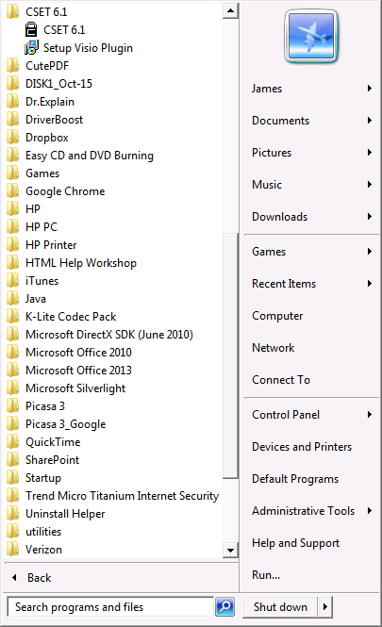

Figure 8-34. Setup Visio Plugin

Successful completion of the plugin will be shown in a pop-up as seen in Figure 8-35. Click OK to close the pop-up.

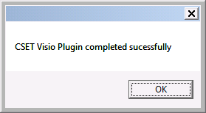

Figure 8-35. Plugin Complete.

9) answering Questions



9

The primary interaction that takes place in CSET happens in the Questions screen. Based on the assessment mode selected, (Questions Based, Standard Requirements Based, or Cybersecurity Framework Based), the actual standards chosen, the security assurance level (SAL), and the components used in the diagram, the tool will display a set of questions (or requirements) for you to read and answer.

Figure 9-1 shows an example of the Questions screen with Universal Questions displayed and answered under a specific topic area, in this case “Personnel.”

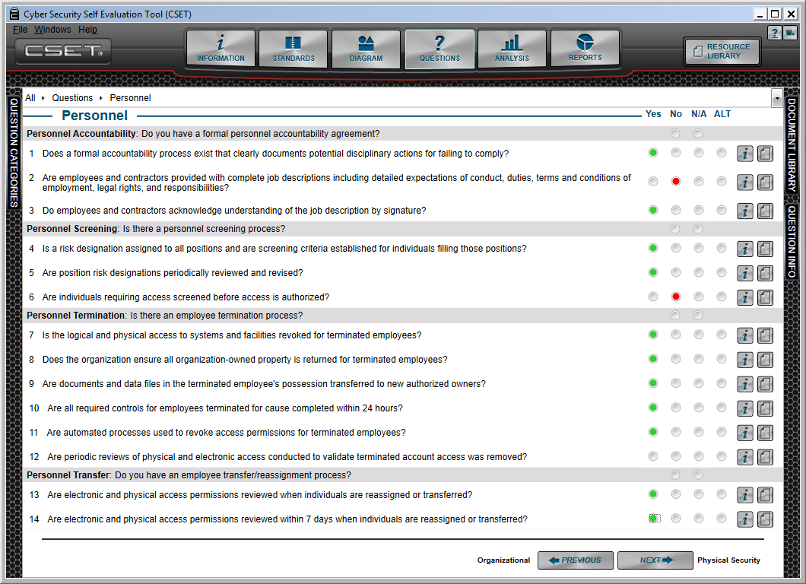

Figure 9-1. Questions Screen.

Each of the different elements in the Questions screen will be discussed in the sections that follow.

Question and Answer Main Area

The application was designed so that each question category would include all the questions related to that category on a single screen. Some categories require scrolling but many will fit within the screen space if the docking windows are collapsed.

Figure 9-2 shows the main sections of the Questions screen.



**1**

**2**

**3**

**4**

**5**

**6**

**7**

**8**

Figure 9-2. Full Questions Area.

1. **Breadcrumb Navigation:** This function serves two purposes. First, it shows you the category that you are working in, even after you have scrolled down on the screen. Second, it can be used for navigating the system. You can click on the arrow next to the label to open a list box that allows you to select a category and go directly to it. You can also click in the space to the right of the category name to collapse the control and type in the exact location. See Figure 9-3.
2. **Category or Section Title:** Each question set will contain a specific number of categories depending on the approach, standards, and SAL selected. For example, a list of categories is shown in the tree structure or in breadcrumbs navigation lists, mentioned above.

The category name is shown as the title of the section. In the example above, “Personnel” is the title for all the questions listed below it.

1. **Answer Types:** The answers for Questions Based and Cybersecurity Framework Based assessments will be Yes, No, N/A, and Alt. If the Requirements Based approach is selected, the titles will be Met and Unmet instead of Yes or No. The process is simple. Read the question in detail and then answer yes if you are meeting the question language and intent, or no if you are not. This is even more specific if you are reading a requirement and are marking it as met or unmet. The radio button colors reflect the answer given. The colors provide a quick visual of how you are doing in each category.

The N/A label means “not applicable” and is used when the question does not apply to the system or facility. It should be used with discretion and has the effect of removing the question from consideration. Any questions marked as N/A will not show up in the online analysis or reports as a gap or missed answer; nor will it count as a positive answer.

The Alt label stands for alternate and is used when an alternate method is being used to address the concern in the question. For example, a question may be asked about whether the servers are located behind locked doors with certain access restrictions. The facility may not have locked doors, but instead, employ a security guard at the door to the server room. This different (security guard) approach does not directly answer the question, but the user may feel like this alternate approach to securing the room is either equal to or better than locks on the doors. An alternate method is scored in a positive way, just as a yes answer is.

If an alternate method is selected, then the user should fill in the description in the Question Detail window in the text box under the label “Alternate Description/Justification.” The questions detail is opened when the paper icon (labeled Item 6) is clicked.

Each question falls under a heading topic in the questions-based approach. Item Number 7 shows an example of a heading. The heading will have a gray background and will only have the No and N/A radio buttons available. When you click on either radio button it will propagate the answer to all the questions underneath the heading. You can always change the answers directly if you wish. This approach saves time when a topic is clearly not being implemented or is not applicable to the facility. For example, if the topic is on wireless devices and wireless has not been implemented in system then clicking the N/A will allow you to bypass the entire group of questions. Likewise, if you are not implementing encryption, you can bypass those questions and just click No to all of them.

1. **Question Numbers:** Each question is given a unique and ordered number within the category. This means that the numbering sequence will restart under each major heading.
2. **Information Button:** Clicking the information button will cause the tool to open the dockable screen with additional information regarding the question. The specific information displayed will be described in detail below.
3. **Comments Button:** When this button is clicked, the system will open a dockable window that will allow you to enter comments, alternate justifications, and descriptive text, add documents related to the question, and mark the question for later review. More detailed information about this window will be provided below.
4. **Question Heading Topic:** As mentioned in Item 3, each question is included under a heading. The heading begins with a label and is followed by either a statement or a question. If the text is a statement, then it is intended that the answers should be reviewed individually. If the text is phrased as a question, and most are, then the numbered questions underneath the heading can be grouped in such a way that a No or N/A answer can be applied to all the questions at once. Regardless of whether the heading is a question or statement, it is intended to give some context and clarity to the group of questions beneath it.
5. **Previous and Next Buttons:** The buttons shown on the bottom of each category group indicate the next category or topic and the previous one, as shown on the right and left of the actual buttons. Clicking on one of these buttons will cause the system to move forward or backward in the category list.

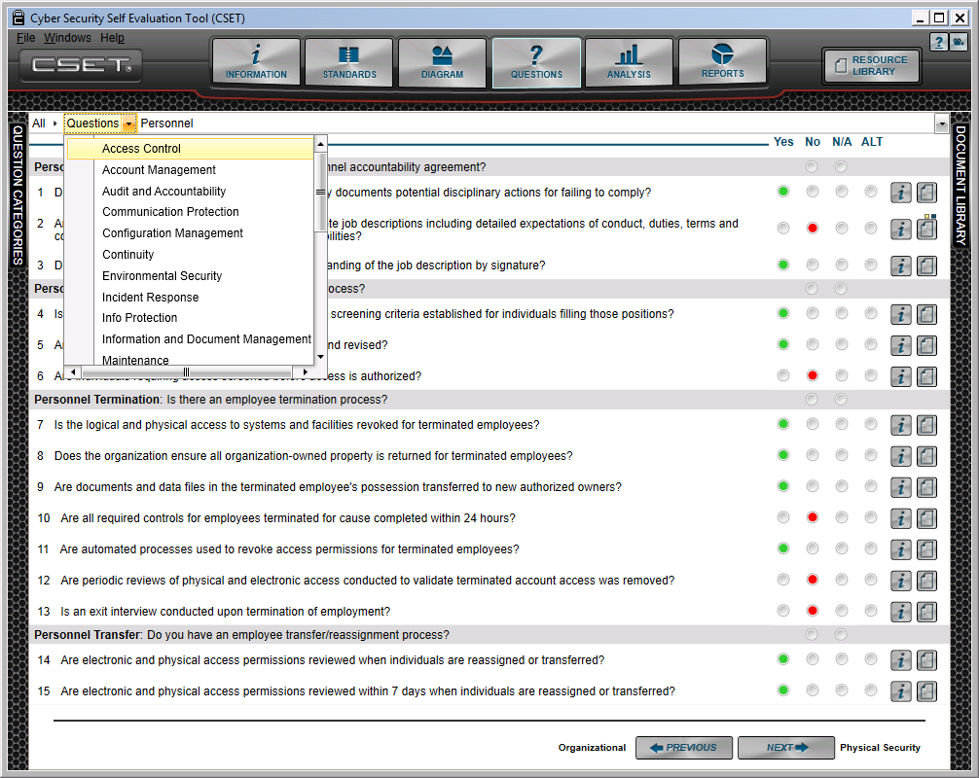

Figure 9-3. Breadcrumb Navigation

If Cybersecurity Framework Based was selected as the Assessment Mode, another icon will appear on the question screen as shown in Figure 9-4. It is the related question drop‑down. Clicking the arrow icon will open a list of questions related to the Framework requirement. The listed questions were taken from the NIST standard provided in the source document as an informative reference.

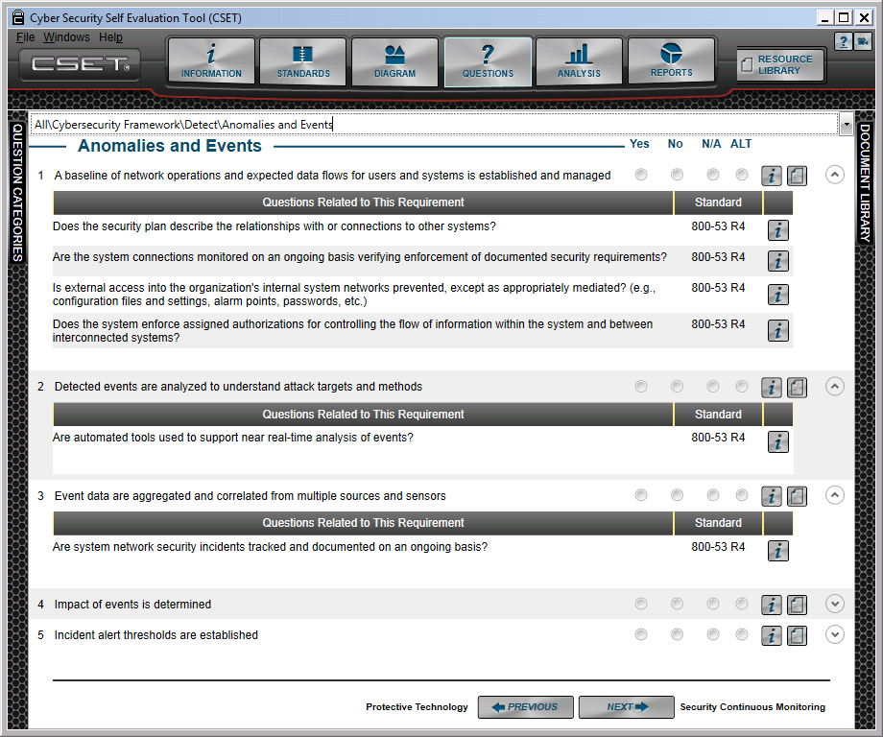

Figure 9-4. Related Question Drop-Down List

Question Information Window

Every question or requirement in CSET has associated information that is provided to help clarify the question or the requirement. The system also displays the underlying requirement, any supplemental text, and additional resources to help address the problem identified.

If the Requirements-based approach is selected, then any universal questions are displayed when the Question Information window is opened.

Figure 9-5 shows the Question Info window that is opened after the “i” icon has been clicked by the user. Each of the parts of the window will be explained below.

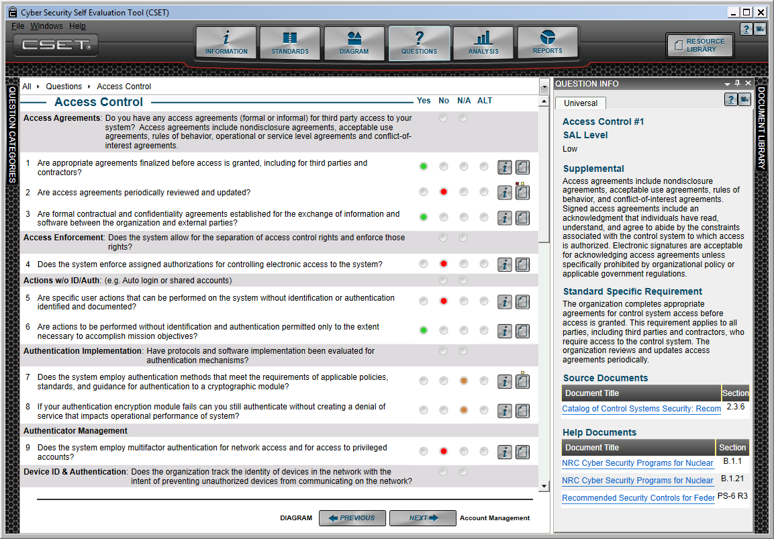

1

3

4

5

6

7

8

2

Figure 9-5. Question Info Window.

1. **Information Icon:** Every question or requirement in CSET has an associated “i” or information button. When this button is clicked, the system will automatically open the Question Info window.
2. **Standard Specific Reference Information:** At the top of the Question Info window, you will see tabs that correspond with selected standards if the question links to that standard. Not all questions will be connected to every standard, and so in some circumstances, there may be only a single tab. If multiple standards were selected, and they all had similar requirements, then a tab would be displayed for each standard selected.

In the example shown above, two standards are referenced, and the Universal option is selected. If you clicked on the tab for the NIST SP800-53 Rev. 3, Appendix I standard, then supplemental and Level Specific Requirement information would be shown that may be different from what you see here. There will always be a different source document, and there may be different help documents.

If you are using the Requirements-based approach, then there will be only one standard shown and instead you will see Universal Questions that are associated with the requirement.

1. **Question Number Reference:** At the top of the window is a label that corresponds with the question number in that section. In the example shown, the question referenced is Number 4 under the Access Control category.
2. **SAL:** The Security Assurance Level.
3. **Supplemental:** This is a valuable addition to many of the standards and provides a readable explanation and elaboration of the subject found in the question or requirement. This text is typically taken from the standard itself and so there may be questions that do not have supplemental information if they were not included in the standard.
4. **Standard Specific Requirement:** This section will add some additional information that will vary depending on the SAL that was selected. It will vary depending on the standard and if there are differences in the requirements based on the SAL.
5. **Source Documents:** There will always be at least one source document for the selected standard or for the Universal question set if that was selected. If there is more than one source, then all the sources will be shown in the list of hyperlinks under the title. If the Universal set was selected, then the source will typically be the DHS Catalog of Control Systems Security: Recommendation for Standards Developers, often referred to as the Catalog of Recommendations. If another standard was selected, then that standard document would be the source. In most cases, the document will open to the section where the requirement is found. If this is not the case, check to make sure that you have an Adobe Reader as mentioned in the System Requirements.
6. **Help Documents:** The Help Documents section is used to provide additional reference information related to the subject in the question. There may be no additional documents; or there may be a long list of files, depending on the subject and what is available. The list contains hyperlinks to documents that were loaded when CSET was installed. In many cases when you click on the hyperlink, the document will open directly to the section related to the subject. In some cases, the document may be a memo or other short paper, and the document is opened to the first page. If no destinations have been added to a PDF formatted file, then it will open to the first page as well. The name of the section is shown on the screen next to the title and can be used to manually find the location in the file.

If Standard Requirements Based is selected as the assessment mode at the Standards screen, an additional section will be added to the Question Info window. The heading Questions Related to this Requirement will appear below the Level Specific Requirement. It shows the language from any questions associated with the requirement. It can provide additional context for the requirement to aid in answering it fully.

Question Detail Window

Several features have been added to the system to either increase the quality of the assessment or to aid you in using it to improve the cybersecurity at your facility.

Figure 9-6 shows the Questions screen with the “Question Detail” window open. Key sections of this screen will be explained below.

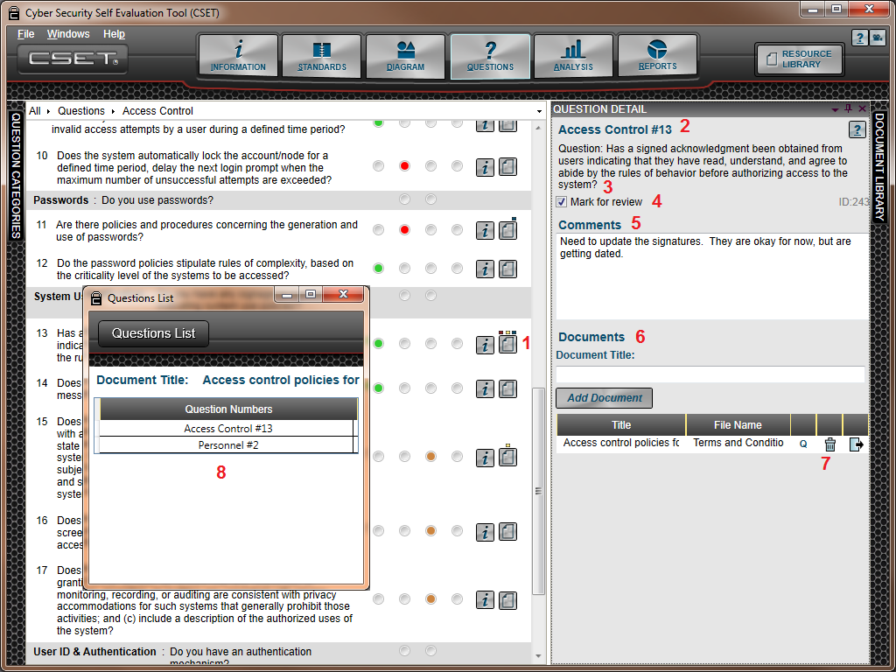

Figure 9-6. Question Detail Screen.

1. **Question Detail Button:** In addition to the Information button, each question in CSET has the Question Detail button represented by the paper with a corner folded down. Clicking on the button will open the Question Detail window shown on the right side of the figure.

A unique set of indicators are displayed above the button for Question 13 in the example. The indicators are represented by small colored boxes placed in different locations above the icon. They represent:

1st position (Red) - This question has been marked for review.

2nd position (Yellow) - This question has comments associated with it.

3rd position (Blue) - This question has one or more documents associated with it.

1. **Question Number:** Each question is given a unique and ordered number within the category. This means that the numbering sequence will restart under each category.
2. **Question Text:** The question itself is repeated for reference.
3. **Mark for Review:** The Mark for Review checkbox is used to flag this question for later review. All questions that have been marked for review can be isolated and displayed using the Question Filter functionality that is discussed below. The filter can also be applied from the Analysis screen.

The Mark for Review feature is often used in assessments when additional information or clarification is required but the team does not want to stop the process to go out and get the data for just one question. The team can return to marked questions at a later time after the information has been found.

1. **Comments:** The Comments text block is a place provided for you to enter comments or other textual information related to the question. Like Mark for Review, filters can also be applied to limit the set of questions to only those with comments attached.

In some assessments, the comments field is only used on rare occasions; in others, the comments are used to record the verification method of answers. This can be a powerful tool to support the quality of the assessment, especially when documents are also attached to support the answer using empirical data. Indeed, a rigorous assessment may require that a comment be entered for every question.

1. **Documents:** Any valid file type can be added to the assessment through the Add Documents button or through the Document Library. When a file is added as part of the questions, it is associated with the question or requirement where it has been added. It is also displayed in the Document Library. Notice that a file called “Access Control Policies for New Hires” has been associated with this question. You may add as many files as you would like to support the answer provided.

7/8

**Document Questions, Deletion, and Export:** In the area shown as part of the document list, there are several features. For example, the spacing of the title, file name, and the icons can be adjusted to allow you to see a longer title for example. To change the default size, you can slide the vertical yellow bar to either enlarge or shrink the space for that column. Simply click on the yellow bar, and slide it to the left or right. The columns contain the following information:

Title: This is the title that you have given the file. It can be updated by clicking in the field and making the change.

File Name: This is the name of the physical file with the extension.

Q: This letter stands for “Questions or Questions List” and shows all questions in the system that are associated with this file. This is helpful if you want to update or delete the document and need to know everywhere it was used. The window marked “8” in the figure above shows an example of the Questions List that appears when you click on the “Q” icon.

Trash Can Icon: This icon represents the “Delete” function. By clicking on this icon you will remove the associated file from the assessment.

Export Icon: The last button will initiate the export process. This will save a copy of the file to a location in your directory.

There is an additional section if the question pertains to diagram “components.” This is explained under the heading “Question Information for Components.”

Figure 9-7 shows the Question Detail window if the “Alt” answer has been selected.

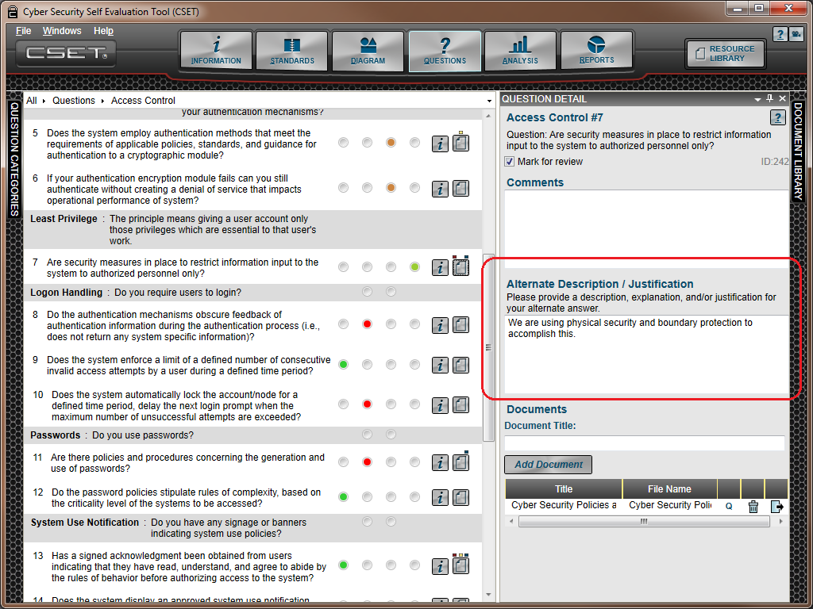

Figure 9-7. Question Detail with Alternate Text Box.

In this example, the Alternate answer radio button has been selected for question Number 7. This question has also been marked for review, and comments have been added.

Whenever the “Alt” button is clicked, the Alternative Description/Justification text box will be added to the Question Detail window. If you mark this answer, you should open the Question Detail window and describe the alternate approach that is being used. While it is recommended to do so, text in this field is not required.

Question Categories Window

The Questions Categories window provides several helpful pieces of information including:

* An ordered list of all categories or subject areas that will be covered in the assessment.
* A quick overview showing which categories have been fully answered based on the checkmarks at the side of each title.
* Filtered questions based on whether they were unanswered, marked for review, or had comments added.
* A reference showing the standards selected and the SAL.

This is a dockable window and can be closed while the questions are being reviewed and answered.

Figure 9-8 shows the Question Categories window with the “Show questions with comments” filter enabled. Each section in the Question Categories has been numbered in red. The sections will be described below.

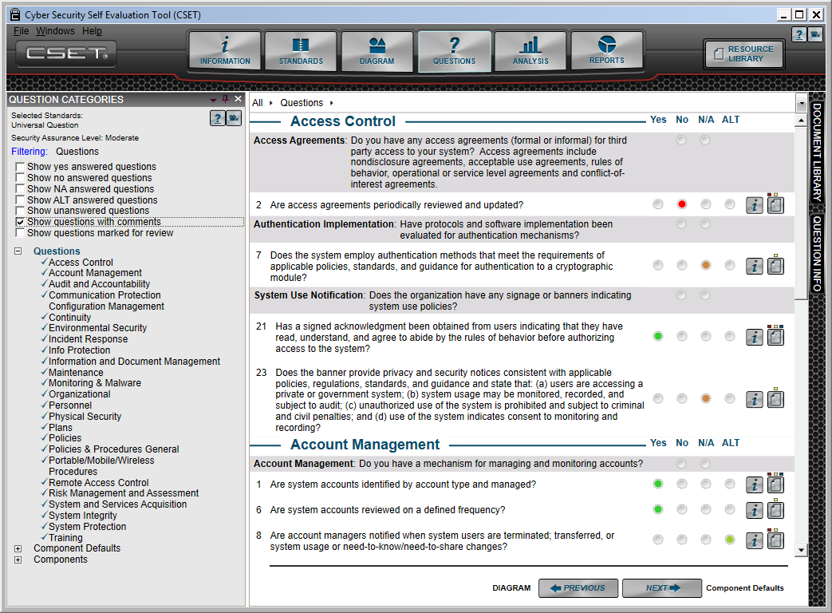

1

2

3

Figure 9-8. Question Categories Screen.

1. **Standards and SAL:** On the top left of the window is a list of the standards that have been selected for the assessment. Below the list is a statement of the SAL that was determined in the Standards screen. This information cannot be changed on this screen but is provided for reference.
2. **Question Filters:** The question filters will limit the list of questions to only those that match the selected filter(s) in the identified category. Click the label “Filter” to show or hide the filtering options. The category is selected by clicking a branch on the category tree. The filter will apply only to that branch. To see a wider range of questions, click the Questions label at the top of the tree. The filter will then consider all the standards or requirements-related questions. It will not include any component-related questions. To see those results, click Component Defaults or Components and reapply the filter. Any combination of filters can be applied. Simply click the checkbox next to the filter(s) you wish to apply, and uncheck the box to disable the filter and redisplay the full list.
3. **Tree Structure Showing Categories:** The tree structure shows the list of question categories, which are included in the assessment. A checkbox next to the title indicates that all the questions have been answered. Categories may be fully answered against one standard or SAL. But if other standards are added, or if the SAL is increased, then additional questions may be added to the list.

When components have been added to the network diagram, it will cause a set of component default questions to be displayed. In addition, if there are overrides marked in the list or if a component has been marked as “Unique” in the diagram, the tree structure will be expanded to include the component type and the component name. The questions will be presented to match the override or unique settings. Additional information on component questions is provided below.

The Questions screen will be where most of the assessment time will be spent. The process is not difficult but it can be tedious. It is recommended that you plan ahead and recognize that it will take hours or even days to accurately answer all the questions presented based on selected standards and the component diagram. The more time you spend understanding the intent of each question and then discussing it as a team, the more valuable will be the assessment.

Component Questions

Figure 9-9 shows an example of a typical component question set with the primary docking windows visible.

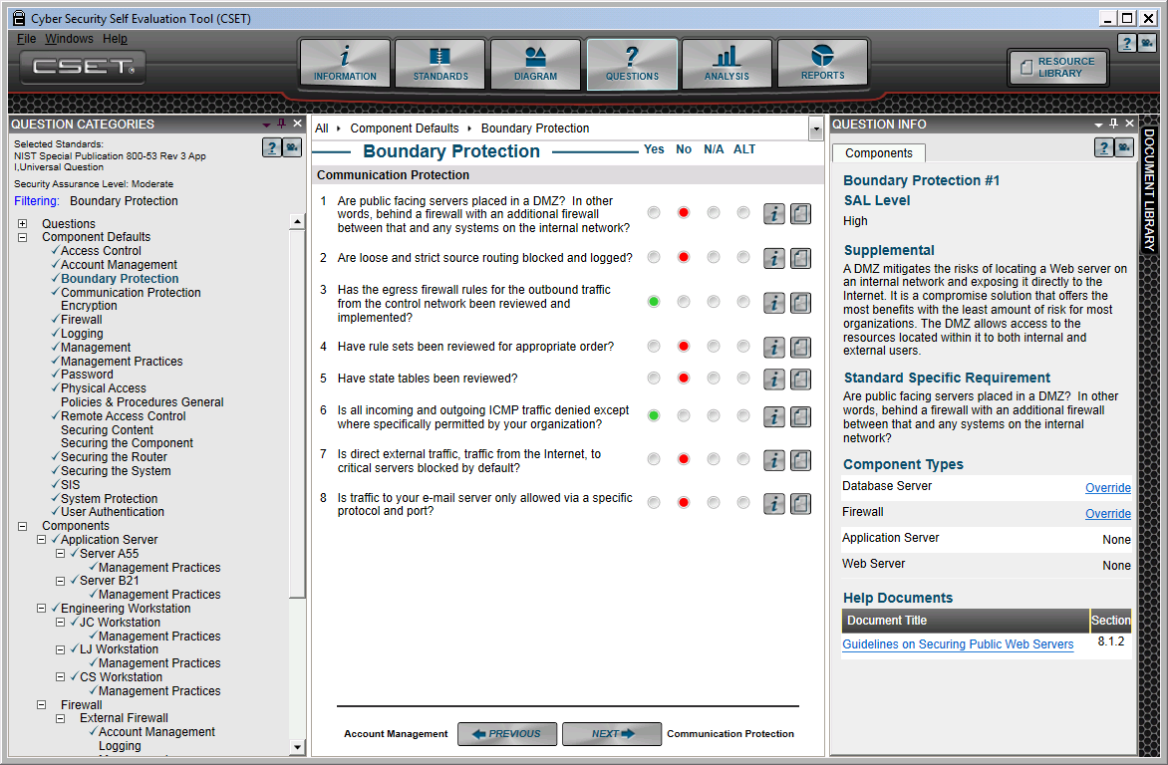

Figure 9-9. Question Information for Component Defaults.

When components have been added to the network diagram, the system will create a set of component default questions. If no additional action is taken, the answers to the default questions will apply to all the components in the diagram. If actions are taken, such as marking a component as unique or overriding the default, then new questions will be presented for each identified component or type. Several rules apply to the way questions are managed.

* A question will be included in the list if it maps to the component placed on the diagram. For example, a clock component may have only one question and one category listed while an application server may have ten categories and over forty questions. A variety of component types will cause all the categories to be displayed along with a large number of questions. This means that only those questions that pertain to selected components will be displayed. Questions that do not pertain to any components on the diagram will not be displayed or counted.
* You may mark any single component as unique in the diagram by clicking the checkbox labeled “Has Unique Questions” in the Question Properties window for the selected component. When you click this checkbox and mark it as true, CSET will add a complete set of questions related to that component type. This means that questions that were presented as component defaults will be asked again specifically for this component. This is true for every component that has been marked as unique.
* You may override a default answer for either a component type or for a single component. The example above shows the Question Information window for component defaults. In addition to the normal reference information, it also includes a new list titled “Component Types.” There is an option of Override or None next to each type. This list will vary for every question and will depend on whether the question applies to the type. To override the default answer for a specific type, simply click on the Override link next to that type.

The None option indicates that this question pertains to this component type, but there are no instances of that component type on the diagram.

Clicking Override opens the Default Network Component Answer Override window shown in Figure 9-10. Here, you answer the question for all instances of that component type. Later, you can change any single answer to match a particular device. In this example, the screen relates to overriding the default answer for the Database Server.

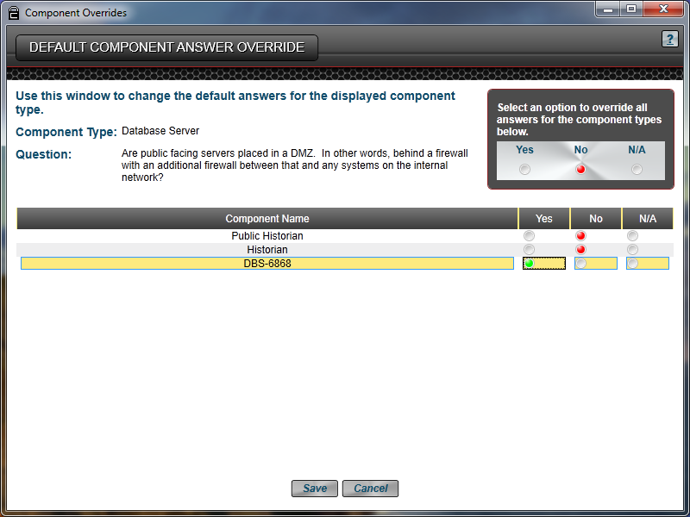

Figure 9-10. Component Answer Override Screen.

There are a few items to remember when using the Override function. They are:

* Any question that you specifically answer, using either the unique checkbox on the Diagram Properties window or the override option in the Question Info screen, will take precedence over any of the component default questions.
* A new heading will be added to the Question Categories tree structure for all the cases where unique or overridden questions are designated. The corresponding question sets will be added as well.

If you have accidently marked components as overridden or just want them to inherit the defaults later on, you can always go back to the diagram and click the “Clear Component Question Overrides” button on the bottom of the Component Properties window.

10) analyze results



10

There are two methods to analyze the results of your assessment. The first option is through the Analysis screen, and the second uses the printed reports. Each approach will be explained below.

Analysis Screen

The analysis screen provides you with a way to measure your security posture against selected standards. It uses charts to provide a visual display of your data and at the same time allows for comparisons across categories, questions, and subject areas.

There is little interaction in the Analysis screen, other than to drill-down on specific data from a given chart. Figure 10-1 shows an image of the Analysis screen with questions that have been answered for the Universal Question set, the NIST SP800-53 Revision 3, Appendix I standard questions, and for components that are included on a control systems network diagram.

The charts will change if Cybersecurity Framework Based is selected as the assessment mode at the Standards screen. They will be discussed later in this section.

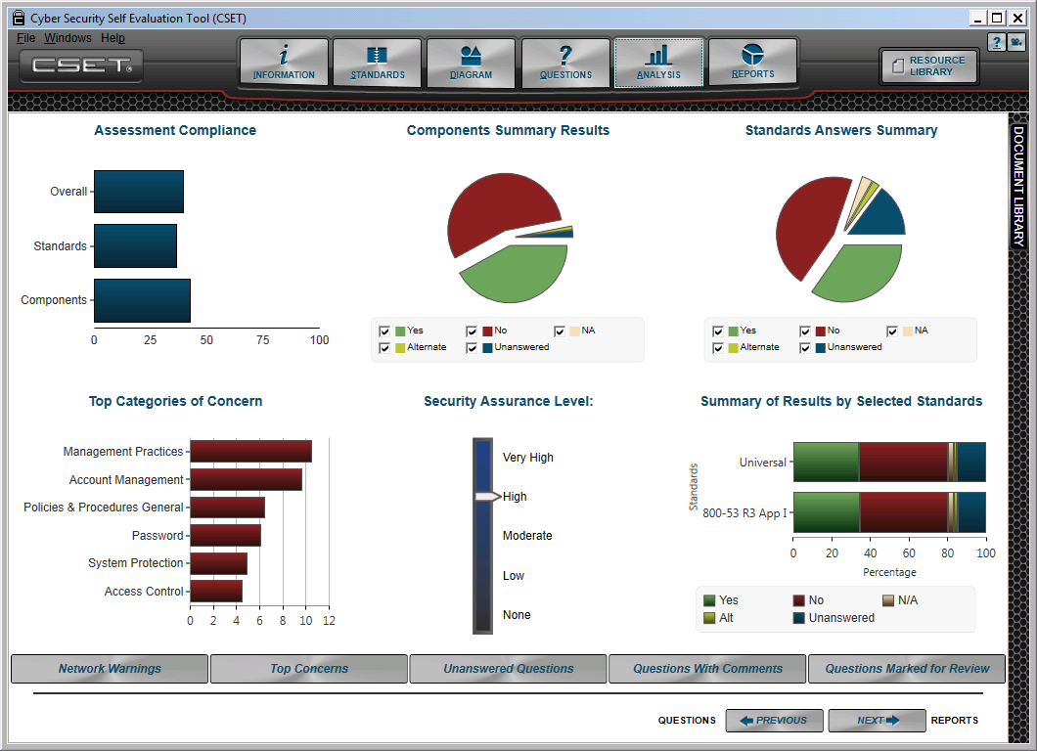

Figure 10-1. Analysis Screen.

There are two main functional areas. The first is the grouping of the charts themselves where in most cases drill-down capabilities exist. The second area is found on the bottom of the screen and consists of a series of buttons. These buttons display filtered or ordered questions, and network warnings.

Display of Analysis Data

The Analysis screen displays six charts, each showing different types of information.

**Assessment Compliance:** This chart shows a comparison of three subjects: (1) the scoring of answers from the standard or standards if more than one has been selected, (2) the scoring of the component questions, and (3) the overall scoring for the control systems being assessed. The numbers shown are a percentage of the positive answers provided compared with the overall number of answers available. Answers marked N/A or not applicable are not counted at all, and answers marked with an Alt or alternative are considered a positive answer like a Yes. A negative answer would be considered either a No or unanswered.

The Overall value is a combination of all the answers. The Standards value is a combination of all standards selected. The Components value represents the percentage of positive answers for all questions based on the diagram.

There is no interaction or drill down for this chart.

**Components Summary Results:** This pie chart shows how the component questions were answered. The answers provided for the component defaults are propagated to all the components to which the question would apply. This means that if you answer yes to a default question that applies to only one actual component and no to a default question that applies to nine components then you would see a 10 percent yes pie slice and a 90 percent no slice, assuming you ignore all other answers.

With this pie chart and the chart titled “Standards Answers Summary,” you have the ability to click on the legend to turn pie slices on and off. This can provide greater clarity if there are extremely thin slices that are not important for your review.

**Standards Answers Summary:** This chart shows how the combination of all standard questions was answered. If only the Universal Questions option was selected, then it shows the results of that set. If more than one standard was selected, then the chart combines the results of all the standards and displays them in this single graphic. As was mentioned above, you can click on the labels below the chart to turn on or off specific slices.

**Top Categories of Concern:** Based on the answers provided, CSET will calculate which subject areas or categories have the most negative answers and then will show the categories in order from worst to best. The chart shows only the highest ranked categories (to see the full listing you must click on the chart to drill-down to the full details).

The top categories are not just a reflection of negative answers, though that does factor heavily into the formula. The results are derived from a combination of answers and weighting of both the questions and the categories from subject matter experts.

**Security Assurance Level:** This image is a simple graphic to show the SAL. In most circumstances you will only see the larger, primary bar for the general SAL. When the CNSSI baseline or overlay has been selected, the tool will show the individual levels for Confidentiality, Integrity, and Availability. Similarly, if DoD is selected, the Confidentiality and MAC levels will be shown. There is no interaction or drill down for this image.

**Summary of Results by Selected Standards:** This summary chart displays the results for all the standards that have been selected. Unlike the pie chart above it, this breaks out the results for each standard individually. The numbers shown and the corresponding length of each bar represent a percentage of the respective answers.

Detail Screens from the Analysis Main Screen

Detail screens are associated with each chart with the exception of the Security Assurance Level and Assessment Compliance. To open a detail screen simply click within the chart area.

For example, the Top Categories of Concern screen shown in Figure 10-2 was opened by the system when the user clicked on the “Top Categories of Concern” chart in the Analysis main screen.

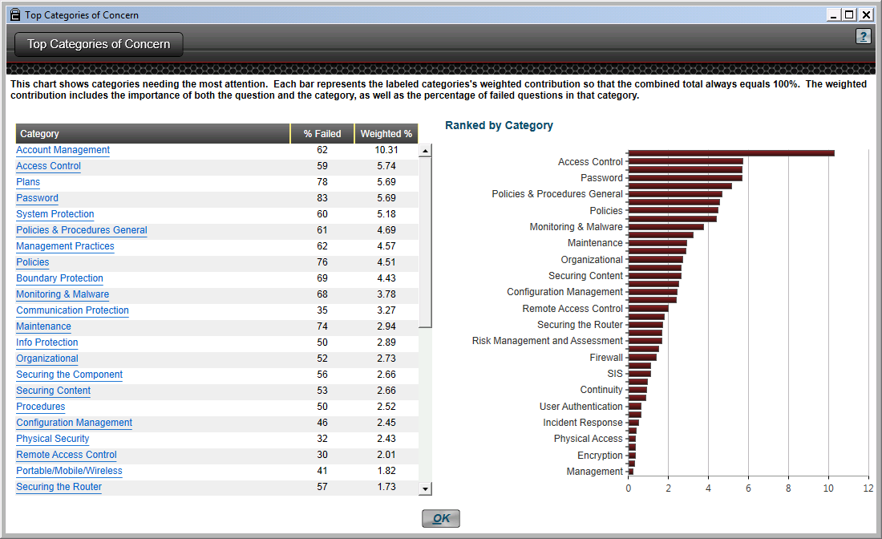

Figure 10-2. Top Categories of Concern Screen.

This new detail screen provides more information than the original chart, including the full set of categories, instead of just the top few. In addition, the screen also displays in a list format the percentage of failed questions (either a No or unanswered) and the weighted percentage. The weighted percentage is what is used to create the bars in the chart at the right. For this particular chart, the longest red bar represents the category needing the most attention. The smallest bar on the bottom represents the category in which you are performing the best.

This screen also includes another layer of detail as shown by the blue hyperlinks in the list of Categories. By clicking on one of the categories, you are able to drill down to even more specific information. Figure 10-3 shows the new Analysis Questions screen that is displayed when a link is clicked.

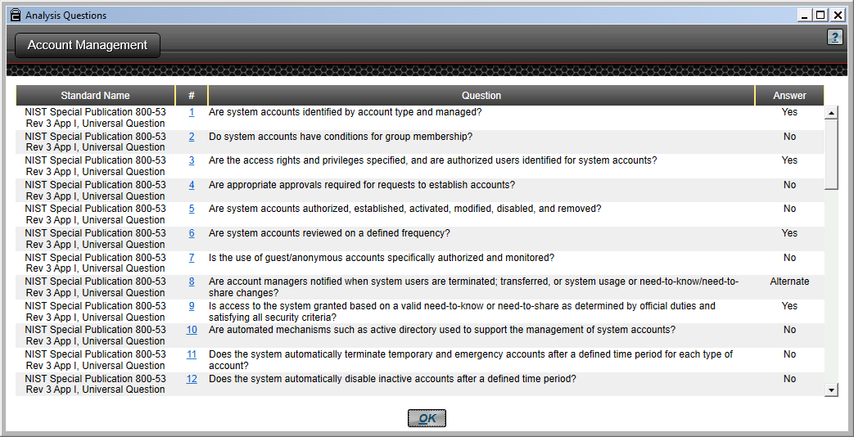

Figure 10-3. Analysis Questions Detail Screen.

The detailed data were a result of the user clicking on the “Account Management” link that was found on the Top Categories of Concern screen. By clicking on the hyperlink, the system reports the actual questions that were presented in this category along with the user response. As you can see under the “#” or number heading, the number is a hyperlink that will open the Question Info docking window for that specific question.

The examples shown above are representative of the detail screens that are provided under each of the respective charts in the main Analysis screen. Figure 10-4 presents the various drill-down options. A description of each of the detail screens can be found by clicking on the help icon within CSET for the specific screen.

Assessment Compliance

None

Components Summary Results

Components Summary

Standards Answers Summary

Overall Results by Category

Top Categories of Concern

Top Categories of Concern

Security Assurance Level

None

Summary of Results by Selected Standards

Summary of Results by Selected Standards

Components by Component Type

Enlarged screen

Standards Drill Down button

Standard by Category

Subject Area link

Analysis Questions

Question Info

docking window

Category link

Analysis Questions

Question Info

docking window

Figure 10-4. Analysis Screen Drill-Down Options.

Analysis Buttons

In addition to the charts found on the Analysis screen, there is also a set of buttons found at the bottom of the Analysis screen, as highlighted in Figure 10-5. Each button shown will open a screen with a different set of data.

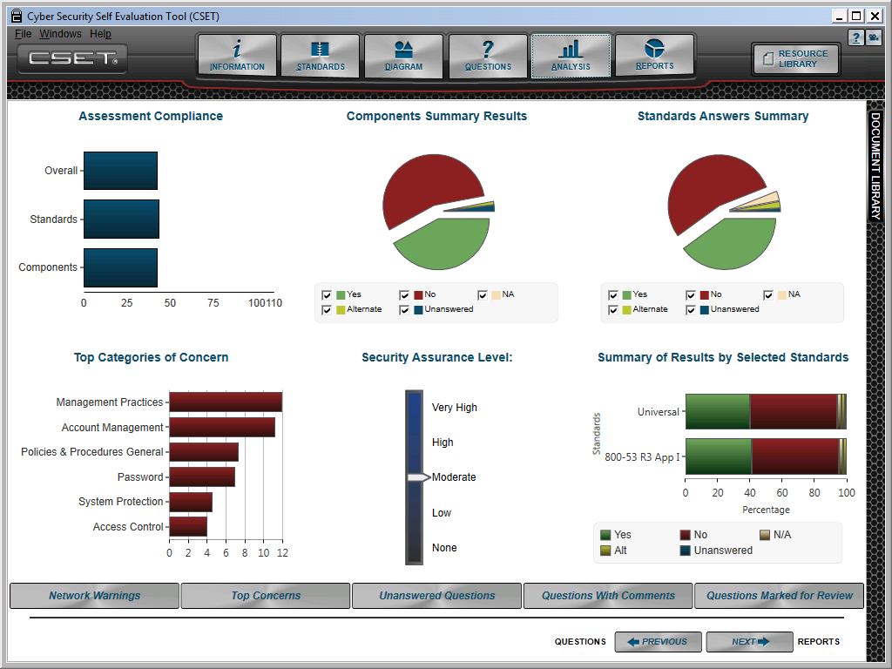

Figure 10-5. Analysis Screen Buttons.

**Network Warnings:** This button will open the Diagram Network Warnings detail screen. This screen shows any warnings that were found on the network diagram. Each warning corresponds with a red icon on the diagram.

**Top Concerns:** This button opens an Top Questions of Concern screen that lists the Rank, Standard, Category, Question Number, Question, and Answer for all questions where the answer was a negative (No) or unanswered. The list is ranked from 1 to the total number of gaps and provides a way to see what the system recommends should be worked on first.

**Unanswered Questions:** This is the first of three buttons that will open the Questions screen and will set the question filter. In this case, the filter is set so that only unanswered questions are displayed for the default category. You must select each category that you wish to filter.

**Questions with Comments:** Like the Unanswered Questions button, this too will open the Questions screen and set the filter to display all questions that had comments associated with them in the identified category.

**Questions Marked for Review:** Like the first two buttons of this type, this button will open the Questions screen and set the filter to only display questions that had the “Marked for Review” field checked.

Framework Analysis

With Cybersecurity Framework Based selected as the assessment mode, the analysis charts change to focus more on profiles, categories, and subcategories as can be seen in Figure 10-6.

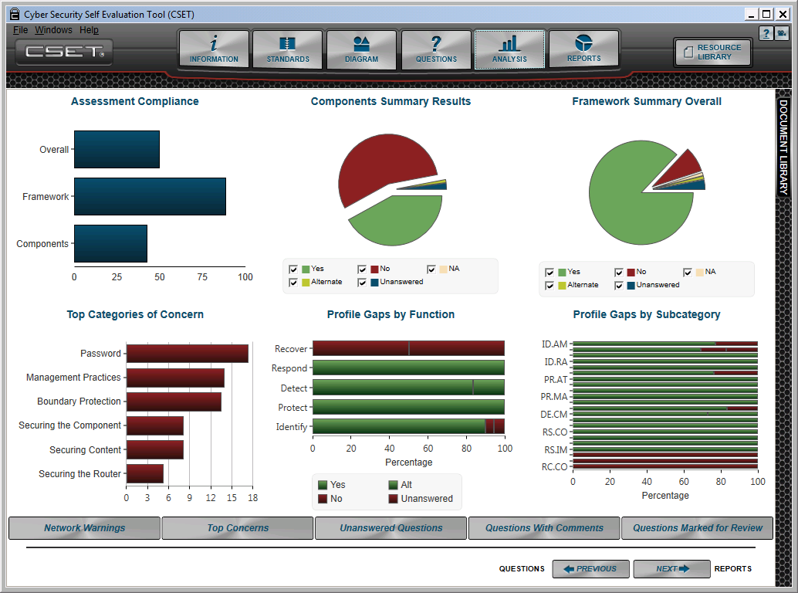

Figure 10-6. Framework Analysis Screen.

The Components Summary Results chart is unchanged from that discussed above. The Assessment Compliance and Top Categories of Concern charts are similar to those discussed above except that they deal with Framework issues rather than issues related to standards and requirements. The remaining charts are described below.

**Framework Summary Overall:** This pie chart shows all the possible answer types as a combined whole. You can click on the labels below the chart to turn on or off specific slices or answer types.

**Profile Gaps by Function:** This chart shows the five core functions on the Framework and how each was answered. The data is presented as a percentage.

**Profile Gaps by Subcategory:** This chart presents the Framework subcategories and how each was answered. Clicking on the chart opens a detail window that shows a larger version of the chart with the related data shown in table form.

Figure 10-7 presents the various drill-down options available when Cybersecurity Framework Based is selected as the assessment mode. More information may be found by clicking on the help icon within CSET for a specific screen.

Assessment Compliance

None

Components Summary Results

Components Summary

Framework Summary Overall

Top Categories of Concern

Top Categories of Concern

Profile Gaps by Function

None

Profile Gaps by Subcategory

Cybersecurity Category Details

Components by Component Type

Enlarged screen

Category link

Analysis Questions

Question Info

docking window

None

Figure 10-7. Framework Analysis Screen Drill-Down Options.

Reports Screen

After you have completed developing the network diagram and finished answering both the standards and the component questions, you can then review the results by either using the online analysis capabilities or by creating and reviewing on-screen or hardcopy reports.

Report Builder

The Reports screen is shown in Figure 10-8. The Executive Summary report option is checked as an example. When you first enter the screen, none of the options will be checked. The Status bar will activate when the Create button is clicked to provide an indication of report creation progress.

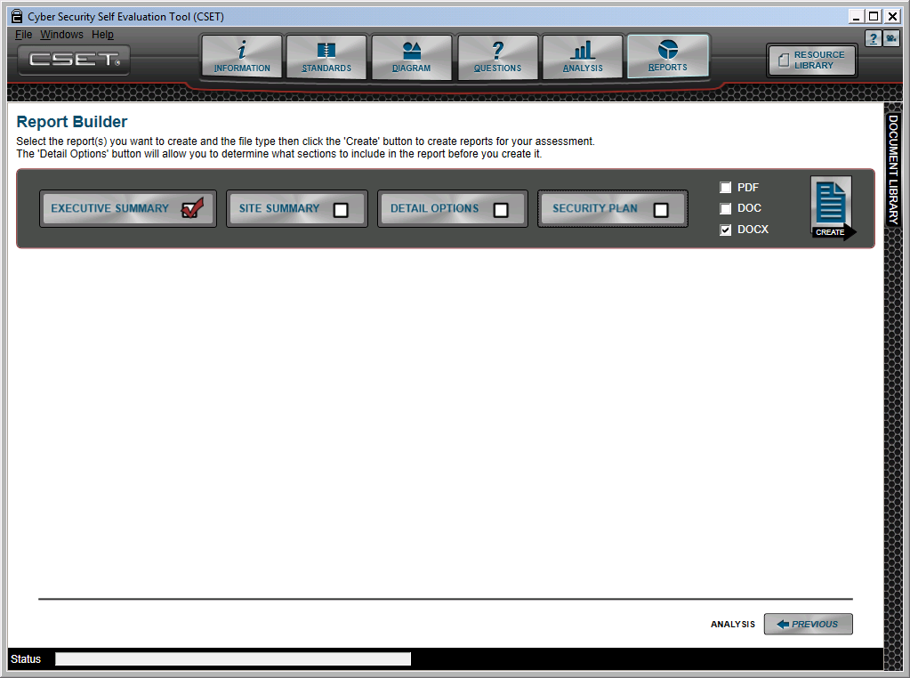

Figure 10-8. Reports Screen.

Four different report options are in the system. Each is intended for a different audience. The first three are presented in increasing levels of detail. The last is in template format for easy tailoring to the specific site security posture. This screen provides the user with a way to select report type, the format, and all the sections that would be included in the report as in the case of the Site Detail Report. Each of the report types are described below.

**Executive Summary:** The Executive Summary option produces the Executive Report, and as the name implies, it is designed for an executive level audience. The person receiving the report may hold any title; however, the intent is to provide limited graphical and high-level, summary information that can be understood quickly.

This report is limited to around five to six pages and does not include any detailed information beyond listing the top categories and areas of concern. It does include the textual “Executive Summary” information that was entered in the Information screen by the user. It also includes the “Description of Assessment,” also found in the Information screen. Some default text is provided; however, you should replace that text with actual summary information that captures the highlights of the assessment.

To create the Executive Summary report, simply check the respective box, and select the format in which the report is to be generated. The options are Portable Document Format (PDF), the Microsoft Word (DOC), or DOCX formats. Once you have selected the format, you then click the “Create” button. This will open the program associated with the selected type and then create the report. You must have an application that can open and display the type for the report to be generated. For example, if you do not have a current PDF reader, then the system will not be able to display a report created using the PDF option.

**Site Summary:** The Site Summary option produces the Site Summary Report, which includes everything in the Executive Report. It is not as lengthy or detailed as the Site Detail report, but it does provide sufficient information to see the results and show what questions were missed. The intended audience for this report is a technical manager or supervisor. This report then provides additional charts at a more detailed level beyond what is found in the Executive Report. It also includes the network diagram and includes a list of all the questions in the assessment that were not positively answered. An important feature is the ranking of the missed questions. Each question is ranked sequentially from one to the total number of questions.

The question ranking is determined by a formula that takes into consideration the weighting of each question, the weighting of each category, and the SAL associated with that question. All questions in CSET have been assigned a unique weighting relative to each other. The categories have been weighted as well. These assignments were determined by subject matter experts and are based on their recommendations. The SAL that is assigned to a question is also considered in the formula. For example, all other things being equal, if Question A has a SAL of “High” and Question B has a SAL of “Low,” then Question B would rank higher in the list than A, because the recommended ranking would encourage addressing basic requirements before addressing the more difficult ones.

The rankings are intended to address the question, “What should I work on first?” It is recommended that you start with the question marked “1” and work your way down based on resources and your cybersecurity plan.

**Detail Options:** This option will generate the Site Detail Report and will include all the report options listed on this screen. When this option has been selected, the system will display the checkbox options shown in Figure 10-9.

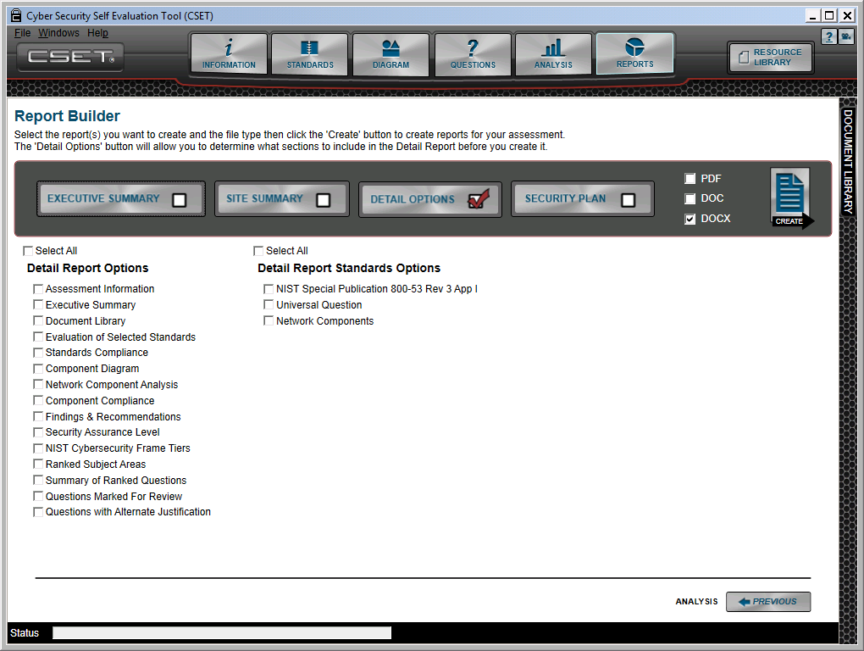

Figure 10-9. Detail Options.

The Detail Options button displays the sections available in the Detail report that can be added to or removed from the report. If all the options are selected and if a large number of questions are missed, then this report can run into the hundreds of pages.

To add a section to the Detail report, simply click the checkbox associated with the section label on the screen. On top of each list is a “Select All” check box that will select all the options at one time.

In addition to the detailed report sections, you can also enable or disable standards that were included in the assessment. To include the data associated with a standard, simply select the checkbox by the listed standard label.

**Security Plan:** The Security Plan option produces the Security Plan template. It provides an overview of system security requirements and to describe the controls in place or planned to meet those requirements. It is designed in template form and, as with the Executive Summary, some default text is provided, which should be replaced with facility-specific text that captures the highlights of the assessment. The default text is distinguished by being in 10 point font and italicized.

The Security Plan Report includes the network diagram and the component inventory list. It presents the top areas of concern. The bulk of the report is a list of all the assessment questions and their answers presented in a control-focused format. Thus, the report provides an overview of the cybersecurity requirements and their status for the facility.

Report Details

The following sections provide more detail on the contents of each of the report types.

Executive Report

The Executive Report has a fixed set of sections that are all generated when the report is created. As such, there are no options to either turn on or turn off. Each of the sections in the report will be discussed below.

**Title Page:** Each of the reports has a cover page that is unique to the report type. Each has assessment-specific information. This includes the assessment name that is taken from the Information screen in the tool, the date that was entered in the Assessment Date field, and the name of the person that was entered in the Principal Assessor/Name field in the Information screen.

**Summary and Description Page:** This is the first page with content and shows a summary look at the standards, component network, and overall compliance based on answers to questions in the assessment. It also includes the description of the assessment and the executive summary text that was entered in the Information screen.

When CSET is installed, the Executive Summary field has generic text included as a starting point; however, the included text should be replaced after the assessment with a real executive summary that is specific to the results presented.

**Standards Summary Page:** The standards summary page displays several items. It first identifies the standards that were used in the evaluation; it then shows in the pie chart the combined breakout of answers for the selected standards. The bar chart provides the greatest level of detail and indicates the overall scoring in each question category for both of the selected standards.

Because more than one standard may be selected, the categories are not specific to either standard, (they would be if only one standard was selected). Instead, the categories are taken from a common list that would apply to both.

This page shows a good overall summary of how you performed against the administrative questions found in the standards.

**Component Summary and Analysis Page:** Like the previous standards summary page, this also provides summary information but for the set of components in the network diagram that you created. On this page, you would see the combined summary of answers for all components in the pie chart. This is basically a percentage of all answers for all the combined component questions. The lower bar chart shows the scoring for each component “type.” To see further detail, you will need to go to the online analysis and drill down to the component itself.

The last item reported is the number of warnings found in the basic network analysis. These are the red circle warnings that are shown in the diagram when the Analyzed Network function has been enabled.

**Top Questions and Areas of Concern:** The final section or page of the Executive Report is the top subject areas of concern and the top five questions.

The top questions and areas are based on the ranked order of both, and the full lists can be found in the Site Summary and the Site Detail reports. Both lists on this page have been limited to only the top five.

If you have selected the “Requirements” approach to the assessment, then the title of the final section will read “Top Requirements of Concern” and the list will be the actual requirement text. Often the requirements are lengthy and may spill over onto another page.

The way that the ranking is determined will be explained below in the Site Summary Report where the full list is shown. The intent is to give a quick picture of what is recommended to be addressed first.

Site Summary Report

The Site Summary Report still provides mostly summary information in the form of a variety of charts; however, it is more detailed than the Executive Report and provides additional charts that the Executive Report does not have.

The intended audience for the Site Summary Report is a manager that is responsible for directing the implementation of the recommendations.

**Simple or Previously Described Sections:** The Site Summary Report includes most of the sections from the Executive Report and additional sections that are understood (like the Table of Contents). These will be listed after which sections new to this report will be described in greater detail.

* Title Page: This was described in the Executive Report and includes the assessment name, date, and the name of the principal assessor.
* Advisory: The Advisory page includes text that recommends using more than just the CSET as an approach for a robust cybersecurity plan. It also makes other recommendations on team makeup and protecting data that should be read and followed.
* Table of Contents: This is a system-generated table that indicates the major sections and the page numbers that begin those sections.
* Assessment Information: This section displays the text that was entered on the Information screen in the tool. It will display all the data with the appropriate labels.
* Summary Percent Compliance: This is identical to the first page of the Executive Report and is described above.
* Evaluation against Selected Standard and Question Sets: This page is also identical to the standards summary page in the Executive Report and is described above.
* Analysis of Network Components: This is the last of the common report pages and is described under the Executive Report.

**Standards Compliance:** A Standards Compliance bar chart will be displayed for every standard selected in the tool. This chart gives the percent of positive answers (either marked as a Yes or Alternative) as compared with the total number of questions in each category. Unlike the earlier combined summary chart, this chart uses the categories that are specific to the standard. The summary chart uses a common set that is shared by all standards. The title on the chart is the short name or abbreviation of the full standard name.

**Component Compliance by Subject Area:** Like the standards, this chart shows the percentage of combined questions that were positively answered in each subject area. Because the components are not linked to any specific standard, the common categories or subject areas are used.

**Network Diagram:** A scaled copy of the network diagram is included in the report. The system scales the diagram to fit on the letter-sized page.

**Network Analysis Findings:** When you develop your network diagram, the system will evaluate basic architectural settings and provide warnings if any weaknesses are identified. An example would be crossing zone boundaries without a firewall or IDS.

**Security Assurance Level (SAL):** The Security Assurance Level page displays the results of your answers and selections related to the SAL. It includes any values that were included in either the General SAL or the NIST SAL. When Cybersecurity Framework Based is selected as the assessment mode, this section will be changed to display the Cybersecurity Framework Tier Determination.

**Document Library:** The next page shows any documents that were included in the assessment. They may have been added in association with specific questions, or added through the Document Library screen. In either case, the document titles and file names are included in the list on this page.

**Ranked Subject Areas:** The Ranked Subject Areas section shows the categories or subject areas that need the most attention. This chart is organized so that the worst areas are shown at the top and then ordered to those areas in which you are doing best. This chart can be helpful in prioritizing what areas to work on first.

The chart shown on this page is the full information as compared with what is found on the last page of the Executive Report. Basically, the top five areas from this chart are displayed on the Executive Report.

The formula for ranking these areas includes several factors such as a weighting given to each area from subject matter experts combined with the number and level of missed questions in each area.

**Summary of Ranked Questions:** This final page in the Site Summary Report includes a list of the questions that were missed in ranked order. This list is intended to answer the question, “What do I work on first?” Like the Ranked Subject areas, this list is based on a formula that includes the number of missed questions, the weighting given to each of those questions, the weighting assigned to the question category or area, the SAL for the question, and the criticality assignment for a component that was marked in the diagram.

All the parameters are factored together. Then each question is ordered in the list with the question that the system recommends you work on first listed on the top and the question or requirement that should be addressed last listed on the bottom.

Detail Report

The Site Detail Report provides the flexibility to customize the output so that sections can be either included or excluded from the report. It also adds several new sections to the report that are not found in the Executive Summary or Site Summary Reports.

The following sections have been described in either the Executive Summary or the Site Detail Report and will not be repeated here. To review the detailed description, please see the respective section above.

* Assessment Information,
* Description and Executive Summary,
* Document Library,
* Evaluation of Selected Standards,
* Standards Compliance,
* Component Diagram,
* Network Component Analysis,
* Component Compliance,
* Findings & Recommendations,
* Security Assurance Level or Framework Tier Determination,
* Ranked Subject areas, and
* Summary of Ranked Questions.

The new sections that are added to the Detail Report include the questions that have had either comments added or were marked for review, the questions that have an alternate solution, and a list of the questions detail for each standard and for the components.

**Question Comments and Questions Marked for Review:** This section includes all the questions that had comments entered or had the Marked for Review checkbox clicked. It identifies the question by area and by number within the subject area and then displays both the question and the comments.

**Alternate Justification Comments:** This report also shows the subject area and the question number as well as the question. It then provides the comment text that was entered as a justification for using an alternate method to accomplish the intent of the question.

**Question Details:** The final section of the report is the question details for the standards and components. It provides a full list of the questions that were asked and the answer that was given.

The questions in this final section are ordered based on the standard or the universal set and are not ordered by ranking as a previous section is. This report also gives you the yes answers rather than just the gaps.

The intent of the reporting functionality is to provide you with a way to print and publish assessment information, including summary charts and lists. It also gives you a hardcopy of the results to be used in meetings, for communications to management, and as a way to assign tasks to technical staff. Combined with the online analysis, these reports can help you clearly understand where weaknesses are and where improvements should be made.

Security Plan Report

The security plan provides an overview of the security requirements of the assessed system and describes the controls in place or planned for meeting those requirements. The Security Plan Report is presented in template format with some generic text (distinguished by being in 10 point font and italicized) that must be replaced with verbiage describing the actual facility and the assessment results. Sections to replace include:

* introduction,
* system identification,
* roles and responsibilities, and
* risk analysis.

**Network Diagram, Zone List, and Inventory List:** The report presents a copy of the network diagram scaled to fit on the letter-sized page. It includes a list of the zones that are included in the network diagram if any were identified. The zone information includes the zone name, security level and percent implemented which is the number of yes answers per the total number of questions for components in the zone. The report then provides an inventory of all network components that were included in the diagram grouped by zone.

**Security Assurance Level (SAL):** The Security Assurance Level page displays the results of your answers and selections related to the SAL.

**Security Plan Controls and Status List:** This section of the security plan lists all the requirements and controls selected during the assessment. The table includes the requirement title, the control description, affected zones and components, and the related questions with the answers that were provided during the assessment. The table is grouped by control, meaning that there may be several questions under each requirement. The table also summarizes the implementation status of each requirement as a percentage of positive answers per number of related questions. It is ordered to match the on-screen display of the control questions so you can more easily find and review requirements of interest.

This is the heart of the report. Using this table, the reader can quickly see all the requirements related to the facility and how closely each is being met.

11) LIBRARIES



11

This section provides detail on using the Resource Library and the Document Library.

Resource Library

The Resource Library contains hundreds of documents and files that can act as a reference on cyber and control system security. It also provides templates, guides, and security plans to assist in building your own plans. Furthermore, it provides unique access to two of the most popular DHS documents: the “Department of Homeland Security: Cyber Security Procurement Language for Control Systems” and the “Catalog of Control Systems Security: Recommendations for Standards Developers.”

The Resource Library is accessed by clicking on the labeled button in the right-hand corner of the CSET Window.

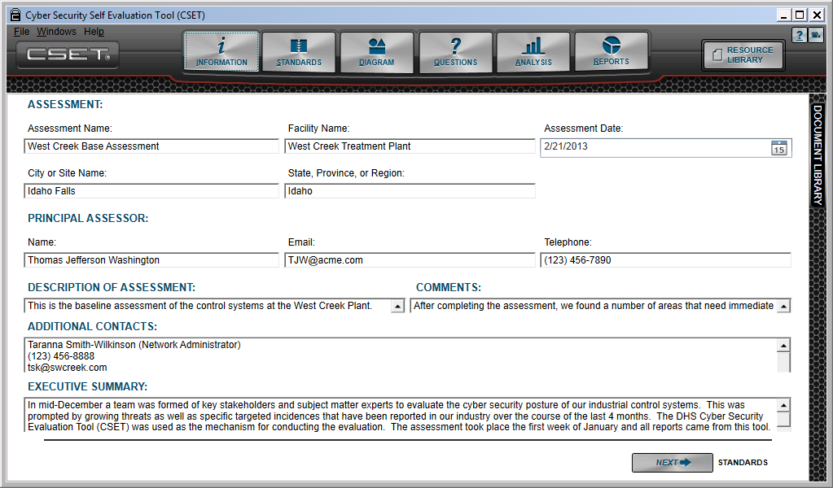

Figure 11-1. Resource Library Button.

The library screen is displayed as a separate window as shown in Figure 11-2.

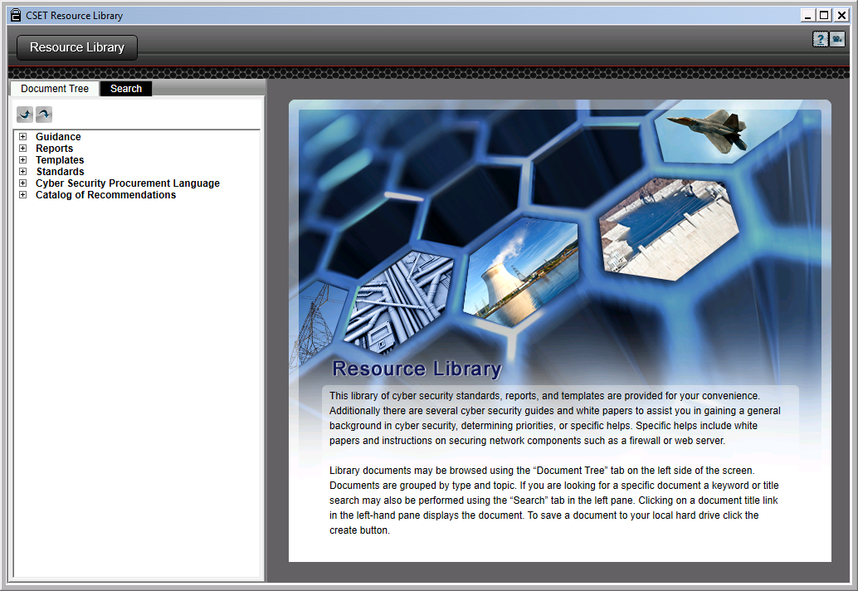

Figure 11-2. Resource Library Window.

Three parts exist to the library, the Document Tree, the Search screen, and the Display window. Each part is shown in Figure 11-3 and will be described below.

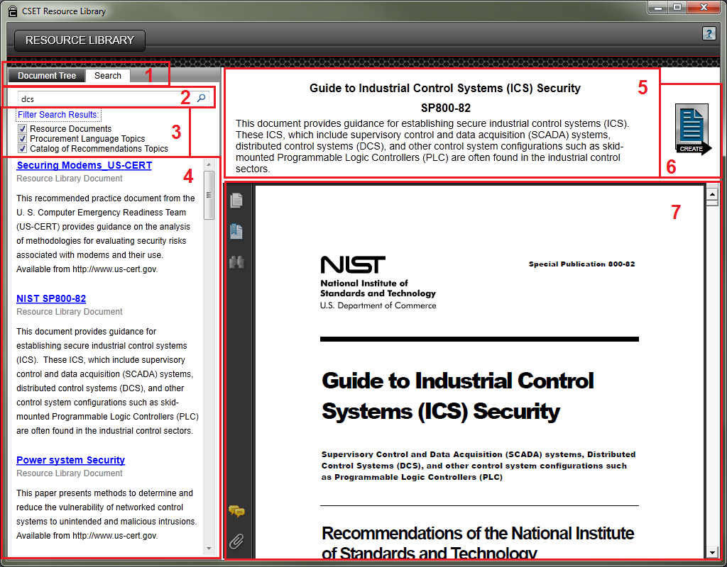

Figure 11-3. Resource Library Parts.

1. **Finding Documents:** Two ways are available to find the documents and information for which you are looking. You can either use the Document Tree or a Search box. They are presented as tabs at the top of the left column.
2. **Search String Text Box:** This is a field where you can type or paste in a string that the system will use to perform the search.
3. **Filter Search Results:** This block is closed by default with all the boxes checked. To filter the data by type (document or topic), you will need to click on the “Filter Search Results” hyperlink to open the options and then check the one you wish to filter. Click the magnifying glass or press the keyboard Enter key to perform the search using the selected filter(s).
4. **Search Results:** After you execute the search, based on your text string and any filtering, CSET will return a set of entries that match your string. Each result includes several elements. The first is the title of the document, formatted as a hyperlink that when clicked, will open the document or topic in the display window. Under the title is the type of information. The choices are Resource Library Document, Procurement Language Topics, and Catalog of Recommendations Topics. The final block is a short abstract that briefly describes the document or the topic. In the example shown above, NIST SP800-82 was selected.
5. **Document Title, Label, and Abstract:** In the upper right area of the window, the title of the selected document is displayed in bold at the top of the block. The abbreviation or label (if there is one) is also bolded and shown below the title, and finally the brief overview or abstract is displayed.
6. **Create Button:** The Create button is opened when a document has been selected for display. This button allows you to save a copy of the document.
7. **Document or Topic Display Window:** This area of the screen displays the document or topic.

The use of each block will be described in greater detail below.

Document Tree

There are two ways to find documents within the library. The first is through the tree structure shown in Figure 11-4. The second is the Search screen that will be discussed later. In the tree structure, all the topics in the library are broken out in a hierarchical format and are placed as the leaf nodes on one or more branches, with a branch representing a topic. Each main topic can be expanded to more detailed subtopics until only the list of documents remains. The branches may be one or several levels deep.

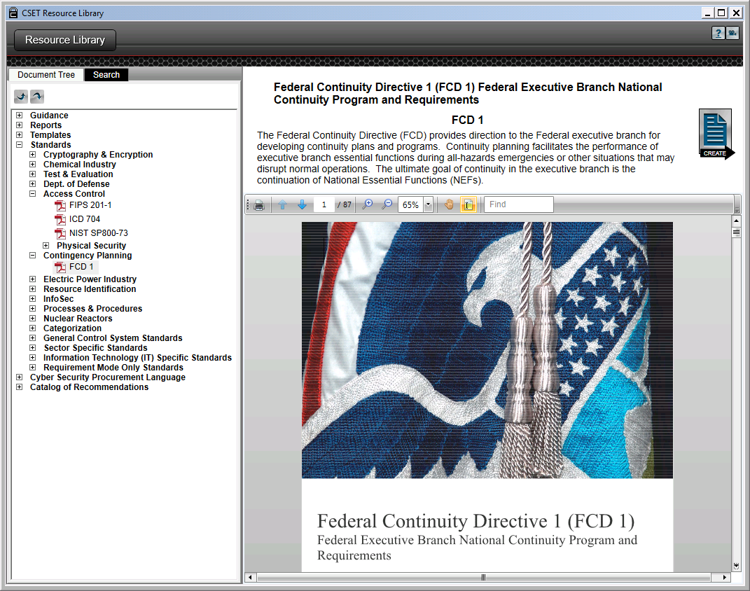

Figure 11-4. Expanded Document Tree.

In the example shown above, the user has clicked the Standards branch and clicked both the Access Control and the Contingency Planning branches to open and expose the documents that are found under them. The user has then clicked on the file icon labeled “FCD 1” under the Contingency Planning branch. The result is that the abstract and file are displayed in the area to the right. If one of the other documents were then clicked, the system would close the FCD 1 document and then open and display the new file.

The final two subjects in the tree labeled “Cyber Security Procurement Language” and “Catalog of Recommendations” are unique and will open special access to the content rather than the files themselves.

**Cyber Security Procurement Language:** If you click on the branch that is labeled Cyber Security Procurement Language, the screen opens and expands the tree to show the topics in the Procurement Language document. (Note that the full document can be found using the Search or Document Tree methods.) Figure 11-5 shows the branch open with the topic “Remote Terminal Units” displayed.

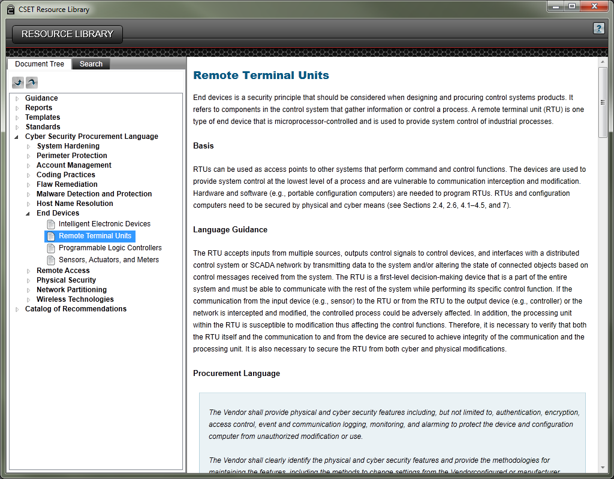

Figure 11-5. Cyber Security Procurement Language.

The example shows the main parts of the tree and the display. You will notice that the final leaf or end topic is exposed by clicking on the branches until the topic is listed, just as the rest of the tree structure works. In this case, instead of a document being opened, the system displays formatted text taken directly from the document.

Each topic includes some or all the following sections:

* Brief Overview of the Topic,
* Basis,
* Language Guidance,
* Procurement Language,
* Factory Acceptance Test (FAT) Measures,
* Site Acceptance Test (SAT) Measures,
* Maintenance Guidance,
* Dependencies, and
* References.

To fully understand how the procurement language was developed, how it is to be used, any limitations and constraints, and general information about the document, you will need to open the document and read the front pages. To access it, click on Search and type in “procurement language.” It will be the first entry in the list.

**Catalog of Recommendations:** This first-level branch will open up the list of topics that are associated with the “Catalog of Control Systems Security: Recommendations for Standards Developers.” Figure 11‑6 shows an example of the subtitle “Organizational Security” opened under the main branch called “Catalog of Recommendations.”

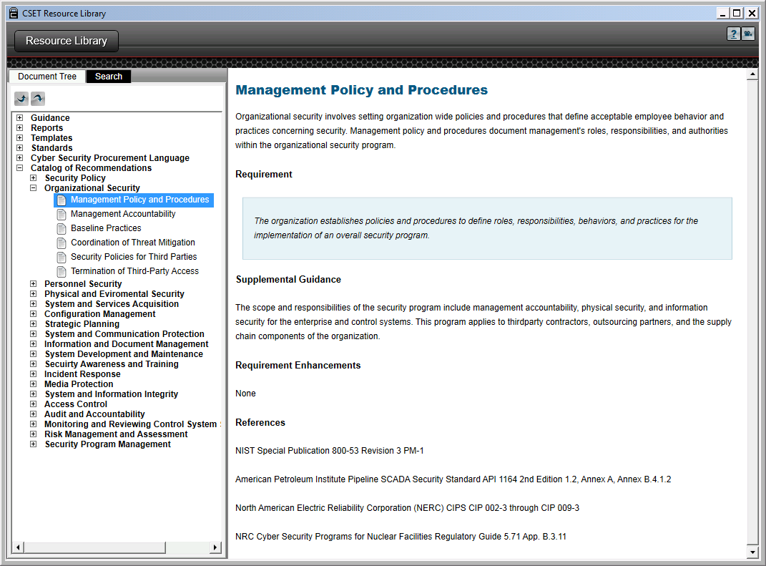

Figure 11-6. Catalog of Recommendations.

Development of the Catalog was originally sponsored by DHS with input from NIST and five national laboratories. Its original intent was to serve as a source of requirements and controls for the developers of ICS standards. The Catalog consolidated the requirements from 15 control systems and information technology standards and has had seven revisions since its inception. Because of its popularity and comprehensive ICS requirements, it has become a principal standard in all versions of CSET and in the ICS community at large, not just among standards developers.

To access a topic, simply click on the branch title in the tree and expose the topics themselves. In the example shown above, “Organizational Security,” was selected; and the topic “Management Policy and Procedures” was chosen.

On the right-hand side of the screen, CSET displays the content from the Catalog.

Each topic includes some or all the following sections:

* Brief Overview of the Topic,
* Requirement Text,
* Supplemental Guidance,
* Requirement Enhancements, and
* References.

Like the procurement language document, to fully understand the background and intent of the Catalog, you will need to open and read the front pages. To access the full document, click on the Resource Library Search and then type in “cor v7.” It will be the first entry in the list.

Search Screen

The Search screen provides a way to find a list of documents based on the text string typed into the text box. Clicking the Search tab opens a search box. Enter the desired text string and click on the magnifying glass or press the keyboard Enter key to begin the search. Figure 11-7 shows an example where the user has typed in the string “Incident.” In this case, the system searches through all the documents for occurrences of “incident” and then ranks and presents them in an ordered list.

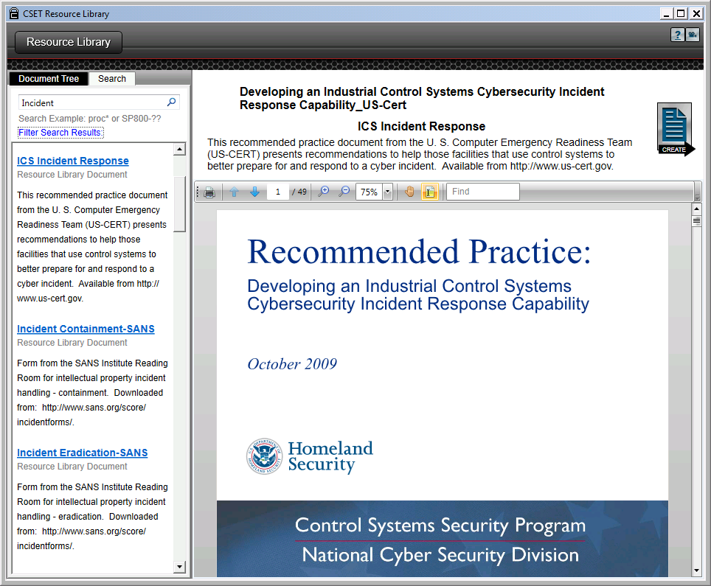

Figure 11-7. Search Screen.

**Wildcards:** There are two different types of “wildcard” characters that you can use in the search. The first is the asterisk character that can be used to substitute for one or more characters. For example, if you typed in “fire*” the search would look for anything starting with those characters and you would see prioritized list starting with topics related to firewalls. Without the asterisk the search would look for “fire” and the first entry would be “Fire Protection.”

You could also substitute exact characters with a question mark. For example, you could type in “NIST SP800-??” to get the NIST special publication 800 series documents where the last two characters are substituted by the wildcard character.

When the system is searching for the text string, it is evaluating both the title and the content of the document. While the search will evaluate against any character string, it is recommended that you be as specific as possible to limit and refine the list. The search is not sophisticated enough to find similar or close spellings. A misspelled word will return no results.

**Topic Searches:** In most cases, you will be searching for a specific subject; however, the search capability can also be used to search for types of documents. In the example above, the returned document is a DHS recommended practice. By entering “recommended practice” in the search text box, you can create a list of all the recommended practices developed by DHS as well as other documents that may use that phrase.

Filtered Search

One additional feature of the search is the ability to filter the output by the type of information (document or topic). Figure 11-8 shows the Resource Library screen with the Filter Search Results option open and the last two topics types selected.

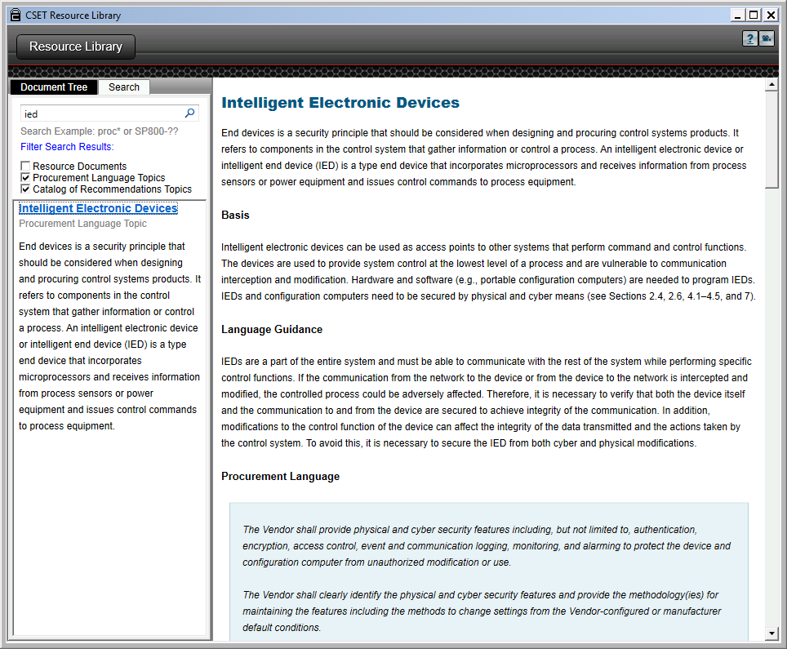

Figure 11-8. Filter Search Results

The “Filter Search Results” link is clicked in the example above. This opens the checkboxes that enable the filtering. By default all result types are enabled. When you click on one or more boxes, you limit the search to only those types. In the figure, for example, the phrase “ied” is only searched for in the Procurement Language and Catalog of Recommendations topic areas. In the case shown, only one result is returned, and it is from the Procurement Language topic list. The user has clicked on the one link with the title “Intelligent Electronic Devices,” and the system has opened up the information related to that topic as shown in the area on the right of the screen.

Document and Topic Display Area

The area to the right of the document tree, or search results, is used to display either the actual document itself or the topic information, depending on what was selected. Figure 11-9 shows the different parts of this display area with a document displayed.

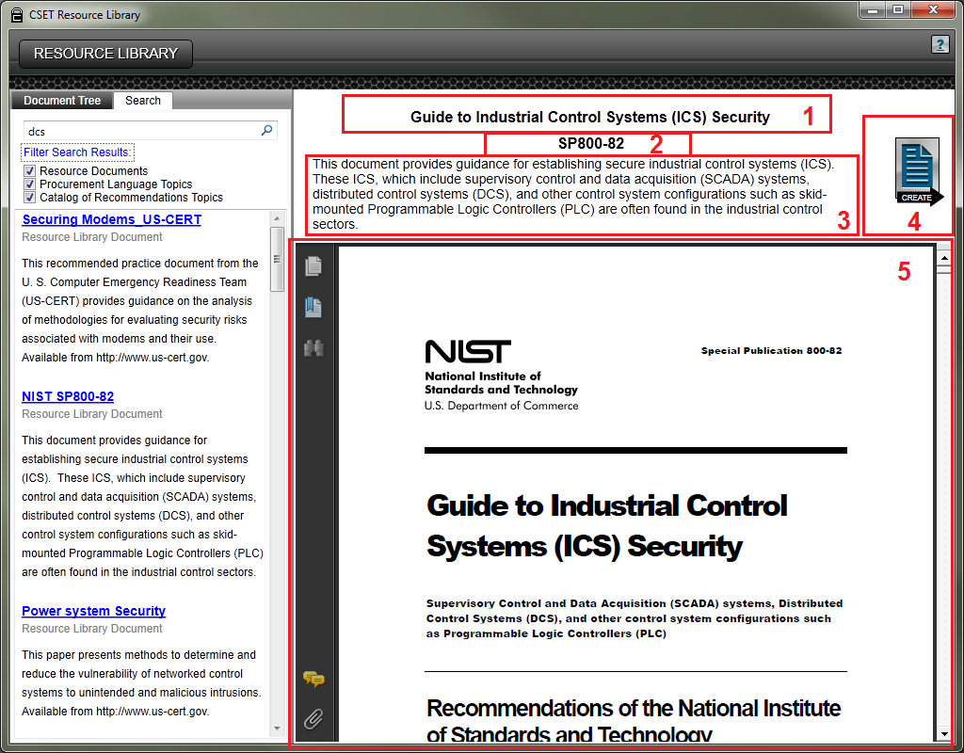

Figure 11-9. Document and Topic Display Area.

Each of the highlighted and numbered areas will be described below.

1. **Document Title:** The top line of the document display is the document title. This is the actual title or an abbreviated title if the document is a memo or other less-structured paper.
2. **Document Label or Abbreviation:** Not all documents will have a label or an abbreviation, but when there is one, it will be displayed below the title. In this example, the label is “SP800‑82.”
3. **Overview or Abstract:** Each document has an associated abstract in CSET. This is typically one paragraph long and is displayed as part of the search results. The statements in Section 3 match the text found under the “NIST SP800-82” hyperlink in the search results area on the left side of the screen. Typically, the abstract is limited to one or two sentences and is intended to provide a brief summation of the document.
4. **Create Button:** This button is used to create a new copy of the document on the workstation in a location that you select. After you click this button, the system opens a directory window that allows you to save the file in a location and with a name of your choosing.
5. **Document Display:** In this screen area, the document itself is opened for display or navigation. Any features that are imbedded in the file, such as bookmarks, destinations, table of contents, etc., will be provided in the viewer.

Document Library

The document library provides a way to see all the files that have been stored in the assessment by the user. During the assessment, a document can be added using the Add Document button on the Question Detail screen which will associate the document with that question. The library can also be accessed using the docking window usually found on the right side of the CSET window. Adding a document this way will not associate it with a specific question.

Figure 11-10 shows an example of the Document Library with several files included. Each of the sections in the window has been labeled and will be explained in the sections below.

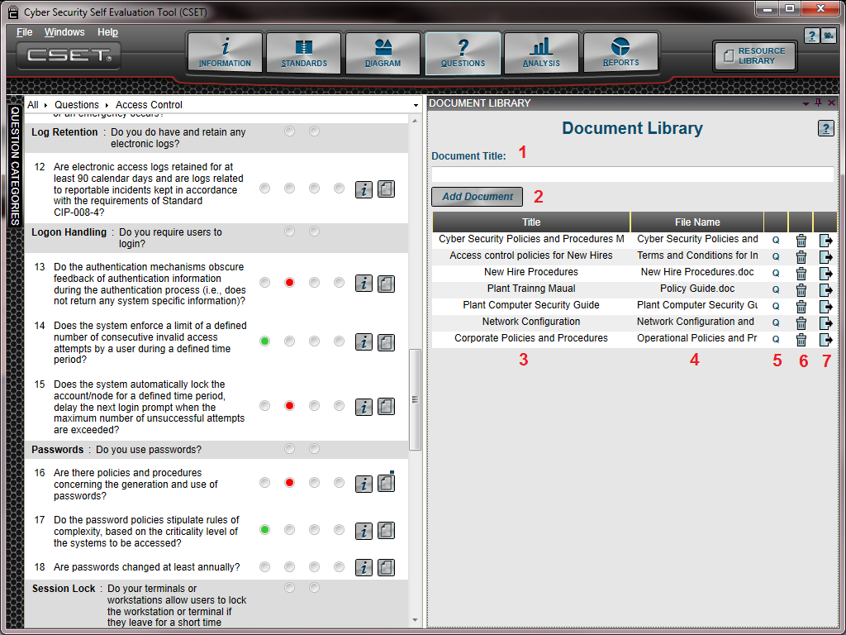

Figure 11-10. Document Library

1. **Document Title:** This field is where you will enter the title or name of the document as it will be identified in the assessment. It is easier to enter the title “before” you add the file. Since there will be times when you are not sure of the title until after you have seen the file name, you may leave this blank and add the title later in the grid. An example is shown under the Number 3 heading.
2. **Add Document:** If you click this button, the system will open a dialog box that will allow you to find and select a file. This will be familiar to you as it uses typical Windows functionality. When you complete the selection process, a new row will be added to the grid with the file name shown in the next open row.
3. **Title Column:** When a document has been added, the title will show in this column. If the title was blank when the file was added, then you can add the title at this time. Figure 11-11 shows an example of the title being added.

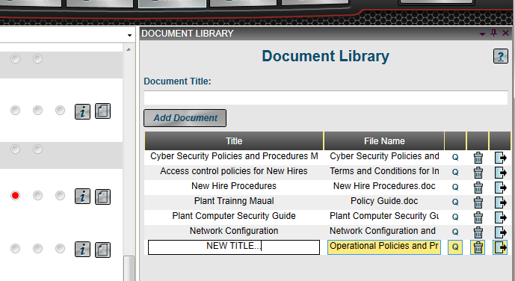

Figure 11-11. Adding a New Title.

To add or change the title, simply double click the mouse in the Title column. The system will display the box as shown in the figure above and while open you can either add or modify the text string.

You will notice the yellow vertical lines that separate the columns. To change the relative size of each column you can click on the yellow line and drag it to the left or right. This will change the heading dynamically as you move it.

1. **File Name:** The name of the file that was selected when you clicked the “Add Document” button is shown in this field. This is for display only. The file name cannot be changed in this field.
2. **Questions Associated with the Document:** The “Q” label for this column stands for questions and will display a list of questions that are associated with this document. Figure 11-12 shows an example of the list box that is displayed when you click on this icon.

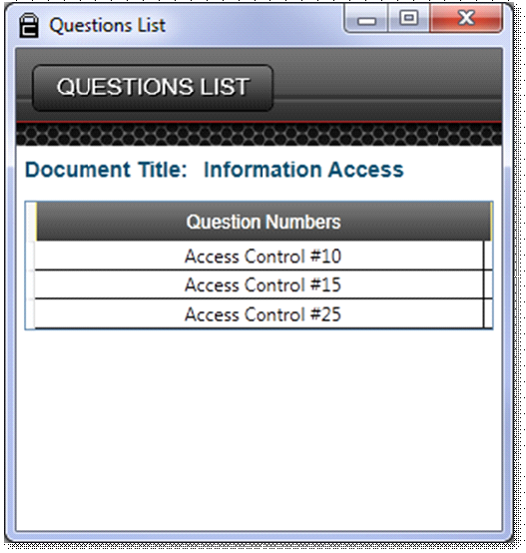

Figure 11-12. Question List

1. **Delete Icon:** The icon that resembles a garbage can will allow you to delete the file from the assessment. Click on the icon next to the file that you want to delete to remove the file from the assessment. It is recommended that you check for questions before you delete the file.
2. **Export File:** The final button in the grid allows you to export the file that is stored in the Document Library. To save the file to a location on your computer or on an accessible drive, click on the icon. The system will display a directory dialog window that you can use to save the file.

ADDITIONAL TECHNICAL GUIDANCE



* Appendix A—Security Assurance Level
* Appendix B—Initiation Scenarios
* Appendix C—NIST Question Downgrade Information
* Appendix D—Upgrade an Older Assessment File
* Appendix E—Use Multiple Assessments (Aggregation)

A) Security Assurance Level



A

The information in this appendix provides additional guidance for users in determining their General Security Assurance Level.

Characterize Assets

This step identifies assets that, if compromised, have the potential to cause undesirable consequences. In addition, assets owned by the organization or in proximity of the compromised facility that could be open to danger should be identified.

The options and resources in the following list may be used, as appropriate, for determining assets:

* Assets identified in risk and vulnerability assessments;
* Capacity, operation, management, and maintenance manuals;
* Risk management program manual;
* Hazardous waste operations and emergency response standards;
* Emergency operations plan, particularly event-escalation criteria;
* Y2K documentation, including asset inventory, criticality determination, contingency plans, etc.;
* Asset inventory and criticality rating in the Computerized Maintenance Management System (CMMS);
* Inventory list of process control/SCADA hardware, including interfaces;
* Safety incident reports indicating accidents or near misses;
* Area maps showing schools, businesses, residential areas, rivers, or other transport paths;
* Population distributions; and
* Wind and water flow maps.

Define Worst‑Case Scenarios

This step helps the assessment team acknowledge and consider the worst‑case scenarios.

In defining worst-case scenarios, it is important to realize that many different ways are available to initiate a compromise of a control system. These include: intentional, directed attacks with the intent of taking control of the system; undirected attacks, such as viruses or worms, that can cause the system to malfunction; and accidents that are caused by or result in inappropriate actions taken by an operator.

The worst-case scenarios should focus on the results, not the method, except as it relates to the compromise. In most cases, an undirected attack will cause problems, such as denial of service, which can shut down the control system and possibly prevent corrective action being taken. Directed attacks can result in an unauthorized person taking control of the system, and then opening or closing valves to create dangerous mixtures or release of materials to the environment.

The secondary consequences of a system compromise should also be considered in developing scenarios. For example, the loss of a power grid supplying power to a large population area may cause a domino effect of further power loss to financial centers, businesses, transportation systems, and heating, cooling for homes, hospitals, schools, etc.

An example of a worst-case scenario might be the intentional and undetected opening of one or more valves causing the release of a toxic material to the atmosphere. The material could then be carried over to a nearby community resulting in injuries, fines, and environmental cleanup costs.

Examples of scenario initiations are provided in Appendix B to stimulate thought and discussion.

Estimate Consequences

Ask these questions. If the identified scenarios were to occur, what would the consequences be to the organization including its customers and the surrounding community? How would the organization be impacted by the following:

* personal health and safety (injury, loss of life);
* loss of capital assets;
* adverse environmental impacts; and
* adverse economic impacts.

The guidelines in this section are provided to assist in estimating a value for the consequences of an undesired event. The guidelines are not prescriptive and do not replace current consequence estimating procedures that the organization may have in place. Each guideline presented in this section correlates to categories contained in questions to determine the SAL for both onsite and distributed assets.

Remember, for a worst-case scenario, select worst-case conditions.

Injury and Loss-of-Life Estimate

Estimates for injury and loss of life can be challenging to determine. To estimate the number of people at risk for each scenario, consider the agents that would cause injury or death, their impact area, and the method of transport. Also, there may be several different agents for a single scenario, such as the force of an explosion, a subsequent fire, and the release of toxic materials.

The tool divides affected persons into two groups: personnel that are onsite and people that are outside the facility boundaries (i.e., people in the surrounding communities). Start by counting the number of people most likely to be onsite or in the area of the distributed asset and then estimate the number of people outside the facility boundaries that could be affected. Different times of the day or different environmental conditions could exacerbate the situation.

The tool also breaks injuries into two categories: injuries that do not require hospital stay and injuries that do require hospital stay. For example, minor exposures to contaminates that can be treated with an eyewash or shower are not as serious as those requiring hospitalization because of a more serious exposure.

Capital Asset Loss Estimate

Capital assets are tangible property used by the organization or community such as buildings, machinery, fixtures, furniture, and equipment.

To estimate the organizational capital asset loss, perform the following steps:

* Determine the total estimated value of each potentially impacted site or distributed asset for each example scenario. The following is a typical list of asset types to consider:
* Buildings, including all structures that serve as buildings, such as permanently established trailers.
* Machinery and equipment, including all motor vehicles (licensed and nonlicensed), trailers, construction and maintenance equipment, fixtures, computers, and office furniture.
* Estimate structure losses (structure replacement value multiplied by the estimated damage in percent). For example, if a plant’s structure replacement value equals $100,000, and the expected damage is 40 percent of the structure, then the loss to this structure is $40,000.
* Estimate content losses (content replacement value multiplied by the estimated damage in percent). For example, if the plant’s content replacement value equals $225,000, and the expected damage is 10 percent of the contents, then the losses to these contents are $22,500.
* Structure and content loss are calculated as

For each asset,   
Structure loss ($) = (structure replacement value) x (% damage)   
Contents loss ($) = (replacement value of contents ($)) x (% damage)

To estimate the community capital asset loss:

* Estimate the value of capital assets that are within the impact area of the scenario and the estimated extent of damage to these capital assets. The same process described for determining organizational assets can be used for determining community assets.

Environmental Impacts

Impacts to the environment can be wide ranging and have far-reaching consequences. These consequences may include cleanup, as a minimum, remediation, and investigations with fines from regulatory agencies. Calculate the environmental consequence by estimating costs for the following:

* direct labor (for cleanup, remediation, etc.);
* contractor (for cleanup, remediation, etc.);
* equipment;
* rented equipment;
* materials;
* fees for permits;
* community mitigation efforts (e.g., portable toilets);
* investigation support;
* fines; and
* material disposal.

Economic Impact

The economic impact due to a worst-case scenario may include costs associated with loss of production, impact to reputation, damage or loss of finished product or feed stock, damage to or loss of the control system due to cyber damage requiring reprogramming of machines or rewriting of code, damage to the physical control hardware would be included under capital equipment, corrective action to prevent similar intrusions in the future, possible law suits, etc.

Losses associated with production are much easier to estimate than some of the other impacts. Production losses can be estimated using the following recommendations:

* Determine functional downtime or the time (in days) that the function would be disrupted because of the event.
* Estimate the average number of days various functions might be unavailable following a worst‑case scenario occurrence.
* Estimate the daily cost of the functional downtime. Divide the average annual budget by 365 to determine the average daily operating budget or sales. Multiply the average daily operating budget by the functional downtime to determine the cost of the loss of function for the period that the service was unable to operate because of the event.
* For example, if a plant has an annual budget of $6,000,000 and an average daily budget of $16,438 ($6,000,000/365), the losses could be estimated by using the annual budget as a proxy for the value of the service to the community. For example, if the plant were down for 7 days, then the cost for the loss of use for 7 days would be $115,066 ($16,438x7).
* Determine the displacement time, or the time in days, that a function may need to operate from a temporary location, if applicable.
* For example, if the administration building is inaccessible for 7 days (functional downtime) and operations are resumed from a trailer for the next 90 days, then the displacement time would be 90 days. Not all functions would require displacement before resuming operation.
* Multiply the displacement cost by the displacement time to determine the cost of the displacement from the regular place of business, as:

For each asset, structure use and function loss =   
(average daily operating budget ($)) x (functional downtime (# of days)) +   
(displacement cost per day ($)) x (displacement time (# of days))

Loss of finished product and feed stock can be estimated by using historical accounts of the amount of product kept onsite at any time. This may be either a maximum (worst case) or an average amount. The cost of the feed stock would be the replacement cost. If not having the feed stock on hand impacts the ability to restart the system, this would also affect loss of production. The loss of finished product would be the cost of producing the lost amount of finished product. This could be determined by using production history as well.

The cost of cyber damage to the control system must be estimated based on what is most likely to be affected according to the scenario. The scenario may require the control system software to be rebuilt or the control code to be reworked, or it may just require that an antivirus program be run on the system. The cost of this effort needs to be estimated. It may also require investigation of what caused the problem and the costs of reworking the system in order to implement a fix.

The economic impact because of loss of reputation or lawsuits is much harder to estimate. History of similar incidents either within the organization or within similar organizations might provide an indication of the potential economic impact.

EVALUATE TOTAL IMPACT

After evaluating each of the consequences and their costs, determine if areas are either counted twice or might mitigate or enhance the impact of the individual consequences. These may need to be adjusted. With these final figures, answer the questions for determining the SAL.

B) Initiation Scenarios



B

The following initiation scenarios are provided as an overview of typical security vulnerabilities associated with shared control system and business system infrastructure or control systems connected to other external networks (hereafter any noncontrol system is referred to as an external network). It is intended that this information will stimulate thought and discussion for the team performing a CSET® assessment, specifically, in determining a SAL. This overview is not intended to be a comprehensive review of all potential threats or vulnerabilities.

Three aspects must be considered when assessing the security posture of a control system:

* **Availability**. The system must be ready and able to store and transmit data when needed.
* **Integrity**. The data stored or transmitted by the system must be complete and correct (not corrupted).
* **Confidentiality**. The system must be able to store and transmit data without unauthorized disclosure of sensitive information.

The following pages describe a “typical” industrial control system/external network environment and provide examples of risks, exposures, and vulnerabilities that are commonly encountered in such environments.

**Typical Mixed‑Use Control/External Network Environment**

In a typical mixed‑use environment, there is separation between industrial control systems and external networks, but both rely on some amount of shared infrastructure (e.g., communications links). Although separated, some connectivity between these networks exists (e.g., public Web or application servers).

There are typically distinct but interconnected networks, including the following:

* **Control system.** The control system consists of servers, workstations, and devices associated with the industrial control systems. Multiple separate systems may be in use and individual systems may span multiple sites.
* **Business Network.** The business network consists of servers and workstations associated with typical office productivity applications, such as email and word processing, as well as specialized applications such as for human resources, payroll, and billing.
* **Other Networks.** These consist of other city, state, federal, or outside agency networks connected via dedicated communications, Virtual Private Networks (VPNs), or other means. Typically, access from such networks is controlled via a firewall. Connections to other networks may be trusted or untrusted.
* **Internet.** For the public Internet, typically, access is allowed to the outside for business use (e.g., email, Web browsing) and limited services may be accessed externally (e.g., Web access to public information). Such access is controlled via a firewall, and the Internet is treated as an untrusted network.
* **Shared Infrastructure.** While the industrial control system and business environments are distinct, there are touch points between them.

Because of the costs and complexity associated with wide area networks, it is common to allow both industrial control system and normal business communications to share the same physical infrastructure.

The need to share information may drive the use of portals between networks in a “dual‑homed” configuration—with direct connection to both networks—or shared servers may be placed on a demilitarized zone network between the industrial control system and the business.

Industrial control system personnel with the need for business application access may be provided workstations that are dual‑homed or provided access to the business network from their industrial control system workstations, or vice versa.

It is important to appreciate the complexity of ensuring security in such environments. While individual products, systems, or networks may be secure when taken individually, they may not be adequately secured or protected in a complex deployment.

Common Initiation Scenarios

The following scenarios describe common security issues that can initiate a worst-case scenario. The scenarios could impact the operation of a facility causing damage, loss of production, impacts to health, safety, and the environment, or other economic impacts. These issues could, in turn, impact system availability, integrity, and confidentiality in a typical mixed‑use environment. These scenarios are provided as food for thought in developing an organization’s worst‑case scenario and the resulting consequences.

Scenario 1: Privilege Escalation

In this scenario, an unknown party (attacker) is able to access sensitive data or systems by means of existing network connections. This access may be gained by a number of means, including:

* **Insufficiently Protected Networks.** Restrictions between networks may be nonexistent, poorly implemented, or may rely on excessive levels of trust between networks.
* **Privilege Escalation.** The outsider, or in some cases an insider, may access a public or loosely secured system with limited functionality and then use that system to “hop” to more sensitive functions. By hopping between systems, the attacker appears to be operating from inside the trusted network.
* **Poorly Secured Resources.** A determined attacker can potentially exploit a number of system weaknesses, including but certainly not limited to the following:
* Unsecured Default Accounts. The attacker leverages widely known default accounts and passwords to gain access.
* Poorly Secured Services. The attacker uses weaknesses in running services and applications to gain access to increased access levels (i.e., gaining access to sensitive system files).
* Weak Network Services. The attacker uses known vulnerabilities in services and applications to execute programs to gain further levels of access.

The attacker might proceed as follows:

1. Identifying the software running on the Web server. While doing simple Internet searches, the attacker locates software capable of exploiting vulnerabilities within the Web server software or the current configuration of the server to allow execution of programs on the Web server.
2. Executing a remote shell (command prompt) on the Web server to launch software identifying internal hosts. Upon discovery of an “interesting” server (the Control system Historian in this example), the attacker attempts to gain access using well‑known default accounts (i.e., Guest), eventually discovering a little‑used account with a default, or easily guessed password to gain access.
3. Using the trust associated with the Control system Historian to gain access to the industrial control system network. In poorly secured systems, there may be excessive trust between “inside” servers and the industrial control system, which can allow easy access. Once in, the attacker uses additional probes to gain access to industrial control systems and to install software, view and manipulate data, or perform any other desired function.

Any such intrusion impacts the industrial control system network at multiple levels:

* **Availability.** Through intentional or accidental reconfiguration, the attacker may disable essential system services, or introduce software (i.e., spam generators) that disrupts the network because of the traffic loads generated.
* **Integrity.** Unauthorized manipulation of data can be done at the attacker’s whim. This may range from simple curious tinkering to direct attempts to impact the industrial control system.
* **Confidentiality.** Sensitive system functions may be identified, and data may be accessed and disseminated to unknown third parties.

Scenario 2: Traffic Sniffing

In this scenario, shared network infrastructure (e.g., hubs, switches, routers) is used for both the industrial control system and business. An unauthorized user (attacker) on a nonindustrial control system network is able to “sniff” network traffic and capture login credentials (username, password), sensitive data, and network information.

The attacker might proceed as follows:

1. In a direct attempt to sabotage the industrial control system, or simply out of curiosity, the attacker installs packet capture (sniffer) software to monitor traffic on the network. This software is capable of capturing any visible traffic and may include the means to circumvent protection offered by switches. In an extreme case, the attacker can use man‑in‑the‑middle attacks to circumvent encryption. Such software can be monitored in real time or simply run in the background to capture traffic of interest. In particular, user login IDs and passwords can be captured in this manner.
2. An authorized user eventually connects to the industrial control system using authentication credentials (username and password). Because of weaknesses in the application, the password is not encrypted or is encrypted using weak and easily circumvented techniques.
3. Having captured the login session, the attacker simply extracts the password from the network traffic stream (if clear text) or runs a password-cracking program against it (if encrypted). Once the user account details are known, the attacker is free to impersonate that user and gain access to the industrial control system.

Any such attack impacts the industrial control system network at multiple levels:

**Availability.** The attacker may intentionally or inadvertently disable the user account. Changes to device configurations may result in a loss of use.

**Integrity.** With access into the system, the attacker can make further attempts to use the same credentials on other systems. Unauthorized manipulation of data can be done at the attacker’s whim. This may range from simple curious tinkering to directed attempts to impact the industrial control system.

**Confidentiality.** Once user credentials are compromised, the attacker may impersonate the user at will. Sensitive system functions may be identified, and data may be accessed and disseminated to unknown third parties.

Scenario 3: Introduction of Malicious Software from Outside the System

In this scenario, a workstation used by an authorized user is compromised by means of malicious software, or malware such as Trojan horses, viruses, or worms (in any combination). Such software is typically written to allow the attacker to generate spam emails.

The sequence of events might occur as follows:

1. A user on an operator workstation with either connections into both networks (dual‑homed) or an internal industrial control system workstation with access to the outside inadvertently downloads a program via an email attachment. Although most users know not to run programs from unknown outsiders, simple carelessness or a well‑crafted “social engineering” message appearing to come from Network Support might convince them to launch the attached program. The program exploits vulnerability in the workstation operating system to install malware (a worm). Once installed, the worm begins replication thus filling the memory.
2. Eventually, the sheer volume of traffic generated by multiple copies of the worm running on the network overwhelms lower-speed Wide Area Network (WAN) links, resulting in loss of communications or a denial of service.

Any such attack impacts the industrial control system network at multiple levels, such as:

**Availability.** The most likely impact is network disruption due to the sheer volume of worm‑related traffic (e.g., probes, spam, and bounce email messages.)

**Integrity.** Remote-control software allows the attacker unrestricted access to the compromised system. If the attacker has some means of accessing the system, unauthorized manipulation of data can be done at the attacker’s whim. This may range from simple curious tinkering to directed attempts to impact the industrial control system.

**Confidentiality.** If remote-control software is installed, sensitive system functions may be identified and data accessed and disseminated to unknown third parties.

C) CSET ACCESSIBILITY Features

C

CSET® Accessibility Features

The features and functions within CSET have been developed to support application users with accessibility requirements. Industry standards have been followed to take advantage of accessibility features built into the Windows 7 operating system and the .NET architecture. These combined capabilities support compliance with Section 508 of the U.S. Rehabilitation Act.

**Note:** The Diagram and Analysis functionality of CSET has not been made accessible or compliant to Section 508 requirements. Accessibility for the diagram functionality can be mostly accomplished by using Microsoft Visio when working with diagrams. Accessibility for the analysis functionality can be accomplished by printing the reports or producing an on-screen version of the reports. Reports can be generated in .PDF, .DOC, and .DOCX formats. All other areas of the CSET application have been developed to meet the accessibility capabilities listed below.

Screen Readers

CSET has been tested with the JAWS screen reading software to ensure that the JAWS reader will read the main text areas and controls of CSET.

High Contrast Functionality

All text areas on CSET other than the Diagram and Analysis pages support switching to High Contrast mode through the Windows operating system.

Keyboard Access

CSET is accessible from the keyboard. All areas of the application other than the Diagram and Analysis pages can be accessed from the keyboard. Most keyboard access is implemented through the access or hot keys listed below with other access accomplished by using TAB and ARROW keys for navigation and SPACE and ENTER keys for selection:

Access Keys

Options Window

Create New Assessment (ALT + N)

*Close Advisory Screen* (ALT + F4)

Open Last Assessment (ALT + L)

Open an Existing Assessment (ALT + E)

Use Multiple Assessments (ALT + M)

View User Guide (ALT + G)

View Video Tutorial (ALT + V)

Help (ALT + H)

Exit Application (ALT + X)

Recovery Window

Open Assessment O

Close Window C

Menu

**File Menu** (ALT + F)

Save Assessment (ALT + F) + S

Save Assessment As… (ALT + F) + A

Close Assessment (ALT + F) + C

Exit (ALT + F) + X

**Windows Menu**  (ALT + W)

Information Screen (ALT + W) + I

Standards Screen (ALT + W) + S

*General SAL Determination* (ALT + W) + N

*NIST SAL Determination* (ALT + W) + T

Questions Screen (ALT + W) + Q

*Question Categories* (ALT + W) + C

Diagram Screen (ALT + W) + D

Symbol Palette (ALT + W) + Y

*Diagram Properties* (ALT + W) + P

Analysis Screen (ALT + W) + A

Reports Screen (ALT + W) + R

Document Library (ALT + W) + O

Resource Library (ALT + W) + L

**Help Menu** (ALT + P)

Help (ALT + L) + H

User Guide (ALT + L) + G

Video tutorials (ALT + L) + V

Access Keys (ALT + L) + K

About (ALT + L) + A

Main Window

Analysis Screen (ALT + A)

Diagram Screen (ALT + D)

User Guide (ALT + G)

Help Window (ALT + H)

Information Screen (ALT + I)

Resource Library Window (ALT + L)

General SAL Determination Window (ALT + N)

Document Library Dock Window (ALT + O)

Questions Screen (ALT + Q)

Reports Screen (ALT + R)

Standards Screen (ALT + S)

NIST SAL Determination Window (ALT + T)

Exit Application (ALT + X)

Next Content Screen N

Previous Content Screen P

General Security Assurance Level Determination

Close Window, Save SAL O

Close Window, Don’t Save SAL C

NIST Security Assurance Level Determination

Close Window, Save SAL O

Close Window, Don’t Save SAL C

Aggregation

To move through tabs (CTRL + Tab)

D) Upgrade an Older Assessment File

D

CSET® allows you to import and upgrade an assessment that was performed in a previous version of CSET. Figure D-1 shows the Start or Welcome screen where you will initiate the process to import and map an assessment from earlier versions of the tool.

 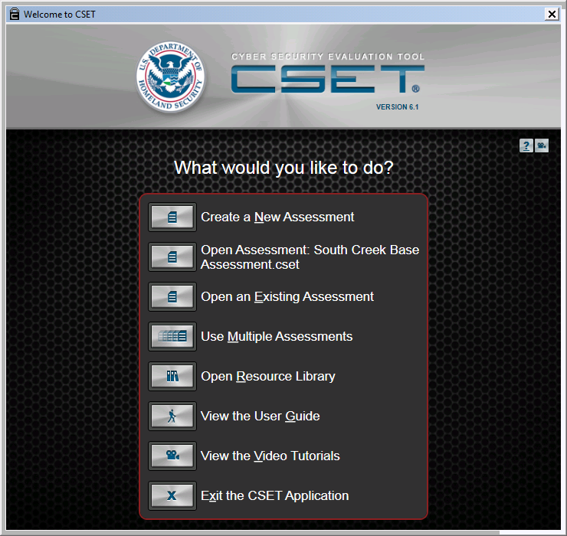

Figure D-1. CSET Welcome Screen.

To find the assessment, click on the “Open an Existing Assessment” button on the navigation screen. The system will then display a file selection dialog screen that will allow you to find and open the assessment. Assessment files created with recent versions of CSET will have a “**.cset**” file extension and will open normally. Assessment files created with older versions of CSET will have a “**.orxml**” file extension. These will have to go through an upgrade process before they can be opened in the current CSET version.

When you select a file that has the file type “**.orxml**,” the system will display the pop-up screen shown in Figure D-2.



Figure D-2. Upgrade Notification Screen.

This screen informs you that you have selected a file created in an earlier version of CSET and then allows you to continue with the upgrade or cancel and return to the navigation screen. Click “Yes” to proceed with the upgrade.

After you have clicked the Yes button, the system will display the Upgrade an Older Assessment File screen as shown in Figure D-3.

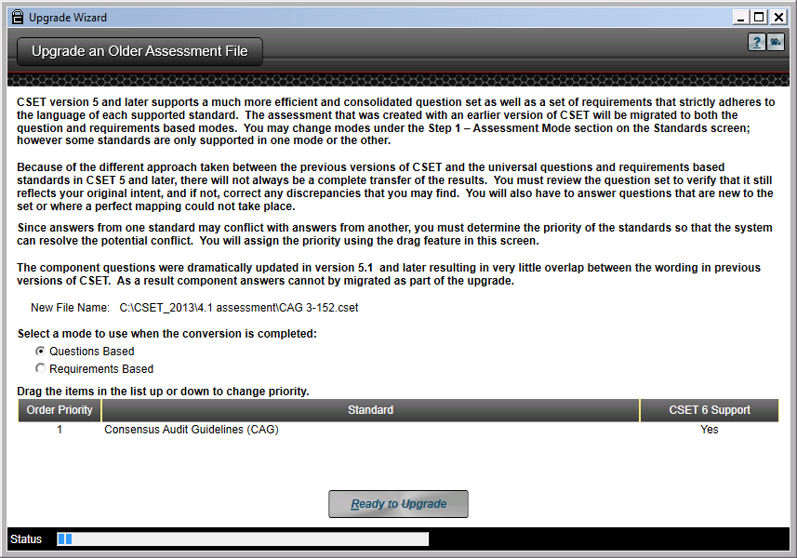

Figure D-3. Upgrade an Older Assessment File.

This process will map answers from previous releases of CSET to both the questions and requirements-based modes in the current release of CSET. Because of the version differences, you will need to review the results of the upgrade and make sure that the intent of your previous answer has been maintained.

For example, CSET Version 5 marked a dramatic change from previous releases in both approach and underlying architecture. Questions that were developed for the previous releases are now mapped separately into both the Universal Questions and into the Requirements-based questions. Because of the different approach used with the questions between releases, it is unlikely that there will be a perfect match. (The exception would be where there are an extremely high number of no responses, and they would translate across to no answers in the current version.)

In versions of CSET prior to Version 5, a single requirement may have been broken out into two or even three questions. Each question may have several basic requirements, and some requirements also include control enhancements, as well as the typical negative response and not applicable. When mapping to later versions, the system connects the responses in the best way possible.

In the sections “Mapping to Universal Questions” and “Mapping to Requirements Based Question” found below, the mapping will be explained in greater detail.

Screen Features

Important areas on the Upgrade screen are as follows.

1. **Disclaimer Text:** These top paragraphs provide a warning that all questions may not transfer fully into the latest release of CSET. The final sections of this appendix provide a more detailed explanation as to how the mapping takes place.
2. **New File Name:** This is the name that was selected in the file selection dialog box. You must verify that this is the correct assessment file to upgrade.
3. **Mode:** This is the mode that will be set after the conversion has been completed. The selection of the mode here will not affect how the file is processed. Rather, it will simply set the mode when it is done. You can change this mode in the Standards Screen later if desired.
4. **Standard Priority List:** If you have used multiple standards in the assessment file that you are upgrading, there may be cases where a similar answer from one question is not answered the same way in another one. This situation may result from slight differences in the wording between standards, misinterpretations of the question and intent, i.e., different people answering each standard in a different way, or simple mistakes in recording answers.

Because of the potential for differences, it is necessary that priority should be given to one set of answers over another. To set the order, you must click and drag the highest standard to the top of the list, (the Number 1 position). You then move the others around to set the order.

The tool will perform the conversion by starting with the lowest priority standard and then proceed to the Number 1 standard with the latest value overwriting and taking precedence over any previous answers. This is true only in the questions-based approach, because each standard is handled directly in the requirements‑based approach.

Mapping to Universal Questions

Figure D-4 shows an example of how the system maps questions from a standard in CSET 4.1 to the Universal Questions first introduced in CSET 5.0.

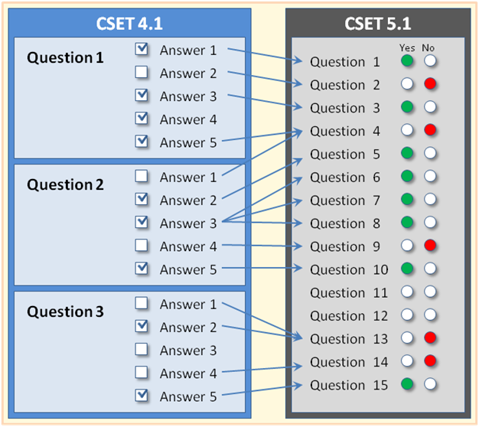

Figure D-4. CSET 4.1 Standard to Universal Questions.

The example above shows a set of three questions in a prior release of CSET; in this case Version 4.1. These questions may have come from the same requirement but the focus is on the topic or subject area and not on the base requirement. In fact, each of the three questions could have come from different standards altogether.

In the example, you are able to see that there is not a pure one-to-one mapping. Question 1, Answers 1-3, all map across to the first three questions in the current version of CSET. Question 4 in CSET 4.1 was a redundant question or perhaps just not relevant and so it was not mapped. Question 4 in the current version was a combined question from the original Question 1, Answer 5 and Question 2, Answer 1. Notice that because one answer was not checked, the mapped answer is “no” even though one of the original answers was “yes.” In another example, Question 2, Answer 3 was broken out in the current version to three different questions, (Questions 6-8). Also, Questions 11 and 12 are new, and so they are left unanswered because nothing maps to them. Other similar situations are shown through the remaining questions and answers.

The example was simplified to show only yes and no answers. The upgrade process will also take into account questions that were marked as Not Applicable and those that used an alternative approach. The system treats these in a similar manner to the yes/no answers.

Mapping to Requirements-Based Questions

Figure D-5 shows an example of the mapping between a previous standard, such as used in CSET 4.1, and a requirement found in the current version.

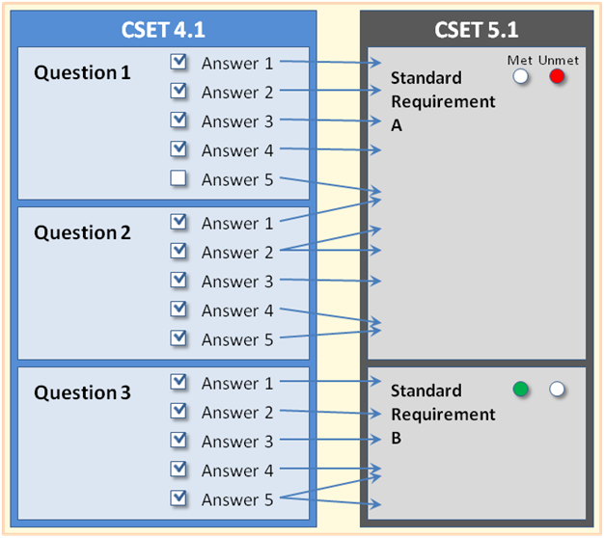

Figure D-5. CSET 4.1 Standard to Requirements.

The requirements-based approach is simpler and more straightforward than the mapping of the Universal Questions. Because of this there is a much higher transfer rate of answers.

In the example shown above, there are again three questions; however, this time they must be from the same standard. Questions 1 and 2 were taken from a single requirement in the standard and broken out in a previous release to make it more manageable. In the mapping, all the answers in the question are considered when deciding if the requirement was met or unmet. In this case, everything was met except for Question 1, Answer 5. Because all answers are required, the Standard Requirement A in the current version is marked as Unmet.

In Question 3, all the answers are checked, and so when the mapping takes place, Standard Requirement B in the current version will be marked as Met.

Component Questions

In Release 5 of CSET, the component questions were completely rewritten both for clarity and to support the new way of handling default questions. While mapping the questions between the 5 release and previous releases, it became evident that only a small percentage of questions could accurately be brought forward while still maintaining the integrity of the question and answer wording. In addition, those answers that did come across introduced greater complexity by creating unique answers for specific component types and components, in many cases making the new default approach almost useless. It was soon evident that it would take longer and be far more onerous for a user to try and work with a set of exceptions created by the transfer than to just answer the component questions from scratch. As a result, the decision was made to not bring across any of the component questions.

E) Use Multiple ASsessments (AGGREGATION)



E

This appendix provides additional information on the aggregation function in CSET. It is accessed by selecting the Use Multiple Assessments button at the Start or Welcome screen as shown in Figure E-1.

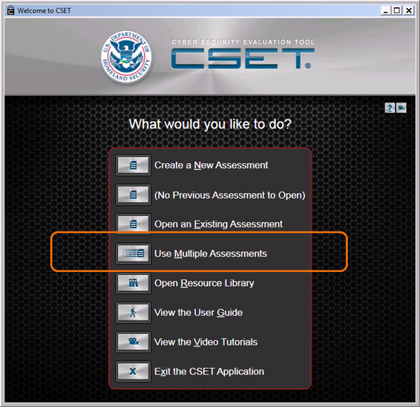

Figure E-1. Use Multiple Assessments Option.

Aggregation means that you want to work with two or more assessments rather than just create a new one. There are three types of aggregation; Trend, Compare, and Merge.

1. Trend shows cumulative changes to a facility over time by analyzing several assessments of the same facility completed, say, annually.
2. Compare looks at multiple assessments to determine their strengths and weaknesses, and creates a summary compliance report. This would be helpful for a facility consisting of several sites, each with their own complete assessment.
3. Merge, also called Combine, melds several partial assessment files into a cohesive whole in the case where the assessment teams were each assigned a portion of the assessment and each created an incomplete assessment file answering only their assigned questions.

The analysis result of Trend and Compare is a report. The result of the Merge function is a new CSET assessment file.

Add Assessments

In order to use these aggregation types, you must first load the subject assessments. To do so, click the Add Assessments button. A file browser window will open allowing you to select the desired files. You may select one or multiple assessment files. Continue adding files until the desired assessments are loaded. Be aware that more assessments take more time to load and analyze. It is recommended that no more than five assessments be analyzed at a time. Figure E-2 shows the Aggregation screen with files added.



Figure E-2. Add Assessments Screen.

The first column in the files table is simply a numerical identifier.

The second column is used to delete the file. Click the “X” to do so.

The Status column is a pass/fail flag showing the success or failure of the file upload.

The Alias is a short nickname used to quickly identify the assessment in the analysis charts. The pre-populated name may be changed by clicking within the box and typing the desired alias.

The Assessment Name comes from the user-entered name supplied under the information tab during the assessment.

The Default flag indicates which assessment will be used as the baseline for the aggregation. Other assessments will be added to it or trending will start from that one. Mode, SAL, and assessment information come from the default assessment. The default assessment is the top one in the list. To change the default, use drag and drop functionality to reorder the listed files.

The File Name is the name of the computer file uploaded to this table.

The Assessment Date comes from the user-entered date supplied under the information tab during the assessment.

The Mode indicates the user-selected option of Questions Based versus Standard Requirements Based approach for the Assessment Mode made under the Standards tab during the assessment.

The Diagram column contains a button which opens the network diagram for that assessment in a non-editable form.

The remaining columns will change depending on the assessments added. They show which standards or questions sets are included in each assessment.

The compatibility estimates reflect the similarity of the standards addressed by the loaded assessments. It is not an estimate of how alike the answers are among the assessments. A low compatibility number means there is little overlap in the questions contained within the loaded standards or in the requirements selected for the assessments.

Screen Features

**Tabs:** Notice that there are two tabs at the top of the screen; Add Assessments and Information. The Add Assessments tab is the default screen shown above. The Information tab, shown in Figure E-3, is similar to the assessment information filled in at the start of a normal assessment, except that it applies to the aggregation rather than an assessment. It provides the user an opportunity to add information identifying the aggregation, the facility, and the participants. Comments and an executive summary may also be added. Some of the fields are pre-populated with text from the default assessment, but it may be edited by the user. This information will be included in the aggregation report or in the new aggregation file.

The Information Tab becomes active only after selecting an aggregation type. At least two assessments must be loaded for the aggregation to be performed.

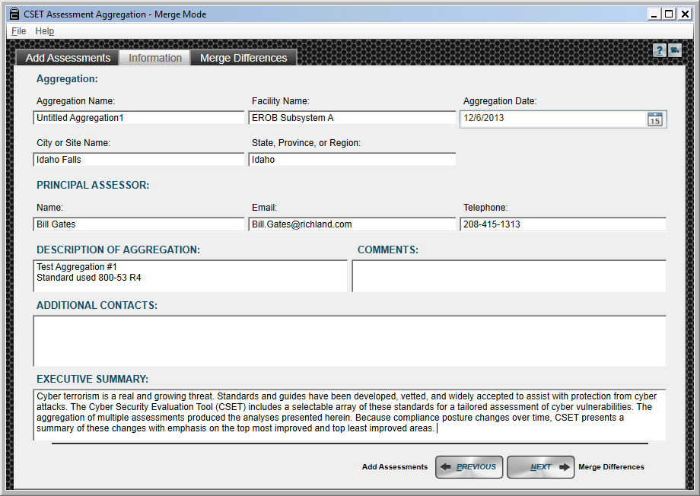

Figure E-3. Aggregation Information Tab.

**Menu Options:** At the top left of the screen are the menu options of File and Help.

File Menu: The options are found under the File menu are similar to those found under the File menu in the normal CSET screen, except they apply to aggregation files rather than assessment files. An aggregation file is identified by a **.cseta** extension. It contains the aggregation information such as the files included in the aggregation, text found under the information tab, and any answers provided for the merge function. An aggregation file is not a report of the aggregation results nor is it the new assessment created after a merge.

If you were to start an aggregation but wish to review it later, the File menu allows you to save it to your computer. You may then open it without waiting for the assessment files to load and the aggregation analysis to complete. Closing an aggregation returns the user to the CSET start screen. Clicking Exit closes CSET.

The options found under the File menu are New, Open, Open Last Aggregation, Save Aggregation, Save Aggregation As, Close Aggregation, and Exit.

Help Menu: The options under the Help menu are the same as those found under the normal CSET Help menu. They are Help, User Guide, Video Tutorials, and About. They are explained elsewhere in this User Guide.

Summary Analytics

**Perform the Analysis:** Once the assessment file table is complete, click the Trend, Compare, or Merge button to begin the analysis. Depending on the number and size of the selected assessment files, analysis may take a few moments. Clicking an aggregation type will add tabs across the top of the screen. Click the new tab to see the results of the aggregation analysis.

**Summary Analytics:** Click this tab to see the graphical results of the aggregation. The displayed information changes with the type of aggregation selected.

**Summary Analytics for Trend**

The analysis for a trend aggregation presents several graphs as shown by Figure E-4. The first graph displays overall compliance by percent ranged over the time covered by the loaded assessments, with components and standards broken out separately. The next graphs on the left side show the top five most and least improved security topic areas, again over the time covered by the assessments analyzed.

The graph on the right side breaks out compliance of each assessment by category. The A, B, C, etc., is the alias assigned to an assessment file under the Add Assessments tab.

A printable report may be created by clicking the Generate Report button. The report will include the information from this analysis screen, the information included under the Information tab, and the Mode and SAL from the default assessment, which is the top one on the list under the Add Assessments tab.

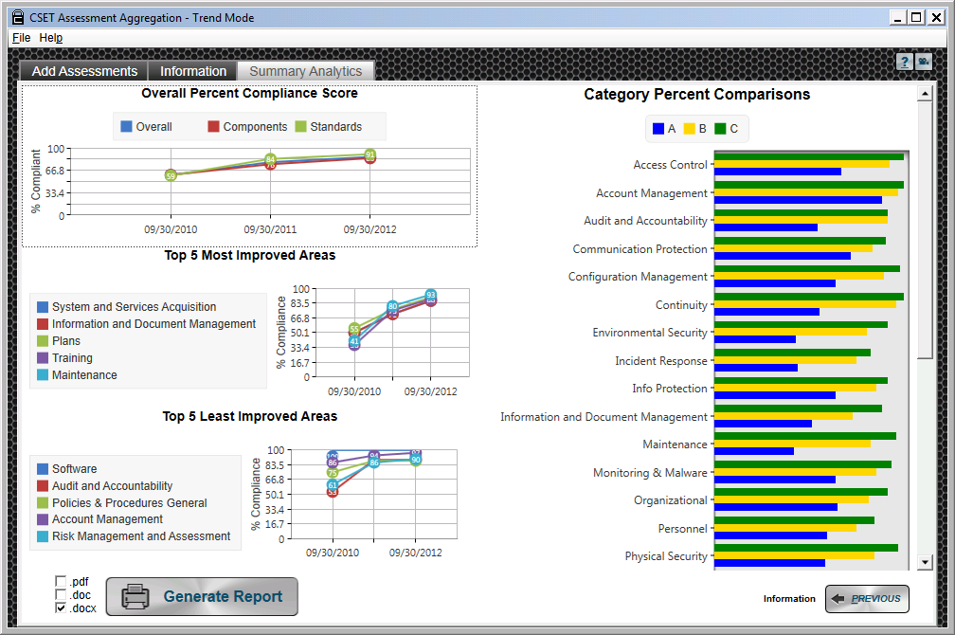

Figure E-4. Summary Analytics for Trend.

**Summary Analytics for Compare**

The analysis for a comparison aggregation is more complex. The Summary Analytics screen has additional tabbed headings as shown in Figure E-5. These are Overall Summary, Top Commonly Missed Questions, Individual Assessment Comparison, and Best to Worst.

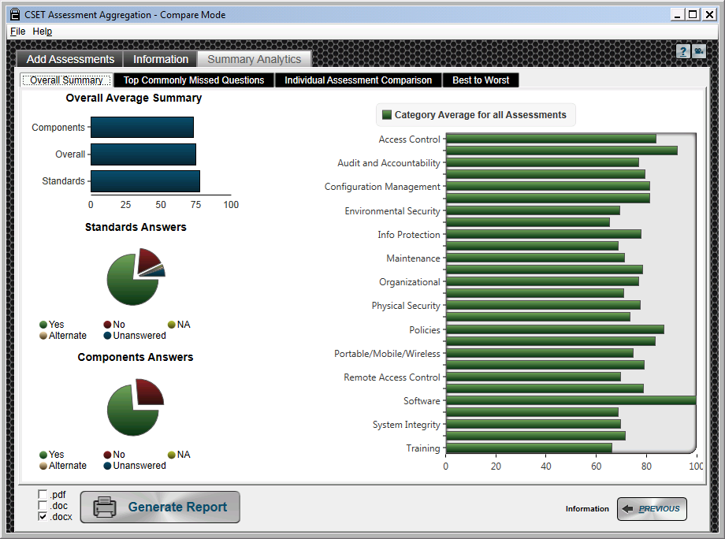

Figure E-5. Summary Analytics for Compare.

Overall Summary: This tab is opened by default after clicking the Summary Analytics tab and presents compliance information by standard versus component (left side charts) and by security category (right side).

Top Commonly Missed Questions: This tab shown in Figure E-6 presents a table of missed questions from all the assessments analyzed listed by category and subcategory. A missed question is one either answered “No” or not answered at all (skipped). Answers of “Yes,” “N/A,” or “ALT” are not included in the table.

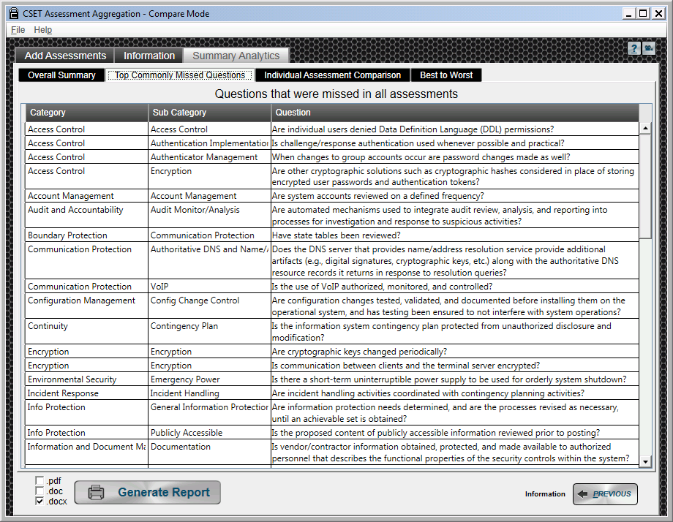

Figure E-6. Top Commonly Missed Questions

Individual Assessment Comparison: This screen, shown in Figure E-7, is similar to the Overall Summary, except that it breaks out the information by assessment. A table shows the total answers given by assessment. Next, a chart displays compliance by components and standards, by assessment. The last graph on the left provides the SAL of each assessment to aid in identifying the high risk facilities.

The right side of the screen shows the compliance status of each assessment by category. The A, B, C, etc., are the aliases as shown under the Add Assessments tab.

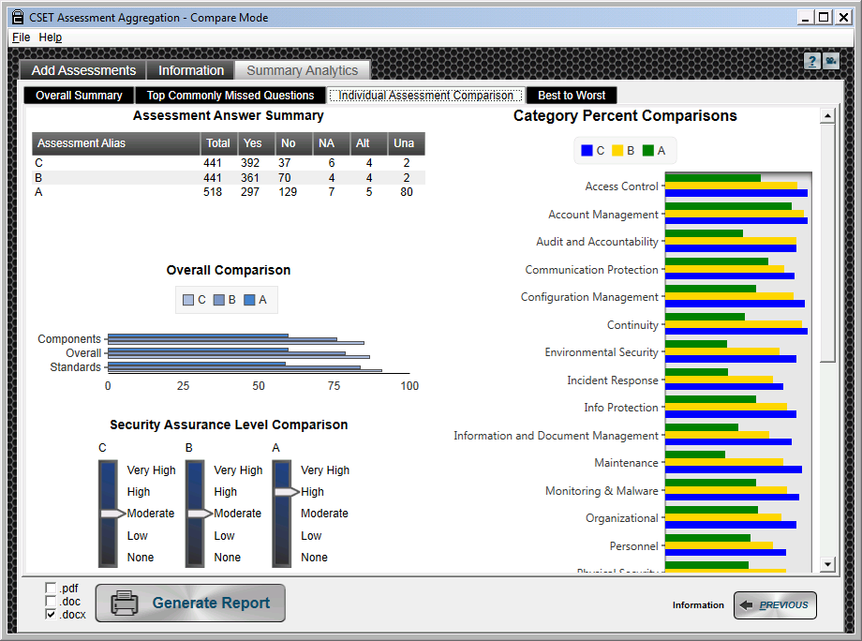

Figure E-7. Individual Assessment Comparison.

Best to Worst: This screen requires the user to select a topic on the left before the graph on the right is populated. Figure E-8 provides an example with Account Management selected.

The graph presents the percent of each answer option by assessment. The bars are ordered to show the most compliant assessment at the top and the least compliant at the bottom. Again, the assessments are labeled using the alias assigned under the Add Assessments tab.

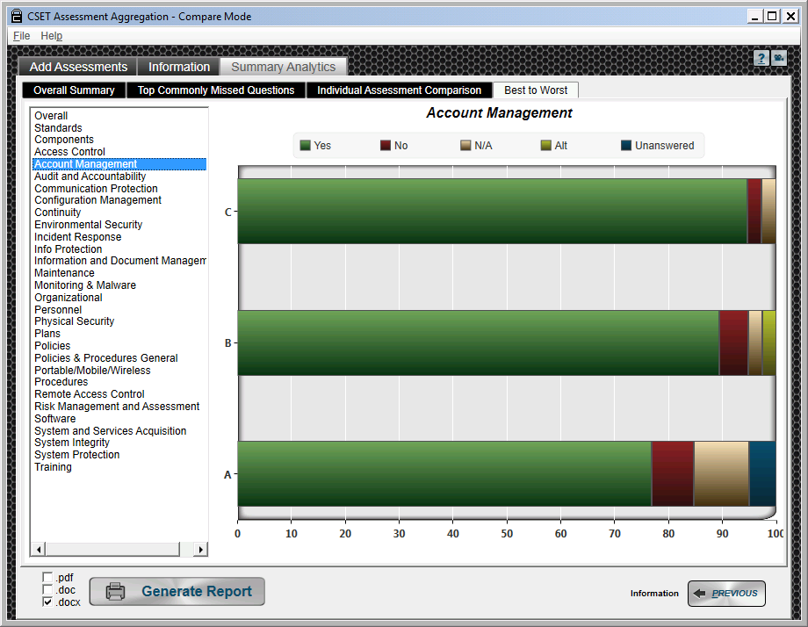

Figure E-8. Best to Worst.

**Summary Analytics for Merge**

The merge function often requires additional input from the user before the aggregation can be completed. Because multiple assessments will be combined into a single assessment, each question may only have one answer. If a question was answered differently among the assessments to be merged, the correct or final answer must be identified. This is done under the Merge Differences tab.

Merge Differences: Click this tab to resolve the problem of different answers being given for the same question. Click a subject area to open it. The table shows the problem question(s) and allows the user to select the desired answer.

If the question was answered in the default assessment, that answer will be pre-populated in the table. To keep that answer, do nothing. To change that answer, click another radio button.

If the question was not answered (left blank) in the default assessment, the answer provided by the second assessment in the Add Assessments screen list will be shown. If not answered in the second assessment, the answer from the third assessment will be used, and so on.

If no answer is pre-populated, that means it was not answered in any of the assessments and must be answered here. If not, it will count as a failed question during assessment analysis and in the printed reports. Continue the process until all the problem questions are resolved.

To save time, the option to accept all answers shown under a subject area is provided. Click the check box labeled Resolve to accept the pre-populated answers to the questions under that topic.

The checkboxes to the left of the questions are to help the user keep track of which questions have been resolved and which have not. A checkmark is automatically added if an answer if changed. A checkmark can be added manually if the pre-populated answer is acceptable.

If the resolution step is skipped altogether and no resolutions are made, the Merge function will use the answers shown on this screen. That means it will accept the answer provided by the default assessment if there was one, or leave the question blank if it was not answered in the default assessment. Blank or skipped answers are considered failed or noncompliant during analysis and in the printed reports. Figure E-9 shows an example screen with Account Management opened for resolution.

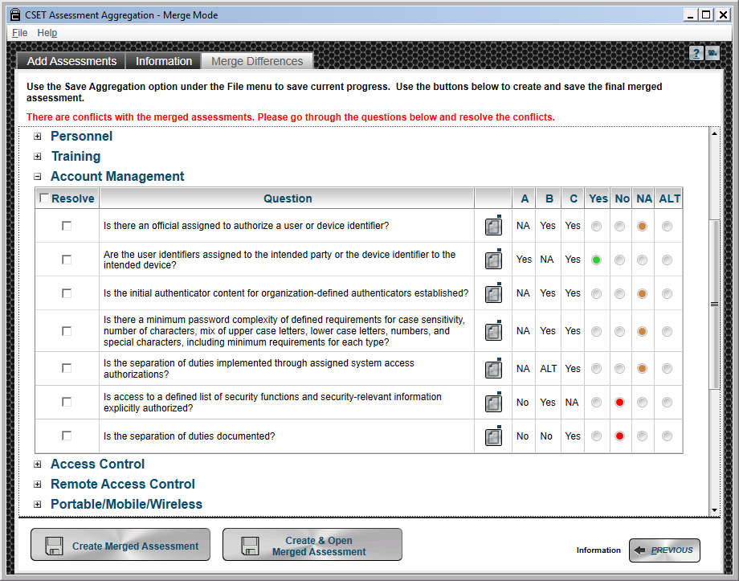

Figure E-9. Merge Differences.

Merge Question Detail Information: Clicking the paper icon in the column next to the question text will open the Merge Question Detail Information screen. Here you can see and edit the comments or alternate text that were entered in any of the subject assessments for that question. You can also see any documents that were saved with a particular assessment and whether the question was marked for review in any of the assessments. The reconciled comments and alternate text entered here will be included in the final merged assessment. Figure E-10 shows the screen.

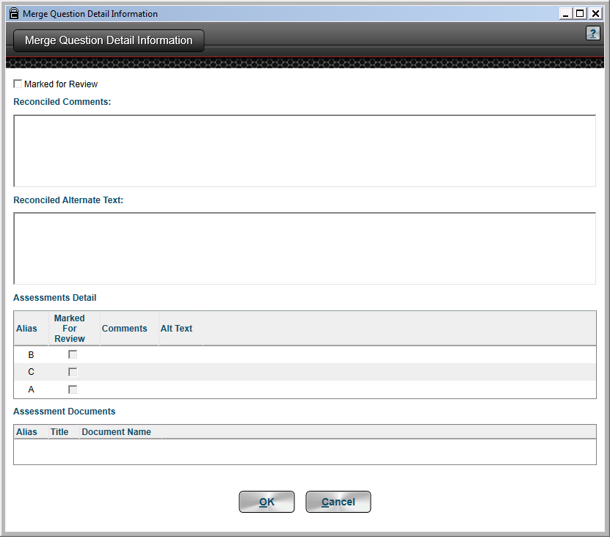

Figure E-10. Merge Question Detail Information.

If you wish to pause while completing the question resolutions, you can save your progress by using the Save Aggregation option under the File menu. This will save the loaded assessment files, the aggregation information, and the question resolutions completed so far. The saved file may be opened later to complete the merge aggregation process. The saved file is not the merged assessment. To create and save the final merged assessment, use the buttons at the bottom of the screen.

Create Assessment: Because the merge function creates a new assessment file rather than a series of charts, there is no button to generate a report. Instead, the create assessment buttons allow the user to create and then name and save the merged information as a new assessment. The new assessment can be opened in CSET just like any other assessment. Clicking Create Merged Assessment allows you to name and save the file. Clicking Create and Open Merged Assessment allows you to name and save the file which then automatically opens in CSET.

Changing Assessment Files: The system will warn you if you try to change assessment files while in the Merge process as this will negate any resolution of question differences that have been completed. Deleting or adding assessments will produce the warning messages shown in Figures E-11 and E-12.

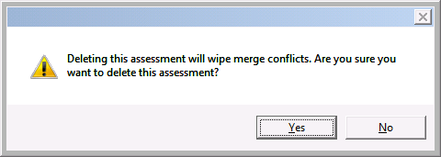

Figure E-11. Merge Warning for Delete

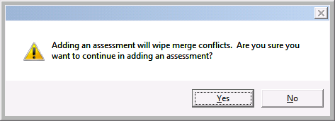

Figure E-12. Merge Warning for Add

F) Cybersecurity Framework



F

This appendix provides additional information on the assessment mode called Cybersecurity Framework Based. This functionality was added to CSET in response to Executive Order 13636, “Improving Critical Infrastructure Cybersecurity” issued on February 12, 2013 which calls for the development of a voluntary risk—based Cybersecurity Framework. The Framework consists of three parts: the Framework Core, the Framework Implementation Tiers, and the Framework Profile.

Framework Core

The Framework Core is a set of cybersecurity activities and references that are common across critical infrastructure sectors organized around particular outcomes. The Core presents standards and best practices in a manner that allows for communication of cybersecurity risk across the organization from the senior executive level to the implementation/operations level. The Framework Core consists of five Functions—Identify, Protect, Detect, Respond, Recover—which can provide a high-level, strategic view of an organization’s management of cybersecurity risk.

The Functions are described as follows:

* Identify. Develop the organizational understanding to manage cybersecurity risk to systems, assets, data, and capabilities.
* Protect. Develop and implement the appropriate safeguards to ensure delivery of critical infrastructure services.
* Detect. Develop and implement the appropriate activities to identify the occurrence of a cybersecurity event.
* Respond. Develop and implement the appropriate activities to take action regarding a detected cybersecurity event.
* Recover. Develop and implement the appropriate activities to maintain plans for resilience and to restore any capabilities or services that were impaired due to a cybersecurity event.

The Framework Core then identifies underlying key Categories and Subcategories for each of these Functions, and matches them with example Informative References such as existing standards, guidelines, and practices for each Subcategory. This structure ties the high level strategic view, outcomes and standards based actions together for a cross-organization view of cybersecurity activities.

The Framework stems from the principle of common criteria. Common criteria processes are particularly useful as a driving force for the mutual recognition and adoption of secure IT products. By using a common criteria framework, users can develop a common understanding of their security requirements (their protection profile) and communicate these to vendors, business partners, and sector associations.

The Functions and Categories are identified as shown in Figure F-1.

|  |  |  |  |
| --- | --- | --- | --- |
| Function Unique Identifier | Function | Category Unique Identifier | Category Name |
| ID | Identify | ID.AM | Asset Management |
| ID.BE | Business Environment |
| ID.GV | Governance |
| ID.RA | Risk Assessment |
| ID.RM | Risk Management Strategy |
| PR | Protect | PR.AC | Access Control |
| PR.AT | Awareness and Training |
| PR.DS | Data Security |
| PR.IP | Information Protection Processes and Procedures |
| PR.MA | Maintenance |
| PR.PT | Protective Technology |
| DE | Detect | DE.AE | Anomalies and Events |
| DE.CM | Security Continuous Monitoring |
| DE.DP | Detection Processes |
| RS | Respond | RS.RP | Response Planning |
| RS.CO | Communications |
| RS.AN | Analysis |
| RS.MI | Mitigation |
| RS.IM | Improvements |
| RC | Recover | RC.RP | Recovery Planning |
| RC.IM | Improvements |
| RC.CO | Communications |

Figure F-1. Function and Category Identifiers

The Framework Core represents a common set of activities for managing cybersecurity risk. In other words, it presents what owners and operators of cyber—assets should do to secure their systems. While it is not exhaustive, it is extensible, allowing organizations, sectors, and other entities to use Subcategories and Informative References that are cost-effective and efficient and that enable them to manage their cybersecurity risk.

As an example, the recommended activities for Asset Management are shown in Figure F-2. The actions listed under Subcategory will, when implemented, increase cybersecurity and decrease risk. The provided references are the standards and guidelines from whence the recommended actions were derived.

|  |  |  |  |
| --- | --- | --- | --- |
| Function | Category | Subcategory | Informative References |
| IDENTIFY  (ID) | Asset Management (AM): The personnel, devices, systems, and facilities that enable the organization to achieve business purposes are identified and managed consistent with their relative importance to business objectives and the organization’s risk strategy. | ID.AM-1: Physical devices and systems within the organization are inventoried | * ISA 99.02.01 4.2.3.4 * COBIT BAI03.04, BAI09.01, BAI09, BAI09.05 * ISO/IEC 27001 A.7.1.1, A.7.1.2 * NIST SP 800-53 Rev. 4 CM-8 * CCS CSC1 |
| ID.AM-2: Software platforms and applications within the organization are inventoried | * ISA 99.02.01 4.2.3.4 * COBIT BAI03.04, BAI09.01, BAI09, BAI09.05 * ISO/IEC 27001 A.7.1.1, A.7.1.2 * NIST SP 800-53 Rev. 4 CM-8 * CCS CSC 2 |
| ID.AM-3: The organizational communication and data flow is mapped | * ISA 99.02.01 4.2.3.4 * COBIT DSS05.02 * ISO/IEC 27001 A.7.1.1 * NIST SP 800-53 Rev. 4 CA-3, CM-8, CA-9 * CCS CSC 1 |
| ID.AM-4: External information systems are catalogued | * COBIT 5 APO02.02 * ISO/IEC 27001:2013 A.11.2.6 * NIST SP 800-53 Rev. 4 AC-20, SA-9 |
| ID.AM-5: Resources (e.g., hardware, devices, data, and software) are prioritized based on their classification, criticality, and business value | * COBIT 5 APO03.03, APO03.04, BAI09.02 * ISA 62443-2-1:2009 4.2.3.6 * ISO/IEC 27001:2013 A.8.2.1 * NIST SP 800-53 Rev. 4 CP-2, RA-2, SA-14 |
| ID.AM-6: Cybersecurity roles and responsibilities for the entire workforce and third-party stakeholders (e.g., suppliers, customers, partners) are established | * COBIT 5 APO01.02, DSS06.03 * ISA 62443-2-1:2009 4.3.2.3.3 * ISO/IEC 27001:2013 A.6.1.1 * NIST SP 800-53 Rev. 4 CP-2, PS-7, PM-11 |

Figure F-2. Framework Core Example.

Each asset owner and operator should review the cited references to determine if additional activities are needed to secure their specific systems. For low—risk assets, some of the recommended activities may be postponed or removed in the interest of allocating resources to securing higher—risk systems.

Framework Tiers

Framework Implementation Tiers (“Tiers”) provide context on how an organization views cybersecurity risk and the processes in place to manage that risk. The Tier selection process considers an organization’s current risk management practices, threat environment, legal and regulatory requirements, business/mission objectives, and organizational constraints. The Tiers characterize an organization’s practices over a range, from Partial (Tier 1) to Adaptive (Tier 4), progressing from informal, reactive implementations to approaches that are agile and risk-informed.

Figure F-3 lists the risk categories and tier levels. A tier is applied to each of the risk categories. The tiers are described below and presented in relation to each category.

| Risk Categories |  | Tiers |
| --- | --- | --- |
| Risk Management Process |  | Tier 1: Partial |
| Integrated Risk Management Program |  | Tier 2: Risk Informed |
| External Participation |  | Tier 3: Repeatable |
|  |  | Tier 4: Adaptive |

Figure F-3. Risk Categories and Tiers.

**Tier 1: Partial**

* Risk Management Process – Organizational cybersecurity risk management practices are not formalized, and risk is managed in an ad hoc and sometimes reactive manner. Prioritization of cybersecurity activities may not be directly informed by organizational risk objectives, the threat environment, or business/mission requirements.
* Integrated Risk Management Program – There is limited awareness of cybersecurity risk at the organizational level and an organization-wide approach to managing cybersecurity risk has not been established. The organization implements cybersecurity risk management on an irregular, case-by-case basis due to varied experience or information gained from outside sources. The organization may not have processes that enable cybersecurity information to be shared within the organization.
* External Participation – An organization may not have the processes in place to participate in coordination or collaboration with other entities.

**Tier 2: Risk Informed**

* Risk Management Process – Risk management practices are approved by management but may not be established as organizational-wide policy. Prioritization of cybersecurity activities is directly informed by organizational risk objectives, the threat environment, or business/mission requirements.
* Integrated Risk Management Program – There is an awareness of cybersecurity risk at the organizational level but an organization-wide approach to managing cybersecurity risk has not been established. Risk-informed, management-approved processes and procedures are defined and implemented, and staff has adequate resources to perform their cybersecurity duties. Cybersecurity information is shared within the organization on an informal basis.
* External Participation – The organization knows its role in the larger ecosystem, but has not formalized its capabilities to interact and share information externally.

**Tier 3: Repeatable**

* Risk Management Process – The organization’s risk management practices are formally approved and expressed as policy. Organizational cybersecurity practices are regularly updated based on the application of risk management processes to changes in business/mission requirements and a changing threat and technology landscape.
* Integrated Risk Management Program – There is an organization-wide approach to manage cybersecurity risk. Risk-informed policies, processes, and procedures are defined, implemented as intended, and reviewed. Consistent methods are in place to respond effectively to changes in risk. Personnel possess the knowledge and skills to perform their appointed roles and responsibilities.
* External Participation – The organization understands its dependencies and partners and receives information from these partners that enables collaboration and risk-based management decisions within the organization in response to events.

**Tier 4: Adaptive**

* Risk Management Process – The organization adapts its cybersecurity practices based on lessons learned and predictive indicators derived from previous and current cybersecurity activities. Through a process of continuous improvement incorporating advanced cybersecurity technologies and practices, the organization actively adapts to a changing cybersecurity landscape and responds to evolving and sophisticated threats in a timely manner.
* Integrated Risk Management Program – There is an organization-wide approach to managing cybersecurity risk that uses risk-informed policies, processes, and procedures to address potential cybersecurity events. Cybersecurity risk management is part of the organizational culture and evolves from an awareness of previous activities, information shared by other sources, and continuous awareness of activities on their systems and networks.
* External Participation – The organization manages risk and actively shares information with partners to ensure that accurate, current information is being distributed and consumed to improve cybersecurity before a cybersecurity event occurs.

It is important to note that successful implementation of the Framework is based upon achievement of the outcomes described in the organization’s Target Profile(s) and not upon Tier determination.

Framework Profiles

The Framework Profile (“Profile”) is the alignment of the Functions, Categories, and Subcategories with the business requirements, risk tolerance, and resources of the organization. A profile enables organizations to establish a roadmap for reducing cybersecurity risk that is well aligned with organizational and sector goals, considers legal/regulatory requirements and industry best practices, and reflects risk management priorities. Given the complexity of many organizations, they may choose to have multiple profiles, aligned with particular components and recognizing their individual needs.

Framework Profiles can be used to describe the current state or the desired target state of specific cybersecurity activities. They support business/mission requirements and aid in the communication of risk within and between organizations. They can reveal gaps to be addressed to meet cybersecurity risk management objectives. Profiles can be used to conduct self-assessments and communicate requirements and results within an organization or between organizations.

CSET Implementation

The Cybersecurity Framework is fully implemented in CSET and integrated into existing functionality for ease of use. The Framework option is selected at the Standards screen. Next, the tiers are established. To aid in selecting the correct tier, a Cybersecurity Framework Tier Determination Wizard is available to help select the appropriate tier in each category for the facility being assessed.

Creation of a profile is the next step. This is vital to implementing the Framework. CSET allows the user to use a default profile which is pre-loaded with all the recommended activities (requirements) found in the Framework Core. New profiles may also be produced. This allows for creation of a requirement set uniquely tailored to the organization’s cybersecurity needs. The user can add or remove recommended activities in the form of questions or requirements to suit the organization’s risk posture and resources. Specific questions can be added to existing categories and new categories with their own question sets can be added to a profile. Target profiles can be created to serve as goals for tracking security improvement progress over time. These tailored profiles can be saved, exported, and shared with other sites, divisions, or business partners to better communicate requirements and to increase uniformity of assessment results.

See the sections on selecting the mode and standards and determining the SAL for information on using the tier and profile screens.

Once the desired profile is selected, the user proceeds to the Question screen to address the framework requirements. The recommended activities are presented as statements in keeping with the source document. Any questions added to the profile by the user are also displayed. Figure F-4 presents an example Question screen showing the Identify>Asset Management activities used as an example earlier in this section. The same requirements seen under the Subcategory heading in the Framework source document are listed in the CSET Question screen. The Informative References from the Framework are presented as linked documents under the heading Help Documents. Clicking the drop‑down button to the right of the statements displays the questions related to that statement. They are taken from the NIST standard listed as an Informative Reference in the Framework document. They are provided as information only to help better understand the context of the statement.

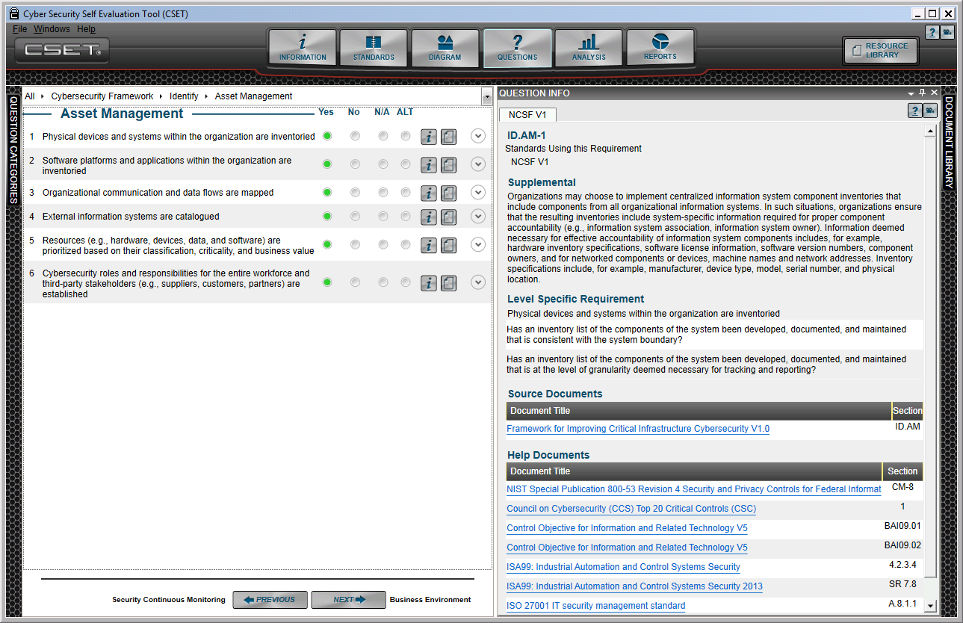

**Related question drop-down**

**Recommended activities from the Framework Subcategory**

**Link to Framework source document**

**Links to Informative Reference documents**

Figure F-4. Framework Question Screen.

Figure F-5 shows the Question screen with the drop‑down list expanded. Click the Drop‑down button again to close the related question list.

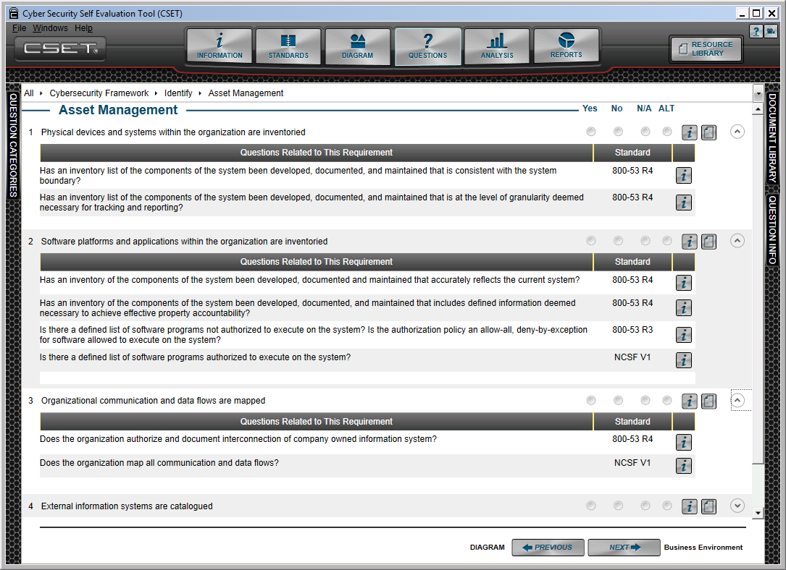

Figure F-5. Expanded Drop-Down List.

Once all the requirements and questions have been addressed, the user may move to the Analysis and Reports sections of CSET for a summary of compliance results. The Analysis section provides an on—line compliance summary. The Reports section generates printable reports that may be reviewed by management so that any needed security improvement tasks can be identified, prioritized, funded, and scheduled.

G) Glossary



G

Acronyms

| Acronym | Definition |
| --- | --- |
| CAG | Consensus Audit Guidelines |
| CFATS | Chemical Facility Anti-Terrorism Standards |
| CIP | Critical Infrastructure Protection |
| CNSSI | Committee on National Security Systems Instruction |
| CoR | Catalog of Recommendations |
| CSET | Cyber Security Evaluation Tool |
| DCS | Distributed Control System |
| DHS | U. S. Department of Homeland Security |
| DoD | U. S. Department of Defense |
| FIPS | Federal Information Processing Standards |
| HMI | Human-Machine Interface |
| ICS | Industrial Control Systems |
| IDS | Intrusion Detection System |
| INGAA | Interstate Natural Gas Association of America |
| IT | Information Technology |
| MAC | Mission Assurance Category |
| N/A | Not Applicable |
| NEI | Nuclear Energy Institute |
| NERC | National Electric Research Council |
| NIST | National Institute of Standards and Technology |
| NRC | Nuclear Regulatory Commission |
| PDF | Portable Document Format |
| PLC | Programmable Logic Controller |
| RBPS | Risk-Based Performance Standards |
| RG | Regulatory Guidelines |
| SAL | Security Assurance Level |
| SCADA | Supervisory Control and Data Acquisition |
| SP800 | Special Publication 800 |
| TSA | Transportation Security Administration |
| URL | Uniform Resource Locator |

Key Terms

|  |  |
| --- | --- |
| Term | Explanation |
| Admin Questions | Questions spawned by the tool in response to the applied standards the user selects. |
| Assessment Report | A summary report of results for each question including user responses, statement of actual requirements (or deficiencies), answers in relation to the overall SAL, and associated help documents. |
| Classified Information | Any information or material that has been determined by the U.S. Government pursuant to an executive order, statute, or regulation, to require protection against unauthorized disclosure for reasons of national security (Classified Information Procedures Act, 18 U.S. Code App. 3, Section 1(a)). |
| Component Diagram | A network topology that best represents the industrial control system configuration. Diagram includes typical components associated with a control system such as Connector, Firewall, Network Router, Network Switch, Serial Switch, Network Hub, Modem, Programmable Logic Controller, remote terminal unit, HMI, Engineering Workstation, Intrusion Detection System, Wireless Access Point, Serial Radio, Application Server, Database Server, Terminal Server, Web Server, Virtual Private Network, Link Encryption, DCS, Printer, and Clock. |
| Component Questions | A generated list of control system cybersecurity questions based on the defined SAL and components contained within the network topology. |
| Confidentiality Level | Applicable to DoD information systems, the confidentiality level is primarily used to establish acceptable access factors, such as requirements for individual security clearances or background investigations, access approvals, and need‑to‑know determinations; interconnection controls and approvals; and acceptable methods by which users may access the system (e.g., intranet, Internet, wireless). The DoD has three defined confidentiality levels: classified, sensitive, and public. |
| Critical Asset | Those facilities, systems, and equipment, which if destroyed, damaged, degraded, or otherwise rendered unavailable, would have a significant impact on the ability to serve large quantities of customers for an extended period of time, would have a detrimental impact on the reliability or operability of the electric grid, or would cause significant risk to public health and safety. |
| Document Library | Repository of documents added to the assessment by the user. |
| Document repository | Electronic copies of associated industrial control systems security documentation are included in the tool for reference, including federal codes, and industry standards and guidelines. |
| Mission Assurance Category | Applicable to DoD information systems, the mission assurance category reflects the importance of information relative to the achievement of DoD goals and objectives. Mission assurance categories are primarily used to determine the requirements for availability and integrity. The DoD has three defined mission assurance categories: MAC I, MAC II, and MAC III. MAC I systems require the most stringent protection measures. |
| Public Information | Official information that has been reviewed and approved for public release by the information owner. |
| Security Assurance Level | The relative consequences of a successful attack against the control system being evaluated. The consequence analysis identifies the worst, reasonable consequence that could be generated by a specific threat scenario. The General SAL provides an overall rating of the criticality based on the users’ review of security threat scenarios and estimated consequences.  The General SAL ranges from Level 1 to Level 5 with Level 5 denoting the most risk and highest potential consequence of an accident or attack. |
| Security Categories | The security categories are related to the NIST 800-53 standards and are defined as:  CONFIDENTIALITY  “Preserving authorized restrictions on information access and disclosure, including means for protecting personal privacy and proprietary information…”  A loss of confidentiality is the unauthorized disclosure of information.  INTEGRITY  “Guarding against improper information modification or destruction, and includes ensuring information non-repudiation and authenticity…”  A loss of integrity is the unauthorized modification or destruction of information.  AVAILABILITY  “Ensuring timely and reliable access to and use of information…”  A loss of availability is the disruption of access to or use of information or an information system. |
| Security Categorization | The NIST 800-53-related security categorizations of Low, Moderate, and High are explained as:  LOW:  The loss of confidentiality, integrity, or availability could be expected to have a limited adverse effect on organizational operations, organizational assets, or individuals.  AMPLIFICATION: A limited adverse effect means that, for example, the loss of confidentiality, integrity, or availability might: (i) cause a degradation in mission capability to an extent and duration that the organization is able to perform its primary functions, but the effectiveness of the functions is noticeably reduced; (ii) result in minor damage to organizational assets; (iii) result in minor financial loss; or (iv) result in minor harm to individuals.  MODERATE:  The loss of confidentiality, integrity, or availability could be expected to have a serious adverse effect on organizational operations, organizational assets, or individuals.  AMPLIFICATION: A serious adverse effect means that, for example, the loss of confidentiality, integrity, or availability might: (i) cause a significant degradation in mission capability to an extent and duration that the organization is able to perform its primary functions, but the effectiveness of the functions is significantly reduced; (ii) result in significant damage to organizational assets; (iii) result in significant financial loss; or (iv) result in significant harm to individuals that does not involve loss of life or serious life threatening injuries.  HIGH:  The loss of confidentiality, integrity, or availability could be expected to have a severe or catastrophic adverse effect on organizational operations, organizational assets, or individuals.  AMPLIFICATION: A severe or catastrophic adverse effect means that, for example, the loss of confidentiality, integrity, or availability might: (i) cause a severe degradation in or loss of mission capability to an extent and duration that the organization is not able to perform one or more of its primary functions; (ii) result in major damage to organizational assets; (iii) result in major financial loss; or (iv) result in severe or catastrophic harm to individuals involving loss of life or serious life threatening injuries. |
| Security Level | The rating of High, Moderate, or Low for Confidentiality, Integrity, and Availability according to FIPS 199 and NIST SP800-60. |
| Sensitive Information | Any information, the loss, misuse, or unauthorized access to or modification of which could adversely affect the national interest or the conduct of federal programs, or the privacy to which individuals are entitled under Section 552a of Title 5, United States Code (the Privacy Act), but which has not been specifically authorized under criteria established by an executive order or an act of Congress to be kept secret in the interest of national defense or foreign policy. |